Title: Identifying Structural Elements of poems, prose, and drama
Grade Level: 4th

Overview
The topic of this unit is North Dakota Native Americans. Students will apply their understanding of any of the five Native American tribes of North Dakota to compose poetry, drama, and prose. Within the unit, each fictional text (poetry, drama, and prose) will be analyzed and learned. Students will draw upon their understanding of the structural elements to compose a prose, drama, or poem. Different instructional strategies will be used to increase student learning. Students will work in whole group, small group, and individual groups. In whole group, the teacher will provide them with more structure and detail on structural elements and the characteristics of each fictional text and model expectations. Small group will be for students to collaborate and communicate their understandings and practice writing a poem, drama, or prose together referring to the structural elements. Independent grouping will be for the students to independently create their own work examples of a prose, drama, or poem, explaining the differences, and referring to its structural elements.
Essential Questions
How do structural elements affect our learning of prose, drama, and poems?
What is the difference between prose, drama, and poems?
Why is writing a prose, drama, and poem important?
What is the significance of structural elements?
What is prose?
How do you write a prose?
How do you write a poem?
How do you write a drama?
How can the writing process help you write a prose, poem, or drama?
How do people express themselves through writing?
Vocabulary to be Emphasised:
- prose
- drama
- poem
- structural elements
Day 1
Vocabulary Words: Structural elements and poem
1. Read and Pronounce the Word
- The teacher will start out the lesson by writing the word on the ActivBoard and pronouncing the word to students. After I say the word the student will repeat it. We will repeat the process one more time to clarify any mispronunciations.
- Students will break the word into syllables. The teacher will break the word into syllables first, then the students will do it. This will be done two times to ensure accuracy and practice.
- Students write the words in their vocabulary notebook.
2. Explain
- The teacher will explain the meaning of the word using familiar language with new examples.
- Structural elements- structural means a structure or a foundation. A house needs a foundation for it to stand up tall and strong. If it didn’t have a foundation the house would collapse and fall apart. That’s the same for writing. You need to know what is needed in a type of writing to write it. That’s what elements are. It is what makes something up. What do you need to build a house? (wood, nails, windows, etc.) Those are all elements that make up the structure of a house.
- Poem- Poems are a type of writing format. It has particular structural elements to write one. For instance, poems have rhyme words, lines, stanza, and repetition. These are all structural elements in a poem.
3. Deepen Understanding
- The teacher will display visuals to represent the vocabulary words.
- Structural elements- the foundation of a house
- poem- an example of a poem
- Students will draw their own representation of the word in their vocabulary notebooks.
4. Coach
- Students will engage in a written task where they will use the word in a sentence.
Day 2
Vocabulary Words: prose and drama
The same processes as in day one will be repeated to instruct students. Steps two and three will have some changes.
1. Read and Pronounce the Word
- The teacher will start out the lesson by writing the word on the ActivBoard and pronouncing the word to students. After I say the word the student will repeat it. We will repeat the process one more time to clarify any mispronunciations.
- Students will break the word into syllables. The teacher will break the word into syllables first, then the students will do it. This will be done two times to ensure accuracy and practice.
- Students write the words in their vocabulary notebook.
2. Explain
- The teacher will explain the meaning of the word using familiar language with new examples.
- Prose- prose is a short story. Any type of chapter book would be a short story, like Charlotte's Web.
- Drama- a drama is a play where people take on the roles of characters, memorize a script, and act out scenes.
3. Deepen Understanding
- The teacher will display visuals to represent the vocabulary words.
- Prose- picture of a book
- Drama-show students a preview of the drama the Lion King from YouTube. https://www.youtube.com/watch?v=-pgZtzDj_7o
- Students will draw their own representation of the word in their vocabulary notebooks.
4. Coach
- Students will engage in a written task where they will use the word in a sentence.
Day 3
Application, Review, and Practice
- Students will refer back to their vocabulary words in their notebooks and review them.
- Students will share their understanding of the words with a partner.
- Students will practice the vocabulary words through various games.
References
Kinsella, K. (n.d.). Professional Learning Activities. Retrieved from http://pubs.cde.ca.gov/tcsii/prolearningtoolkit/kinsellaindex.aspx

Day 4
Inductive Reasoning Strategy:
Students will get in their group for small group discussions. I will start the lesson by giving each group a student work sample of a script, poem, and narrative prose. Students will discuss what they observe in their group and list the items they brainstormed on a paper. Students must follow the additional steps in the “Small Group Discussion: Brainstorming” section below.
Small Group Discussion: Brainstorming
- Students will work together in small groups of five and assigned to small group based on their group dynamics. A leader and recorder will be chosen for the group. Leaders will be chosen based on their leadership skills.
- Each group member will have a role to fulfill.
  - Leader: The leader will begin the brainstorming session by presenting the problem. The problem is what are the structural elements of a prose, poem, and drama? Leaders will also make sure that all ideas are expressed and members are contributing to the discussion, enforce discussion rules, and give positive reinforcements.
  - Recorder: the recorder records all ideas and contributes to discussion. He or she is chosen by the pace at which they write. The recorder needs to be able to write fairly quickly.
  - Contributors: Contributors are the other students who share ideas creatively and intelligently.
- Students will brainstorm each topic (prose, drama, and poetry) for about 5 minutes each. A total of 15 minutes.
    - Physical Movement: Between each discussion session, students will stand up and stretch.
- Problems to anticipate: Disagreements may occur during discussions. When this happens there will be no criticism and group members will handle the situation with respect towards others’ suggestions and talk out the problem; coming to an agreement. Another problem that may arise is students not participating in discussion. The leader these students by encouraging them to “piggyback” off of others’ ideas, asking for their ideas or opinions, and provide positive reinforcements.
- Evaluate: The teacher will be evaluate small group discussion by listening to ideas and opinions, how well they stay on task, and the quantity of items brainstormed. When the discussion is over, members of the group will evaluate their ideas and prioritize the most important to less important.
- Group Effectiveness: The success of small group learning will be assessed on how well students can accurately perform the follow-up activity, the quantity of items they brainstormed, and the accuracy of the results.
Rules for Small Group Discussion:
- Respect each other’s’ ideas; no criticizing (making fun of others)
- Encourage everyone to participate
- Use classroom voices
- Listen
- Take turns speaking
Whole group: Advance Organizer Model/Shared Learning
After students have observed the work samples and discussed their observations the teacher will ask students what their definition of fictional text means and display a hierarchy chart using an anchor chart of the three fictional text. Then the teacher will isolate each text independently and the class will discuss the characteristics of each. Students will draw upon their knowledge from the items they brainstormed from small group discussion and contribute to the class discussion. Lastly, the students will compare and contrast the similarities and differences among the different types of fictional text.
Focus Standards: Common Core State Standards
- 4.RL.5 Explain major differences between poems, drama, and prose, and refer to the structural elements of poems (e.g., verse, rhythm, meter) and drama (e.g., casts of characters, settings, descriptions, dialogue, stage directions) when writing or speaking about a text.

- 4.W.3 Write narratives* to develop real or imagined experiences or events using effective technique, descriptive details, and clear event sequences.
- Orient the reader by establishing a situation and introducing a narrator and/or characters; organize an event sequence that unfolds naturally.
- Use dialogue and description to develop experiences and events or show the responses of characters to situations.
- Use a variety of transitional words and phrases to manage the sequence of events.
- Use concrete words and phrases and sensory details to convey experiences and events precisely.
- Provide a conclusion that follows from the narrated experiences or events.

- 4.W.4 Produce clear and coherent writing in which the development and organization are appropriate to task, purpose, and audience. (Grade-specific expectations for writing types are defined in standards 1–3.)

- 4.W.5 With guidance and support from peers and adults, develop and strengthen writing as needed by planning, revising, and editing. (Editing for conventions should demonstrate command of Language standards 1–3 up to and including grade 4.)

- 4.W.6 With some guidance and support from adults, use technology, including the Internet, to produce and publish writing as well as to interact and collaborate with others; demonstrate sufficient command of keyboarding skills to type a minimum of one page in a single sitting.

Objectives:
At the end of this lesson, you will be able to:
* (Knowledge Level) describe the structural elements of prose, poetry, and drama.
* (Knowledge Level) recognize the differences between prose, poetry, and drama.
* (Comprehension Level) explain the differences between prose, poetry, and drama when writing or speaking.
* (Comprehension Level) classify the structural elements of prose, poetry, and drama.
* (Application Level) produce clear and coherent writing.
* (Application Level) use technology to produce and publish writing.
* (Analysis Level) analyze others' writing to plan, edit, and revise.
* (Analysis Level) organize a sequence of events.
* (Synthesis Level) integrate dialogue and description into my narrative writing.
* (Synthesis Level) develop my narrative using transitional words and sensory details.
* (Evaluation Level) conclude my narrated experiences or events with a conclusion.
* (Evaluation Level) prove the differences in prose, drama, and poetry through writing or speaking referring to structural elements.

Possible Questions to Ask Students Using Bloom’s Taxonomy:
Knowledge:
- LIST the structural elements of prose, drama, and poetry.
- DESCRIBE the importance of identifying structural elements of text.
- STATE the three types of fictional text we are learning about.
- What are ways you can TELL the differences in prose, drama, and poetry? (Through writing or speaking).
- DEFINE structural elements, prose, drama, and poetry.
Comprehension:
- EXPLAIN the differences between prose, drama, and poetry.
- How can we use writing to DISTINGUISH the differences in text?
- How can we use speaking DISTINGUISH the differences in text?
- GIVE AN EXAMPLE of a prose, drama, or poem.
- INFER how writing or speaking distinguishes the differences in text.
Application:
- DRAMATIZE a scene you plan on using for your drama on Native Americans.
- ORGANIZE a sequence of events for your prose.
- DISCOVER the structural elements of a prose, drama, and poem.
- CONSTRUCT an outline of a prose, drama, or poem.
- How does producing an outline help you better CONSTRUCT a plan?
Analysis:
- COMPARE the similarities in prose, a drama, and poetry using a Venn Diagram.
- CONTRAST the differences in prose, a drama, and poetry using a Venn Diagram.
- BREAK DOWN your Native American drama into scenes.
- ANALYSIS the structural elements in your poem, drama, and prose.
- POINT OUT the structural elements in your poem, drama, and prose.
Synthesis:
- WRITE a prose about one of the ND Native Americans tribes.
- REVISE, edit, and plan your writing based on the support and guidance from peers.
- REWRITE your rough draft.
- WRITE clear and coherent writing that fits your task, audience, and purpose.
- GENERATE ideas for your poem, prose, or drama.
Evaluation:
- JUDGE whether or not your peers’ writing accurately portrays a ND Native American tribe.
- EXPLAIN how knowing the different types of structural elements for each type of text (prose, drama, and poetry) helped you successfully write?
- CRITIQUE a peer’s writing or speech.
- CONCLUDE the ending of the prose.
- EVALUATE your writing to make sure you have the correct elements of a prose, drama, or poem.

Possible Learning Activities:

Content | Knowledge | Comprehension | Application | Analysis | Synthesis
Prose | List the structural elements of prose | Give an example of what a prose is | Organize a sequence of events in a story | Make an outline for you story and begin writing it | Critique peers’ writing, revise, and use technology to publish writing
Drama | List the structural elements of drama | Match structural elements of drama to its correct category | Dramatize a drama you wrote | Break down your drama into scenes | Critique peers’ writing, revise, and use technology to publish writing
Poetry | List the structural elements of poetry | Explain the differences between poems, dramas, and prose | Construct a poem | Analyze your poem for structural elements | Critique peers’ writing, revise, and use technology to publish writing

The Eight Intelligence Areas Identified by Gardner
- Visual/Spatial
Learning Activity- Imagine what a poem, drama, or prose look like in your mind picture the format of letters and words, pictures possibly, the length, size of letters, etc.

- Verbal/Linguistic
Learning Activity- Share your image with a partner. Students will brainstorm possible structural elements. Then note-taking will take place and students will write a drama, prose, and poem

- Logical/Mathematical
Learning Activity- Students will identify spelling, grammar, and punctuation errors on students’ writing. They will offer suggestions and comments to the author.

- Bodily/ Kinesthetic
Learning Activity- Drama: students will create props, settings, select peers for characters, and duplicate scripts to dramatize a play on the Native Americans they also have the option of using digital storytelling to perform their drama.
Prose- students will use digital storytelling programs online to create a story or role play in the classroom.
Poem- students will memorize the poem they wrote, create props, and perform their poem for the class.

- Musical
Learning Activity- students will create a jingle for their drama, prose, and poem to introduce their story.

- Interpersonal
Learning Activity- students will work together in groups to create a drama (each group member will write a scene) and/or prose.

- Intrapersonal
Learning Activity- while working together and during small group discussion time, students will respectfully listen to others comments/suggestions and together as a group make the best decision. Students will use positive language and not criticize others’ ideas.

- Naturalist
Learning Activity- students will base their drama, prose, and poem off their knowledge of the life of one of the ND Native American tribes in the late 1800s. They will draw upon the information they learned from ND Studies on different types of plant and how the Native Americans used them, their lifestyle, hunting, gathering food, etc.

Building Critical Thinking & Strategic Learning Skills:

Student Summaries:
Students will summarize the differences between prose, drama, and poetry.

Assessments:
An assessment I could use that is based off the multiple intelligences is a rubric. The rubric will contain the learner outcomes in the first column as the criterion. Then there will be four levels of proficiency that include the multiple intelligence to measure student learning.

Structural Elements Pretest & Posttest

1. Name three structural elements of drama:
1.
2.
3.

2. Name three structural elements of prose:
1.
2.
3.

3. Name three structural elements of poetry:
1.
2.
3.

Formative Assessments

Think-Pair-Share- Think-pair-share will be used when I ask the questions from the Possible Question to Ask Students Using Bloom’s Taxonomy section.

A-B-C Summaries- Each student will choose a letter from the alphabet. I will either say the word- prose, poetry, or drama. Students will think of a word that’s related to the topic that begins with their selected letter.

Ticket to Leave- Students have to write on a set of paper the major differences between prose, drama, and poetry.

Choral Response- In response to a cue, students will retell what I taught students about the skill that is being taught. Then groups will share what they discussed.

Observation- I will talk around the room while students are in small groups or individually to assess whether students are on track, understanding directions, or concepts. Conferences will be set up to provide more structure and support for student(s) that have misconceptions.

Hand Signals- Students will display their understanding of the concept by using hand signals. I may ask students if you understand the concept well and can explain it put a thumbs up. If you do not yet understand the concept thumbs down. If you are not completely sure about the concept wave your hand.

Web or Concept Map- Students will use a Venn Diagram to show the differences of the structural elements of drama, prose, and poetry.

Analogy Prompt- Students will complete the prompt. Drama/prose/poetry is like……... because……..

Differentiating Instruction:

Questions Stems for English Language Learners
Level | Question Stem
Beginning | Point to the word prose, poem, or drama  Find the definition to the word.  Match the definition to the word.  Is this a correct match?
Early Intermediate | Yes/no question: Is it important to determine the structural element of prose, drama, and poetry?  Either/or question: Is this writing example a poem or a prose?  Literal question: How do you know? Refer to your Language/Reading Notebook and tell me what it says word for word to support your answer.  Question that will cause the student to generate a list of words: What is the first thing that comes to mind when you think of prose/drama/poetry?
Intermediate | Tell me about your experience with writing poetry, drama, and prose.  Talk about possible structural elements of a prose/ drama/prose.  What do you think about poetry (dramas/prose)? Do you enjoy it?  Describe how writing expresses emotions?  Explain the differences between prose, drama, and poetry.  Retell the structural elements of prose, drama, and poetry.
Early Advanced | Why is it important to write?  How can you express your ideas and feelings other than writing?  Give an example of prose, drama, or poetry.  What is your opinion on writing?  Should all students learn how to write a prose, drama, or poem?  Summarize the importance of writing dramas, poems, or prose.  What is the evidence that poems have stanzas, lines, rhyme words, etc.
Advanced | Using evidence from the text, explain why this is a poem/drama/prose.  Using evidence from the text, explain how your drama/prose/poem displays factual information about your ND Native American Tribe.  What are the reasons that you need to know the structural elements of writing?  What would happen if no one knew how to write?  Compare your prose/drama/poem with another students.  How are _poems____ and _prose____ different?  How are _poems____ and _prose____ the same?  How are _poems____ and _drama____ different?  How are _poems____ and _drama____ the same?  How are _drama____ and _prose____ different?  How are _drama____ and _prose____ the same?

Questions for Gifted and Talented Students

DETAIL the events in your prose using sensory and descriptive language.

DETAIL the responses of characters in your drama using dialogue.

What PATTERN of errors does the student’s writing contain?

What is the PATTERN of our writing process?

Explain the lifestyle of the (Sioux) tribe from the MULTIPLE PERSPECTIVES of the “white” man and (Sioux).

How would someone from each of theses MULTIPLE PERSPECTIVES react to hunting and killing animals for food? A Native American, a member from PETA (people who believe animals are not to eat, experiment on, for entertainment, or abuse), a nomad, and vegan.

What is the BIG IDEA with structural elements?

What is the BIG IDEA of writing clearly and logically?

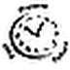
How does the process of writing CHANGE OVER TIME?

How does a drama or prose CHANGE OVER TIME?

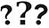
What UNANSWERED QUESTIONS do you have about the beginning, middle, or end of your prose?

What UNANSWERED QUESTIONS do you have about publishing your writing?

Using the LANGUAGE OF THE DISCIPLINE of an author, explain how to write a poem, drama, or prose. (The professional viewpoint of an author is linked to this question.)

Using the LANGUAGE OF THE DISCIPLINE of a student, explain why writing is a form of communication (The professional viewpoint of a student is linked to this question.)

What are the LAWS AND RULES to incorporating transitional words into your writing ?

What are the LAWS AND RULES of writing?

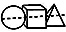
What INTERDISCIPLINARY RELATIONSHIPS are there between what we read from (student’s name) and (student’s name) and what we know about poems?

What INTERDISCIPLINARY RELATIONSHIPS are there between these two groups’ dramas?

What TRENDS in writing leads us to believe there is a writing process?

What TRENDS in prose lead us to believe it is a narrative?

When is it ETHICAL to kill buffalo or other game that live in North Dakota?

When is it ETHICAL to wear animal skins as clothing?

Possible Learning Activities Involving Technology:

Edmodo
I plan on using Edmodo as a way for students to post their assignments online and assess students. Students assignments will be their final draft of their poem, prose, and drama script. An assessment will be created on Edmodo and students will use their iPads to log in and complete the quiz on structural elements.

Directions for Students:
- Go to https://www.edmodo.com
- Click on the Students tab
- Type in the group code: f38ebh
- Type in your first and last name
- Create a username and password (write it down so you won’t forget)
- Click on Structural Elements on the left hand side
- Click on Posts
- Type in a message
- Attach your assignment

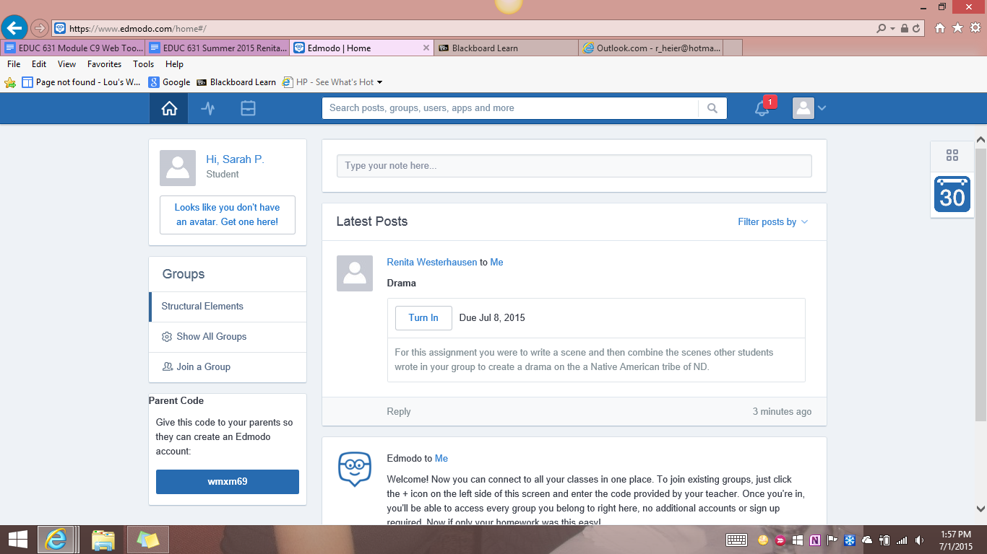

Voki
Voki will be used to enhance my lessons on the structural elements of prose, drama, and poetry. I can create engaging presentations by creating characters, doing voice overs, and displaying attractive visuals.

Directions:
- Go to http://www.voki.com/
- Create an account
- Click on the create tab
- Create your speaking character
- When you are finished click save
- Name the file and scene
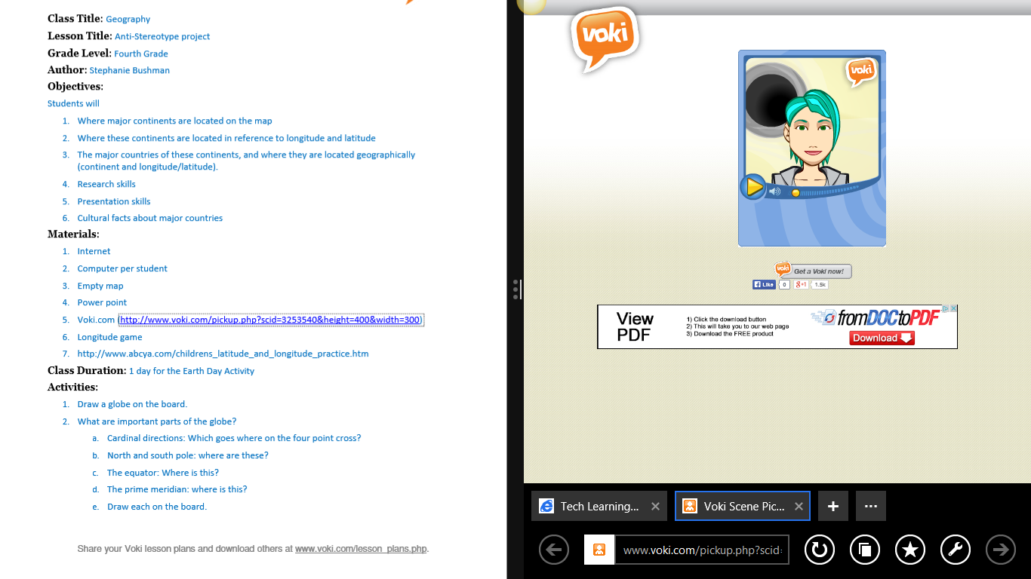
Wordle
Wordle will be used in my lesson as a way to review skills and assess students’ understanding. Students will create a “word cloud” of the structural elements of each fictional text.

Directions:
- Go to http://www.wordle.net/
- Click on “Create your own”
- Paste a bunch of text into the text box
- Click on go
Possible Activities for Early Finishers:
- Help the teacher will administrative tasks
- be a peer tutor
- check over work
- work on unfinished work
- silent read prose, poetry, or a drama
- write a poem, prose, or drama of their choice

