PLEASE JOIN US ONLINE FOR A
Google Air Hangout with Dr. Steven L. Layne:
In Defense of Read Aloud (Sustaining Best Practice)
Tuesday, April 21 (4:15pm Central, 5:15pm Eastern)

Featuring Dr. Steven L. Layne, Judson University Literacy Professor and Author
Amy Kappele, Reading Specialist & Elementary Reading Literacy GPS Facilitator
And a Panel of CUSD #303 St. Charles Educators

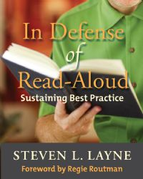
Topics
- What’s All the Fuss About Reading Aloud
- Establishing a Successful Read -Aloud
- Selecting the Appropriate Read –Aloud
- The Art of Reading Aloud

Who Should Participate
early childhood teachers, classroom teachers, literacy coaches, reading specialists, instructional support coaches, principals, parents and anyone else that reads to children and young adults

How to Participate
- Register in advance for the Google Air Hangout:
https://plus.google.com/events/ch8dsi0rh66h2vcbiggmpqtlb5o

For ongoing discussions, resources, and additional virtual events on similar topics, join your colleagues in the GPS Network’s Reading Elementary Literacy Group, facilitated by Amy Kappele at http://www.gpsnetwork.org

