British Literature

*Gulliver’s Travels* Poster Board Project

Your job is to “teach” your section of the novel to the rest of the class. You will need a poster board visual in order to accomplish this. Your poster board must contain the following elements:

* A Freytag Pyramid that fully addresses the plot
* A visual representation that will give students a mnemonic device for your section
* A detailed analysis of the topic(s) Swift is satirizing
* A detailed analysis of the literary devices Swift uses for the satire
* Visually pleasing

You will use your poster board to lead your lesson on your section for the rest of the class.

C:\Users\ChristiansenAM\AppData\Local\Microsoft\Windows\Temporary Internet Files\Content.IE5\EIDI5STL\MC900295595[1].wmf

British Literature

*Gulliver’s Travels* Poster Board Project

Your job is to “teach” your section of the novel to the rest of the class. You will need a poster board visual in order to accomplish this. Your poster board must contain the following elements:

* A Freytag Pyramid that fully addresses the plot
* A visual representation that will give students a mnemonic device for your section
* A detailed analysis of the topic(s) Swift is satirizing
* A detailed analysis of the literary devices Swift uses for the satire
* Visually pleasing

You will use your poster board to lead your lesson on your section for the rest of the class.

C:\Users\ChristiansenAM\AppData\Local\Microsoft\Windows\Temporary Internet Files\Content.IE5\EIDI5STL\MC900295595[1].wmf

English 11

*Gulliver’s Travels* Cheat Sheet

Your job is to create a “cheat sheet” for your section of the novel. This will be turned in to turnitin.com to check that you have done the work alone.

Your document should be visually pleasing and easy to read and must include the following elements:

* A detailed but concise rendering of the plot
* A “visual” mnemonic device to helps students remember what your section is about
* A detailed listing of the elements of society that Swift is satirizing
* A detailed listing of the literary devices that Swift uses in creating his satire.

This is due to turnitin.com by 2/13/15 at 11:00 p.m.

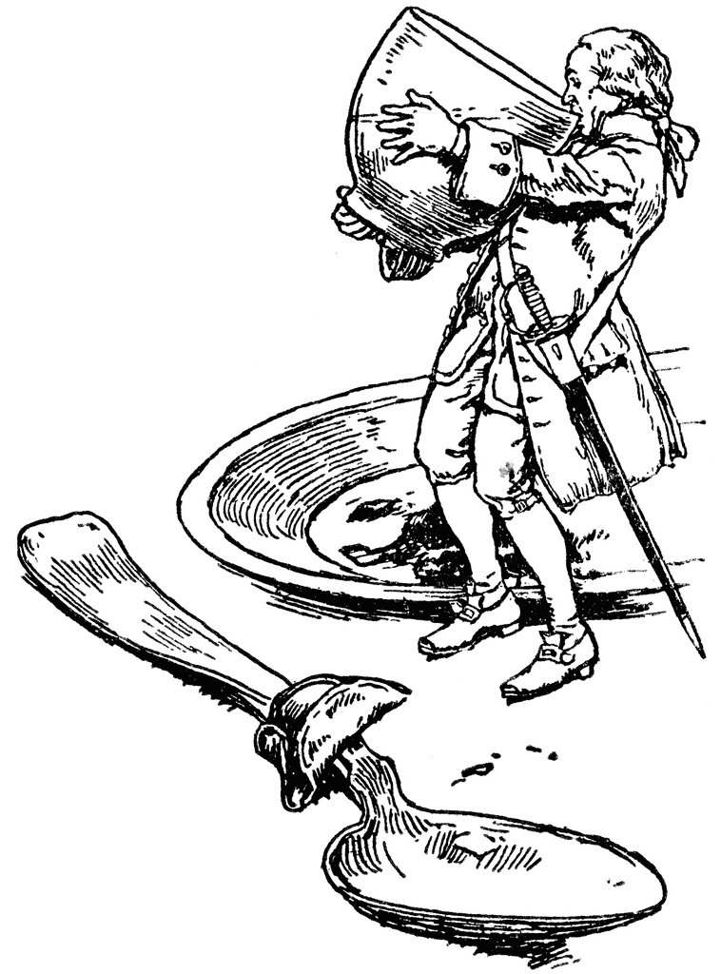

Section 1 Section2 Section 3 Section 4

Section 1 Section2 Section 3 Section 4

Section 1 Section2 Section 3 Section 4

Section 1 Section2 Section 3 Section 4

Section 1 Section2 Section 3 Section 4

Section 1 Section2 Section 3 Section 4

Section 1 Section2 Section 3 Section 4

Section 1 Section2 Section 3 Section 4

Section 1 Section2 Section 3 Section 4

Section 1 Section2 Section 3 Section 4