**C:\Users\huberj\AppData\Local\Microsoft\Windows\Temporary Internet Files\Content.IE5\O5COX8KW\MC910217272[1].wmf**

**Shakespeare Song**

Pick a song that reflects Shakespeare or his life in four ways. Print the lyrics and underline or highlight and explain why you think it is like Shakespeare in those ways. You will present your findings tomorrow to the class.

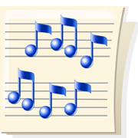

**Rubric**

____/10- On task in class

____/16- Four ways that the song relates to Shakespeare with explanation

____4- Speech Mechanics

_____/30-Total

Comments:___________________________________________________________________