3rd Grade BINGO Qrt. 3
Name ________________________________________________
Common Sense Media Digital Passport  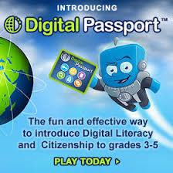 | Complete Code.org Course  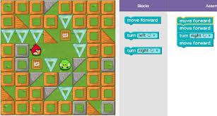 | Make a list and use bullets | Make a poster about coding or internet safety. Save it and Print it.
Use Active Inspire or an Story Maker iPad app and write an ebook about a technology topic  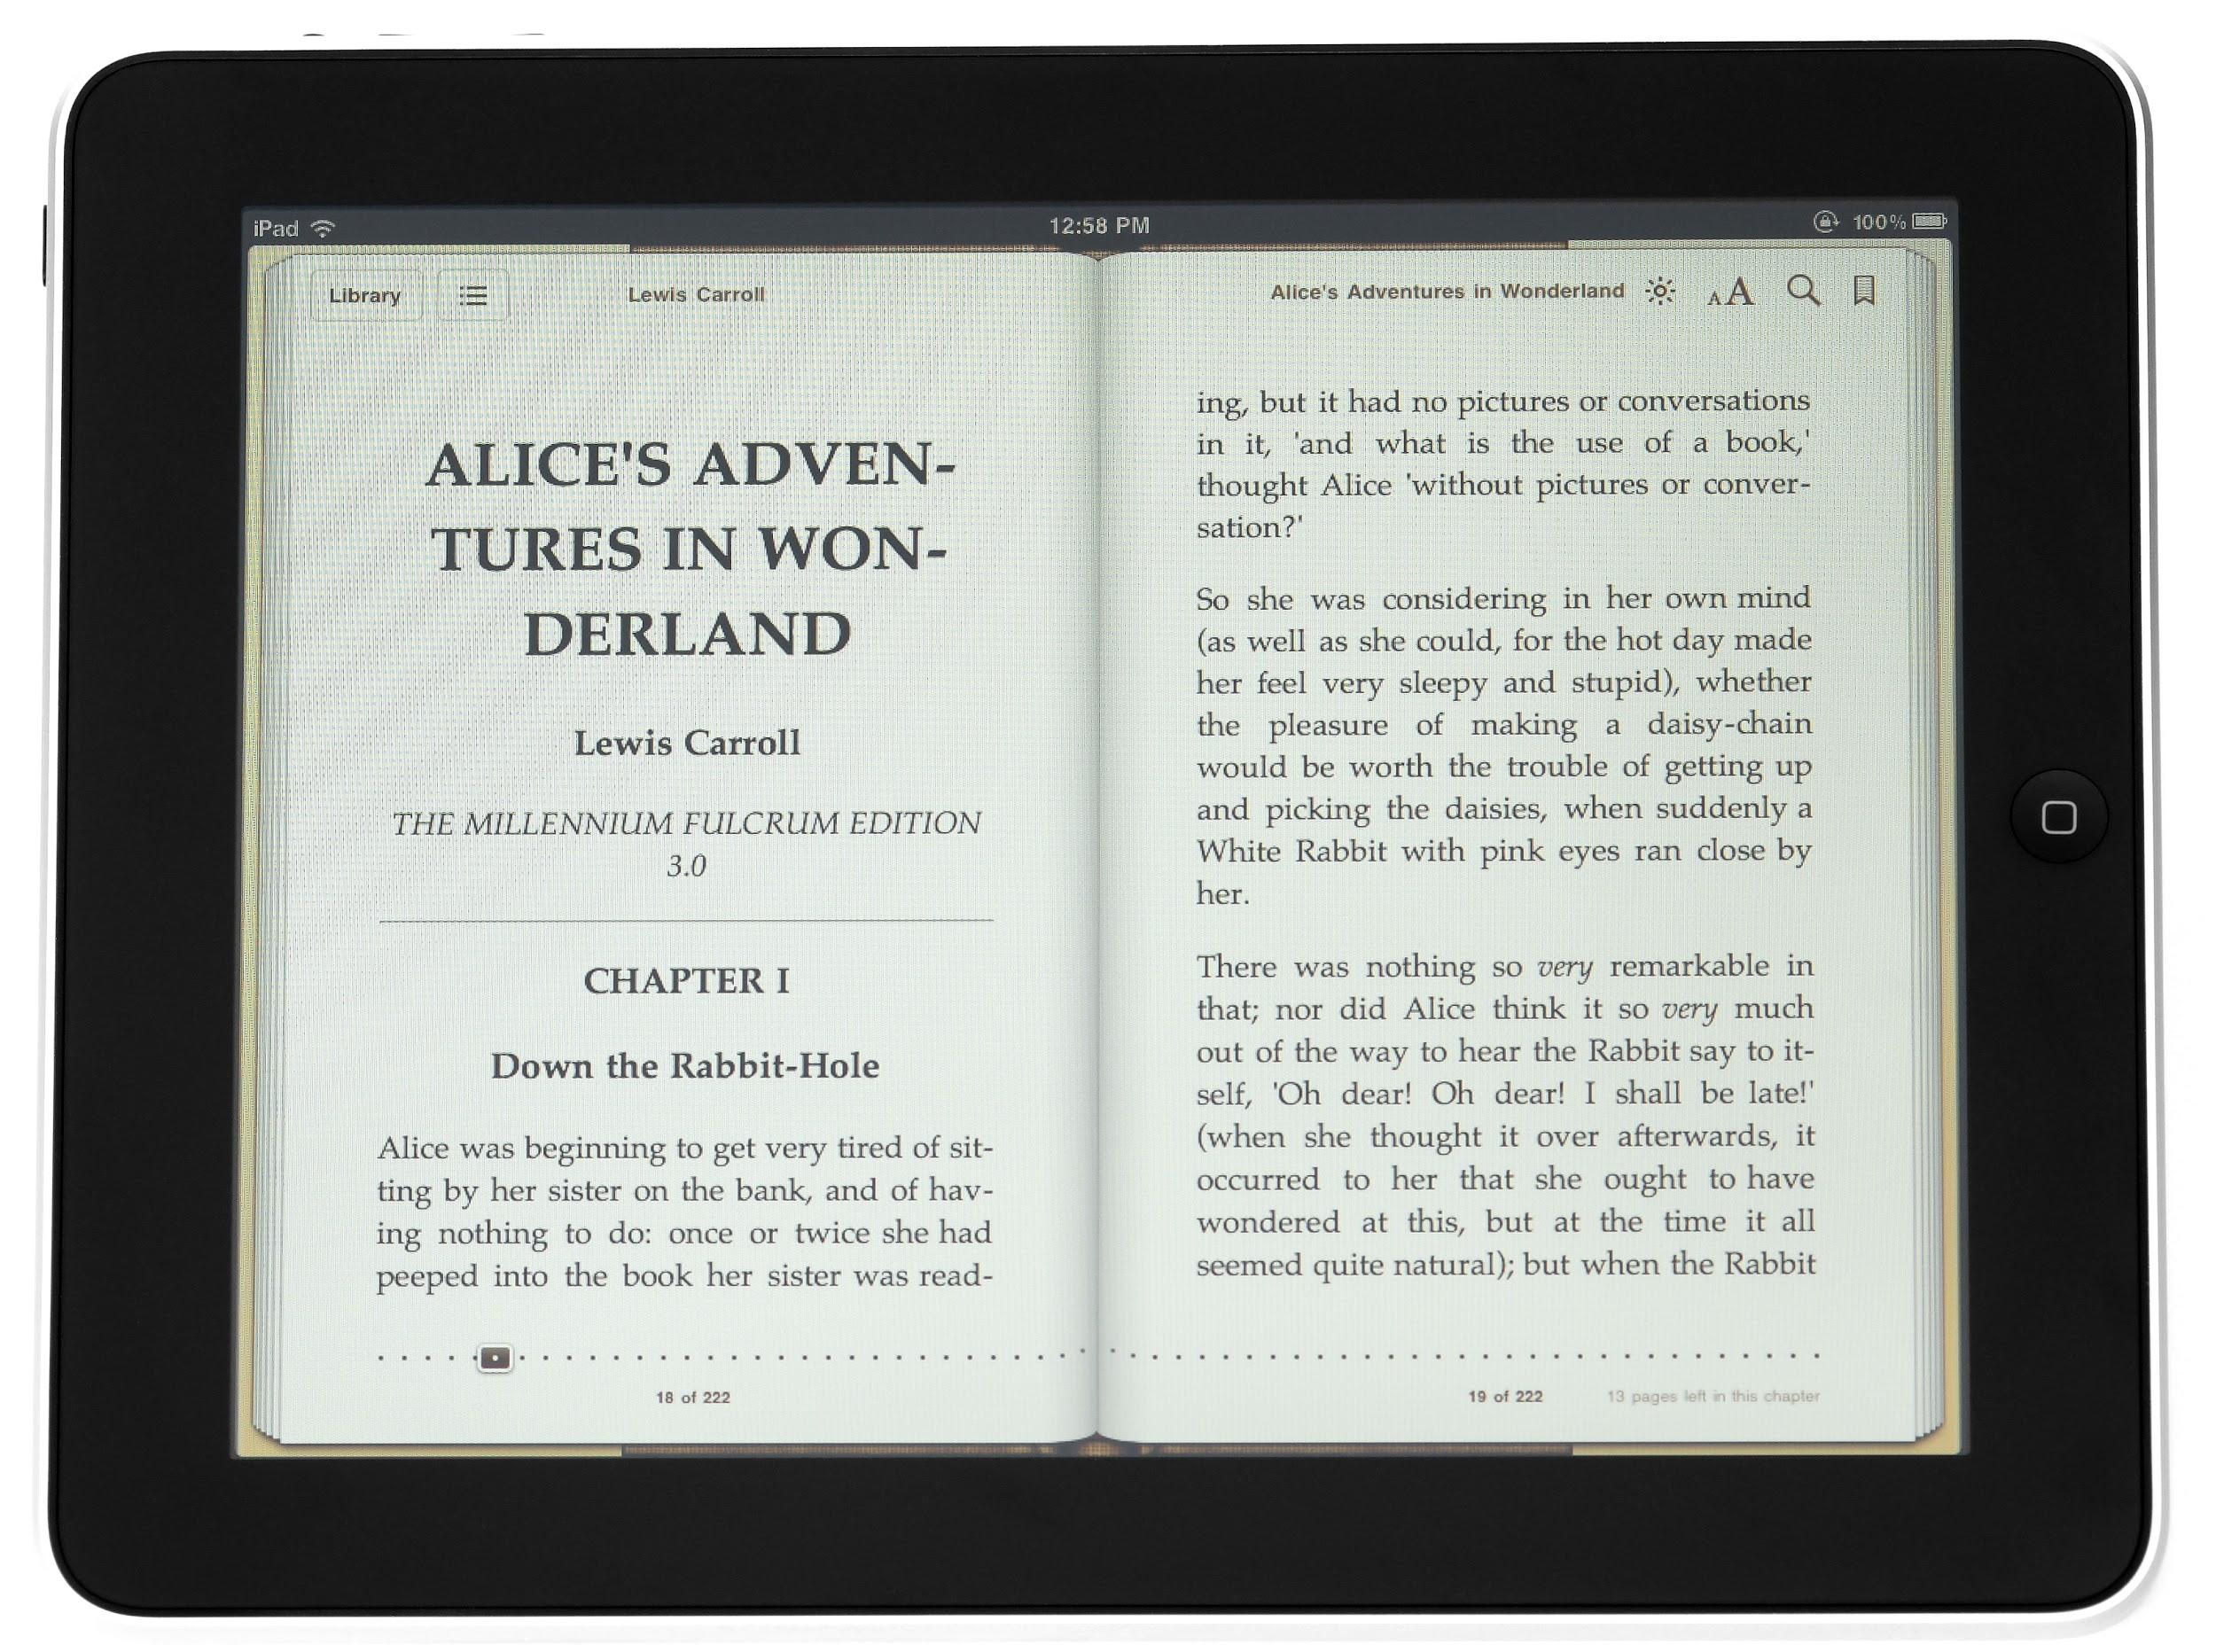 | Complete Code.org Course | Complete Typing Challenge with 15 words per minute or more | Common Sense Media Digital Passport
Publish one of your stories in Word and change the font size and color. Add a picture.  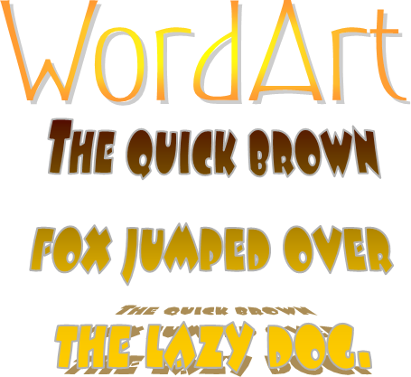 | Common Sense Media Digital Passport | Complete Code.org Course | Complete Typing Challenge with 15 words per minute or more
Complete Typing Challenge with 15 words per minute or more | Make a digital art project using the tool of your choice. | Common Sense Media Digital Passport | Complete Code.org Course

