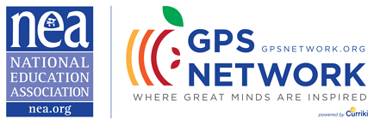
Upcoming Webinar
“Inclusion: How to Create a Positive Classroom Experience”
Wednesday, Jan. 7, 8:00 pm ET/5:00 pm PT

Moderated by NEA GPS Network Facilitators:
Victoria Huey, Special Education Secondary Group
Tanika Johnson, Special Education 3-5 Elementary Education Group
Stephanie Trevitz, PK3 Early Childhood Group
Anthony Colucci, Gifted and Talented Group
Tricia Roach, Special Education and Common Core Group

Join the discussion about how to promote inclusion in your school.
A free starter resource kit will be provided to all attendees!

For information about this webinar visit:
http://neaorg.adobeconnect.com/e8m7q2ukhly/event/event_info.html

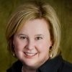

Featuring Nicole Eredics
- 15 years as a teacher, and parent, inclusion education advocate.
- Founder of the blog, The Inclusive Class.
- Co-host for The Inclusive Class Podcast.
- Acknowledgements in The National Dissemination Center for Children with
Disabilities, Special Education Advisor, The Whole Child.
- The Inclusive Class with Brookes Publishing Company.
- Specializes in solutions and strategies for facilitating inclusive classroom
settings for students with special needs

