In Bhutan, a Bid to Turn Basketball From a Royal Sport to a National One
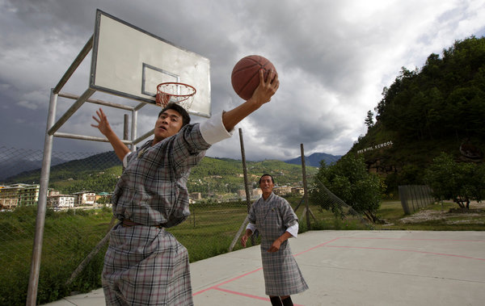
Kuni Takahashi for The New York Times
Students at the Pelkhil School in Thimphu, Bhutan. Few in this nation of 742,000 are taller than 6 feet.

By GARDINER HARRIS

Published: October 14, 2013

THIMPHU, Bhutan — With just seconds left in the game, the queen of Bhutan went to the hole like a hungry snow leopard pouncing on a mountain goat, taking two dribbles and three long strides before putting up a royal layup.

Kuni Takahashi for The New York Times
Basketball being played at a youth center in Thimphu. As Bhutan puts together a national team, a lack of height and a lack of defense are obstacles facing its South Korean coach.
Yes, your majesty!
Queen Jetsun Pema Wangchuck’s final basket was just one of 17 she made in a friendly game of basketball last month with nine other women. Basketball may be a street game in the United States, but it is the game of kings and queens in Bhutan.
Indeed, the 23-year-old queen, who plays almost every day, is surprisingly good. The royal set shot is as sweet as honeyed ghee, and the royal dribble as poised as a monk in meditation. Her statistics in that game were like those of an N.B.A. star: 34 points, 3 rebounds and 4 assists. (Perhaps it helped that the Bhutanese custom forbidding citizens from touching a royal without an invitation seems to extend to the basketball court.)
“If I had known you’d be counting, I would have played harder,” she said with a laugh. The queen’s husband, King Jigme Khesar Namgyel Wangchuck, his brother and two half-brothers also play regularly. But after decades of being a largely royal preserve, basketball here is about to have its breakout moment.
A South Korean coach has been hired to cobble together a national team that many hope will someday be able to challenge its neighbors for bragging rights in South Asia and beyond. Bhutan has tried many times to win an international game but, except for a single victory in a three-on-three tournament, has never succeeded.
Bhutan’s main problem is height. Few in this nation of 742,000 are taller than 6 feet. The queen is 5-5, and her husband and brothers-in-law are not much taller. Dunking is almost as rare as dragons.
“And I don’t think our backboards are strong enough to take a lot of dunking,” said Paljor Dorji, an impish 70-year-old known as Benji, who learned basketball from Canadian Jesuits at a boarding school in Darjeeling, India. He is widely credited with bringing the sport to Bhutan and instilling a passion for it in the royal family.
There is a saying in basketball that height cannot be taught, and Kiyong Kim, the new national team coach, says he does not intend to try.
“In order to cover the height problem, I’m trying to get them into a faster style of play,” Mr. Kim said through a giggling young interpreter. “We need stronger defense and better fast breaks.”
On a worn parquet floor in the tired gymnasium where Queen Wangchuck played, Mr. Kim began that process Sept. 2. About 50 young men showed up for the first of what Mr. Kim promised would be years of regular practices.
“The most important things are attendance, physical fitness, your ability to understand the game and, lastly, your enthusiasm as defenders,” he said in an opening speech that could have been taken straight from “Hoosiers,” a movie about an underdog basketball team in a tiny Indiana town.
And like the coach in “Hoosiers,” Mr. Kim promised that his players would rarely handle a ball in the first weeks of practice. For the next two hours, Mr. Kim put his recruits through a series of lunges, squats and pivots — the essential moves of a vigorous defense.
Bhutanese players say their best hope for a win could be against the Maldives, a country with half of Bhutan’s population that is threatened by global warming. As sea levels rise, Maldivians may have trouble finding places to play, players noted. And facing them in Thimphu’s thin air (the city’s altitude is 7,710 feet) could provide a crucial advantage.
“The thing I’ve noticed about Bhutanese basketball is that you guys don’t really care about defense,” Mr. Kim shouted while his players sweated and groaned in an extended squat. “That has to change. That will change.”
It is a problem that could have resulted from basketball’s royal birth. Bhutanese royalty — like some princes of American basketball — is known more for enthusiastic shooting than vigorous defense. Bhutan’s fourth king, 57-year-old Jigme Singye Wangchuck, now retired and widely referred to simply as K4, still plays daily (Mr. Dorji instilled a passion for the game in the king when he was a teenager) and is rumored to have made 65 3-pointers in a game (the N.B.A. record is 12). No one seems to know how many shots he missed in that mythic match, as security guards shoo away the curious when K4 plays.

