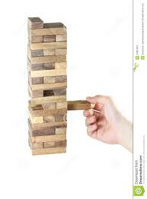
Jenga review game-
This is a game played in teams. You can determine the size of the teams. The students take turns taking a piece out of the Jenga tower. For each piece that they receive, they have to translate the word (conjugate the verb, identify the person/picture, or saw the phrase) denoted for that number. Then, they must use that word in one (two or more) complete sentences in the target language. Their peers are the judges- but you are walking around too to check up on them. If they cannot do this task, they have to draw another piece.
You fill in this chart with the vocabulary, grammar or culture from your current lesson. You win this like you win Jenga.
1 |  | 22
2 |  | 23
3 |  | 24
4 |  | 25
5 |  | 26
6 |  | 27
7 |  | 28
8 |  | 29
9 |  | 30
10 |  | 31
11 |  | 32
12 |  | 33
13 |  | 34
14 |  | 35
15 |  | 36
16 |  | 37
18 |  | 39
19 |  | 40
20 |  | 41
21 |  | 42

43-40 Students create questions / vocabulary for each other.

