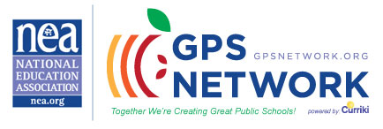

Early Childhood Special Education (Pre-K – 2nd) Teachers!!!

Join the GPS Network and connect with other teachers nationwide! See what teachers are doing across the nation to implement the Positive Practices in their Classrooms!

This is a network for ALL practitioners & stakeholders in the field of education, members and non-members. This is an effort designed to bring us all together so that classrooms nationwide connect and collaborate to increase student achievement!

Please invite other teachers to join and share the exciting things going on in the lives of their students! Groups are available for all grades and subject levels!

Join our Special Ed Early Childhood (Pre-K – 2nd) Grades Community:
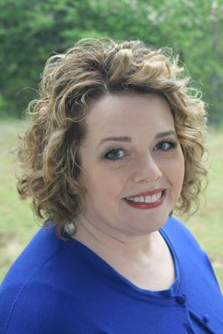
- Login onto www.gpsnetwork.org
- Register as a member of the GPS Network & Sign In
- Click > Collaborate Tab
- Scroll down to the Featured Professional Topic Groups
- Click > Special Education Early Childhood (Pre-K – 2nd) Grades
- Click > Join This Group
- Please add biographical information about yourself
For more information about the Special Education Early Childhood (Pre-K – 2nd) Grades Community, do not hesitate to contact me at strevitz@gmail.com.

- Also, you may find us at http://spedearlychildhood.groups.gpsnetwork.org
Stephanie Trevitz, Ed.D., NBCT
Group Facilitator

