Counting on Excellence: How Parents Can Help Their Children Learn Mathematics

from the National Mathematics Advisory Panel
In today’s highly competitive economy, solid skills in mathematics, including algebra, are a necessity—not just for scientists and engineers, but for everyone. Being proficient in mathematics helps to improve students’ college and career options and to increase their future income levels. Beyond the education, career and economic benefits, a solid background in mathematics helps students to better understand their world and to become good citizens.

As a parent, you may be anxious about your own math skills or perhaps feel challenged by the difficulty of your child’s math homework, but your child will benefit greatly if you maintain a positive, encouraging attitude. And whether or not you completely understand your child’s math assignments, you can still help as he or she progresses through school by asking the right questions, helping your child approach the problems with the right attitude, and getting extra help from the teacher or a tutor as needed.

We now know from the findings of the National Mathematics Advisory Panel that there
are several things parents can do and must do to help ensure that their child succeeds in mathematics.
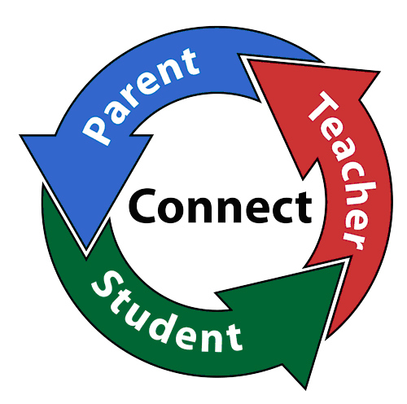
Positive Parent Attitudes About Mathematics Education Are Important to Student Success

• Research shows that a child’s goals for and beliefs about learning are related to his or her performance in mathematics. Even if you as a parent feel you are not good in math or perhaps feel uncomfortable with the mathematics being taught in a given day’s lesson, you can still support your child’s mathematics learning by showing you value mathematics. Your child will follow suit.

• Students who believe that their hard work makes them “smarter” are more likely
to try harder in mathematics, and their efforts result in better performance. On the
other hand, students who believe that intelligence is inborn generally do not achieve as well, and they do not take full advantage of feedback or constructive criticism regarding their performance.

