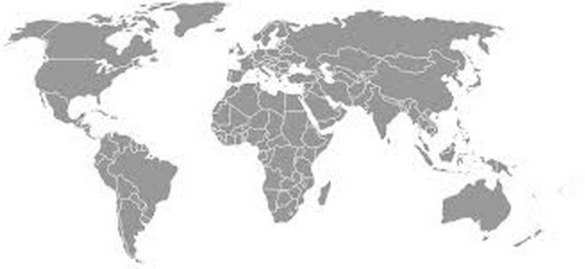
Chemical Conflicts around the World
Since the beginning of recorded history, humans have been extracting elements from their ores and then finding all kinds of uses for them. For example, you may never have heard of the metal neodymium, but you probably have some in your pocket right now, maybe even in your ear! That is because neodymium is used in the production of both cell phones and ear phones/ear buds. It also has applications associated with hybrid car production, petroleum processing and laser technology, just to name a few.
Pb
Be
Co
Au
Ag
Ti
Mn
U
Nd
Cr
Ni
C
These elements, however, are not evenly distributed across the Earth’s surface. Hence some countries have a wealth of some minerals deposits and totally lack others. Furthermore, these elements rarely come out of the ground ready to be used. Most of them have to be refined from their ores, and some countries have better resources for doing this than others. As you might imagine, this sets the stage for all kinds of international issues and conflicts pertaining to trade, politics, technology, human rights and the environment. It could be argued that the competition for access to these elements is what has caused most if not all of the prosperity and poverty, success and suffering of various countries and cultures since the beginning of civilization. It’s all about chemistry!
Which brings us to the assignment…
Phase 1: Research your options. Be resourceful!
You will pick a partner – make sure it is someone whom you think you can work well – and you will have three weeks to research a variety of elements, what they are used for, where they are mined and/or processed – which must be somewhere outside the US – and what controversy/conflict/issue(s) exists concerning them. You will submit the Chemical Conflicts Proposal Sheet during the week of Sept 9-13. This will be submitted on-line through Quia, but a copy of this form is provided on page 2 below. You must submit your first three choices. Since we want all the presentations to be different, if there are any duplicate proposals, the first one submitted will get their first pick – so it pays to submit the proposal on Quia as early in the week as possible – only one submission is needed per pair of students.

Phase 2: Developing your presentation. Be creative!
Once your proposal has been accepted and you know for certain which element you will be presenting on, work together with your partner to develop a presentation on this element. This can be in any format you choose: straightforward presentation (though make sure it is not boring!), skit, song, rap… It’s up to you. There are a few specific requirements:
- Duration: The presentation should be designed to last anywhere from 4 to 6 minutes.
- Power-point slide show: The presentation must have an accompanying power-point slide show with text and graphics/images. [Creative original animations will count for bonus!] The slideshow should be well integrated into what you present, but it should not be the entire show. In other words, your presentation should not just be the two of you flipping through the slides: you two should be the stars of the presentation and the slide-show should just supplement what you present. Images/photos are very effective, but you are limited to NO MORE THAN 75 WORDS OF TEXT. This is to prevent you from just reading your entire presentation off the slide show. You will have a hand-held remote to advance through the slideshow. Among all the images, the slideshow should contain a map which indicates where the country is located. If there are any short imbedded videos in the slideshow, they must be sent along with it or they will not show up on the teacher’s computer. These can last no more than 30 seconds total.
- Emphasize the conflict. In as much as there is some issue or conflict involved, one of you should argue one side of the issue, while the other argues the other – like a mini-debate.
- KNOW WHAT YOU ARE GOING TO SAY. Make sure you have spent time rehearsing with your partner and with the slide show. If you need to work from note-card, you may but it will come with a 5 point deduction each. If you read a great deal of your presentation off the note cards, it will translate into an additional deduction of up to 10 points each.
Show that you really understand the issues involved as well as the chemistry. Learn as much as you can about the culture, the customs and the language of the country involved, and try to integrate these into your presentation. Try to see the conflict through the eyes of someone in that country.
Phase 3: The Presentation. Be brave!
These presentations will be spread out over a three-week period in January, one each day at the beginning of class. These dates will be assigned to you by a random draw. The power-point slideshow and a rough “script” – an outline of what’s being said by whom – must be submitted by Jan 10. These presentations will be videotaped and put on-line and there will be links to them on my website. Ideally this webpage will be in the form of a map like the one shown above, with element symbols serving as “buttons” you can push to take you to the video-links. Your grades out of 100 pts will be based on the rubric below on page 3.

Note: this is just a copy of the proposal: the actual proposal will be done on-line (Quia).
Chemical Conflicts Proposal Sheet Names: ________________ _________________ Per: ____
1st Choice: Element name: _________________ Symbol: ___ Primary Use/Application: _______________________
Country which mines this element: _____________ and/or country which processes this element: _________________
Explain the conflict/controversy/issue that relates to this element*:

2nd Choice: Element name: _________________ Symbol: ___ Primary Use/Application: _______________________
Country which mines this element: _____________ and/or country which processes this element: _________________
Explain the conflict/controversy/issue that relates to this element*:

3rd Choice: Element name: _________________ Symbol: ___ Primary Use/Application: _______________________
Country which mines this element: _____________ and/or country which processes this element: _________________
Explain the conflict/controversy/issue that relates to this element*:

* This might be in form of human rights violation or environmental problem or political barrier…

Grading Rubric for Chemical Conflicts around the World Presentation Names: _____________ _____________
The presentation lasts less than 1 min or more than 7 min  1. Duration  (1 pt) | The presentation lasts less than 1.5 min or more than 6.5 min  (4 pt) | The presentation lasts less than 2 min or more than 6 min  (7 pt) | The presentation lasts the required 2.5-6 min  (10 pt)
The slideshow contains many typos and shows very little originality  2. Slideshow  (3pts) | The slideshow contains a few typos and shows limited originality  (8 pts) | The slideshow contains no typos or it shows a great deal of originality  (12 pts) | The slideshow contains no typos and it shows a great deal of originality  (15 pts)
The slideshow contains more than 75 words of text and no references  (1 pt) | The slide show contain more than 75 words of text OR less than 2 refs  (4 pt) | The slide show contain fewer than 75 words and only 2 refs  (8 pt) | The slide show contain fewer than 75 words & 3+ references  (10 pt)
The presentation is 90%+ presented by just one of the two students  3. Balance  (Does not apply to students presenting solo)  (1 pt) | The presentation is 75-90% presented by just one of the two students  (4 pt) | The presentation is 60-75% presented by just one of the two students  (7 pt) | Both students contribute more or less equally during the presentation  (10pt)
The presentation was poorly researched & does not succeed at teaching the class  4. Research & Communication  (2pts) | The research was adequate at best but the presentation is a bit confusing  (8 pts) | The research was adequate and the presentation is OK but nothing special  (14 pts) | The topic is well researched and well communicated to the audience  (20 pts)
Neither side of the debate is very compelling  5. Debate  (1 pts) | One side of debate is strong, the other is weak, or both sides are just OK  (4pts) | One side of the debate is strong, but the other is just OK  (7pts) | The debate is well presented from both sides  (10 pts)
The entire presentation is hard to hear  6. Annunciation  (2 pt) | Neither student does a good job with projecting their voice or annunciating well  (4pts) | One student annunciates clearly; the other, not so much  (6 pts) | Both students project their voices well and annunciate clearly  (8 pts)
Almost no eye contact with the audience is made  7. Addressing the audience  (1 pt) | Neither student does a good job of addressing the entire audience  (3 pts) | One student addresses the entire audience; the other, not so much  (5 pts) | Both students do a good job of addressing the entire audience  (7 pts)
Almost nothing at all is done to convey any cultural aspects into the presentation  8. Cultural inclusion  (1 pts) | A little is done to convey any cultural aspects into the presentation  (4 pts) | Cultural aspects of the country are somewhat integrated into the presentation  (7 pts) | Cultural aspects of the country are well integrated into the presentation  (10 pts)
Deductions: Use of note cards: -5 to -25
Powerpoint & script not submitted on time: -5 to -25
Not prepared to present on assigned date: -10 to -30
Comments:
Overall score:_______ /100

