Approximate Time Frame: 6 - 8 weeks
Connections to Previous Learning:
Grade 2 students extend counting and modeling of quantities to equal groups and arrays. Students will begin to model multiplication using rectangles partitioned into equivalent squares

Focus of the Unit:
Grade 3 students continue to work with products and quotients of whole numbers and apply properties of operations to problem-solving situations. Students will uncover patterns within multiplication and division and use these to build fluency.

Students will utilize multiplication to find a total number of objects when there are a set number of groups with an equal number of objects in each group or when an equal amount of objects are added or collected numerous times. There are two distinct models of division: partition models and measurement (repeated subtraction) models.
? | ? | ? | = | 12
- Partition models provide students with a total number and the number of groups. These models focus on the question, “How many objects are in each group so that the groups are equal?” A context for partition models would be: There are 12 cookies on the counter. If you are sharing the cookies equally among three bags, how many cookies will go in each bag?

- 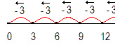Measurement (repeated subtraction) models provide students with a total number and the number of objects in each group. These models focus on the question, “How many equal groups can you make?” A context for measurement models would be: There are 12 cookies on the counter. If you put 3 cookies in each bag, how many bags will you fill?

Students in Grade 3 will also work with properties (rules about how numbers work) of multiplication. This grade will take their understanding beyond previous expectations, in which students were asked to simply identify properties. While students DO NOT need to not use the formal terms of these properties, student must understand that properties are rules about how numbers work, and they need to apply each of them in varied situations. Brief definitions for each of the properties follows:
- The associative* property states that the sum or product stays the same when the order of addends or factors is changed. For example, when a student multiplies 7 x 5 x 2, a student could rearrange the numbers to first multiply 5 x 2 = 10 and then multiply 10 x 7 = 70.
- The commutative property (order property) states that the order of numbers does not matter when you are adding or multiplying numbers. For example, if a student knows that 5 x 4 = 20, then they also know that 4 x 5 = 20.
- The distributive* property of multiplication over addition is a strategy for using products students know to solve products they don’t know. Students would be using mental math to determine a product. Here are ways that students could use the distributive property to determine the product of 7 x 6. Again, students should use the distributive property, but can refer to this in informal language such as “breaking numbers apart”.
7 x 6  7 x 5 = 35  7 x 1 = 7  35 + 7 = 42 | 7 x 6  7 x 3 = 21  7 x 3 = 21  21 + 21 = 42 | 7 x 6  5 x 6 = 30  2 x 6 = 12  30 + 12 = 42
Another example of the distributive property is the area model of multiplication. This helps students determine the products and factors of problems by breaking numbers apart and visualizing their products. For example, for the problem 7 x 8 = ?, students can decompose the 7 into a 5 and 2, and reach the answer by multiplying 5 x 8 = 40 and 2 x 8 =16 and adding the two products (40 +16 = 56).
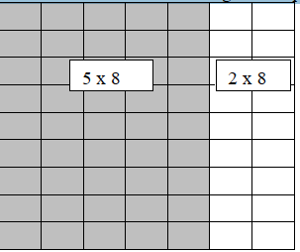

*The use of parentheses are important in modeling the associative and distributive properties.
With respect to fluency, the standards use the word fluently, which means accuracy, efficiency (using a reasonable amount of steps and time), and flexibility (using strategies such as the distributive property). When students are asked to know facts from memory, the focus must not be solely upon timed tests or repetitive practice. Students must have numerous and varied experiences working with manipulatives, pictures, arrays, and numbers to internalize the basic facts (up to 9 x 9). By studying patterns in multiplication facts and relating multiplication to division, students will build a foundation for fluency with these facts. Some strategies students may use to attain fluency are listed below:
• Multiplication by zeros and ones
• Doubles (2s facts), Doubling twice (4s), Doubling three times (8s)
• Tens facts (relating to place value, 5 x 10 is 5 tens or 50)
• Five facts (half of tens)
• Skip counting (counting groups of __ and knowing how many groups have been counted)
• Square numbers (ex: 3 x 3)
• Nines (10 groups less one group, e.g., 9 x 3 is 10 groups of 3 minus one group of 3)
• Decomposing into known facts (6 x 7 is 6 x 6 plus one more group of 6)
• Turn-around facts (Commutative Property)
• Fact families (Ex: 6 x 4 = 24; 24 ÷ 6 = 4; 24 ÷ 4 = 6; 4 x 6 = 24)
• Missing factors

NOTE: Students should have exposure to multiplication and division problems presented in both vertical and horizontal forms.

Connections to Subsequent Learning:
Grade 4 students will multiply and divide with increasingly difficulty. They will also extend multiplication and division concepts into factors and multiples. Patterns that flow from these operations will be generated and analyzed. Finally, Grade 4 students will multiply a fraction by a whole number.
Adapted from North Carolina Department of Public Instruction, Instructional Support Tools for Achieving New Standards (Updated 2012.)

From the Operations & Algebraic Thinking progression document, pp. 22, 23, 24, 25- 26-27

Students focus on understanding the meaning and properties of multiplication and division and on finding products of single-digit multiplying and related quotients.^{3.OA.1–7} These skills and understandings are crucial; students will rely on them for years to come as they learn to multiply and divide with multi-digit whole number and to add, subtract, multiply and divide with fractions and with decimals. Note that mastering this material, and reaching fluency in single-digit multiplications and related divisions with understanding.^{3.OA.7} may be quite time consuming because there are no general strategies for multiplying or dividing all single-digit numbers as there are for addition and subtraction. Instead, there are many patterns and strategies dependent upon specific numbers. So it is imperative that extra time and support be provided if needed.
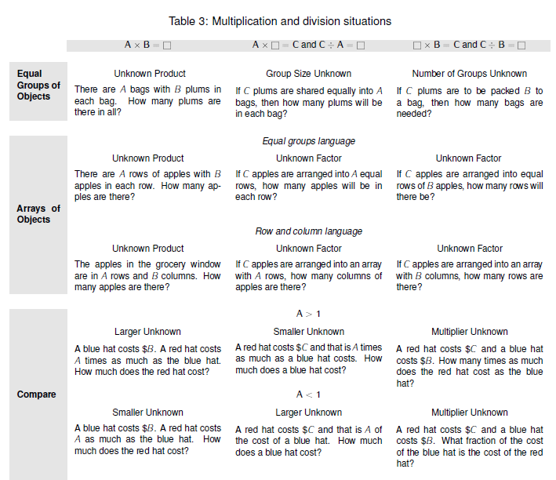

In Equal Groups, the roles of the factors differ. One factor is the number of objects in a group (like any quantity in addition and subtraction situations), and the other is a multiplier that indicates the number of groups. So, for example, 4 groups of 3 objects is arranged differently than 3 groups of 4 objects. Thus there are two kinds of division situations depending on which factor is the unknown (the number of objects in each group or the number of groups). In the array situations, the roles of the factors do not differ. One factor tells the number of rows in the array, and the other factor tells the number of columns in the situation. But rows and columns depend on the orientation of the array. If an array is rotated 90º, the rows become columns and the columns become rows. This is useful for seeing the commutative property for multiplication ^{3.OA.5} in rectangular arrays and areas. This property can be seen to extend to Equal Group situations when Equal Group situations are related to arrays by arranging each group in a row and putting the groups under each other to form an array. Array situations can be seen as Equal Group situations if each row or column is considered as a group. Relating equal group situations to arrays, and indicating rows or columns within arrays, can help students see that a corner object in an array (or a corner square in an area model) is not double counted: at a given time, it is counted as part of a row or as a part of a column but not both.

As noted in Table 3, row and column language can be difficult. The array problems given in the table are of the simplest form in which a row is a group and Equal Groups language is used (“with 6 apples in each row”). Such problems are a good transition between the Equal Groups and array situations and can support the generalization of the commutative property discussed above. Problems in terms of “rows” and “columns,” e.g., “The apples in the grocery window are in 3 rows and 6 columns,” are difficult because of the distinction between the number of things in a row and the number of rows. There are 3 rows but the number of columns (6) tells how many are in each row. There are 6 columns but the number of rows (3) tells how many are in each column. Students do need to be able to use and understand these words, but this understanding can grow over time while students also learn and use the language in the other multiplication and division situations. Grade 3 standards focus on area measurement. ^{3.MD.5-7} Area problems where regions are partitioned by unit squares are foundational for Grade 3 standards because area is used as a model for single-digit multiplication and division strategies. ^{3.MD.7} Throughout multiplication and division learning, students gain fluency and begin to know certain products and unknown factors. All of the understandings of multiplication and division situations, of the levels of representation and solving, and of patterns need to culminate by the end of Grade 3 in fluent multiplying and dividing of all single-digit numbers by 10. ^{3.OA.7} Such fluency may be reached by becoming fluent for each number (e.g., the 2s, the 5s, etc.) and then extending the fluency to several, then all numbers mixed together. Organizing practice so that it focuses most heavily on understood but not yet fluent products and unknown factors can speed learning. To achieve this by the end of Grade 3, students must begin working toward fluency for the easy numbers as early as possible. Because an unknown factor (a division) can be found from the related multiplication, the emphasis at the end of the year is on knowing from memory all products of two one-digit numbers. As should be clear from the foregoing, this isn’t a matter of instilling facts divorced from their meanings, but rather the outcome of a carefully designed learning process that heavily involves the interplay of practice and reasoning. All of the work on how different numbers fit with the base-ten numbers culminates in these “just know” products and is necessary for learning products. Fluent dividing for all single-digit numbers, which will combine just knows, knowing from a multiplication, patterns, and best strategy, is also part of this vital standard.

Desired Outcomes
Standard(s):
Represent and solve problems involving multiplication and division.
3.OA.1 Interpret products of whole numbers, e.g., interpret 5 × 7 as the total number of objects in 5 groups of 7 objects each.
3.OA.2 Interpret whole-number quotients of whole numbers, e.g., interpret 56 ÷ 8 as the number of objects in each share when 56 objects are partitioned equally into 8 shares, or as a number of shares when 56 objects are partitioned into equal shares of 8 objects each.
3.OA.4 Determine the unknown whole number in a multiplication or division equation relating three whole numbers.
3.OA.5 Apply properties of operations as strategies to multiply and divide.

Understand properties of multiplication and the relationship between multiplication and division.
3.OA.6 Understand division as an unknown-factor problem.

Multiply and divide within 100.
3.OA.7 Fluently multiply and divide within 100, using strategies such as the relationship between multiplication and division (e.g., knowing that 8 × 5 = 40, one knows 40 ÷ 5 = 8) or properties of operations. By the end of Grade 3, know from memory all products of two one-digit numbers.

Solve problems involving the four operations, and identify and explain patterns in arithmetic.
3.OA.9 Identify arithmetic patterns (including patterns in the addition table or multiplication table), and explain them using properties of operations.
Transfer: Students will apply…
- Knowledge of multiplication and division to solve real-world problems.
- Problem-solving skills to find the unknown in both multiplication and division problems.
- Properties of operations to identify arithmetic patterns.

Equal groups Unknown products problem situation example: There are 7 bags with 3 apples in each bag for the field trip. How many apples in all? 7 x 3 = ?
Understandings: Students will understand that …
- Visual images and numerical patterns of multiplication and division will assist in solving problems.
- The Properties of Operations will help in performing computation as well as in problem-solving situations. (Distributive Property of Multiplication, Commutative Property of Multiplication, Identity, and Zero.)

Essential Questions:
- How does modeling multiplication and division problems help in finding solutions?
- How can the strategy of breaking apart (decomposing) numbers make multiplication easier to understand?
- How can we use multiplication to solve division problems?
- How do multiples and factors relate to multiplication and division?

Highlighted Mathematical Practices: (Practices to be explicitly emphasized are indicated with an *.)
*
1. Make sense of problems and persevere in solving them. Students demonstrate their ability to persevere and identify appropriate strategies to solve multiplication and division problems embedded within sophisticated problem-solving situations.
*
*
2. Reason abstractly and quantitatively. Students demonstrate reasoning by justifying and explaining products of whole numbers as groups of objects (equal groups/equal sharing). Students will make the connection between quantity and area models of multiplication and division.
3. Construct viable arguments and critique the reasoning of others. Students will explain why specific multiplication and division strategies work. They will also listen to each other and explain what their peers have said.
*
4. Model with mathematics. In this unit, students are asked to use various modalities to show multiplication and division situations (drawings, arrays, objects, etc.). Students are asked to communicate how their visuals represent these situations.
5. Use appropriate tools strategically. Students will use concrete models to represent multiplication and division situations.
6. Attend to precision. Students represent and describe the process of computations using inverse operations to justify their work.
7. Look for and make use of structure. Students will recognize and identify patterns existing within and between multiplication and division. Students will utilize parentheses to display the structure of these problems, i.e., 2(3 x 4) or 15 – (2 x 3). Students use this knowledge when applying strategies to evaluate real-world situations of multiplication and division embedded within various problem-solving structures.
8. Look for express regularity in repeated reasoning. Students will observe commonalities within and between multiplication and division.
Prerequisite Skills/Concepts:  Students should already be able to…  - Model with equal groups by partitioning rectangles.  - Solve equations for the unknown.  - Identify arithmetic patterns. |  | Advanced Skills/Concepts:  Some students may be ready to…  - Identify and work with factors and multiples.  - Multiply and divide multi-digit whole numbers.  - Multiply fractions by whole numbers.
Knowledge: Students will know…  - Multiplication and division facts. |  | Skills: Students will be able to …  - Interpret products of whole numbers as the total number of objects in “so many” groups of “so many” objects each. (3.OA.1)  - Interpret whole-number quotients of whole numbers as the number of objects in each share or as a number of equal shares. (3.OA.2)  - Determine the unknown whole number in a multiplication and division equation relating three whole numbers. (3.OA.4)  - Apply properties of operations as strategies to multiply and divide. (3.OA.5)  - Understand division as an unknown-factor problem. (3.OA.6)  - Fluently multiply and divide within 100, using various strategies. (3.OA.7)  - Identify arithmetic patterns (including patterns in the addition table or multiplication table). (3.OA.9)  - Explain arithmetic patterns using properties of operations. (3.OA.9)
WIDA Standard:
English language learners communicate information, ideas and concepts necessary for academic success in the content area of Mathematics.
English language learners will benefit from:
- Concrete models of multiplication and division processes.
- Repeated verbalization of processes along with an Anchor Chart highlighting terms and steps.

Academic Vocabulary:
Critical Terms:  multiplication  decomposing  array  multiple  product  factor  divisor  dividend  quotient  remainder  equal gorups  equal shares  fact family/related facts |  |  | Supplemental Terms:  inverse operation  distributive property  commutative property  zero property  identity  equation
Assessment
Pre-Assessments | Formative Assessments |  | Summative Assessments | Self-Assessments
Sample Lesson Sequence

