Name ___________________________________________ Date _________
Mixed Numbers and Improper Fractions Homework
Visual | Mixed Number | Improper Fraction
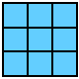

Name ___________________________________________ Date _________
Mixed Numbers and Improper Fractions Homework
Visual | Mixed Number | Improper Fraction

Name _____________________________________ Date _____________
Ways to Represent the Fraction 2 ¼
Area Model | Improper Fraction
Decomposed Fraction

Number Line

Name _____________________________________ Date _____________
Ways to Represent the Fraction 2 ¼
Area Model | Improper Fraction
Decomposed Fraction

Number Line

Name __________________________________ Date _________
Mixed Numbers & Improper Fractions……Decomposing & Composing Fractions
Improper Fraction | Decomposed Fraction | Mixed Number

Name __________________________________ Date _________
Mixed Numbers & Improper Fractions……Decomposing & Composing Fractions
Improper Fraction | Decomposed Fraction | Mixed Number
Name _________________________________________________ Decomposing Fractions

Part 1: Today you will share 4 ways to decompose 10/10. Start with shading in the area models below. Make sure to make them all different.

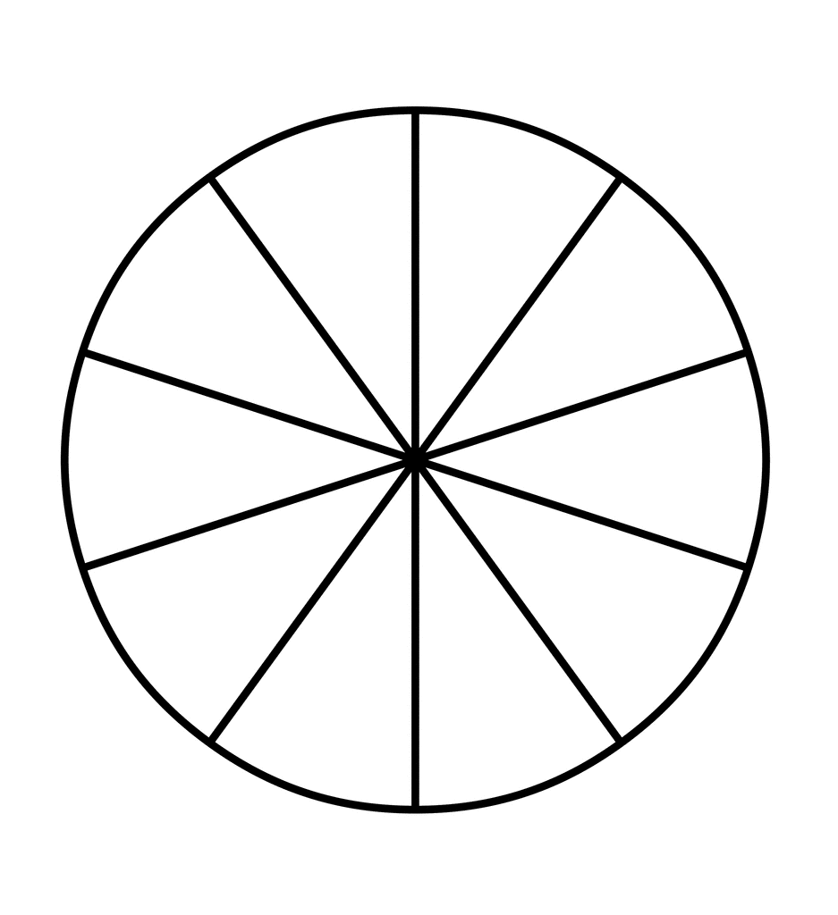

Part 2: Use the area models above to show 4 ways to decompose 10/10.
Variation | Decomposed Fraction
1
2
3
4

Part 3: Use what you’ve learned to find two ways to decompose the fraction 6/6.
Variation | Decomposed Fraction
1

2

