In this toolkit, we have included a web button that can be placed on your website to easily direct individuals to experience the Smarter Balanced assessments first-hand by taking the Practice or Training Tests. You can also encourage stakeholders in your state to post the button on their websites.

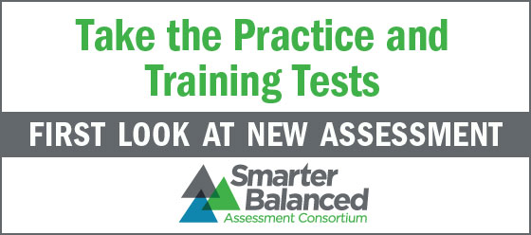

Website that can be accessed with button:

<a href="http://sbac.portal.airast.org/"><img src="http://www.smarterbalanced.org/wordpress/ads/SmarterBalance_AssessmentBanner_140x62_v2.jpg" border="0" /></a>

