Name___________________Date_________
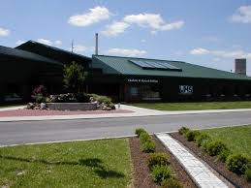
KWL Chart
“The Vanderburgh Humane Society”
What I Know | What I Want to Learn | What I Learned

