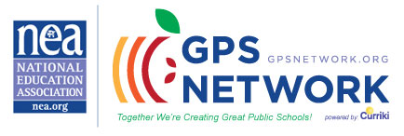

4th Grade ELA Teachers!!!
Join the GPS Network and connect with other teachers nationwide! See what teachers are doing across the nation to implement the Common Core State Standards!
This is a network for ALL practitioners in the field of education, members and non-members. This is an effort designed to bring teachers together, so that classrooms nationwide connect and collaborate!

Please invite other teachers to join and share the exciting things going on in the lives of their students while engaged in learning the standards!

If you would like to join our CCSS 4th grade ELA Community:
- Login onto www.gpsnetwork.org
- Register as a member of the GPS Network
- Search in the Groups Field “Common Core ELA 4th Grade”
- Click > Common Core ELA 4th Grade
- Click > Join This Group
- Please add a sentence or two about yourself as a bio (feel free to add more)
For more information about the Common Core ELA 4th Grade Community, do not hesitate to contact me at VictoriaKReese@gmail.com.

Victoria Kemp Reese, Ed.D.
Group Facilitator

