GPS Network Site Training
Useful Links
GPS Network: www.gpsnetwork.org
My Profile: http://www.gpsnetwork.org/xwiki/bin/view/MyCurriki/Profile

STEP 1: INVITING MEMBERS
- Click on Members Tab
- Click Invite New Member
- Enter email addresses, each separated by a comma
- Modify the invitation text if you would like
- This is an open invitation to a mailing list: check the box only if you are using a distribution email address that sends messages to multiple recipients (e.g., a group email address like gps.moderators@nea.org)
- Click Invite

Member Statuses:
- Current Members: Anyone who has successfully joined your group
- Pending: For private groups, people who have requested membership to your group and are waiting for a group leader to accept them into the group
- Denied: For private groups, people who requested membership to your group, but where denied access to the group
- Invitations: folks who have received an invitation but have not yet joined the group

STEP 2: POSTING RESOURCES
Resources should be organized into folders, which are called “Collections.” To CREATE A COLLECTION:
- Go to Resources Tab
- Click the Add a Group Collection button
  - Title - required
  - Description - required
  - Subject – required
  - Education Level – required
  - Keywords: single words separated with spaces or commas
    - what words someone would search for to find this collection?
  - Instructional Component Type – required
- Click Next>>
- Fill in the information as follows:
  - Access Privileges:
    - Public: anyone (whether they’re in your group or not) can view and edit the collection/resource
    - Protected: anyone (whether they’re in your group or not) can read the collection/resource, but they cannot edit
    - Private: only you (or your group members) can view and edit
  - Hide from search: check the box only if you do not want anyone to find the collection/resource when they search the site (the only way to find it is to go to your group Resources tab)
  - Language: English (I hope!)
  - Rights Holder: Yourself (or NEA…or whoever made the resource)
  - License: Creative Commons Attribution 3.0 (default)
  - Terms of Use: leave the box checked
- Click Next>>

TO UPLOAD A RESOURCE:
- Click on Build Up link in the collection you want to add the resource to
- Select the type of resource you would like to upload or create, Click Next>>
- Fill in the required information:
  - Title - required
  - Description - required
  - Subject – required
  - Education Level – required
  - Keywords: single words separated with spaces or commas
    - what words someone would search for to find this collection?
  - Instructional Component Type – required
- Click Next>>
- Fill in the information as follows:
  - Access Privileges:
    - Public: anyone (whether they’re in your group or not) can view and edit the collection/resource
    - Protected: anyone (whether they’re in your group or not) can read the collection/resource, but they cannot edit
    - Private: only you (or your group members) can view and edit
  - Hide from search: check the box only if you do not want anyone to find the collection/resource when they search the site (the only way to find it is to go to your group Resources tab)
  - Language: English (I hope!)
  - Rights Holder: Yourself (or NEA…or whoever made the resource)
  - License: Creative Commons Attribution 3.0 (default)
  - Terms of Use: leave the box checked
- Click Next>>

TO DELETE A RESOURCE:
- Navigate to the Resources tab for your group
- Click on the “View All” button (next to the search bar)
- Navigate to the resource you want to delete
- Click on the Delete button to the right of the resource.

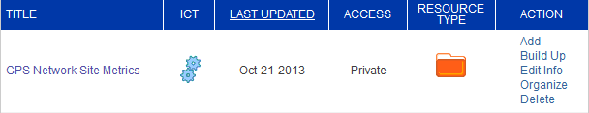

STEP 3: CREATING AND MANAGING DISCUSSIONS

Add New Discussion Topic

Edit Discussion Topic or Comment | Click on Topic, then on
Delete Discussion Topic or Comment | Click on Topic, then on
Respond to Discussion Topic

Share a Discussion Topic | 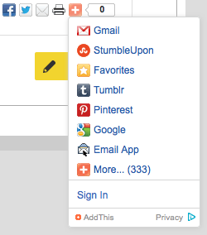
Thumbs Up a Discussion Topic/Comment | Topic:
Flag a Comment
Copy URL to Comment
Respond to a Comment | 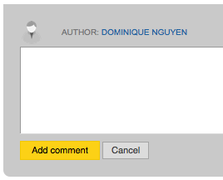

STEP 4: SENDING MESSAGES

Messages can be sent to the entire group, individual members, or to roles (e.g., group leaders or participant/contributor). The Messages tab keeps a record of all messages that were sent to you (or the group) and by you.

Create a New Message:
- Click the Create button:
- Provide message subject or title
- Enter the message content body
- Select who to send the message to:
  - Entire Group
  - Specific Roles: Group Leader or Contributor/Participant
  - Individual Group Members: Select from list
- Notifications: select the box if you want an email to be sent to the recipients (otherwise, they will only see the message in the message tab when they log into the site)
- Click Send Message
TYPES OF RESOURCES

Something I already have or know about:
A file from my computer
  - Word Doc (.doc, .docx, .rtf): download to view
  - Adobe PDF: download to view
  - Powerpoint slides: download to view
  - Excel Spreadsheet (.xls, .xlsx, .csv): download to view
  - Image File (.jpg, .png, .gif): image will appear in the collection
  - Video File (.mov, .mpg, .avi): download to view
A video I want to play on GPS Network
  - Video File (.mov, .mpg, .avi): video will be embedded to view from within the collection (no need to download)
A link for a great web resource
  - URL from any site
  - YouTube links will embed the video into the collection
Something I want to make on GPS Network:
A resource I'll create from "scratch"
A folder where I'll organize resources

INSTRUCTIONAL COMPONENT TYPES
Definitions: http://www.gpsnetwork.org/Coll_curriki/InstructionalComponentTypeICT?&bc=

Activity: Assignment/Homework
Activity: Exercise
Activity: Experiment/Lab
Activity: Game
Activity: Graphic Organizer/Worksheet
Activity: Problem Set
Activity: WebQuest
Asset: Animation/Simulation
Asset: Article/Essay
Asset: Audio/Speech/Lecture
Asset: Diagram/Illustration
Asset: Glossary/Vocabulary List
Asset: Index/List
Asset: Photograph
Asset: Reference
Asset: Script/Transcript
Asset: Study/Data/Research
Asset: Table/Graph/Chart
Asset: Template
Asset: Video/Presentation/Slides
Asset: Webcast/Podcast
Book: Fiction
Book: Non-Fiction
Book: Readings/Excerpts
Book: Text Book
Curriculum: Answer Key
Curriculum: Assessment/Test
Curriculum: Full Course
Curriculum: Lesson Plan
Curriculum: Rubric
Curriculum: Scope & Sequence
Curriculum: Standards
Curriculum: Study Guide/Notes
Curriculum: Syllabus
Curriculum: Tutorial
Curriculum: Unit
Curriculum: Workbook

