Functions: Basics and Applications

Name(s):

A function is a relation with an important property. For example:\

The following are functions

1) Mapping

**input** **output**

bear

animal

cat

9 number

The following are **NOT** functions

**input** **output**

bear

animal

cat

number 9

**2) Graphs**

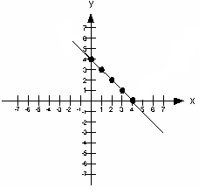

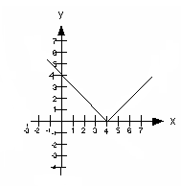

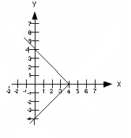

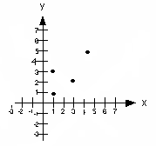

3) Ordered Pair

(1, -1), (2, -2), (3, -2) (1, -2), (1, -3), (2, 5)

4) Equations

y = x^2 x = y^2

1. What property ensures that the relations on the left are functions and those on the right are not?

2. Define a function:

1. The graph to the right shows a function. Determine the following:

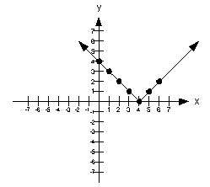

* 1. 
  2. 
  3. 
  4. 

In each of the following cases, find the x value

that will make the equation true:

* 1. If  then x = ________
  2. If  then x = ________ or x = _______
  3. If  then x = ________ or x = _______

1. Consider the following functions…



Evaluate the following:

1. 
2. An x value for which 
3. 
4. 
5. Value(s) of *n* for which *g(n)=10*
6. 
7. 3*k*(*x*) =
8. 
9. Solve 
10. 
11. 
12. An d value for which 
13. 5*g*(*n*)
14. What value of *d* makes *v(d)* undefined?

**Function Applications:**

5. The humerus is the long bone that makes up the upper part of your arm. The function  predicts a person’s height (h) in centimeters based on the length of their humerus (x) in centimeters. About how tall would a person be if their humerus were 32 cm? About how long would a person’s humerus be if that person were 168 centimeters tall? Round to the nearest tenth.

6. A cell phone company charges their customers based on the number of minutes used….

* For using 0 to 500 minutes there is only a $45 service charge.
* For using more than 500 to 1000 minutes there is a $20 service charge plus $0.05 per minute.
* For using over 1000 minutes there is a $30 service charge plus $0.04 per minute.

Fill in the piecewise function to the right that gives the total charge as a function of the number of minutes used .



Find the following and interpret the result…



7. In each case give the domain of the function.

1. 
2. 