East Meadow U.F.S.D.

CAP 2012 - 2013

Grade 5 - Latin America: Past and Present

Literacy Opportunities

Bowling Green Elementary School
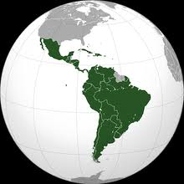

Bowling Green Elementary
Louis R. DeAngelo, Superintendent of Schools
Maria Ciarametaro, Principal
Facilitator – Jennie Re
Writers – Ellen Kelter
Jocelyn Weston

Latin America: Past and Present

Literacy Opportunities for Grade Five

Table of Contents

Abstract 3
Rationale 4
New York State P-12 Common Core Learning Standards 5 - 9
Lesson #1: Visual Text: How to Read Maps 10 - 13

Lesson #2: Compare and Contrast: Resource Map of South America 14 - 16

Lesson #3: Note Taking and Categorizing: Biomes of Latin America 17 - 19

Lesson #4: Man Changes the Map: History of the Panama Canal 20 - 22

Lesson #5: Data Charts: Famous People of Latin America 23

Lesson #6: Analysis and Interpretation: Political Cartoons 24 - 26

Lesson #7: Cultural Connections: Understanding an Aztec Legend 27 - 29

Lesson #8: Research Project: Passport to Adventure 30 -31
Bibliography 32

Kelter~Re~Weston 11/2012

Latin America: Past and Present

Literacy Opportunities for Grade Five

Abstract

This CAP, Latin America: Past and Present, includes a wide range of literacy opportunities for grade five which will allow teachers to merge Social Studies content with appropriate reading and writing strategies in alignment with NYS Common Core Standards.

Students will read and understand informational text for different purposes, write informative or explanatory text and narratives based on their reading, engage effectively in a range of collaborative discussions and produce a research project. Students will also create visual displays and oral presentations to enhance the development of the themes or key ideas of grade five Social Studies content.

These lessons, which contain suggestions for differentiated instruction, are applicable to multilevel or heterogeneous classrooms and provide opportunities for teachers to enrich their Social Studies and Literacy curricula.

Kelter~Re~Weston 11/2012

Latin America: Past and Present

Literacy Opportunities for Grade Five

Rationale

This CAP introduces teachers to instructional opportunities that are aligned with the New York State Common Core Learning Standards. The writers have included specific lessons in the areas of reading, writing, and critical thinking using primary source documents and non-fiction literature. Teachers of grade five who use this curriculum will find an appendix of references to enable their students to interact with text, use graphic organizers, and to become active readers and writers.

The reading strategies are applicable to the fifth grade Social Studies curriculum. The following categories will be included in lessons throughout the CAP:

- Geography
- Ecosystems
- Economy
- History
- Culture and Tourism

Each lesson presented in this CAP includes the following components:

- Lesson Objective
- Vocabulary
- Procedure
- Resources
- Suggestions for Differentiated Instruction

The strategies suggested by the writers are applicable to small group or whole class instruction and may be used across the curriculum. These strategies will enable the teacher to differentiate instruction to best meet the needs of each student.

Kelter~Re~Weston 11/2012

Latin America: Past and Present

Literacy Opportunities for Grade Five
Reading: Foundational Skills

Phonics and Word Recognition
- RF.5.3. Know and apply grade-level phonics and word analysis skills in decoding words.
    - Use combined knowledge of all letter-sound correspondences, syllabication patterns, and morphology (e.g., roots and affixes) to read accurately unfamiliar multisyllabic words in context and out of context.

Fluency
- RF.5.4. Read with sufficient accuracy and fluency to support comprehension.
    - Read grade-level text with purpose and understanding.
    - Read grade-level prose and poetry orally with accuracy, appropriate rate, and expression.
    - Use context to confirm or self-correct word recognition and understanding, rereading as necessary.

Reading: Literature

Key Ideas and Details
- RL.5.1. Quote accurately from a text when explaining what the text says explicitly and when drawing inferences from the text.
- RL.5.2. Determine a theme of a story, drama, or poem from details in the text, including how characters in a story or drama respond to challenges or how the speaker in a poem reflects upon a topic; summarize the text.
- RL.5.3. Compare and contrast two or more characters, settings, or events in a story or drama, drawing on specific details in the text (e.g., how characters interact).

Craft and Structure
- RL.5.4. Determine the meaning of words and phrases as they are used in a text, including figurative language such as metaphors and similes.
- RL.5.5. Explain how a series of chapters, scenes, or stanzas fits together to provide the overall structure of a particular story, drama, or poem.
- RL.5.6. Describe how a narrator’s or speaker’s point of view influences how events are described.

Integration of Knowledge and Ideas
- RL.5.7. Analyze how visual and multimedia elements contribute to the meaning, tone, or beauty of a text (e.g., graphic novel, multimedia presentation of fiction, folktale, myth, poem).
- RL.5.8. (Not applicable to literature)
- RL.5.9. Compare and contrast stories in the same genre (e.g., mysteries and adventure stories) on their approaches to similar themes and topics.

Range of Reading and Complexity of Text
- RL.5.10. By the end of the year, read and comprehend literature, including stories, dramas, and poetry, at the high end of the grades 4–5 text complexity band independently and proficiently.

Reading: Informational Text

Key Ideas and Details
- RI.5.1. Quote accurately from a text when explaining what the text says explicitly and when drawing inferences from the text.
- RI.5.2. Determine two or more main ideas of a text and explain how they are supported by key details; summarize the text.
- RI.5.3. Explain the relationships or interactions between two or more individuals, events, ideas, or concepts in a historical, scientific, or technical text based on specific information in the text.

Craft and Structure
- RI.5.4. Determine the meaning of general academic and domain-specific words and phrases in a text relevant to a grade 5 topic or subject area.
- RI.5.5. Compare and contrast the overall structure (e.g., chronology, comparison, cause/effect, problem/solution) of events, ideas, concepts, or information in two or more texts.
- RI.5.6. Analyze multiple accounts of the same event or topic, noting important similarities and differences in the point of view they represent.

Integration of Knowledge and Ideas
- RI.5.7. Draw on information from multiple print or digital sources, demonstrating the ability to locate an answer to a question quickly or to solve a problem efficiently.
- RI.5.8. Explain how an author uses reasons and evidence to support particular points in a text, identifying which reasons and evidence support which point(s).
- RI.5.9. Integrate information from several texts on the same topic in order to write or speak about the subject knowledgeably.

Range of Reading and Level of Text Complexity
- RI.5.10. By the end of the year, read and comprehend informational texts, including history/social studies, science, and technical texts, at the high end of the grades 4–5 text complexity band independently and proficiently.

Writing

Text Types and Purposes
- W.5.1. Write opinion pieces on topics or texts, supporting a point of view with reasons and information.
    - Introduce a topic or text clearly, state an opinion, and create an organizational structure in which ideas are logically grouped to support the writer’s purpose.
    - Provide logically ordered reasons that are supported by facts and details.
    - Link opinion and reasons using words, phrases, and clauses (e.g., consequently, specifically).
    - Provide a concluding statement or section related to the opinion presented.
- W.5.2. Write informative/explanatory texts to examine a topic and convey ideas and information clearly.
    - Introduce a topic clearly, provide a general observation and focus, and group related information logically; include formatting (e.g., headings), illustrations, and multimedia when useful to aiding comprehension.
    - Develop the topic with facts, definitions, concrete details, quotations, or other information and examples related to the topic.
    - Link ideas within and across categories of information using words, phrases, and clauses (e.g., in contrast, especially).
    - Use precise language and domain-specific vocabulary to inform about or explain the topic.
    - Provide a concluding statement or section related to the information or explanation presented.
- W.5.3. Write narratives to develop real or imagined experiences or events using effective technique, descriptive details, and clear event sequences.
    - Orient the reader by establishing a situation and introducing a narrator and/or characters; organize an event sequence that unfolds naturally.
    - Use narrative techniques, such as dialogue, description, and pacing, to develop experiences and events or show the responses of characters to situations.
    - Use a variety of transitional words, phrases, and clauses to manage the sequence of events.
    - Use concrete words and phrases and sensory details to convey experiences and events precisely.
    - Provide a conclusion that follows from the narrated experiences or events.

Production and Distribution of Writing
- W.5.4. Produce clear and coherent writing in which the development and organization are appropriate to task, purpose, and audience. (Grade-specific expectations for writing types are defined in standards 1–3 above.)
- W.5.5. With guidance and support from peers and adults, develop and strengthen writing as needed by planning, revising, editing, rewriting, or trying a new approach.
- W.5.6. With some guidance and support from adults, use technology, including the Internet, to produce and publish writing as well as to interact and collaborate with others; demonstrate sufficient command of keyboarding skills to type a minimum of two pages in a single sitting.

Research to Build and Present Knowledge
- W.5.7. Conduct short research projects that use several sources to build knowledge through investigation of different aspects of a topic.
- W.5.8. Recall relevant information from experiences or gather relevant information from print and digital sources; summarize or paraphrase information in notes and finished work, and provide a list of sources.
- W.5.9. Draw evidence from literary or informational texts to support analysis, reflection, and research.
  - Apply grade 5 Reading standards to literature (e.g., “Compare and contrast two or more characters, settings, or events in a story or a drama, drawing on specific details in the text [e.g., how characters interact]”).
  - Apply grade 5 Reading standards to informational texts (e.g., “Explain how an author uses reasons and evidence to support particular points in a text, identifying which reasons and evidence support which point[s]”).

Range of Writing
- W.5.10. Write routinely over extended time frames (time for research, reflection, and revision) and shorter time frames (a single sitting or a day or two) for a range of discipline-specific tasks, purposes, and audiences.
    - Use a variety of transitional words, phrases, and clauses to manage the sequence of events.
    - Use concrete words and phrases and sensory details to convey experiences and events precisely.
    - Provide a conclusion that follows from the narrated experiences or events.

Speaking & Listening

Comprehension and Collaboration
- SL.5.1. Engage effectively in a range of collaborative discussions (one-on-one, in groups, and teacher-led) with diverse partners on grade 5 topics and texts, building on others’ ideas and expressing their own clearly.
    - Come to discussions prepared, having read or studied required material; explicitly draw on that preparation and other information known about the topic to explore ideas under discussion.
    - Follow agreed-upon rules for discussions and carry out assigned roles.
    - Pose and respond to specific questions by making comments that contribute to the discussion and elaborate on the remarks of others.
    - Review the key ideas expressed and draw conclusions in light of information and knowledge gained from the discussions.
- SL.5.2. Summarize a written text read aloud or information presented in diverse media and formats, including visually, quantitatively, and orally.
- SL.5.3. Summarize the points a speaker makes and explain how each claim is supported by reasons and evidence.
- Presentation of Knowledge and Ideas
- SL.5.4. Report on a topic or text or present an opinion, sequencing ideas logically and using appropriate facts and relevant, descriptive details to support main ideas or themes; speak clearly at an understandable pace.
- SL.5.5. Include multimedia components (e.g., graphics, sound) and visual displays in presentations when appropriate to enhance the development of main ideas or themes.
- SL.5.6. Adapt speech to a variety of contexts and tasks, using formal English when appropriate to task and situation

Latin America: Past and Present

Literacy Opportunities for Grade Five

Lesson #1: How to Read Maps

Objective: Students will be able to read and analyze political and topographical maps of Latin America.

Vocabulary:
capitol city compass rose
continent country
equator latitude
longitude map legend/key
pictographs prime meridian
regions scale
plateaus pampas

Resources:
map_la.gif latin-america-political-map.jpgmodernworldhistory2009.wikispaces.com
Vidiani.com “Maps of the World. 2011-2012 http://www.vidiani.com/

Procedure:
- Present the following maps of Latin America on an overhead, computer or SMART Board:
- political map
- topographical map
- resources map

- The political map of the Latin American countries shows their borders.
  - Which countries share a border?
  - Locate the Dominican Republic (shares a border with Haiti) and Bolivia (shares a border with Brazil, Peru, Paraguay, Argentina and Chile) on the map.
    - In which country would you rather live: the Dominican Republic or Bolivia? Consider each country’s location and political factors. Explain your answer.
    - Notice that the countries’ borders are not evenly divided. What are the possible reasons for this?

- The topographical map of Latin America is a representation of the Earth's surface that shows the location and shape of natural features such as lakes, rivers, mountains, plateaus and low-lying grasslands. Use this map to answer these questions.
- If you were a sheep farmer, where would you be most likely to live? Explain.
- If you were a commercial fisherman, where in South America would you choose to live? Explain.
- If you owned a lumber mill, where would you find the resources to supply your business? Explain.

Opportunities for Differentiation:

For students who require additional support:
- Provide an individual map and highlighters for each student.
- Use one of the maps to create a jigsaw puzzle to further geographical awareness.

For students who are more able:
- Think and write: How would life in the Brazilian rain forest be different from life in the Andes Mountains in Chile or Peru?
- When you look in the night sky north of the equator, you can see configurations of stars that we call constellations. Which constellations are seen by inhabitants of Latin America who live south of the equator during the winter months? …in the summer months?

Latin America: Past and Present

Literacy Opportunities for Grade Five

Map #1 Political Map of Latin America

http://www.zonu.com/fullsize-en/2009-11-19-11221/Physical-and-hydrographic-map-of-Latin-America.html

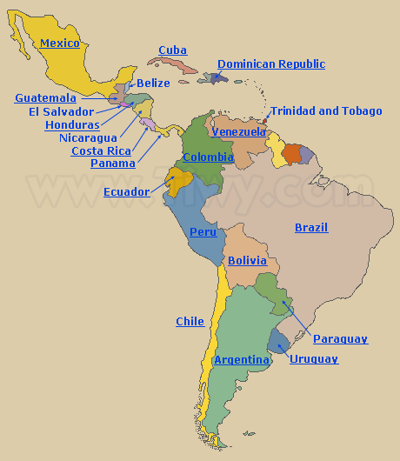

Latin America: Past and Present

Literacy Opportunities for Grade Five [part 2]

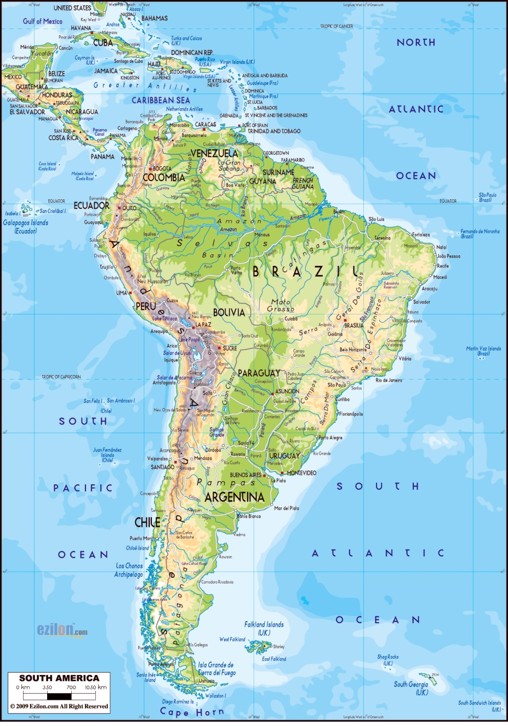
Map #2 SMART Topographical Map of Latin America

Vidiani.com “Maps of the World. 2011-2012 http://www.vidiani.com/

Latin America: Past and Present

Literacy Opportunities for Grade Five

Lesson #2: Compare and Contrast: Resources Map of South America

South America Product Map. Class Brain.com., 2006 http://www.classbrain.com/art last updated Jun 2, 2012.
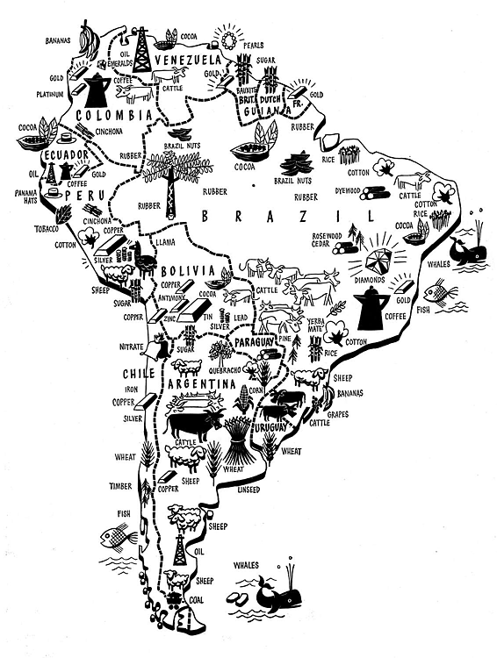

America: Past and Present

Literacy Opportunities for Grade Five

Lesson #2: Compare and Contrast: Resources Map of South America [part 2]

Objective: Students will read and interpret an economic map of South America. Which resources and industries are found in South American countries?

Vocabulary: Present terms and note map icons with labels.

timber bauxite copper emeralds fish
cocoa Brazil nuts coal sheep coffee
cotton gold silver cattle rubber
iron ore bananas diamonds sugar oil

Resource: Economics and Resources Map of Latin America
South America Product Map. Class Brain.com., 2006 http://www.classbrain.com/art last updated Jun 2, 2012

Procedure:
- Present the following map of South America on an overhead, computer or SMART Board.
- South America product map: economics and resources
- Use the labeled icons to answer the following questions:
  - Describe two ways in which South American economies are alike and two ways in which they are different.
  - Which resources helped Venezuela develop its economy? Which resource do you think is most profitable? Explain.
  - Which countries provide the most resources for manufacturing? Name those natural resources.
  - Which countries rely most heavily on farming? Why?
  - In which countries would Hershey’s Chocolate Company want to invest? Explain.
  - Which South American countries were settled by the British, Dutch or Portuguese?

America: Past and Present

Literacy Opportunities for Grade Five

Lesson #2: Compare and Contrast: Resources Map of South America [part 3]

Opportunities for Differentiation:

For students who need more support:

Children will categorize natural resources and agricultural products. The categories will include mining, farming, forests, oceans and rivers.

For students who are more able:

Consult a dictionary and define the word deforestation in your

notebook.

Explain what it means in your own words.

Why do you think this is a global or worldwide problem?

Kelter ~Re~Weston 11/2012

Latin America: Past and Present

Literacy Opportunities for Grade Five

Lesson #3: Note Taking and Categorizing: Biomes of Latin America

Objective: The students will be able to identify the different ecosystems in Latin America.

An ecosystem is a community of living organisms that share an environment. The largest ecosystems are called biomes.

Latin American biomes include the desert, forest, grassland, marine and freshwater biomes.
Freshwater |  | 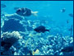  Marine |  | 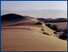  Desert |  | 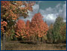  Forest |  | 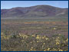  Grassland |  | 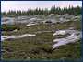  Tundra
Top photo by David K. Smith, UCMP. Ponds & lakes photos, from left: Glenn and Martha Vargas © 2004 California Academy of Sciences; David K. Smith, UCMP; Gerald and Buff Corsi © 2001 California Academy of Sciences; Glenn and Martha Vargas © 2004 California Academy of Sciences. Streams & rivers photos, from left: Dr. G Dallas and Margaret Hanna © 1999 California Academy of Sciences; Susan Middleton © 2003 California Academy of Sciences; Lorraine Elrod © 2000 California Academy of Sciences; Dr. Robert Thomas and Margaret Orr © 2004 California Academy of Sciences. Wetlands photos, from left: Dr. Robert Thomas and Margaret Orr © 1999 California Academy of Sciences; David K. Smith, UCMP; Gerald and Buff Corsi © 2005 California Academy of Sciences.
Vocabulary:
ecosystem rainforest biome Atacama Desert (Chile)
Patagonia savanna desert Andes Mountains
pampas altiplano (high plains) alpine biome
marine biome

Resources:

Topographical map of Latin America; Vidiani.com “Maps of the World. 2011-2012 http://www.vidiani.com/

Article about the tundra of the Andes Mountains

Procedure:

      - Review the topographical map of Latin America to locate the Andes Mountains.
      - Read the passage about the tundra biome of the Andes.
      - Group students for cooperative investigations of the other Latin America biomes.

Latin America: Past and Present

Literacy Opportunities for Grade Five

Lesson #3: Note Taking and Research: Biomes of Latin America [part 2]

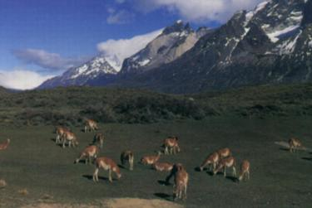 | 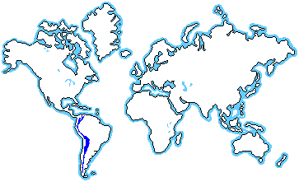

The Andes Mountains are located in South America, running north to south along the western coast of the continent. The latitude is 10° N. to 57° S. The longitude is 70° W. to 80° E.
The Andes Mountains are the longest and one of the highest mountain ranges in the world. They stretch 4,500 miles from north to south along the west coast of the continent.
The climate is not the same throughout this biome because there are some places nearer to the equator than others. The Andes are separated into three natural regions: the southern, central, and northern regions. In the northern region it is hotter because it is closest to the equator. There are rain forests in this region due to the more humid, rainy climate. In the southern region, the mountains are nearer to the Antarctic and it is much colder. It is not very populated in the southern area.
In the central region of this biome, the weather is milder because it is not near either the equator or the cold Antarctic. The largest herb in the world, puya raimondii, grows in this region and can survive at high elevations up to 13,000 feet. The herb can also live for 100 years. The leaves of this herb all grow from one big stem, which allows for moisture to run down the leaves to the base of the plant. So, during times of drought, the plant can survive.
Many of the plants which grow in the Andes Mountains are small in size to conserve energy. Their leaves can be stiff and strong to protect them from frost and cold weather if they are high in the mountains.
The Andes Mountains supply homes to birds such as the flamingo, Andean flicker, the condor, and the hillstar hummingbird. Many varieties of land animals including the mountain lion, the red perll, llamas and the speckled bear also inhabit this area. The giant toad and Andean iguana are some examples of native reptiles. This iguana is one of the few lizards found in this cold climate.
The Andes Mountains are harmed by humans who cut down trees which provide shelter and food for many Andean animals. Mining for gold, silver, and copper erodes the soil and harms the plants of the Andes.

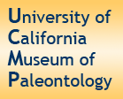
Follow this link to find information about the biomes listed above. Group the students [no more than 4 in a group] to investigate the animals, plants, and non-living things that are present in each of the biomes.
Focus Questions:
- What are the major characteristics of each biome?
- How do the different life forms survive at this high elevation? [adaptations]
- Map one of the food chains present in this biome.
- Draw a scene from the biome you are investigating. Label all living and non-living things in your illustration.

Opportunities for Differentiation:
    - Ask students to make a chart of plants, animals, and non-living things in their biome. Teacher will first partially complete the chart.
    - Think and Answer: If you were a visitor to one of these biomes, what equipment would you take to help you survive in extreme temperatures and high elevations?

Kelter ~Re~Weston 11/2012
Latin America: Past and Present

Literacy Opportunities for Grade Five

Lesson #4: Man Changes the Map: History of the Panama Canal

Objectives:
- How did the Panama Canal solve problems?
- How did the building of the Panama Canal create problems?
- What was the economic impact of the Panama Canal?
- Using available data, select important facts to include in written a summary.

Resources:

http://library.thinkquest.org/27638/panama.html

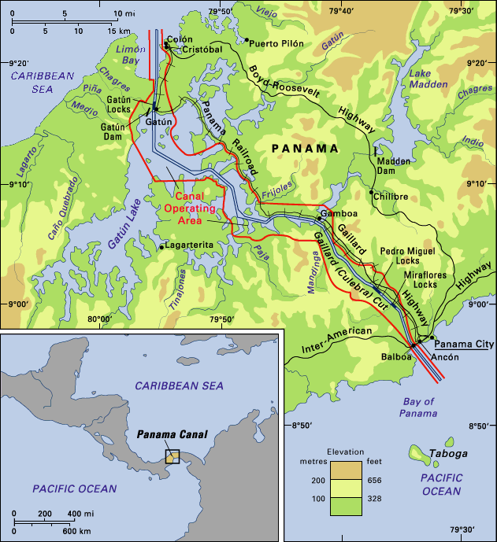
Procedure:
- Display the following prompt and map on the board or on an overhead to introduce the events that led to the construction of the Panama Canal:

Prompt:

From 1899-1902, the Filipinos, under the leadership of Emilio Aguinaldo, fought United States rule in the Philippines. By 1902, the United States had defeated the Filipino troops. In November, 1903, the United States supported Panama in her quest for independence from Colombia. In return for this support, the United States was granted control over a 10-mile-wide strip of land in Panama in order to build the Panama Canal.

Latin America: Past and Present

Literacy Opportunities for Grade Five

Lesson #4: Man Changes the Map: History of the Panama Canal [part 2]

- Use the data chart below, write a summary of the key ideas.
Size | Length, 51 miles from deep water to deep water. Minimum width of the navigable channel is 500 feet.
Locks | Six pairs or a total of 12. Each is 1,000 feet long and 110 feet wide. Normal permissible transit draft is 39 1/2 feet of tropical fresh water. The lock system lifts ships to 85 feet above sea level.
Construction | Work begun by United States May 4, 1904. Opened for traffic Aug. 15, 1914. Earth and rock excavated before opening, 239 million cubic yards. Initial cost, $380,000,000.
Approximate distance saved  by using the canal | New York City to San Francisco, Calif., 7,900; Liverpool, England, to San Francisco, 5,600; New York City to Yokohama, Japan (compared with a Suez Canal route), 3,300.
Tolls | Laden merchant ships, $1.83 per measurement ton. (A Panama Canal measurement ton is each 100 cubic feet of space usable for revenue.) Ships in ballast, without cargo or passengers, $1.46 per measurement ton. Special vessels, $1.02 per displacement ton (each long ton 2,240 pounds of water displaced).
Fast Facts | - About 32 oceangoing vessels pass through the canal daily.  - All ships passing through the canal pay an average of $28,000 for passage.  - About 140 million tons of oceangoing commercial cargo are shipped through the canal in a single year.  - Over 2.4 million tons of automobiles are moved through the canal every year, most of them being transported from Japan to the United States.  - Vessels using the canal come from more than 70 nations.
Panama Canal Achievements | - In the year 1915, the first year of operation, about 5 million tons of cargo were shipped through the Panama Canal.  - In 1924, 27 million tons of cargo was carried through it.  - Between 1925 and 1941 the annual amount varied between 18 million and 31 million.  - There was a dip in total cargo during World War II, but since then nearly every year has shown an increase.  - The figure for 1950 was about 30 million tons.  - By the early 1960s the volume had almost doubled.

Suggested Summary Format: The following information may be given to students in the form of a checklist or a rubric.
FIRST, answer the following questions:
- What are you summarizing? [topic or main idea?[
- What does it begin with?
- What is in the middle?
- How does it end?
NEXT, remember to…
- delete trivial information.
- delete repetitive information.
THEN, ask yourself the following questions:
- Is anything left out?
- Is the information in the right order?
- Have I written about what is most important?
FINALLY, reread your writing out loud to see if your writing…
- makes sense and
- sounds right.

Opportunities for Differentiation
- Show the PBS video of the History of the Panama Canal. [1 hour 22 minutes] It contains excellent primary source information and historical references that place the Panama Canal history in context with the rest of the world. http://video.pbs.org/video/1747929120. PBS also produced a shorter video to explain the construction and functioning of the locks. This video is strongly recommended for children who require shorter text. It also includes a variety of primary source documents including photographs and diagrams.

- Work with a small group to build a model canal lock to show how boats pass through the Panama Canal.

- Write a journal entry from the point of view of one of the historical figures of the time. In your writing, express the obstacles that this person had to overcome.

- Using reference materials, predict what kinds of goods and resources travel through the canal. Locate where they come from and where they could be going.

Kelter ~Re~Weston 11/2012

Latin America: Past and Present

Literacy Opportunities for Grade Five

Lesson #5: Data Chart: Famous People of Latin America

Objectives:
- to develop an appreciation for the many contributions of people from Latin America
- to organize data in the form of an informational chart

Vocabulary:
pioneer achievement contribution
honorary notable laudatory
eminent accolade distinguished
innovator visionary accomplishment

Resource: World Atlas, South America and Central America http://www.worldatlas.com/copyright.htm [note: follow links for timeline and biographies]

Procedure:
- Present a data chart with the following headings:

Name

Country of Birth

Date of Birth and Death [if the person is deceased]

Important Achievement[s]
- Review the sample below. [Note: These important people are from Brazil.]
- Use a similar chart to organize data for other prominent Latin American people.

Name | Country of Birth | Date of Birth-Death | Important Achievement[s]
Vital Brazil | Brazil | 1895 - 1950 | Scientific experiments led to snake, scorpion, and spider bite anti-venom medicines
Alberto Santos-Dumont | Brazil | 1873 - 1932 | Pioneer in aeronautics; designed and flew a dirigible above the Eiffel Tower in 1900.
Edison Arantes do Nascimento, known as Pelé | Brazil | 1940 | Named Football [Soccer] Player of the Century in 1999
Kelter ~Re~Weston 11/2012

Latin America: Past and Present

Literacy Opportunities for Grade Five

Lesson #6: Analysis and Interpretation: Political Cartoons

Objective:
- Students will be able to analyze and interpret multiple meanings of political cartoons.
- Students will gather information about the construction of the Panama Canal.
- Students will evaluate the portrayal of President Theodore Roosevelt during this time in history.

Resources:
  - American Experience. “Panama Canal.” http://www.pbs.org. , 2011.
  - “The Man Who Can Make the Dirt Fly” Cartoon by Dalrymple PBS,org http://www.corbisimages.com.

Procedure:
- Use pre-reading strategies. Present the definition of a political cartoon:
A political cartoon is a type of drawing used to present opinions, comments, or criticisms of a situation, person, or event. Cartoons help us understand information by presenting it in a visual and memorable way. Cartoonists use many different techniques to achieve their goals:
- Caricature - exaggerating one or more physical features of a character- such as enlarging a mouth to show someone who often speaks out on an issue.
- Symbol - a recognizable item used to communicate an idea such as Uncle Sam representing the United States.

- Like a piece of text, a political cartoon may contain characters, a setting, objects, actions and a caption, speech bubbles or other text.
- Using the political cartoon, “The Man Who Can Make Dirt Fly,” ask the students to analyze the components of the cartoon (see above item) as they complete the response sheet.
- The students should be directed to use other sources of information to learn about the building of the Panama Canal. These sources should represent other points of view, if possible.
- The students may work in groups to complete a compare and contrast T-Chart or Venn Diagram using the two political cartoons.

Latin America: Past and Present

Literacy Opportunities for Grade Five

Lesson #6: Analysis and Interpretation: Political Cartoons [part 2]

Opportunities for Differentiation:
- Students will research the administration of President Theodore Roosevelt and his actions to determine what kind of role of the United States played in the building of the Panama Canal.
- Students may create a timeline of events starting in 1881 and ending in 1914 when the Panama Canal was completed.

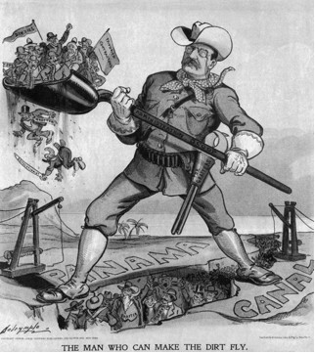
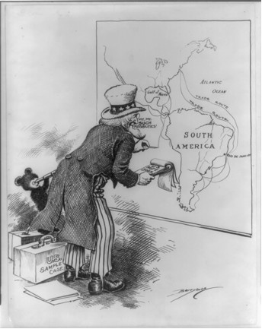

Kelter ~Re~Weston 11/2012

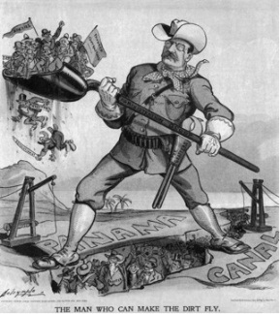
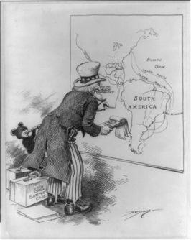

Latin America: Past and Present

Literacy Opportunities for Grade Five

Lesson #6: Analysis and Interpretation: Political Cartoons [part 3]
Name ______________________________Date _____________
POLITICAL CARTOONS
1. List the objects or people that you see in the cartoon.
_________________________________________________________________________________________________________________________________________________________________________________________________________________________________
2. Which objects or people are symbols? What do you think each one means?
_________________________________________________________________________________________________________________________________________________________________________________________________________________________________
3. Are there any important clues (words, places, numbers) to the meaning of the cartoon? _________________________________________________________________________________________________________________________________________________________________________________________________________________________________
4. Describe what is happening in the cartoon. _________________________________________________________________________________________________________________________________________________________________________________________________________________________________
5. What is the political or social issue presented in the cartoon? _________________________________________________________________________________________________________________________________________________________________________________________________________________________________
6. What is the cartoonist’s viewpoint on this issue? How do you know? _________________________________________________________________________________________________________________________________________________________________________________________________________________________________
7. Who might agree/disagree with the cartoon? Why? _________________________________________________________________________________________________________________________________________________________________________________________________________________________________
___________________________________________________________________________

Latin America: Past and Present

Literacy Opportunities for Grade Five

Lesson #7 Cultural Connections: Understanding an Aztec Legend

Quetzalcoatl Stories

Objectives:
- Students will make cultural connections using an Aztec legend.
- Students will be encouraged to use critical thinking to analyze the origins of a legend.
- Students will understand the differences between written stories and stories that are shared in an oral tradition.
- Students will be able to retell the legend using grade-level vocabulary.
Resource: Odrowaz-Sypniewska, B.F.A. , Margaret. Welcome to the My Mexican Articles “Quezalcoatl’s discovery of corn.” http://www.angelfire.com/mi4/polcrt/Mexico.html, October 12, 2012.

Procedure:
- Discuss the following questions prior to reading the legend “Queztalcoatl’s Discovery of Corn.”
- Who is the main character of the legend? What are his special abilities?
- How did observing the ants give Quetzalcoatl an idea for helping his people?
- Describe the steps that he took to bring food to his people. Use sequence signal words in your writing or oral response.
- Why do you think Quezalcoatl smiles at the end of the story?
- Review the following vocabulary words:
a) contemplate [think deeply] b) fissure [crack] c) harnessing [controlling] d) maize [corn meal]
3. Read the passage.
4. Discuss or write the answers to the questions.

Latin America: Past and Present
Literacy Opportunities for Grade Five

Lesson #7 Cultural Connections: Understanding an Aztec Legend [part 2]
QUETZALCOATL'S DISCOVERY OF CORN
Aztec legends were passed on, as an oral tradition, from generation to generation. This is only one version of this story:
The good god Quetzalcoatl was sitting on a mountainside contemplating the earth, when he noticed a red ant bringing a kernel of corn from inside the mountain. He saw the ants transfer them again and again and wondered upon the importance of this seed. He observed one seed that was left, by the ants, and decided to taste it. Quetzalcoatl found it pleasant and he thought that the people could use this seed to plant and produce more seeds to eat.
Quetzalcoatl decided to turn himself into a black ant so he could follow the red ants into the small crevice in the rock. He then discovered that there was a great pile of these seeds there. He ate a few more and became fond of the idea of this kernel being food for his people.
Then Quetzalcoatl decided that this seed was much too valuable to only be used by ants. He decided to use his powers of harnessing the thunder and lightning and he made a great storm. This storm was so powerful that the thunder rumbled the earth's surface and the lightning lit up the sky. He then took the form of a bolt of lightning and hurled himself at the crack that passed into the caverns in the mountain. The rock began to tremble with the lightning's force. Then the rocks burst out and slide down the mountainside. The people in the village were frightened by the tumbling rock slide. However, no one was hurt, so they waited for the storm to end and then explored to see what might have happened, since even from their village they could see an opening in the mountain's side.
Their leader, Quetzalcoatl, told his people that the opening contained a seed that he thought the people could plant and grow. The resulting plants they could harvest for food. He then told them how to grind it into a powder for bread. He explained that it could also be boiled in water, and if put into a covered pottery container, over a flame, it could would burst open and produce a white softer form of the seed.
The people planted the seeds and watered and cared for them until they burst forth into a tall plant which bore wonderful fruit. When the storm passed the people traveled to the opening. They looked inside and could see many red ants carrying off seeds. One of the people walked inside the fissure and saw a great pile of maize. The people decided to taste it and found it to their liking. They planted the seeds, as instructed, and watered and nurtured them until they burst forth into a tall plant which bore the wonderful fruit of their labors. So they gathered more seeds, from the cobs, dried them, and grew them from that day onward.
Quetzalcoatl smiled and decided to tell them about beans and squash.

Latin America: Past and Present

Literacy Opportunities for Grade Five

Lesson #7 Cultural Connections: Understanding an Aztec Legend [part 3]

Opportunities for Differentiation
- Compare and contrast this legend with other legends.
- Create a flip book to reinforce sequencing skills and to encourage artistic interpretations.
- Choose a natural event like an earthquake or lightning storm and write an original legend to explain it.
- Research the Aztecs to find out about Montezuma’s reign as king.

Latin America: Past and Present

Literacy Opportunities for Grade Five

Lesson #8: Producing Short Research Projects: Passport to Adventure

Objective: Students will have an opportunity to apply skills taught in this CAP.

Procedures:
- Students will investigate one of the following well-known countries and their landmarks in Latin America [assign or self-selection]:
- The Galapagos Islands, Ecuador
- Machu Picchu, Peru
- Easter Island, Chile
- Iguazu Falls, Argentina
- Angel Falls, Venezuela
- Cloud Forest, Costa Rica
- Option: Choose other countries for the students to investigate

- Students will locate resources and gather information about the country.
- Students will take notes to answer the following questions:
- Where is the country located? [longitude, latitude, etc.]
- What are the physical features of this country?
- Which language[s] are spoken?
- Which currency [money] is used?
- What are some of the important landmarks a tourist can visit?
- What are some traditional foods that are eaten?
- What are the important natural resources of this country?
- What is the capitol city?
- What are some of the special holidays or activities that would make this country an interesting place to visit?
- Students will locate books, pictures, charts, and other primary source documents related to travel.
- Students will plan a one-week trip using a calendar and keeping in mind weather patterns, transportation, accommodations and meals.
- Students will design a passport and a travel brochure for their trip.
- Additional components of the project may include:

Power Point slide shows, drawings, postcards, journal writings, photo essays, recipes, tourist phrases, musical selections, well-known artists, architecture, historical events.
- Students will share a “Passport Journey” with the class in an oral report.

Opportunities for Differentiation:

.How does this landmark compare with a similar location in the United States?

What are the advantages or disadvantages of: traveling alone? …with a tour group?
Kelter ~Re~Weston 11/2012

Name _________________________________________________________ Date_____________

Passport to Adventure: Oral Report Rubric

Name of Presenter _________________________________________

Country __________________________________________________

Score each criteria on a scale of 1-5. [5 is best] Total the points received and multiply by 10. Answer the two questions on the bottom of this page.

- The presenter explained the main idea
of the project. 1 2 3 4 5

- The presenter spoke in a loud and clear
voice that could be heard. 1 2 3 4 5

- The materials or product choice was
appropriate for the subject of the research. 1 2 3 4 5

- The research project showed effort and care.
It was neatly done and organized. 1 2 3 4 5

- The presenter shared many interesting facts. 1 2 3 4 5

- I learned many new facts and ideas. 1 2 3 4 5

- The presenter was able to answer questions 1 2 3 4 5
about the topic.

8. The product was creative in some way. 1 2 3 4 5

9. The sources the presenter used were varied. 1 2 3 4 5

10. I was convinced to visit this country. 1 2 3 4 5

TOTAL POINTS _____________

Please give the presenter a compliment. Be specific.

Please give the presenter a helpful suggestion for future presentations.

________________________________________________________________________________________________________________________________

Latin America: Past and Present

Literacy Opportunities for Grade Five
List of Citations

Berson, Michael J., Tyrone C. Howard, et al. Canada and Latin America. Orlando: Harcourt, 2007. Print.

Jacobs, H. H., B. Randolph, and M. L. LeVasseur. Latin america. Needham, MA: Pearson Prentice Hall, 1998. Print.

Latin America. N.d. www.worldatlas.comWeb. 11 Oct 2012.

Latin America Political Map. 2009. Vidiani.comWeb. 10 Sept 2012

“The Man Who Can Make the Dirt Fly” Cartoon by Dalrymple PBS,org http://www.corbisimages.com.

Milord, Susan. Tales Alive! Charlotte, Vermont: Williamson, 1995.

Odrowaz-Sypniewska, B.F.A. , Margaret. Welcome to the My Mexican Articles “Quezalcoatl’s discovery of corn.” http://www.angelfire.com/mi4/polcrt/Mexico.html, October 12, 2012.

"Panama." Panama n.pag. Thinkquest.orgWeb. 10 Sept 2012.

"Panama Canal." 7 Wonders of the World:www.thinkquest.orgWeb. 3 Oct 2012.

Panama Canal. 2012. video. PBS.org. American ExperienceWeb. 11 Oct 2012.

Panama Canal Locks . http://www.history.com/videos/panama-canal-locks#transcontinental-railroad [Video] 1996-2012, A&E Television Networks, October 18, 2012.
Physical and Hydrographic Map of Latin America. 2009. www.zonu.comWeb. 17 Oct 2012.

South America Product Map. 2006. www.classbrain.comWeb. 10 Sept 2012.

