Spinners at the School Carnival
Written by:
Maryann E. Huey
Drake University
maryann.huey@drake.edu

Overview of the Lesson
Students are asked to predict the outcomes of an unequally divided spinner. Students collect data through actual spins and construct frequency charts. They will then have an opportunity to revise their predictions. Classroom level data are collected, graphed, and used as a basis for a discussion about experimental data and expected outcomes.

GAISE Components
This investigation follows the four components of statistical problem solving put forth in the Guidelines for Assessment and Instruction in Statistics Education (GAISE) Report. The four components are: formulate a question, design and implement a plan to collect data, analyze the data by measures and graphs, and interpret the results in the context of the original question. This is a GAISE Level A activity.

Common Core State Standards for Mathematical Practice
1. Make sense of problems and persevere in solving them.
4. Model with mathematics.

Common Core State Standard Grade Level Content (Grades 3 through 5)
3.MD. Represent and interpret data.

NCTM Principles and Standards for School Mathematics
Data Analysis and Probability Standard for Grades 3-5
Formulate questions that can be addressed with data and collect, organize, and display relevant data to answer them:
- design investigations to address a question and consider how data-collection methods affect the nature of the data set;
- collect data using observations, surveys, and experiments;
- represent data using tables and graphs such as line plots, bar graphs, and line graphs.
Select and use appropriate statistical methods to analyze data:
- describe parts of the data and the set of data as a whole to determine what the data show.

Prerequisites
Students will have constructed basic graphs (such as line plots, bar graphs) prior to completing the lesson.

Learning Targets
Students will be able to organize the results of a probability experiment in a frequency table. Students will be able to summarize the results of a probability experiment. Students will be able to make predictions based on the results of a probability experiment. Students will become aware that the more they repeat an experiment, the more reliable their results will be.
Time Required
A one-hour class period.

Materials Required
20 (student) and 1 (teacher) unequal spinners with 5 sections (copy master attached on page 11)
20 (student) and 1 (teacher) large paper clips
20 recording sheets and grid sheet (copy master attached on page 10)
1 easel-sized grid paper chart

Instructional Lesson Plan

The GAISE Statistical Problem-Solving Procedure

I. Formulate Question(s)
Describe the following hypothetical scenario to your students to launch the lesson: At the school carnival, there is a game where students spin a spinner. The spinner has three equal sections and two other sections that are equal, but smaller, as shown in Figure 1.

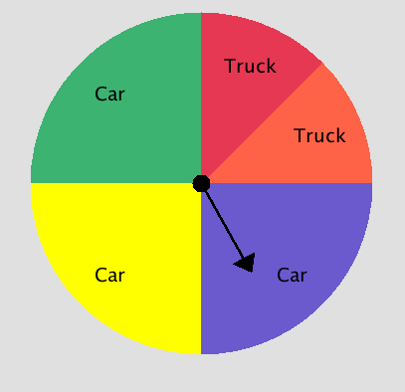
Figure 1. The spinner.

Three of the sections (yellow, green, and purple) represent winning a toy car of the same associated color and the fourth and fifth sections (red and orange) represent winning either a red or orange toy truck. You win either the colored toy car or the colored toy truck depending on the color the spinner lands upon. The parents responsible for the game want to know how many of each type of colored toy cars and trucks they must buy if they are expecting about 200 students to play the game at the carnival.

Display the spinner shown in Figure 1. Ask students how many outcomes are possible with the spinner (i.e. Which colors could the spinner land upon)?

With a document camera projector, model a few spins using a large paper clip as the spinner. Unfold on the outer loop of the paper clip, so that one end is still enclosed by a loop. Place your pencil through the looped end and hold it on the center of the spinner. Use your finger to flick the extended paper clip, as shown in Figure 2.

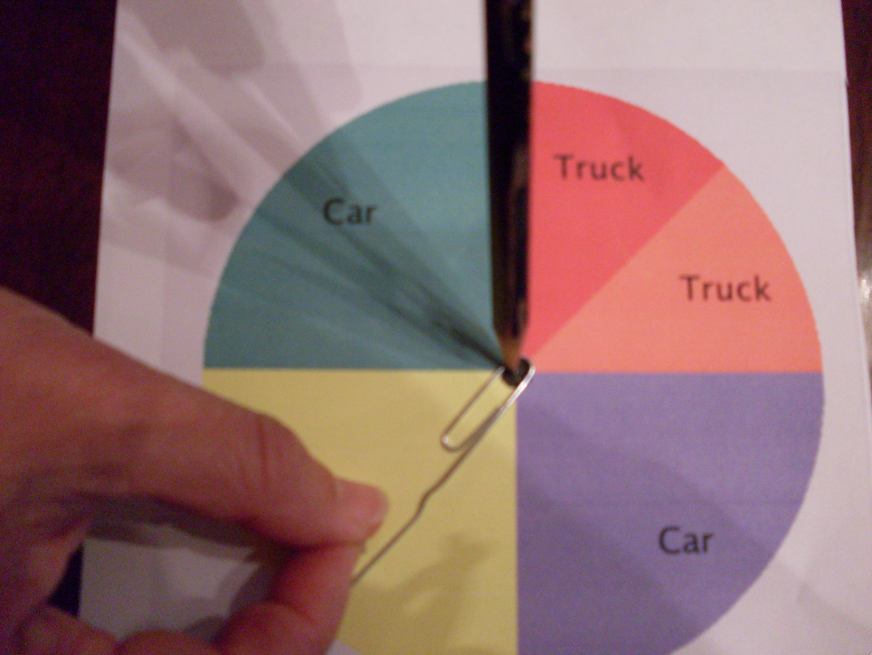
Figure 2. Using a paper clip as a spinner.

Ask students what can happen when you spin? Could you ever get a purple car? Why or why not? Ask which outcome relates to winning a yellow toy car? Which outcome relates to winning a red toy truck? Could you ever win a purple truck (i.e. an impossible outcome)? Do you think you will get a toy car or a toy truck when you spin the spinner? Why? Which colors will the spinner stop on more often than others? The goal here is to generate the sample space, which is {red truck, orange truck, purple car, yellow car, and green car}, and to have students begin to understand that since the sections in this spinner are not equal the outcomes in the sample space are not equally likely.

Give each student a copy of the spinner and a large paper clip. Have the students practice spinning the spinner by flicking their fingers onto the paper clip and holding the looped portion of the paper clip in place with the tip of a pencil. You may wish to have the students tape their spinner to their desk or table. The spinner should be on a flat surface.

Ask students, “If the game was played 20 times, about how many of each colored toy car and truck do you think will be given away? How many times will no car be given away? If the game was played 200 times, about how many times will the spinner land on each color?” The goal is for students to think about the likelihood of each outcome. Some students will realize that the spinner is not fair, while others may not. Write down a range of student responses on the board regarding their predictions for how many of each color is likely with 200 spins. After students respond, explain that they are going to have an opportunity to test their predictions by playing this game.

- Design and Implement a Plan to Collect the Data
Give each student a recording worksheet with a frequency table, as shown in Table 1, and assign each student to work with a partner. Have the pairs of students spin the spinner a total of 20 times with each student spinning 10 times. Have students keep track of their results by making tally marks on the frequency table. Note: The number of spins should equal 200 divided by the number of students in your class. If this is not a whole number then adjust the 200.

Table 1. Student worksheet frequency table.
Outcome | Tally | Total
Purple Car
Yellow Car
Green Car
Red Truck
Orange Truck

- Analyze the Data
Place each pair of students with another pair (to form groups of four students). Ask the pairs of students to compare the results in their frequency table with each other. Were the results the same or different? Why do you think all of the results were not the same? Sample data from one class is shown in Table 2.

Table 2. Pairs of students’ sample data from one class.
 | Pair 1 | Pair 2 | Pair 3 | Pair 4 | Pair 5 | Pair 6 | Pair 7 | Pair 8 | Pair 9 | Pair 10 | Total
Yellow | 6 | 2 | 5 | 12 | 6 | 5 | 6 | 2 | 5 | 3 | 52
Purple | 4 | 5 | 6 | 4 | 5 | 4 | 5 | 7 | 7 | 8 | 55
Green | 8 | 6 | 6 | 2 | 5 | 6 | 7 | 6 | 4 | 4 | 54
Orange | 0 | 3 | 2 | 1 | 2 | 2 | 0 | 3 | 2 | 4 | 19
Red | 2 | 4 | 1 | 1 | 2 | 3 | 2 | 2 | 2 | 1 | 20

Ask the students to combine results into one table for the group (40 spins total). Before they begin, ask the students, “What will be the total number of spins for the group?”. Have the students create a line plot of the 40 spins representing their combined experimental data on the grid paper (page 10). Demonstrate how to organize the grid paper as shown below in Figure 3.

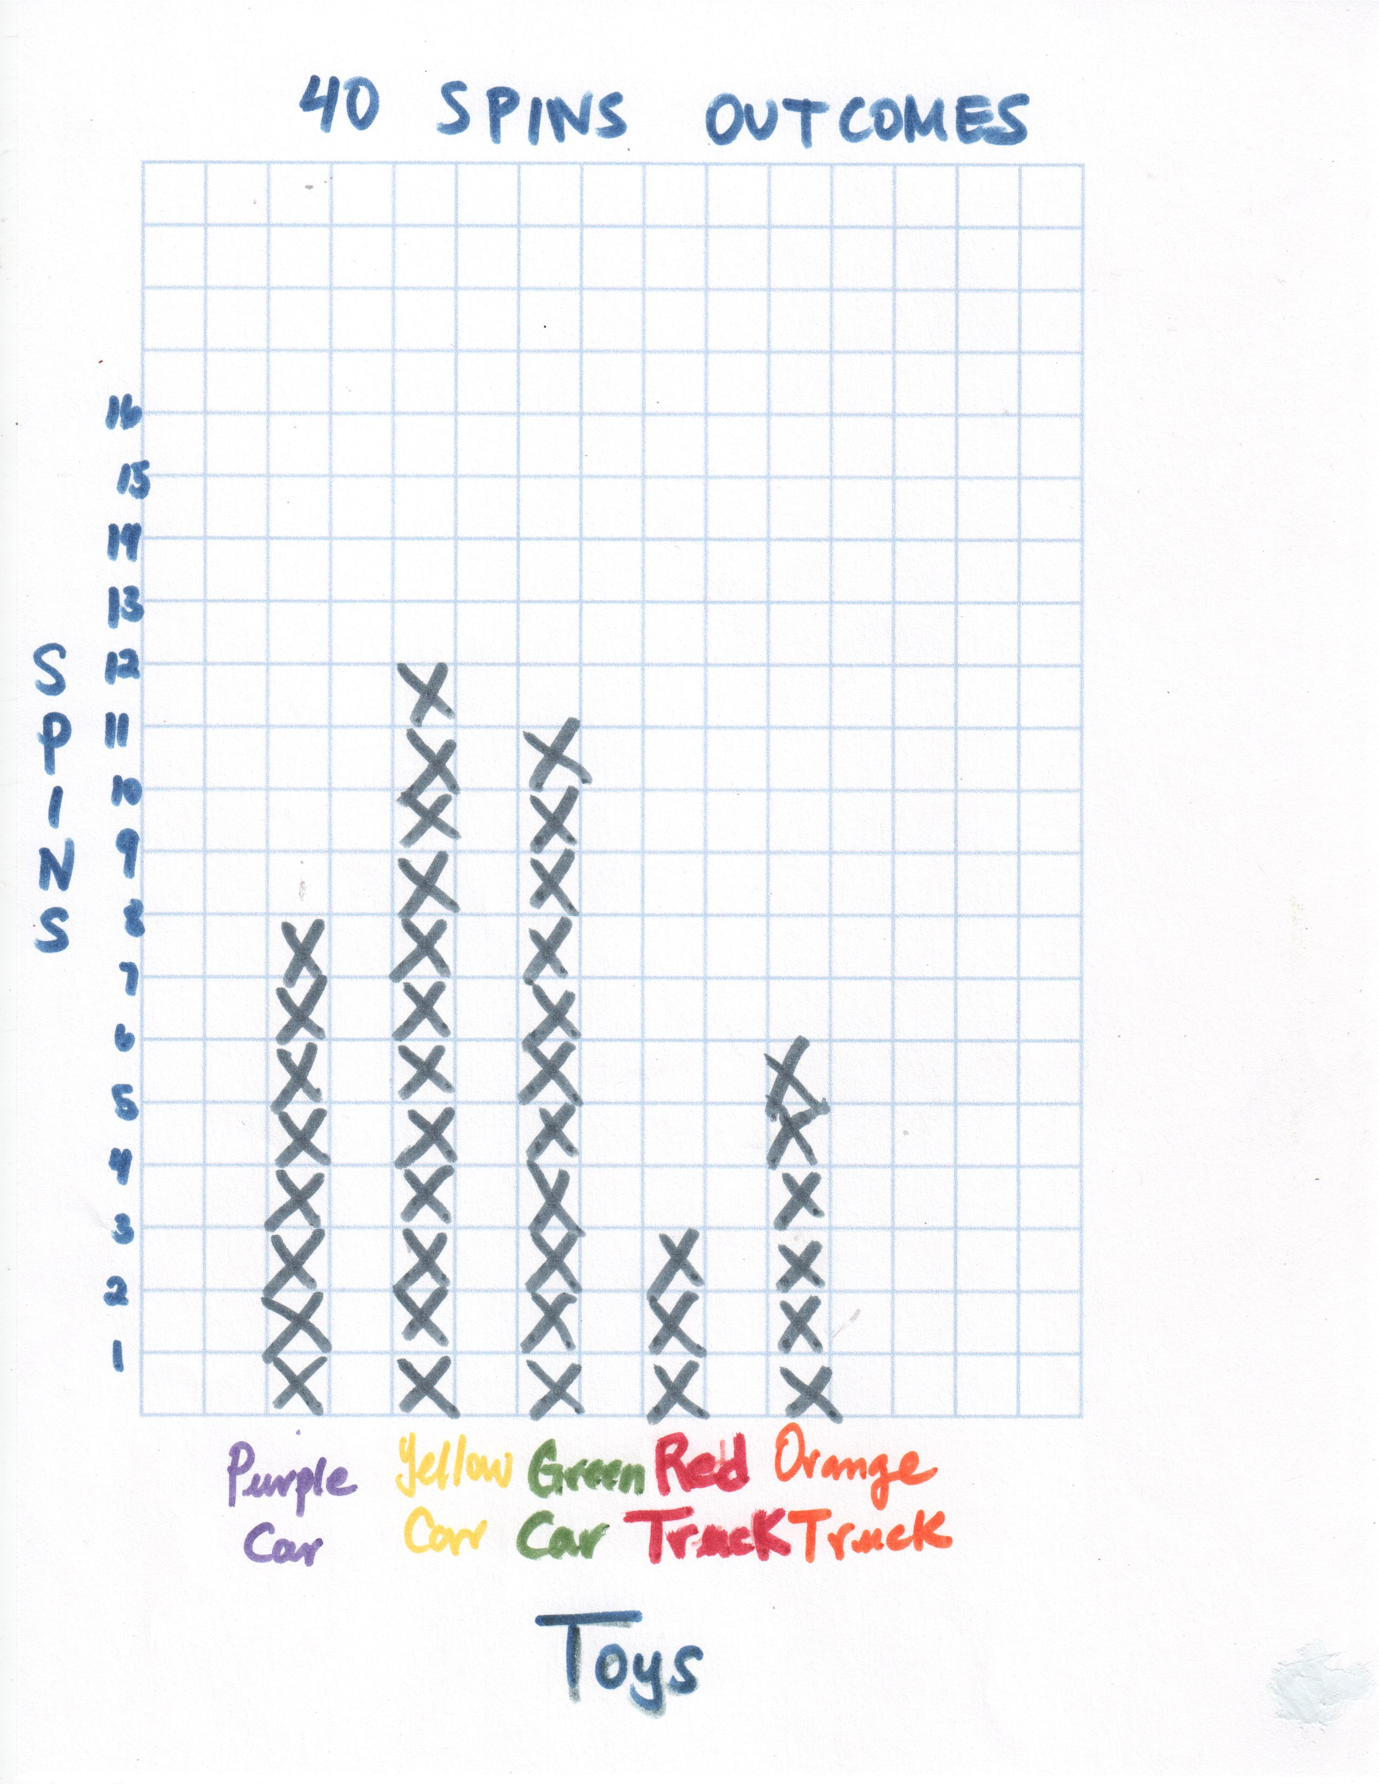
Figure 3. A line plot of combined group results from 40 spins.
A classroom level line plot of all 200 spins will also be created. This line plot should be set up and visually available for modeling purposes. Be sure that the vertical axis is labeled “Number of Spins” with hash marks representing one spin each. The horizontal axis should be labeled with the possible outcomes “Purple Car”, “Yellow Car”, “Green Car”, “Orange Truck” and “Red Truck”. The chart also should have a title similar to “Frequencies for 200 Spinner Outcomes”.

IV. Interpret the Results
Next, the students should adjust their predictions based on the experimental data they have collected. Be sure not to “give away” the answer or steer students to the theoretical expected values. For such a small sample size, the outcomes may not mimic what would theoretically be expected. Students should be allowed ample time to grapple with the additional data and perhaps deviations from their initial expectations whether based on theoretical reasoning or prior experiences.

Lastly, discuss the class level data. What outcomes are about the same? What outcomes are different? Did this align with your expectations or how was it different? Be sure to have the spinner visually available so that students can justify their responses in relation to the proportion of area designated to various outcomes in relation to the experimental results. Discuss that experimental data tends to be similar to what we would expect, but that variation occurs. Discuss that if more data were collected, we would expect the variation to eventually reduce between outcomes. Finally, answer, with input from students, how many of each toy should be purchased prior to the carnival.

Assessment
1. Students in Ms. Smith’s class asked 40 students at their school to spin the spinner below. A student won a small prize if the spinner stopped in the section labeled yellow.

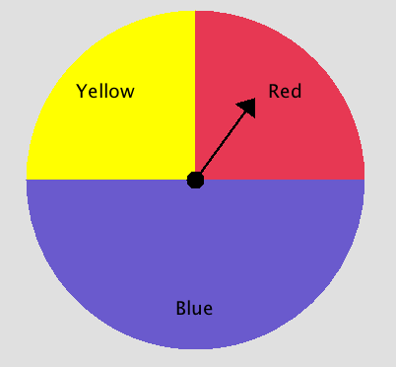

About how many times would you predict the spinner would stop in the section labeled yellow?
Use words, numbers, and/or a drawing and explain how you made your prediction for the number of times the spinner would stop in yellow out of 40 spins.

Answer:
The spinner is predicted to stop in the section labeled yellow about 10 times. The yellow section accounts for one fourth of the spinner. One fourth of forty is 10.

2. Darnel and Cara spun their spinner 20 times, and then compared results with another group. Darnel noticed that the other group had more red trucks than he and Cara had tallied. Darnel thinks the other group made a mistake or purposely tried to spin the red truck outcome. Cara disagrees saying, “Anything can happen because it is a game of chance”. Which student is correct?

Answer:
Both students exhibit common conceptions that are worthy of discussion. Cara may not be connecting that the area of each section relates to the likelihood that an outcome will occur. Some students view “chance” as a completely unpredictable event. Highlighting that one would expect more cars than trucks (75% versus 25% of the spinner) as outcomes and verifying this prediction with group data can provide a basis for chance events not being completely unpredictable. Would it be likely to have 20 spins all land on the red truck outcome? Or the purple car? Did any group have data such as this?

Darnel may have a resistance to variably that occurs in experimental data and rather expects outcomes to match theory. Darnel’s concern is better addressed by a comparison of group data to classroom level data. The variability between outcomes will be less with the larger sample size, but again, not identical to theoretical values. A discussion of sample size related to number of spins should focus on the idea that as the number of spins increase, we would expect the results to tend towards theoretical values. However, small sample sizes, similar to those generated by pairs of students (20 spins), may be very different than the theoretical expectations.

The response to the last question on the student activity sheet should be discussed. Students may resist the idea that theoretical values are best to inform the purchase of toys, if the classroom level data included an unexpectedly large or small number of one particular outcome. The parents should purchase 50 of each color car and 25 of each color truck. However, some students may feel that the experimental results hold sway due to an outcome being “lucky” or “unlucky.” Experience is the best and perhaps only remedy for this stance. Encourage students, time permitting, to gather more data and see if their predictions hold.

Possible Extensions
1. Change the number of students who will play the game to 400. Ask students how many toy cars and trucks need to be ordered.
2. Have students go to the website: http://nlvm.usu.edu/en/nav/frames_asid_186_g_1_t_5.html?open=activities&from=topic_t_5.html At this website students can create a spinner with 5 unequal sections and then spin the spinner a large number of times. Students should record the results in a frequency table and draw conclusions as to how many toy cars and trucks need to be purchased.

References
1. Guidelines for Assessment and Instruction in Statistics Education (GAISE) Report, ASA, Franklin et al., ASA, 2007 http://www.amstat.org/education/gaise/

2. Website: http://nlvm.usu.edu/en/nav/vlibrary.html (Adjustable Spinner in Data Analysis & Probability grades 3-5.)

3. Related to Investigation 6.4: How Many Spins to Win the Prize? of the ASA module Bridging the Gap written by Pat Hopfensperger, Tim Jacobbe, Deborah Lurie, and Jerry Moreno (2012).

Spinners at the School Carnival Activity Sheet
At the school carnival, there is a game where students spin a spinner. Three of the sections (yellow, green, and purple) represent winning a toy car of the same associated color and the fourth and fifth sections (red and orange) represent winning either a red or orange toy truck.

1. Predict how many of each outcome will occur if you spin the spinner 200 times. Make sure your choices add up to 200.

Outcome | Predicted Number of Outcomes  in 200 Spins
Purple Car
Yellow Car
Green Car
Red Truck
Orange Truck

2. Spin the spinner 20 times with a partner and record the outcomes in the table below with tallies. When you are finished with all 20 spins, record the totals for each outcome.

Outcome | Tally for 20 Spins | Total
Purple Car
Yellow Car
Green Car
Red Truck
Orange Truck

3. Compare your results with another pair of students. Combine your data in the table below.

Outcome | Tally for 40 Spins | Total
Purple Car
Yellow Car
Green Car
Red Truck
Orange Truck

4. Using the data for 40 spins, create a line plot for how many times each color was spun on grid paper provided. Be sure to include:
  - A title for your plot.
  - Labels on the horizontal and vertical axes.
  - X’s for each spin that fill up exactly 1 square.

5. Based on your experimental data, predict how many of each outcome will occur if you spin the spinner 200 times. Make sure your choices add up to 200.

Outcome | Predicted Number of Outcomes  in 200 Spins
Purple Car
Yellow Car
Green Car
Red Truck
Orange Truck

6. When you are done, take your team’s data and add it to the class line plot.

7. How many of each toy should the parents buy, if 200 students will play the spinner game at the school carnival?

Purple Car____________

Yellow Car____________

Green Car____________

Red Truck____________

Orange Truck____________

