Grades 11-12 –Mary Shelley’s *Frankenstein* for *2014 and BEYOND!*– 2014-2015

Kimberly LoFaso – Facilitator

Mary Kudla – Writer

Carrie Piombino- Writer

November 2014

2014-2015

East Meadow School District

English

Table of Contents

|  |  |
| --- | --- |
| Abstract | 3 |
| Rationale | 4 |
| Understanding by Design | 5 |
| Mary Shelley “Close Reading” Worksheet | 6 |
| Mary Shelley Teacher Diction Worksheet | 8 |
| Allusion- Lesson | 10 |
| Allusion- Lesson PowerPoint | 12 |
| “The Rime of the Ancient Mariner” Worksheet | 19 |
| “Twitter” Activity Sheet | 22 |
| New York Times Article “Grand Allusion” | 23 |
| Introduction to Shelley- Quiz | 26 |
| Language and Imagery- Lesson | 33 |
| Quotation Identification Worksheet | 34 |
| Perspective- Lesson | 36 |
| Volume 2- Part 1 Worksheet | 37 |
| Volume 2 and 3- Part 2 Worksheet | 39 |
| “I Am” Poem Format #1 | 41 |
| “I Am” Poem Format #2 | 42 |
| Works Cited | 43 |

Abstract

Our goal is to take Shelley’s masterpiece and modernize the teaching of it through the use of news articles, non-fiction pieces, technology, and recent news events, all while meeting the new Common Core State Standards 1, 2, 3, 4, 5, and 7 through our lessons, group and independent activities, writing assignments, quizzes, etc.

Rationale

This CAP will relate directly to the new Common Core State Standards as it will implement non-fiction works of literature and innovative approaches toward creating a love of Shelley’s masterpiece within our students. Our goals include meeting the Standard: Students and Learning by responding to factors influencing learning as well as the Standard: Content and Instructional Planning by enabling our students to demonstrate content knowledge; use diverse instructional strategies; and design learning to connect prior knowledge. We will address the Standard: Instructional Practice by setting high expectations and challenging learning; using a variety of approaches to meet student needs; engaging students to develop multi-disciplinary skills; and monitoring student progress and adapting instruction accordingly. The Standard: Learning Environment will be addressed as we create an intellectually/challenging environment; and use resources to create a safe/productive environment. We will also address the Standard: Assessment for Student Learning by using a wide-range of assessment tools; and preparing students for assessments. Finally, we will also strive to meet the Standard: Professional Growth by engaging in ongoing professional development, simply by partaking in such a create experience with our fellow colleagues!

Understanding by Design

|  |  |
| --- | --- |
| Stage One – Desired Results | |
| New York State Common Core English Language Arts Standards for 11th and 12th graders:  Students will be able to…   1. Self-select text to respond and develop innovative perspectives. 2. Establish and use criteria to classify, select, and evaluate texts to make informed judgments about the quality of the pieces. 3. Develop factual, interpretive, and evaluative questions for further exploration of the topic(s). 4. Interpret, analyze, and evaluate narratives, poetry, and drama, aesthetically and philosophically by making connections to: other texts, ideas, cultural perspectives, eras, personal events, and situations. 5. Explore and inquire into areas of interest to formulate an argument. | |
| Understanding(s)  Students will understand that   1. Literature can connect to the world in which we live. 2. The issues characters dealt with during Shelley’s times should be discussed as well as read about, as they are still relevant to our modern day lives. | Essential Question(s):   1. How can we better teach Shelley’s *Frankenstein*? 2. How can we help students better understand the format and meaning of Shelley’s *Frankenstein*? |
| Students will know   1. The meaning of Shelley’s *Frankenstein*. 2. The similarities they have to Shelley’s characters and their internal and external conflicts, despite the difference in setting. | Students will be able to   1. Identify common issues teenagers are forced to face in today’s world in comparison to those that the characters deal with in Shelley’s *Frankenstein*. 2. Read, understand, and connect to Shelley’s *Frankenstein*. |
| Stage 2 – Assessment of Evidence | |
| Performance Task(s):   1. Enjoy and understand Shelley’s *Frankenstein*. 2. Make connections to life and personal experiences while reading news articles and completing a variety of tasks. | Other Evidence:   1. To create and provide a unified and comprehensive method of teaching students abut Shelley’s *Frankenstein* and the powerful impact it can have upon the reader. |
| Stage 3 – Learning Plan | |
| Learning Activities:   1. Assessment activities of the common issues our teenagers deal with on a daily basis. 2. Worksheets, articles, activities, lesson plans, and web-sites to help student’s comprehension of the common issues in relation to Shelley’s *Frankenstein.* | |

***Mary Wollstonecraft Shelley*  
(1797-1851)**

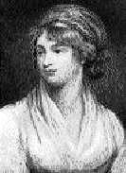

Born August *1.*____, 1797, in London, England, Mary Shelley came from a rich literary heritage. She was the daughter of William *2.*____________, a political theorist, novelist, and publisher who introduced her to eminent intellectuals and encouraged her youthful efforts as a writer; and of Mary Wollstonecraft, a writer and early *3.*________________ thinker, who died of puerperal fever *4.*____ days after her daughter's birth.

In her childhood, Mary Shelley educated herself amongst her father's *5.*________________________________________, which included critic William Hazlitt, essayist Charles Lamb and poet Samuel Taylor Coleridge. Another prominent intellectual in Godwin's circle was *6.*________ Percy Bysshe Shelley. Mary met Percy Shelley in *7.*________, when she was *8.*_______________. Shelley was *9.*______________ at the time, but the two spent the summer of 1814 traveling together. A *10.*__________________ was born prematurely to the couple in February, 1815, and died *11.*____ days later. In her journal of March 19, 1815, Mary recorded the following dream, a possible *12.*______________________ for Frankenstein: "Dream that my little baby came to life again - that it had only been cold & that we rubbed it before the fire & it lived." A son, *13.*______________, was born to the couple in January, 1816.

In the summer of 1816, Percy Shelley and *14.*____-year-old Mary visited the poet *15.*____________________ at his villa beside Lake Geneva in Switzerland. Stormy weather frequently forced them indoors, where they and Byron's other guests sometimes read from a volume of *16.*__________________________. One evening, Byron challenged his guests to *17.*__________ one themselves. Mary's story became *18.*________________________.

Mary and Percy Shelley were *19.*______________ December *20.*____, 1816, just weeks after Shelley's first wife, Harriet, *21.*______________. Mary gave birth to another daughter, *22.*__________, in 1817, but she only lived for a year.

Mary Shelley's Frankenstein was published in *23.*________, when Mary was 21, and became a huge success. The first edition of the book had an unsigned preface by Percy Shelley. Many, disbelieving that a 19-year-old *24.*__________ could have written such a *25.*____________ story, thought that it was his novel.

In 1818, the Shelleys left England for *26.*__________. In 1819, following the *27.*__________ of 3-year-old William, Mary suffered a nervous breakdown. Of the Shelleys' children, only one, Percy Florence, born in 1819, survived past childhood. Further *28.*______________ struck Mary in 1822 when her husband Percy Shelley *29.*______________ during a heavy squall in the Gulf of Spezia near Livorna.

Mary, only 25 years old and a *30.*__________, returned to England with her son, determined not to marry again. She devoted herself to her son's welfare and education, and continued her career as a professional writer. Shelley gave up writing long fiction when realism started to gain popularity, exemplified by the works of *31.*______________________________. She wrote numerous *32.*__________________________ for periodicals, particularly The Keepsaker, and produced several volumes of Lives for Lardner's Cabinet Cyclopedia and the first authoritative *33.*______________ of Shelley's poems (1839, 4 vols.).

Mary Shelley lived in England until her death from a *34.*_____________________ in Bournemouth, England, on February 1st, 1851. She was *35.*____ years old.

Adapted from the National Library of Medicine  
"Frankenstein: Penetrating the Secrets of Nature"

***Mary Wollstonecraft Shelley- Teacher’s Diction Version*  
(1797-1851)**



Born August 30, 1797, in London, England, Mary Shelley came from a rich literary heritage. She was the daughter of William Godwin, a political theorist, novelist, and publisher who introduced her to eminent intellectuals and encouraged her youthful efforts as a writer; and of Mary Wollstonecraft, a writer and early feminist thinker, who died of puerperal fever 10 days after her daughter's birth.

In her childhood, Mary Shelley educated herself amongst her father's intellectual circle, which included critic William Hazlitt, essayist Charles Lamb and poet Samuel Taylor Coleridge. Another prominent intellectual in Godwin's circle was poet Percy Bysshe Shelley. Mary met Percy Shelley in 1812, when she was fifteen. Shelley was married at the time, but the two spent the summer of 1814 traveling together. A baby girl was born prematurely to the couple in February, 1815, and died twelve days later. In her journal of March 19, 1815, Mary recorded the following dream, a possible inspiration for Frankenstein: "Dream that my little baby came to life again - that it had only been cold & that we rubbed it before the fire & it lived." A son, William, was born to the couple in January, 1816.

In the summer of 1816, Percy Shelley and 19-year-old Mary visited the poet Lord Byron at his villa beside Lake Geneva in Switzerland. Stormy weather frequently forced them indoors, where they and Byron's other guests sometimes read from a volume of ghost stories. One evening, Byron challenged his guests to write one themselves. Mary's story became Frankenstein.

Mary and Percy Shelley were married December 30, 1816, just weeks after Shelley's first wife, Harriet, drowned. Mary gave birth to another daughter, Clara, in 1817, but she only lived for a year.

Mary Shelley's Frankenstein was published in 1818, when Mary was 21, and became a huge success. The first edition of the book had an unsigned preface by Percy Shelley. Many, disbelieving that a 19-year-old woman could have written such a horror story, thought that it was his novel.

In 1818, the Shelleys left England for Italy. In 1819, following the death of 3-year-old William, Mary suffered a nervous breakdown. Of the Shelleys' children, only one, Percy Florence, born in 1819, survived past childhood. Further tragedy struck Mary in 1822 when her husband Percy Shelley drowned during a heavy squall in the Gulf of Spezia near Livorna.

Mary, only 25 years old and a widow, returned to England with her son, determined not to marry again. She devoted herself to her son's welfare and education, and continued her career as a professional writer. Shelley gave up writing long fiction when realism started to gain popularity, exemplified by the works of Charles Dickens. She wrote numerous short stories for periodicals, particularly The Keepsaker, and produced several volumes of Lives for Lardner's Cabinet Cyclopedia and the first authoritative edition of Shelley's poems (1839, 4 vols.).

Mary Shelley lived in England until her death from a brain tumor in Bournemouth, England, on February 1, 1851. She was 54 years old.

Adapted from the National Library of Medicine  
"Frankenstein: Penetrating the Secrets of Nature"

English 12 Regents

New York State Common Core-

L.6- Analyze a case in which grasping point of view requires distinguishing what is directly stated in a text from what is really meant.

R.1- Cite strong and thorough textual evidence to support analysis of what the text says explicitly as well as inferences drawn from the text, including determining where the text leaves matters uncertain.

W.9- Draw evidence from literary or informational texts to support analysis, reflection, and research.

***Objective-***

The objective of this lesson is for students to understand what an allusion is through the use of Coleridge’s “The Rime of the Ancient Mariner” in relation to Mary Shelley’s *Frankenstein*.

Aim- Understanding Shelley’s use of Allusion within the introductory letters to *Frankenstein*

Do Now- Do you believe in superstitions? Why or why not? Share a superstition you are familiar with.

Procedure-

1. Students will discuss their Do Now responses with the class:
2. Students will be made aware that many sailors (as well as athletes, etc.) are very superstitious people:
3. Share popular sailor superstitions, including that of the *albatross*
   * 1. Don't Kill an Albatross!
     2. Seabirds were thought to carry the souls of dead sailors and it is considered bad luck to kill one. However, it is considered good luck if you see one!
4. What is the common belief if one does NOT follow the rules of a superstition?
   * 1. Expected responses include: negative events will occur, death is imminent, bad luck will be inevitable
5. “The Rime of the Ancient Mariner” focuses on an “ancient mariner” or old sailor, who does not abide by the common superstitions most sailors follow.
6. Students will be asked to consider what allusion Shelley uses within the letters at the start of *Frankenstein*.
   1. Students will be directed to locate the allusion to “The Rime of the Ancient Mariner” within letter II, on page 21 of *Frankenstein*
7. Students will copy the definition of allusion into their notes-

**allusion-** (noun) A reference in a written work to something from history, art, religion, myth, or another work of literature. Writers use allusions to give readers additional insights about what is happening in the story and why. Shelley makes frequent use of allusions in *Frankenstein*.

1. “The Rime of the Ancient Mariner” will be distributed to the class by our Ditto Distributor
2. Students will listen to the Part I being read (as per Orson Wells) via YouTube.
   1. After the first 5 stanzas have been read, the class will be consider the following questions:
      1. Where is the Mariner located at the opening of the poem?
      2. Why does the wedding guest listen to the Mariner?
3. Students will discuss and analyze their responses by summarize what we read thus far into a “tweet” of no more than 140 characters complete with a #hash tag:
4. Crazy old sailor making me listen to his story #weddingguestproblems
5. Each group will be assigned 2-3 of the 15 remaining stanzas to analyze with their groups
6. Group responsibilities include: *(Please see the enclosed worksheet)*

1. Read your assigned stanzas aloud within your group.

2. Define any 3-5 words or terms you are unfamiliar with:

3. Summarize the information your stanza discusses.

4. Create a “Tweet” that accurately summarizes your assigned stanzas.

\**Note-* *ALL group members MUST participate. It is suggested you each take charge of a task and/or responsibility.*

1. Pre-determined groups will meet to work on the assignment as follows:
   1. Group 1- Stanzas 6-7
   2. Group 2- Stanzas 8-10
   3. Group 3- Stanzas 11-12
   4. Group 4- Stanzas 13-15
   5. Group 5- Stanzas 16-18
   6. Group 6- Stanzas 19-20
2. Students will work collaboratively for 5-10 minutes (depending upon time).
   1. If time allows, the groups will begin to present their findings to the class. The group presentations will most likely continue into the next day.

**Closure-** What is an allusion? For what purpose do you think Shelley chose to use Coleridge’s poem

within *Frankenstein*?

**Homework-** *Please see the enclosed Homework Ditto:*

1. Review your group’s assigned stanzas once more. Prepare to present your assigned stanzas to the class.
2. Locate examples of any allusions that you can find within movies, music, literature, etc. You will be awarded extra credit for accurate and appropriate examples that we can share with the class.
3. Read The New York Times article “Grand Allusion” and answer related discussion questions

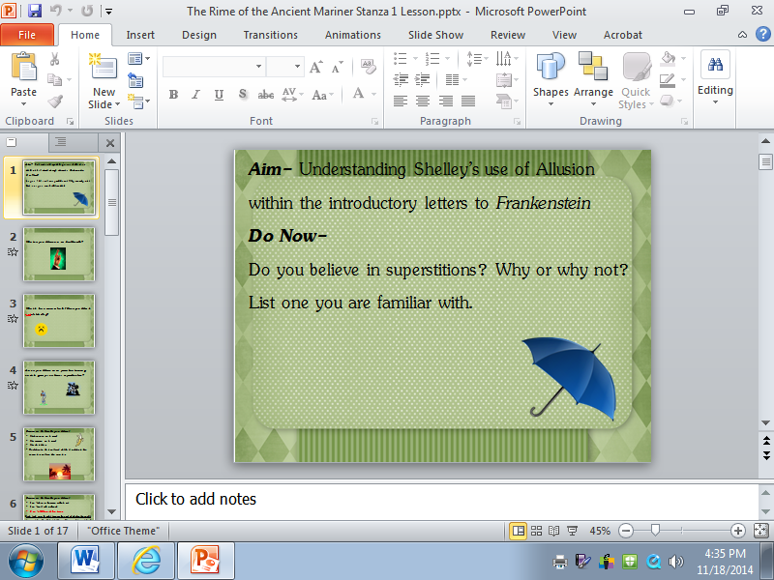

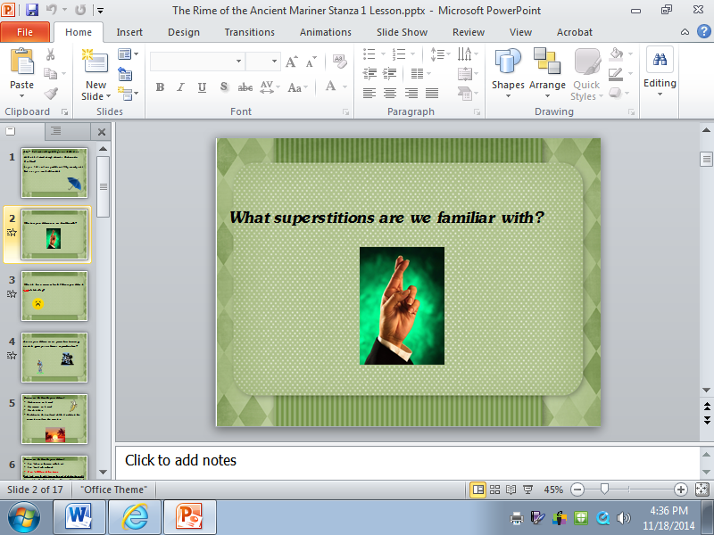

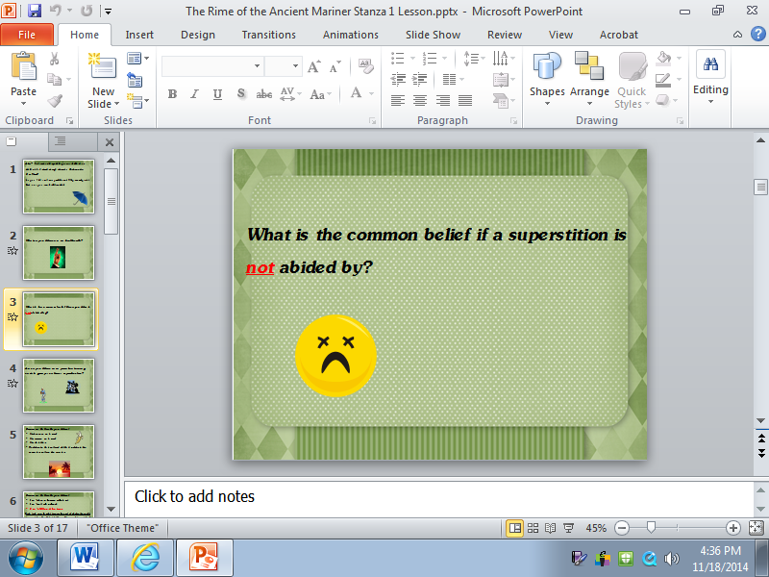

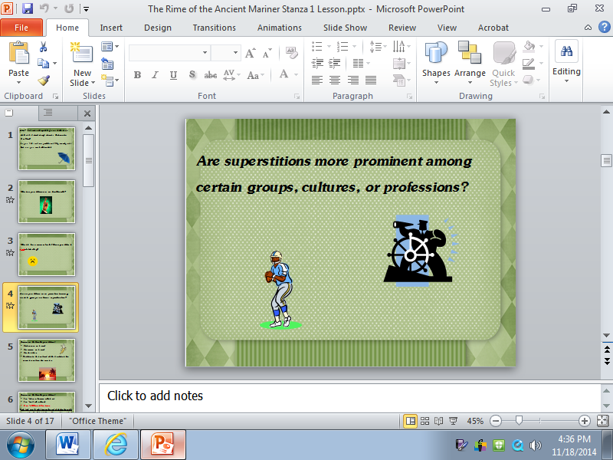

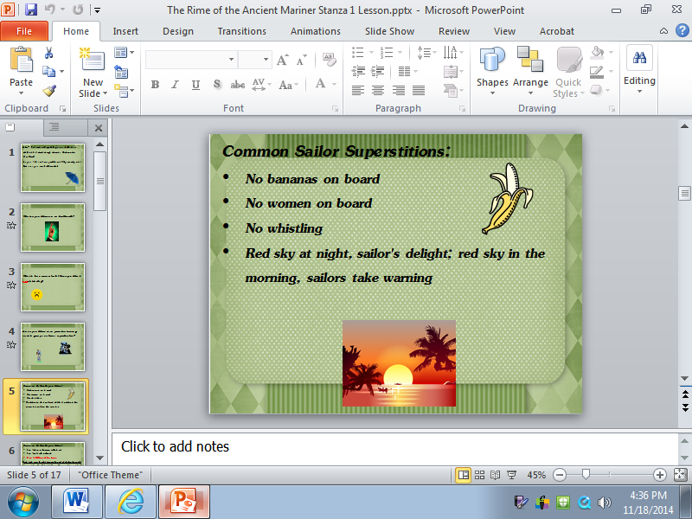

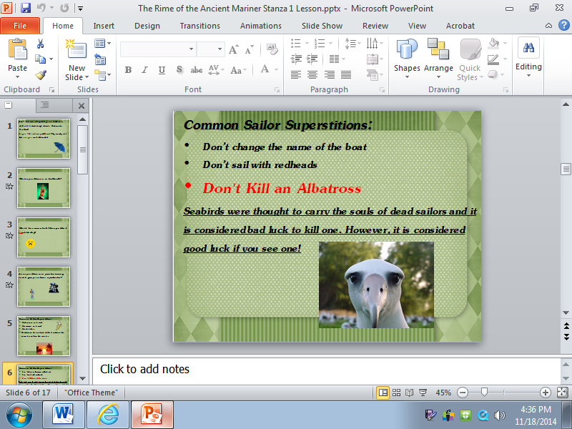

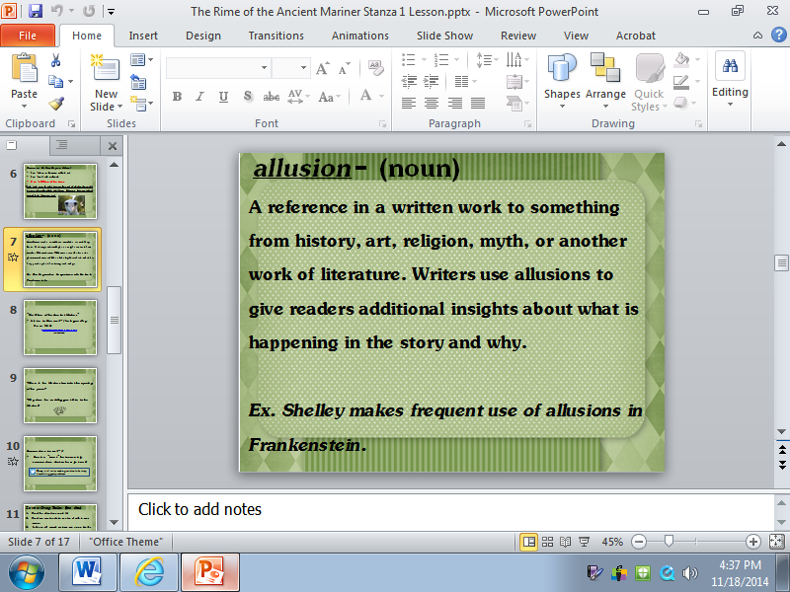

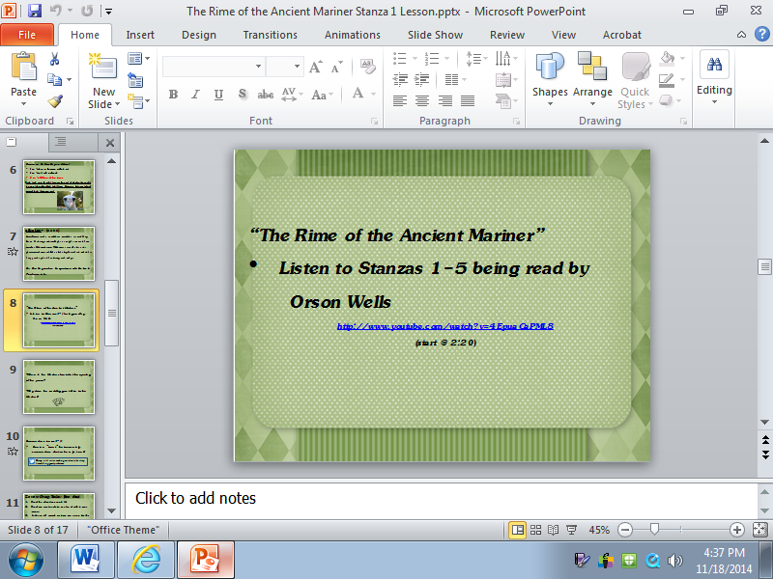

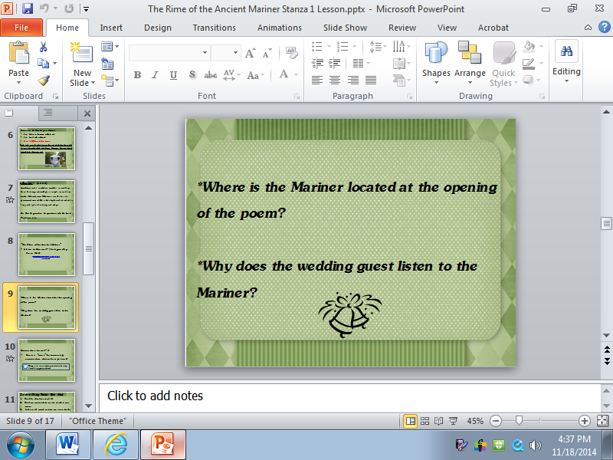

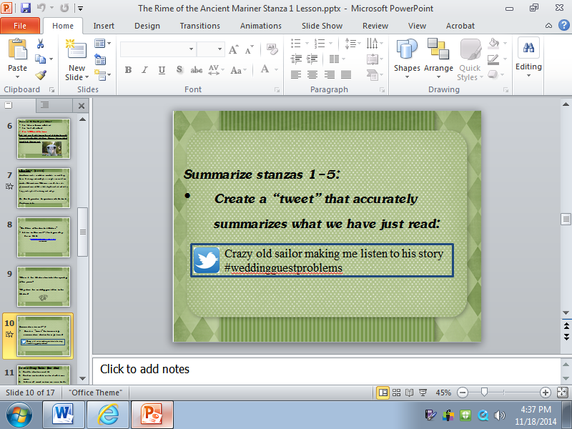

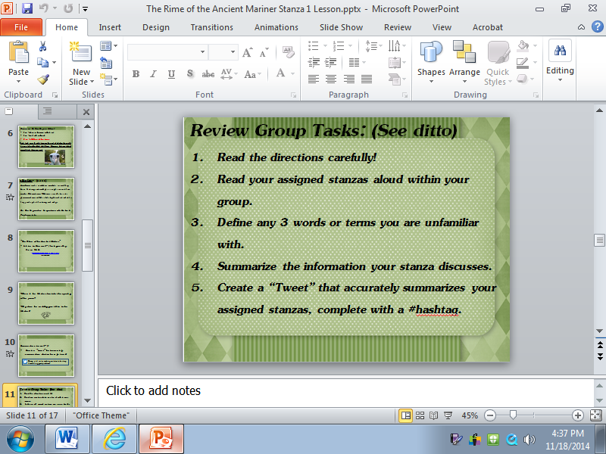

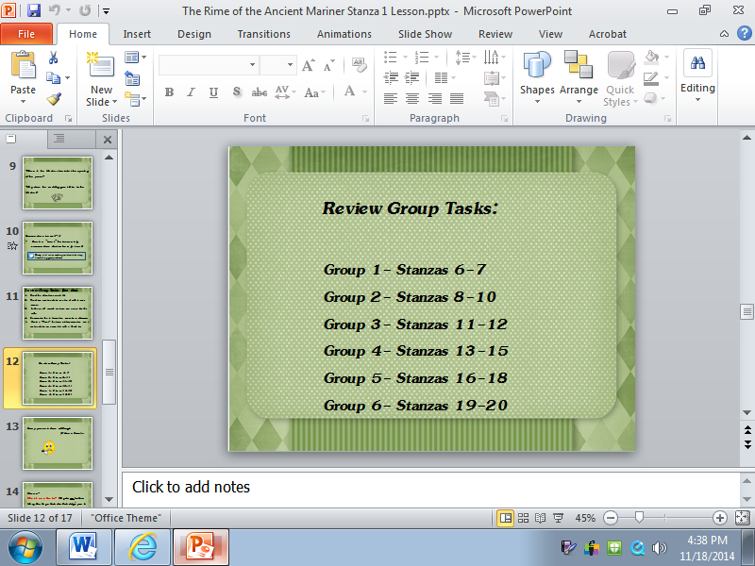

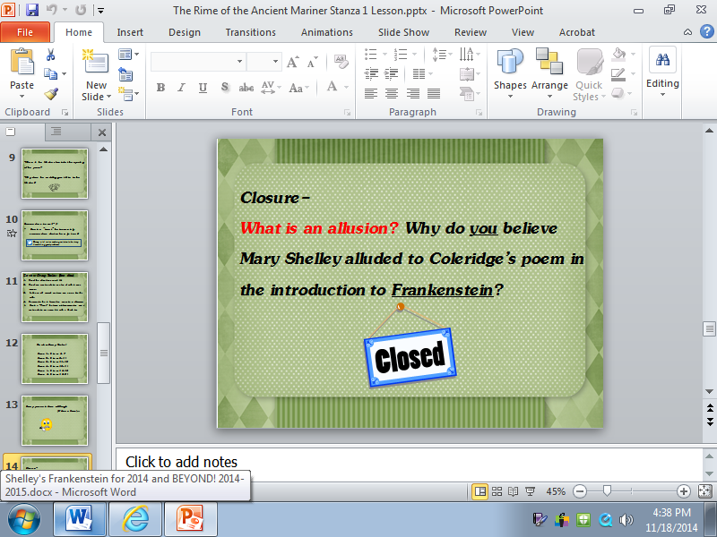

**The Rime of the Ancient Mariner**  
*by Samuel Taylor Coleridge*

C:\Users\kimlofaso.INST\AppData\Local\Microsoft\Windows\Temporary Internet Files\Content.IE5\BU899HO4\MC900391742[1].wmf  
PART ONE

IT IS an ancient Mariner, 1  
And he stoppeth one of three.  
'By thy long grey beard and glittering eye,  
Now wherefore stopp'st thou me?  
  
The Bridegroom's doors are opened wide, 5  
And I am next of kin;  
The guests are met, the feast is set:  
May'st hear the merry din.'  
  
He holds him with his skinny hand, 9  
'There was a ship,' quoth he.  
'Hold off! unhand me, grey-beard loon!'  
Eftsoons his hand dropt he.  
  
He holds him with his glittering eye-- 13  
The Wedding-Guest stood still,  
And listens like a three years' child:  
The Mariner hath his will.  
  
The Wedding-Guest sat on a stone: 17  
He cannot choose but hear;  
And thus spake on that ancient man,  
The bright-eyed Mariner.  
'The ship was cheered, the harbour cleared, 21  
Merrily did we drop  
Below the kirk, below the hill,  
Below the lighthouse top.  
  
The Sun came up upon the left, 25   
Out of the sea came he!  
And he shone bright, and on the right  
Went down into the sea.  
  
Higher and higher every day, 29  
Till over the mast at noon--'  
The Wedding-Guest here beat his breast,  
For he heard the loud bassoon.  
  
The bride hath paced into the hall, 33  
Red as a rose is she;  
Nodding their heads before her goes  
The merry minstrelsy.  
  
The Wedding-Guest he beat his breast, 37  
Yet he cannot choose but hear;  
And thus spake on that ancient man,  
The bright-eyed Mariner.  
  
And now the Storm-blast came, and he 41  
Was tyrannous and strong:  
He struck with his o'ertaking wings,  
And chased us south along.

With sloping masts and dipping prow, 45   
As who pursued with yell and blow  
Still treads the shadow of his foe,  
And forward bends his head,  
The ship drove fast, loud roared the blast,  
And southward aye we fled.  
  
And now there came both mist and snow, 51  
And it grew wondrous cold:  
And ice, mast-high, came floating by,  
As green as emerald.  
  
And through the drifts the snowy clifts 55  
Did send a dismal sheen:

Nor shapes of men nor beasts we ken--  
The ice was all between.  
  
The ice was here, the ice was there, 59  
The ice was all around:  
It cracked and growled, and roared and howled,  
Like noises in a swound!  
  
At length did cross an Albatross, 63  
Thorough the fog it came;  
As if it had been a Christian soul,  
We hailed it in God's name.  
  
It ate the food it ne'er had eat, 67  
And round and round it flew.  
The ice did split with a thunder-fit;  
The helmsman steered us through!  
And a good south wind sprung up behind; 71  
The Albatross did follow,  
And every day, for food or play,  
Came to the mariners' hollo!  
  
In mist or cloud, on mast or shroud, 75  
It perched for vespers nine;  
Whiles all the night, through fog-smoke white,  
Glimmered the white Moon-shine.'  
  
'God save thee, ancient Mariner! 79  
From the fiends, that plague thee thus!--  
Why look'st thou so?'--'With my cross-bow  
I shot the Albatross.'

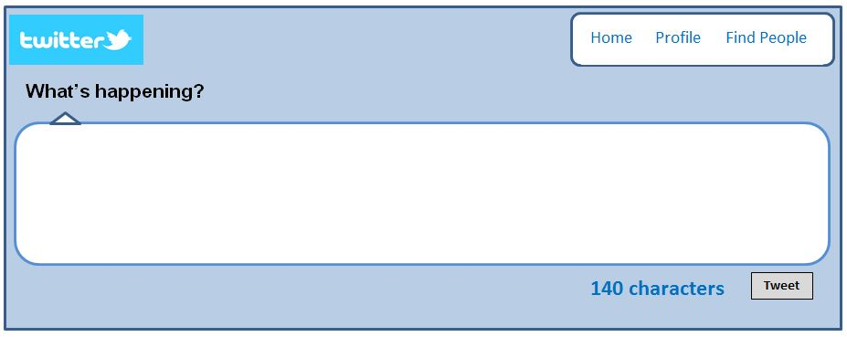

[The New York Times](http://www.nytimes.com/)

February 3, 2012

**Grand Allusion**

**By ELIZABETH D. SAMET**

A good friend recently treated me to one of the preposterous yet mostly true tales for which I prize him. This one involved the Texas Tech University mascot’s horse, Double T., skidding on the turf during a pregame gallop and careening into a stadium wall. While my friend described the fatal accident, I recalled the scene in “Anna Karenina” in which Vronsky’s horse — whose name I had momentarily forgotten and was desperately reaching for — falls in the steeplechase and must be put down.

“Like Vronsky’s horse!” I announced. “You know,” I stumbled on, “Vronsky’s horse . . . injured at the races . . . has to be shot. . . . What’s the name of Vronsky’s horse?”

“Who’s Vronsky?” my friend shrugged, and I was reminded that each unhappy allusion is unhappy in its own way.

There’s a brisk, largely invisible traffic in allusion going on all the time all around us. Because the most successful allusions require only tacit acknowledgment — or, at most, an allusive reply equally opaque to the clueless — we are frequently saved the embarrassment of recognizing our own ignorance and exclusion. Allusions tend to become visible only when, for some reason, they demand a response yet, like unreciprocated handshakes, fail to be grasped. When someone simply has to ask, to the discomfort of all, “Who’s Vronsky?”

“Oh, just some guy I know who had a horse named Frou-Frou.”

When they fail, allusions leave us exposed: either enmeshed in inelegant, patronizing explanations or cast adrift with insufficient provisions on the murky seas of a childlike half-understanding. Failed allusions produce feelings of betrayal on all sides because they reveal mistaken assumptions about shared frames of reference and like-mindedness. Parties embroiled in an allusion gone wrong eye each other with suspicion across a newly opened chasm and wonder who is really at fault: is the speaker a snob or the listener a dolt?

Some people know exactly who you are when you say, “Don’t make it sad, Cricket, I don’t feel that way,” or, “Gimme a whiskey. . . . And don’t be stingy, baby.” They laugh when you mention Charles Dikkens with two k’s, the well-known Dutch author. They are by no means nonplused when you growl in frustration, “Bastard Normans, Norman bastards.” In other words, certain friends have the training to appreciate a good part of the idiosyncratic tapestry of film, literature and other materials you’ve woven together over the years — and the patience and generosity to unravel the rest. When they don’t, and you, preferring the Scylla of the swindle to the Charybdis of condescension, suffer whatever rolls trippingly off your tongue to pass for something original, you’re no longer clever but a cheat. Unlike most tricks, the allusion triumphs only when people know precisely how it is done.

If allusion courts various personal and social risks in everyday life, in the classroom it has its own special dangers. Teachers, especially English teachers, train students to spot allusions everywhere. It is a mark of arrival to know that the title of Fitzgerald’s novel “Tender Is the Night” refers to Keats’s “Ode to a Nightingale” or that the title of Stanley Kubrick’s 1957 film “Paths of Glory” alludes to Thomas Gray’s wildly popular 18th-century “Elegy Written in a Country Churchyard.” Some of the best moments in class occur when a student, seeing something that once was invisible, draws her own potentially enriching connections. Yet such discoveries have become increasingly rare.

The Internet has turned students into supremely efficient trackers who grow up believing there is a seamless web of Google-ready allusion waiting to be exploited. Perhaps like spelling, memorizing phone numbers and reading a map, recognizing allusions without technological assistance is becoming an obsolete skill. Today any quotation can be identified in seconds, any suspicion of intertextuality immediately confirmed or denied. Well, almost any. Some authors play with this very assumption by planting red herrings in their work: David Foster Wallace, for example, or Arthur Phillips in his recent novel, “The Tragedy of Arthur.” By intermingling manufactured and verifiable allusions in the same poem, Robert Pinsky has baffled several keyboarding Natty Bumppos of my acquaintance.

Allusion can feel like something of a parlor game even in the best of times. In the 1940s, in a discussion of T. S. Eliot’s densely allusive poem “The Waste Land,” the formalist critics William K. Wimsatt and Monroe C. Beardsley questioned prevailing assumptions about the value of allusion-hunting. Eschewing the role of literary detective, they rejected the notion that we “do not know what a poet means unless we have traced him in his reading.” “Eliot’s allusions work,” they argued in “The Intentional Fallacy,” “when we know them — and to a great extent even when we do not know them, through their suggestive power. . . . It would not much matter if Eliot invented his sources,” as Walter Scott and Coleridge had done. Wimsatt and Beardsley’s warning that identifying an allusion does not amount to the same thing as understanding its significance has renewed urgency in the current age of allusion-­automation, for if the Web makes it that much easier for the allusion-hunter to bag his quarry, it does not necessarily tell him how to dress it.

Reacting against the insider trading characteristic of so much 20th- and 21st-century literature in the wake of modernism, some students refuse allusion altogether. Their impatience can extend beyond arguably esoteric literary references to the period details an author might invoke. Some of my students recently expressed frustration with Frank O’Hara’s elegy for Billie Holiday, “The Day Lady Died.” Who cares, they asked, about the brand of cigarettes O’Hara smoked, the literary journals he read, the train he caught or the jazz club he frequented? I think they resented O’Hara’s personal catalog of 1959 New York City, and they were largely unmoved by a classmate’s claim that the apparent triviality was precisely the point. We read O’Hara’s poem in an anthology that identified many of the references, but what use is a footnote that simply inventories the unfamiliar landmarks of an alien world? In trying to illuminate an allusion in class, I sometimes feel as if I’m opening one nesting doll after another until there’s nothing left at all.

Confronted by a vertiginous cascade of allusions, each one pointing to yet another unknown, retreating to the snail shell of the mind seems a whole lot more attractive: a poem responds to you, you don’t respond to it. In a letter she wrote the day she died, Elizabeth Bishop complained to the editor of an anthology that included some of her poems about the notes that had been appended: “If a poem catches a student’s interest at all, he or she should damned well be able to look up an unfamiliar word in the dictionary. . . . You can see what a nasty teacher I must be — but I do think students get lazier and lazier & expect to have everything done *for* them.” Bishop saw in her students’ resistance evidence of a bias against knowledge in favor of feeling: “They mostly seem to think that poetry — to read or to write — is a snap — one just has to *feel* — & not for very long, either.” She closed, “If you can get students to *reading*, you will have done a noble work.”

Sometimes I read that letter with students. They “get it” — absolutely — even when they have to ask, “Who’s Elizabeth Bishop?”

*Elizabeth D. Samet is the author of “Soldier’s Heart: Reading Literature Through Peace and War at West Point.”*

### 

### 

### 

### 

### 

### 

### 