Because cursing calls on the thinking and feeling pathways of the brain in roughly equal measure and with handily assessable fervor, scientists say that by studying the neural circuitry behind it they are gaining new insights into how the different domains of the brain communicate - and all for the sake of a well-venomed retort.

Other investigators have examined the physiology of cursing, how our senses and reflexes react to the sound or sight of an obscene word. They have determined that hearing a curse elicits a literal rise out of people. When electrodermal wires are placed on people's arms and fingertips to study their skin conductance patterns and the subjects then hear a few obscenities spoken clearly and firmly, participants show signs of instant arousal.

Their skin conductance patterns spike, the hairs on their arms rise, their pulse quickens, and their breathing becomes shallow.

Interestingly, said Kate Burridge, a professor of linguistics at Monash University in Melbourne, Australia, a similar reaction occurs among university students and others who pride themselves on being educated when they listen to bad grammar or slang expressions that they regard as irritating, illiterate or déclassé.

"People can feel very passionate about language," she said, "as though it were a cherished artifact that must be protected at all cost against the depravities of barbarians and lexical aliens."

Dr. Burridge and a colleague at Monash, Keith Allan, are the authors of "Forbidden Words: Taboo and the Censoring of Language," which will be published early next year by the Cambridge University Press.

Researchers have also found that obscenities can get under one's goosebumped skin and then refuse to budge. In one study, scientists started with the familiar Stroop test, in which subjects are flashed a series of words written in different colors and are asked to react by calling out the colors of the words rather than the words themselves.

If the subjects see the word "chair" written in yellow letters, they are supposed to say "yellow."

The researchers then inserted a number of obscenities and vulgarities in the standard lineup. Charting participants' immediate and delayed responses, the researchers found that, first of all, people needed significantly more time to trill out the colors of the curse words than they did for neutral terms like chair.

The experience of seeing titillating text obviously distracted the participants from the color-coding task at hand. Yet those risqué interpolations left their mark. In subsequent memory quizzes, not only were participants much better at recalling the naughty words than they were the neutrals, but that superior recall also applied to the tints of the tainted words, as well as to their sense.

Yes, it is tough to toil in the shadow of trash. When researchers in another study asked participants to quickly scan lists of words that included obscenities and then to recall as many of the words as possible, the subjects were, once again, best at rehashing the curses - and worst at summoning up whatever unobjectionable entries happened to precede or follow the bad bits.

Yet as much as bad language can deliver a jolt, it can help wash away stress and anger. In some settings, the free flow of foul language may signal not hostility or social pathology, but harmony and tranquillity.

"Studies show that if you're with a group of close friends, the more relaxed you are, the more you swear," Dr. Burridge said. "It's a way of saying: 'I'm so comfortable here I can let off steam. I can say whatever I like.' "

Evidence also suggests that cursing can be an effective means of venting aggression and thereby forestalling physical violence.

With the help of a small army of students and volunteers, Timothy B. Jay, a professor of psychology at Massachusetts College of Liberal Arts in North Adams and the author of "Cursing in America" and "Why We Curse," has explored the dynamics of cursing in great detail.

The investigators have found, among other things, that men generally curse more than women, unless said women are in a sorority, and that university provosts swear more than librarians or the staff members of the university day care center.

Regardless of who is cursing or what the provocation may be, Dr. Jay said, the rationale for the eruption is often the same.

"Time and again, people have told me that cursing is a coping mechanism for them, a way of reducing stress," he said in a telephone interview. "It's a form of anger management that is often underappreciated."

Indeed, chimpanzees engage in what appears to be a kind of cursing match as a means of venting aggression and avoiding a potentially dangerous physical clash.

Frans de Waal, a professor of primate behavior at Emory University in Atlanta, said that when chimpanzees were angry "they will grunt or spit or make an abrupt, upsweeping gesture that, if a human were to do it, you'd recognize it as aggressive."

Such behaviors are threat gestures, Professor de Waal said, and they are all a good sign.

"A chimpanzee who is really gearing up for a fight doesn't waste time with gestures, but just goes ahead and attacks," he added.

By the same token, he said, nothing is more deadly than a person who is too enraged for expletives - who cleanly and quietly picks up a gun and starts shooting.

Researchers have also examined how words attain the status of forbidden speech and how the evolution of coarse language affects the smoother sheets of civil discourse stacked above it. They have found that what counts as taboo language in a given culture is often a mirror into that culture's fears and fixations.

"In some cultures, swear words are drawn mainly from sex and bodily functions, whereas in others, they're drawn mainly from the domain of religion," Dr. Deutscher said.

In societies where the purity and honor of women is of paramount importance, he said, "it's not surprising that many swear words are variations on the 'son of a whore' theme or refer graphically to the genitalia of the person's mother or sisters."

The very concept of a swear word or an oath originates from the profound importance that ancient cultures placed on swearing by the name of a god or gods. In ancient Babylon, swearing by the name of a god was meant to give absolute certainty against lying, Dr. Deutscher said, "and people believed that swearing falsely by a god would bring the terrible wrath of that god upon them." A warning against any abuse of the sacred oath is reflected in the biblical commandment that one must not "take the Lord's name in vain," and even today courtroom witnesses swear on the Bible that they are telling the whole truth and nothing but.

Among Christians, the stricture against taking the Lord's name in vain extended to casual allusions to God's son or the son's corporeal sufferings - no mention of the blood or the wounds or the body, and that goes for clever contractions, too. Nowadays, the phrase, "Oh, golly!" may be considered almost comically wholesome, but it was not always so. "Golly" is a compaction of "God's body" and, thus, was once a profanity.

Yet neither biblical commandment nor the most zealous Victorian censor can elide from the human mind its hand-wringing over the unruly human body, its chronic, embarrassing demands and its sad decay. Discomfort over body functions never sleeps, Dr. Burridge said, and the need for an ever-fresh selection of euphemisms about dirty subjects has long served as an impressive engine of linguistic invention.

Once a word becomes too closely associated with a specific body function, she said, once it becomes too evocative of what should not be evoked, it starts to enter the realm of the taboo and must be replaced by a new, gauzier euphemism.

For example, the word "toilet" stems from the French word for "little towel" and was originally a pleasantly indirect way of referring to the place where the chamber pot or its equivalent resides. But toilet has since come to mean the porcelain fixture itself, and so sounds too blunt to use in polite company. Instead, you ask your tuxedoed waiter for directions to the ladies' room or the restroom or, if you must, the bathroom.

Similarly, the word "coffin" originally meant an ordinary box, but once it became associated with death, that was it for a "shoe coffin" or "thinking outside the coffin." The taboo sense of a word, Dr. Burridge said, "always drives out any other senses it might have had."

Scientists have lately sought to map the neural topography of forbidden speech by studying Tourette's patients who suffer from coprolalia, the pathological and uncontrollable urge to curse. Tourette's syndrome is a neurological disorder of unknown origin characterized predominantly by chronic motor and vocal tics, a constant grimacing or pushing of one's glasses up the bridge of one's nose or emitting a stream of small yips or grunts.

Just a small percentage of Tourette's patients have coprolalia - estimates range from 8 to 30 percent - and patient advocates are dismayed by popular portrayals of Tourette's as a humorous and invariably scatological condition. But for those who do have coprolalia, said Dr. Carlos Singer, director of the division of movement disorders at the University of Miami School of Medicine, the symptom is often the most devastating and humiliating aspect of their condition.

Not only can it be shocking to people to hear a loud volley of expletives erupt for no apparent reason, sometimes from the mouth of a child or young teenager, but the curses can also be provocative and personal, florid slurs against the race, sexual identity or body size of a passer-by, for example, or deliberate and repeated lewd references to an old lover's name while in the arms of a current partner or spouse.

Reporting in The Archives of General Psychiatry, Dr. David A. Silbersweig, a director of neuropsychiatry and neuroimaging at the Weill Medical College of Cornell University, and his colleagues described their use of PET scans to measure cerebral blood flow and identify which regions of the brain are galvanized in Tourette's patients during episodes of tics and coprolalia.

They found strong activation of the basal ganglia, a quartet of neuron clusters deep in the forebrain at roughly the level of the mid-forehead, that are known to help coordinate body movement along with activation of crucial regions of the left rear forebrain that participate in comprehending and generating speech, most notably Broca's area.

The researchers also saw arousal of neural circuits that interact with the limbic system, the wishbone-shape throne of human emotions, and, significantly, of the "executive" realms of the brain, where decisions to act or desist from acting may be carried out: the neural source, scientists said, of whatever conscience, civility or free will humans can claim.

That the brain's executive overseer is ablaze in an outburst of coprolalia, Dr. Silbersweig said, demonstrates how complex an act the urge to speak the unspeakable may be, and not only in the case of Tourette's. The person is gripped by a desire to curse, to voice something wildly inappropriate. Higher-order linguistic circuits are tapped, to contrive the content of the curse. The brain's impulse control center struggles to short-circuit the collusion between limbic system urge and neocortical craft, and it may succeed for a time.

Yet the urge mounts, until at last the speech pathways fire, the verboten is spoken, and archaic and refined brains alike must shoulder the blame.

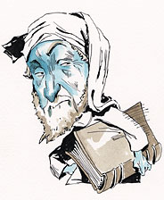

Geoffrey Chaucer's "Canterbury Tales" were unabashedly bawdy and profane. That may be why students can still be persuaded to read them.

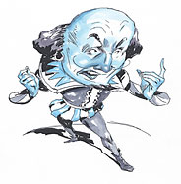

William Shakespeare, in keeping with traditions of Elizabethan drama, peppered his plays with profanity and celebrated the vulgar as well as the sublime.

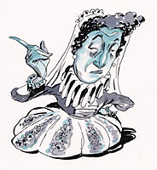

Queen Elizabeth I, like her father, Henry VIII, was known for her unbridled language at court, and her taste for the ribald entertainment of theater.

“Almost Before We Spoke, We Swore”

Vocabulary & Discussion Worksheet

by Natalie Angier

**C:\Users\kimlofaso.INST.012\AppData\Local\Microsoft\Windows\Temporary Internet Files\Content.IE5\SJGM0IK1\MC900311840[1].wmf**

# **Aim**- Understanding the vocabulary present in “Almost Before We Spoke, We Swore”

# **Do Now**- Define the following terms using a dictionary…

# **Vocabulary**-

Page 1

* + Pandemic-
  + Scurrilous-
  + Gentility-
  + Patois-
  + Peremptory-
  + Quintessential-
  + Linguist-

Page 2

* + Amalgam-
  + Fervor-
  + Déclassé-
  + Lexical-
  + Trill-

Page 3

* + Titillating-
  + Risqué-
  + Interpolations-
  + Provosts-

Page 4

* + Expletives-
  + Euphemisms-
  + Gauzier-

Page 5

* + Coprolalia-
  + Scatological-
  + Desist-
  + Neocortical-

**Reaction-** Write a reaction to this article and what you have learned about human language using 7-10 of the vocabulary terms defined above. For each reaction, include an MLA-style citation noting the exact line you are referencing from the article. You may also use direct quotes, but will need citations for this as well! Please complete this on a separate sheet of paper.

Aim: Introduction to *The Canterbury Tale’s* Prologue

Do Now: Describe the “pilgrims” you have travelled with before. Where did you travel to? Was it a long or short journey? Have you, or anyone you know, ever been on an actual pilgrimage?

New York State Common Core-

L.6- Analyze a case in which grasping point of view requires distinguishing what is directly stated in a text from what is really meant.

R.1- Cite strong and thorough textual evidence to support analysis of what the text says explicitly as well as inferences drawn from the text, including determining where the text leaves matters uncertain.

W.9- Draw evidence from literary or informational texts to support analysis, reflection, and research.

Lesson:

1. Students will share and discuss their DO Now responses with their “Think-Pair-Share” partners
2. The class will discuss and review the various reasons why an individual might go on a pilgrimage
3. Students will review The General Prologue chart
4. The teacher will start by reading the introduction to the prologue to the class, while the students follow along and compile answer for the Knight
5. Once the full description of the Knight has been read, the class will stop to fill in all areas including:
   1. Characterization
   2. Chaucer’s attitude toward this character
   3. The actor or actress you would cast to play this character in a movie
   4. A theme song that best describes the character
6. Next, the class will meet with their groups to compare notes and compile a complete chart for the Knight.
7. Groups will share their responses with the class, as examples are listed on the SmartBoard for students to add to their individual charts.
8. Students will complete the prologue and the related chart (This will take a few days to get through and can be assigned in part as homework).
9. The class will review the various pilgrims as a whole as students volunteer to share their concept of each pilgrim.
10. Groups will complete the Modern Day Pilgrim assignment after viewing the sample for ideas
11. Groups will present their Modern Day pilgrims to the class

*Closure:* Which pilgrim’s story do you believe will be the most entertaining to read? Explain why you feel this way!

*Homework:* Study the prologue chart for the *Name That Pilgrim* quiz

Canterbury Tales “The General Prologue”

j0215537

|  |  |  |  |  |
| --- | --- | --- | --- | --- |
| **Pilgrim** | **Chaucer’s Characterization?** | **Chaucer’s Attitude?** | **Actor/**  **actress?** | **Theme Song?** |
| The Knight |  |  |  |  |
| Squire |  |  |  |  |
| Yeoman |  |  |  |  |
| Prioress |  |  |  |  |
| Monk |  |  |  |  |
| Friar |  |  |  |  |
| Merchant |  |  |  |  |
| Clerk |  |  |  |  |
| Sergeant-at-Law |  |  |  |  |
| Franklin |  |  |  |  |
| Haber-dasher, Carpenter, Weaver, Dyer, Tapestry Maker |  |  |  |  |
| Cook |  |  |  |  |
| Shipman |  |  |  |  |
| Doctor of Medicine |  |  |  |  |
| Wife of Bath |  |  |  |  |
| Parson |  |  |  |  |
| Plowman |  |  |  |  |
| Miller |  |  |  |  |
| Manciple |  |  |  |  |
| Reeve |  |  |  |  |
| Summoner |  |  |  |  |
| Pardoner |  |  |  |  |
| Host |  |  |  |  |

*Next, place a heart next to the best pilgrims and an X next to the worst, as according to Chaucer.

**The Modern-Day Pilgrim**

MC900329243[1]

Directions- With your group, select ***one*** of the two assignments listed below. Your pilgrim and poem will be presented to the class. All work must be written on a separate sheet of paper or typed. See the sample for ideas!

**CHOICE #1:** Your assignment is to create a modern day pilgrim to join Chaucer’s pilgrims on their journey to Canterbury. You must add your pilgrim to Chaucer’s Prologue. Where in the prologue are you going to place your pilgrim? Is your pilgrim friendly with any of Chaucer’s other pilgrims? What is the occupation of your pilgrim?

Then you must describe the pilgrim’s physical characteristics. What is your pilgrim wearing? Include other characteristics of the pilgrim as well. Does your pilgrim have a name? (Is he/she a positive or negative pilgrim?) After you have finished brainstorming, you now must take this information and put it in the form of a poem. This poem should:

* Consist of 15-20 lines
* Have a specific occupation
* Fully characterize the pilgrim including both physical and emotional descriptions
* Allude to the reason this pilgrim might be making pilgrimage
* Use a specific rhyme scheme
* Be creative and funny- but also appropriate!

**CHOICE #2:** Your assignment is to create a modern day pilgrim who is going on a pilgrimage of your own creation. What is the purpose of the pilgrimage? How many pilgrims are going on this pilgrimage? Where would your pilgrim be placed on the line? What is your pilgrim’s mode of transportation? Where does your pilgrimage begin? Where does your pilgrimage end? What is the occupation of your pilgrim?

Then you must describe the pilgrim’s physical characteristics. What is your pilgrim wearing? Include other characteristics of the pilgrim as well. Does your pilgrim have a name? (Is he/she a positive or negative pilgrim?) After you have finished brainstorming, you now must take this information and put it in the form of a poem. This poem should:

* Consist of 15-20 lines
* Have a specific occupation
* Fully characterize the pilgrim including both physical and emotional descriptions
* Allude to the reason this pilgrim might be making pilgrimage
* Use a specific rhyme scheme
* Be creative and funny- but also appropriate!

**Sample 21st Century Pilgrim: Luigi**

**C:\Users\kimlofaso.INST.012\AppData\Local\Microsoft\Windows\Temporary Internet Files\Content.IE5\1NPLQNNO\MC900240507[1].wmf**

There once was a pizza man who loved to make food

He wore a dirty apron and was a chubby old dude

His name was Luigi and his bruschetta was delicious

He used a lot of garlic and hated washing dishes

Luigi has red rosy cheeks and a shiny bald head

He yelled “Mangia mangia!” as he made homemade bread

He used fresh mozzarella and parmesan cheese

His restaurant was the best and only aimed to please

His customers told him has sauce was the best

The tomatoes, onions, and garlic gave it some zest

He said it was an old family recipe his Grandma had invented

But one day the truth came out as he angrily vented

The truth was he used Ragu, Contadina, and Barilla

He couldn’t make sauce any better than a gorilla

Perhaps this is why he is going on pilgrimage to pray

And ask Thomas a Beckett to help his cooking by the end of the day!

***“Name That Pilgrim” Quiz***



***Directions***- Write the name of the pilgrim described in the following quotations.

1. ____________________ “…and he would help the poor for the love of Christ and never take a penny… He paid in tithes in full when they were due On what he owned, and on his earnings too…”
2. ____________________ “Yet he was rather close as to expenses And kept the gold he won in pestilences.”
3. ____________________ “Bold in his speech, yet wise and full of tact, There was no manly attribute he lacked. What’s more, he was a merry-hearted man…”
4. ____________________ “A wrangler and buffoon, he had a store Of tavern stories, filthy in the main. He was a master hand at stealing grain.”
5. ____________________ “And he was under contract to present The accounts, right from his master’s earliest years. No one ever caught him in arrears.”
6. ____________________ “…a most distinguished man Who from the day on which he first began To ride abroad had followed chivalry.”
7. ____________________ “Garlic he loved, and onions too, and leeks. And drinking strong wine till he was hazy. Then he would shout and jabber as if crazy, And wouldn’t speak a word except in Latin.”
8. ____________________ “As for his skill in reckoning in tides, Currents and many another risk besides, Moons, harbours, pilots, he had such dispatch That from Hull to Carthage none was his match.”
9. ____________________ “…and his horse was thinner than a rake And he was not too fat, I undertake, but I had a hollow look, a sober stare: The thread upon his overcoat was bare.”
10. ____________________ “He knew of every Judgment, case and crime Recorded since King William’s time.”
11. ____________________ “And in his hand he bore a mighty bow. His head was like a nut, his face was brown, And he knew the whole of woodcraft up and down.”
12. ____________________ “he knew the taverns well in every town And every innkeeper and barmaid too Better than lepers, beggars and that crew.”
13. ____________________ “…so (he) had set His wits to work, none knew he was in debt, He was so stately in negotiation, Loan, bargain, and commercial obligation.”
14. ____________________ “Their wisdom would have justified a plan To make each one an alderman: They had capital and revenue, Besides their wives declared it was their due.”
15. ____________________ “In company she liked to laugh and chat And knew the remedies of love’s mischances, An art in which she knew the oldest dances.”
16. ____________________ “He stayed at home and watched over his fold So that no wolf should make the sheep miscarry He was a shepherd and no mercenary.”
17. ____________________ “He ‘d sewed a holy relic in his cap: His wallet lay before him on his lap, Brimful of pardons come from Rome all hot. He had the same small voice as a goat has got.”
18. ____________________ “…and he was never rash Whether he bought on credit or paid cash. He used to watch the market most precisely And got in first, and so he did quite nicely.”
19. ____________________ “He liked a fat swan best, and roasted whole. His palfrey was as brown as is a berry.”
20. ____________________ “But what a pity – so it seemed to me, That he should have an ulcer on his knee, As for blancmange, he made it with the best.”
21. ____________________ “Her forehead, certainly, was fair of spread, Almost a span across the bow, I own; She was by no means under grown.”
22. ____________________ “Singing he was, or fluting all the day; He was as fresh as is the month of May.”
23. ____________________ “His house was never short of baked-meat pies, Of fish and flesh, and these in such supplies It positively snowed with meat and drink.”

Aim- Recognizing the outcome of Greed…

Do Now- List 3 people in the media who were motivated by greed. What was the outcome for each?

New York State Common Core-

L.6- Analyze a case in which grasping point of view requires distinguishing what is directly stated in a text from what is really meant.

R.1- Cite strong and thorough textual evidence to support analysis of what the text says explicitly as well as inferences drawn from the text, including determining where the text leaves matters uncertain.

W.9- Draw evidence from literary or informational texts to support analysis, reflection, and research.

Lesson:

1. Students will share and discuss their DO Now responses with their “Think-Pair-Share” partners
2. The class will compile a master list on the smart board using the chart on the powerpoint
3. The class will view John Stossel’s exposee on “greed”
   1. <http://www.youtube.com/watch?v=n5K6TJWBIFQ>
4. After the video clip is complete, students will freewrite their reaction for 3 minutes
5. Students will be asked to consider what greed typically results in
6. Reactions to the clip will be shared and discussed as students draw information from their freewriting activity
7. Students will review the discussion questions for The Pardoner’s Tale and begin reading on page 244

*Closure:* What can we infer about those in our society who become too greedy?

*Homework:* Finish reading “The Pardoner’s Tale” and complete all discussion questions

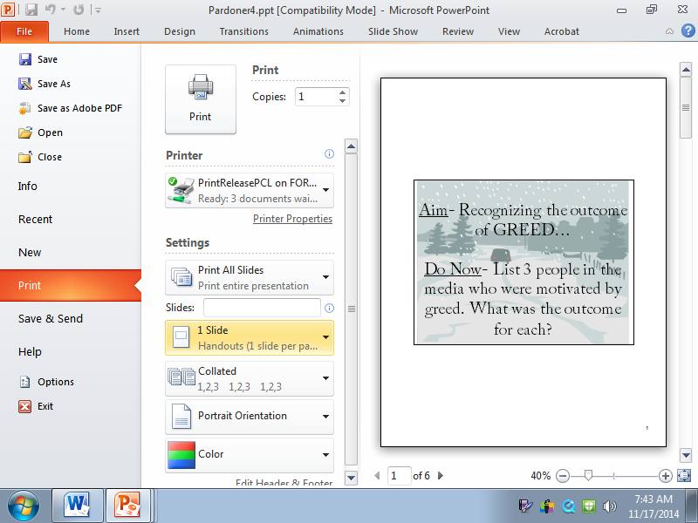



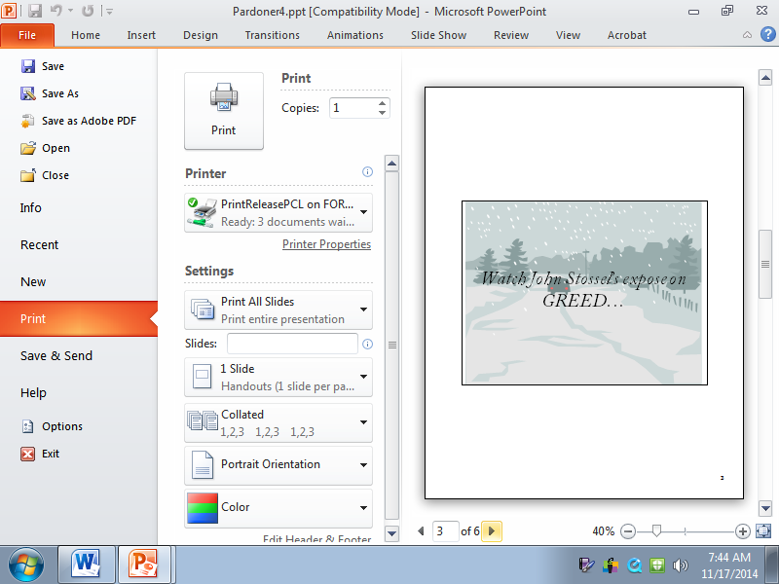

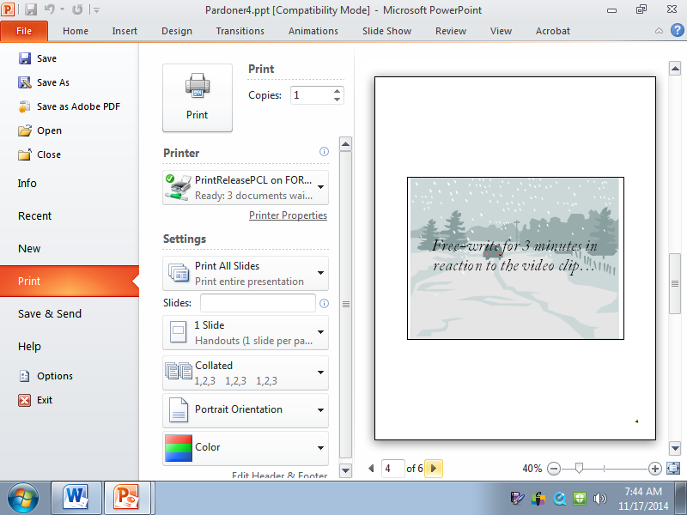

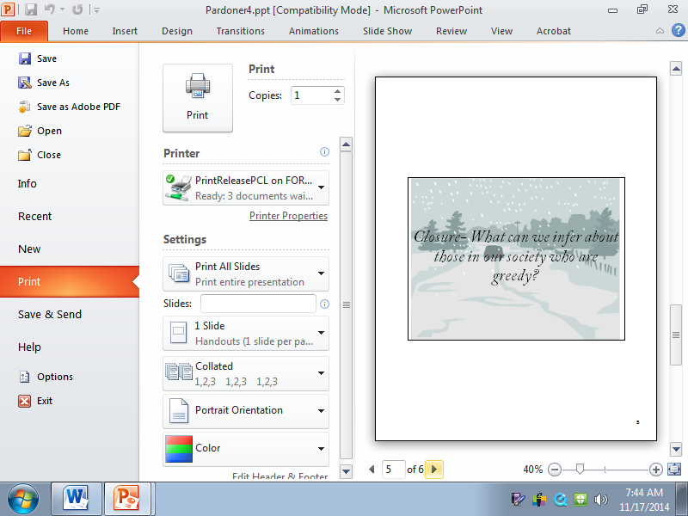



***“The Pardoner’s Tale”***

**

*Discussion Questions*

1. What bargain or agreement did the rioters make at the tavern?
2. They met an old man as they began their journey. What was the old man's problem?
3. Where does the old man send the rioters?
4. What did they find where the old man sent them?
5. Why did they have to bring the treasure home at night?
6. Why was one youth sent to town?
7. What plan did the two other youths make to kill the one when he returned from town?
8. What plan did the one who went to town make to kill the two others when he got back?
9. Who died, and how did it happen?
10. What lesson or moral is emphasized in this tale?

Aim- Identifying and understanding the 7 deadly sins

Do Now- List as many of the 7 deadly sins as you can recall. What is a suitable punishment for each sin?

New York State Common Core-

L.6- Analyze a case in which grasping point of view requires distinguishing what is directly stated in a text from what is really meant.

R.1- Cite strong and thorough textual evidence to support analysis of what the text says explicitly as well as inferences drawn from the text, including determining where the text leaves matters uncertain.

W.9- Draw evidence from literary or informational texts to support analysis, reflection, and research.

Lesson:

1. Students will share and discuss their DO Now responses with the class
2. The class will review the New York Times compilation of the original punishments for the 7 deadly sins
3. The class will be asked to share their reaction to this article
4. Students will be asked to consider:
   1. Which of the 7 deadly sins the Pardoner suggests is the worst of all?
   2. Why does he believe this?
   3. Do you agree or disagree with him?
   4. Is he the best judge of character?
   5. Why or why not? Hint: Refer back to the prologue for more details!
5. Next, place a checkmark next to each sin the Pardoner is guilty of committing. The rioters?
   1. List 3 examples of the Pardoner’s sins directly from the text. Include the page number so your classmates can read along as you share!
   2. List 3 examples of the 3 rioters’ sins directly from the text. Include the page number so your classmates can read along as you share!

*Closure:* How is the Pardoner able to swindle people and convince them to pay him for pardons? Would you believe him? Do you believe the rioters got what they deserve? Why or why not!

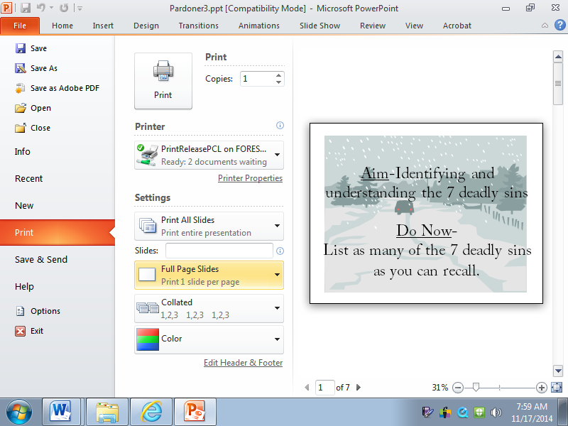

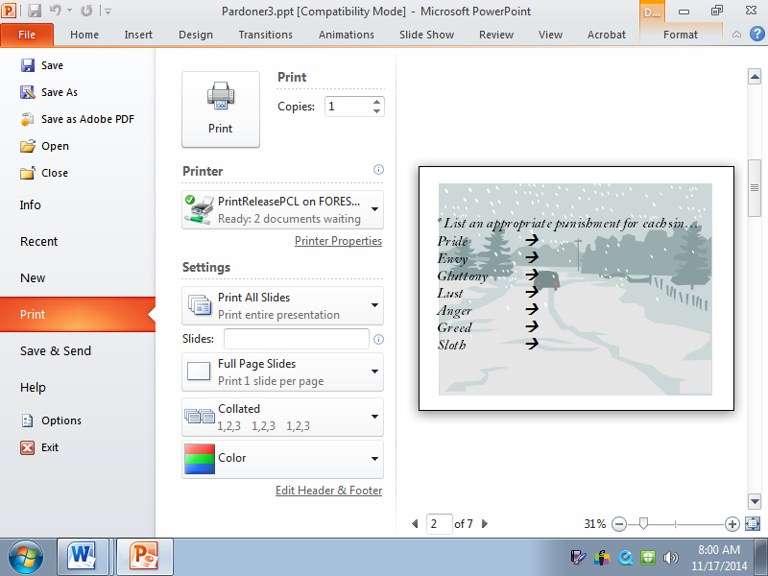

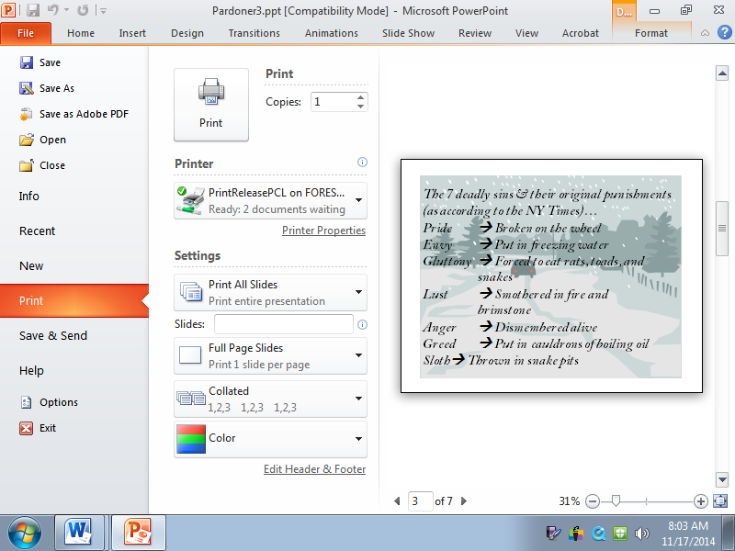

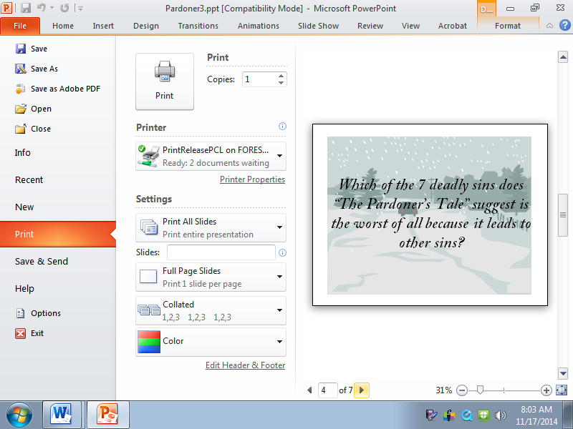



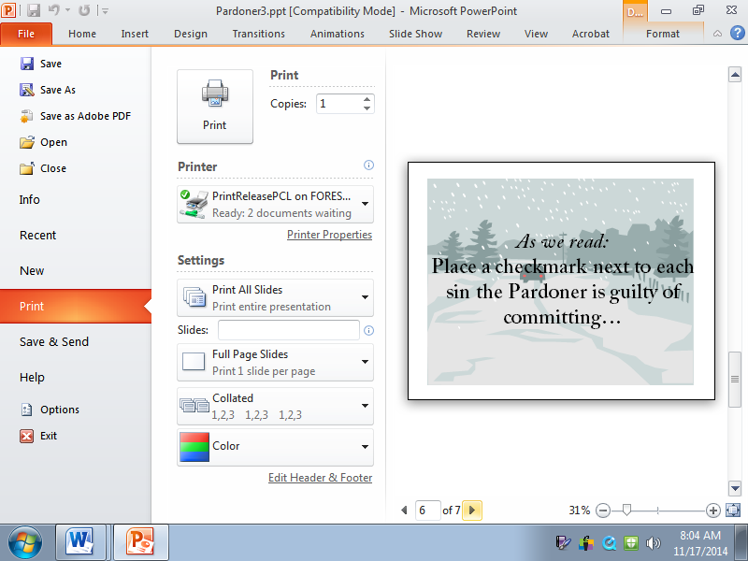

Aim- Understanding personification in both “The Pardoner’s Tale” and the poem “Incident in a Rose Garden”

Do Now- Personify GREED in a brief paragraph using all 5 of your senses

New York State Common Core-

L.6- Analyze a case in which grasping point of view requires distinguishing what is directly stated in a text from what is really meant.

R.1- Cite strong and thorough textual evidence to support analysis of what the text says explicitly as well as inferences drawn from the text, including determining where the text leaves matters uncertain.

W.9- Draw evidence from literary or informational texts to support analysis, reflection, and research.

Lesson:

1. Students will share and discuss their Do Now responses with their “Think-Pair-Share” partners
2. Next, students will share their Do Now responses with the class as a whole
3. Students will be asked to volunteer to read “Incident in a Rose Garden” aloud for the class. One student will be chosen to read for the Gardener, the Master, and for Death.
4. As students listen to the poem, they are encouraged to take notes, ask questions, and share their reactions to the poem in the margin on the right side of the worksheet.
5. Class questions will be addressed and individual student interpretations will be shared.
6. Next, students will listen to the poem being read once more.
7. Groups will meet to complete the discussion questions:
   1. Explain the connection this poem has to “The Pardoner’s Tale” of *Canterbury Tales:*
   2. Give 5 examples showing how Death is personified in this poem:
   3. Give 3 examples showing how Death is personified in “The Pardoner’s Tale”:
   4. What is foreshadowed at the conclusion of this poem?
8. The class will review these responses as a whole, specifically focusing on the connections that can be made to “The Pardoner’s Tale”
9. Students will listen to the additional lines that Donald Justice added later in life, while considering which ending they prefer and why.

***Closure:*** What literary device is at play in both “The Pardoner’s Tale” and the poem “Incident in a Rose Garden”

***Homework***: Study all notes on “The Pardoner’s Tale” and the poem “Incident in a Rose Garden” for an upcoming quiz

***Incident in a Rose Garden***

*Donald Justice*

*j0304917*

*Interpretation-*

*Gardener:* Sir, I encountered Death  
  Just now among our roses.  
  Thin as a scythe he stood there.  
  I knew him by his pictures.  
  He had his black coat on,                          5  
  Black gloves, a broad black hat.  
  I think he would have spoken,  
  Seeing his mouth stood open.  
  Big it was, with white teeth.  
  As soon as he beckoned, I ran.                    10  
  I ran until I found you.  
  Sir, I am quitting my job.  
  I want to see my sons  
  Once more before I die.  
  I want to see California.                         15

*Master:* Sir you must be that stranger  
  Who threatened my gardener.  
  This is my property, sir.  
  I welcome only friends here.  
*Death:* Sir, I knew your father.                    20  
  And we were friends at the end.  
  As for your gardener I did not threaten him.  
  Old men mistake my gestures.  
  I only meant to ask him                           25  
  To show me to his master.  
  I take it you are he?

***Discussion Questions-***

1. Explain the connection this poem has to “The Pardoner’s Tale” of *Canterbury Tales:*
2. Give 5 examples showing how Death is personified in this poem:
3. Give 3 examples showing how Death is personified in “The Pardoner’s Tale”:
4. What is foreshadowed at the conclusion of this poem?

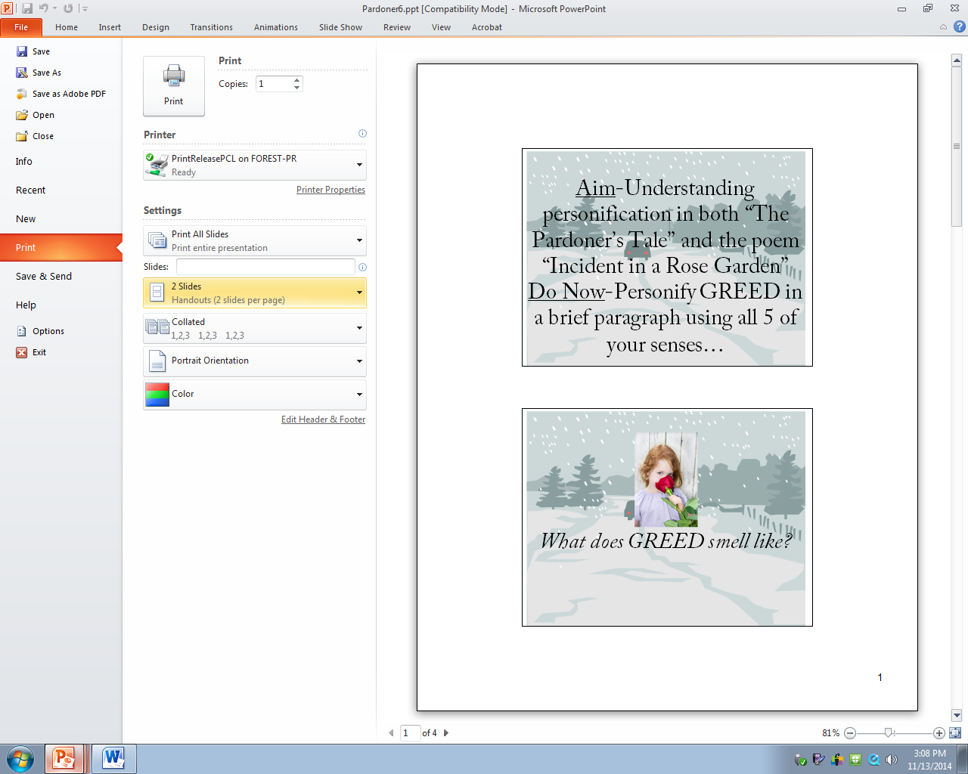

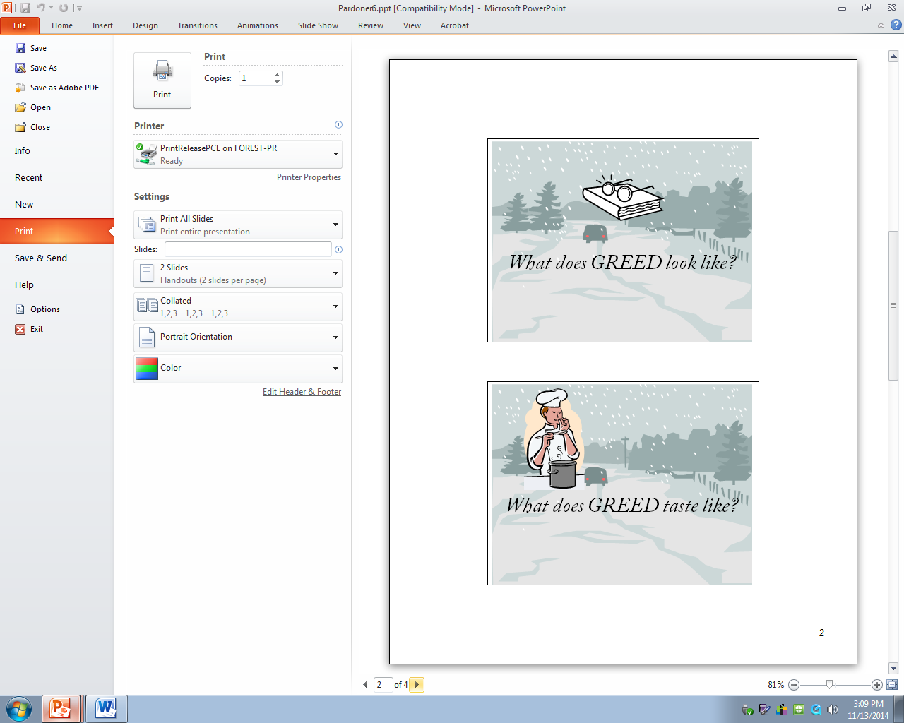

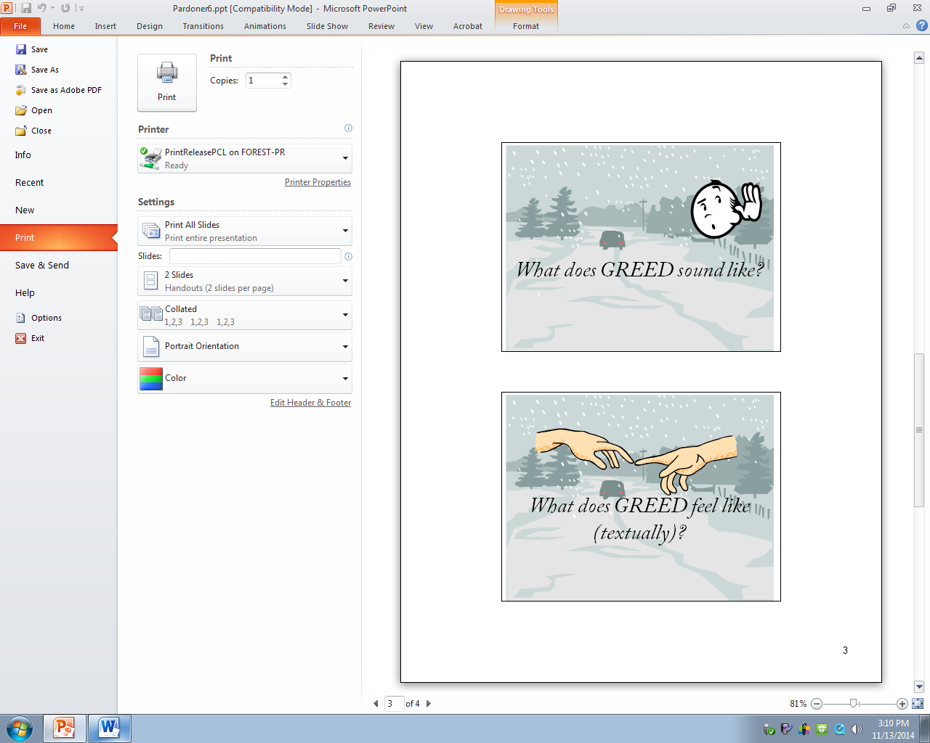

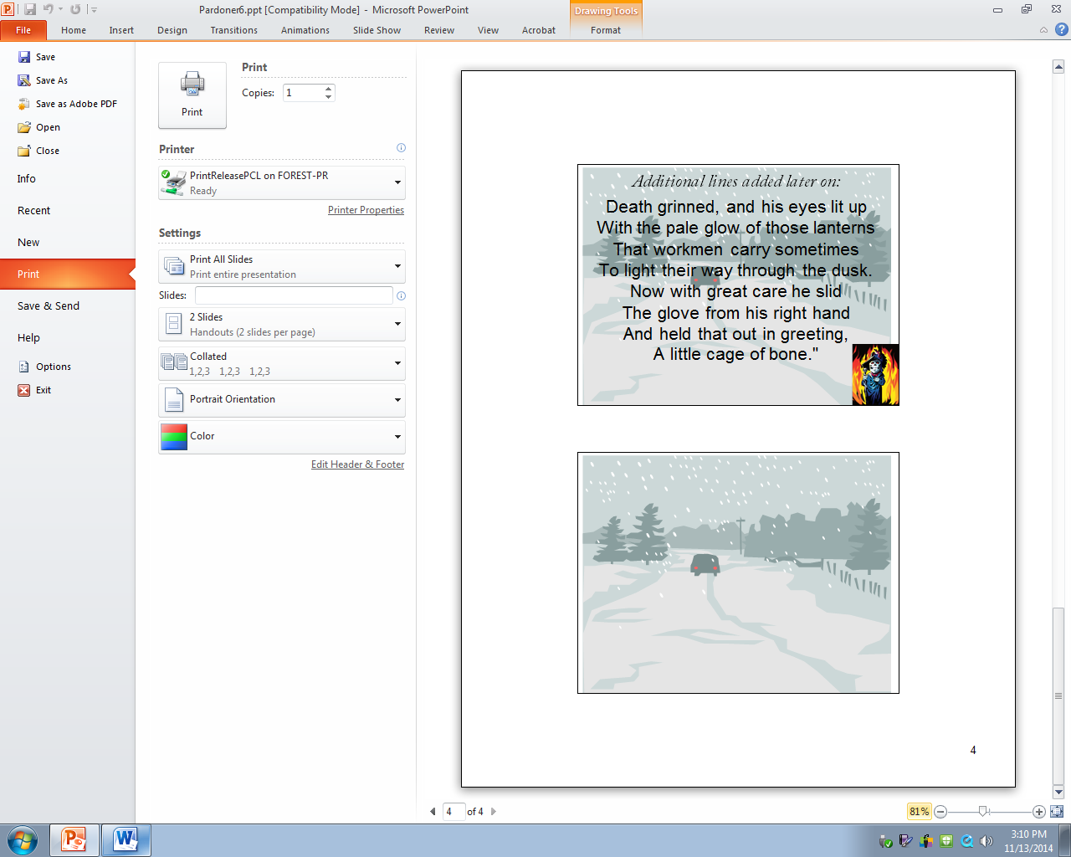

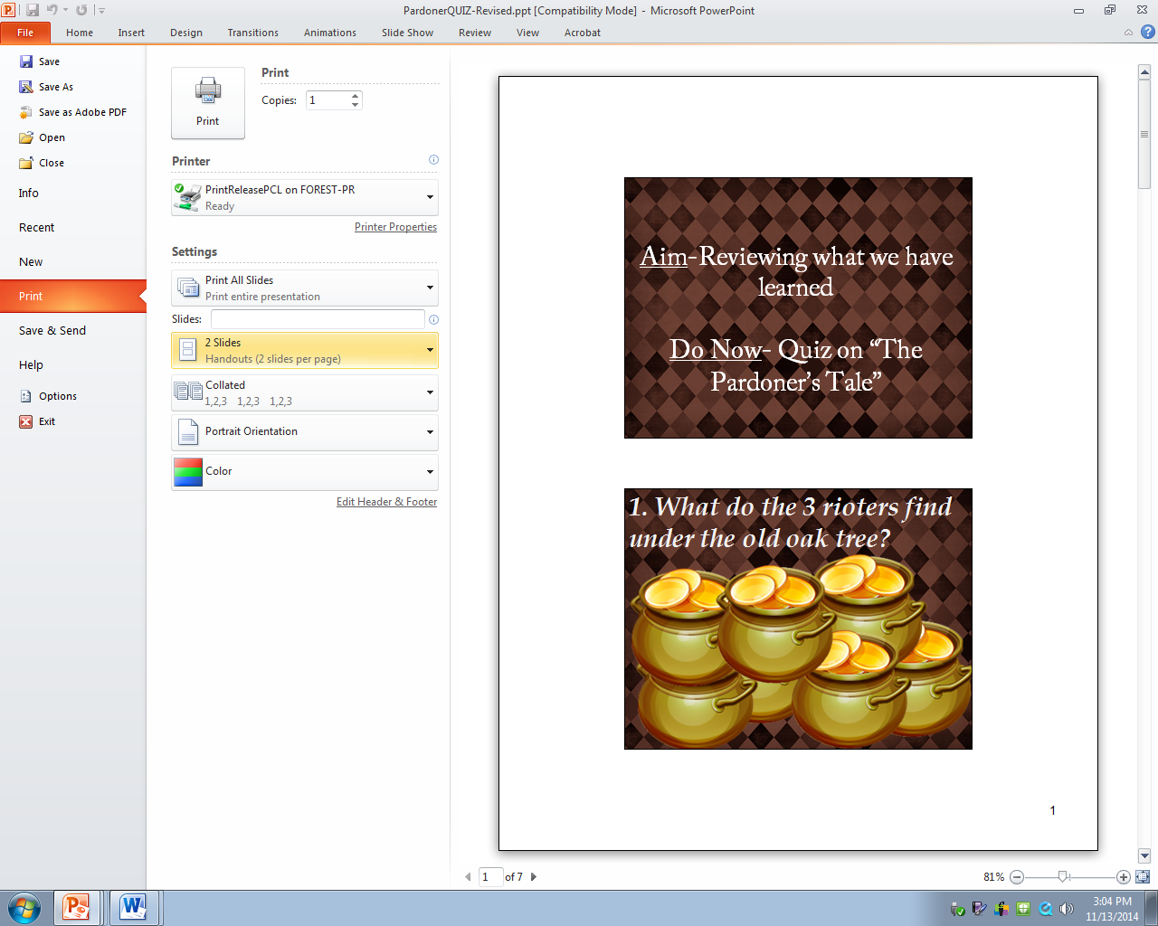

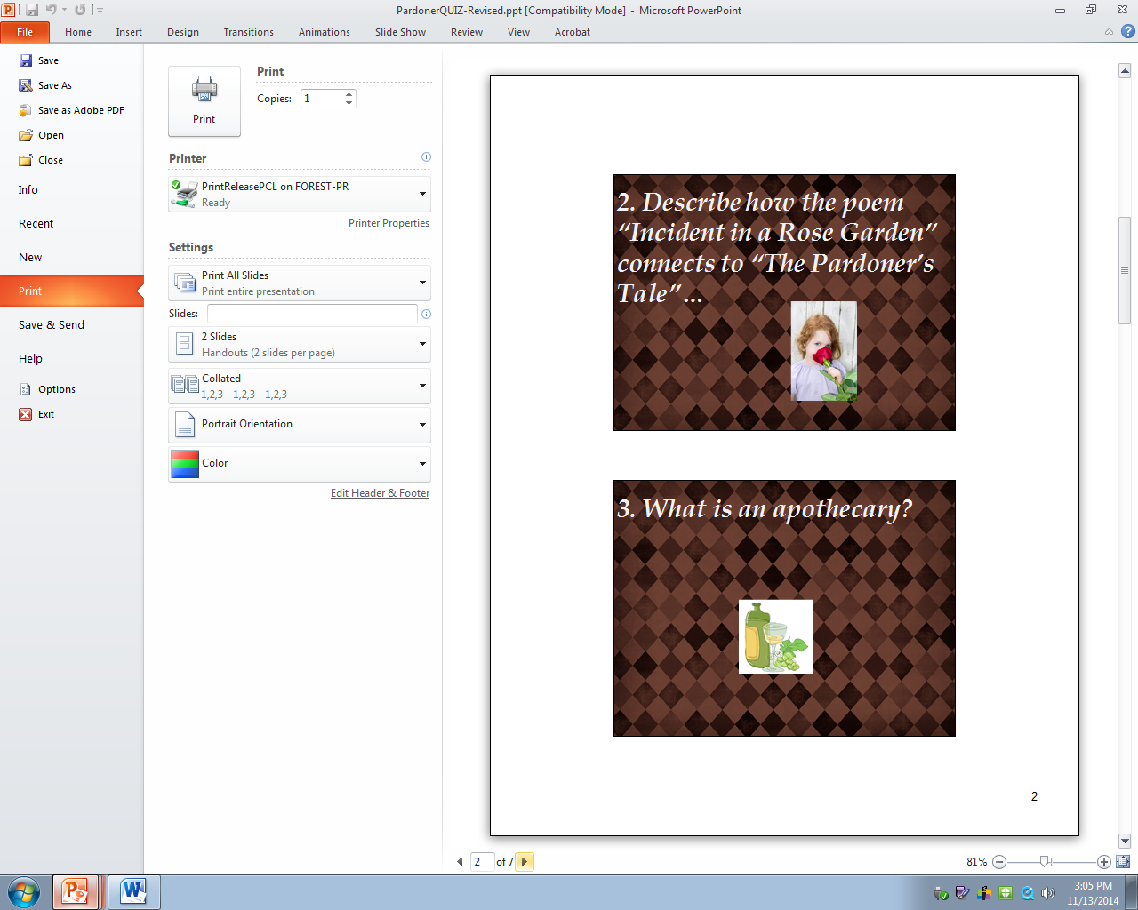

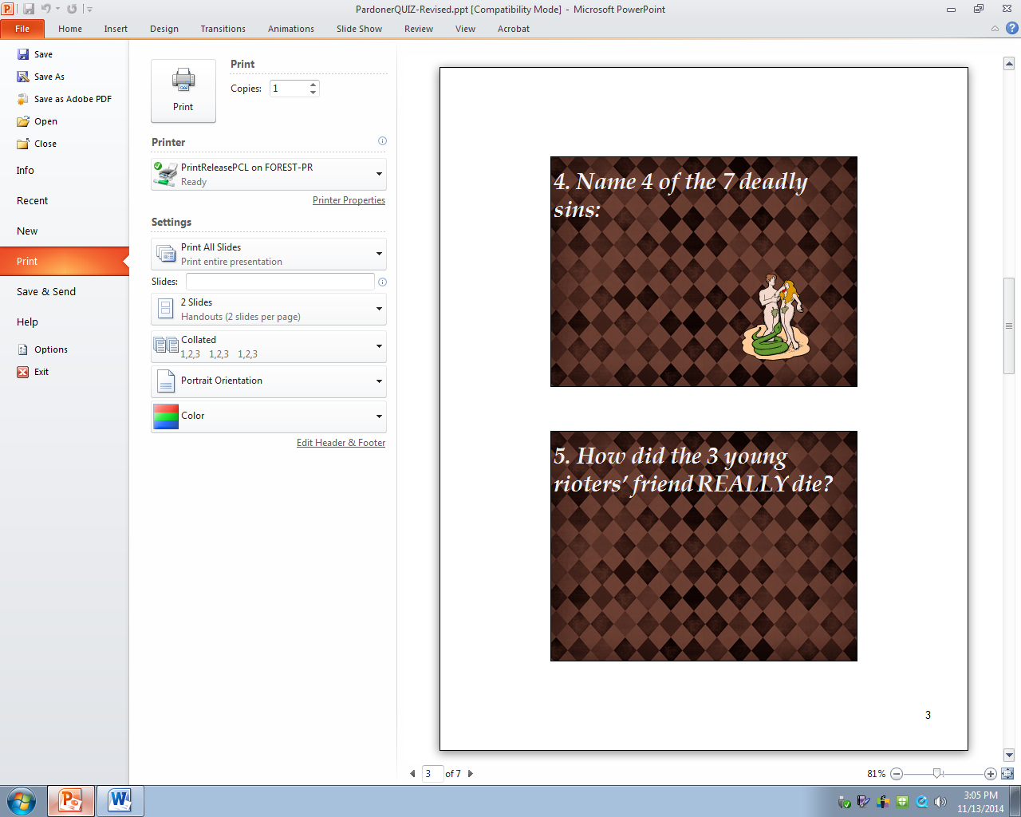

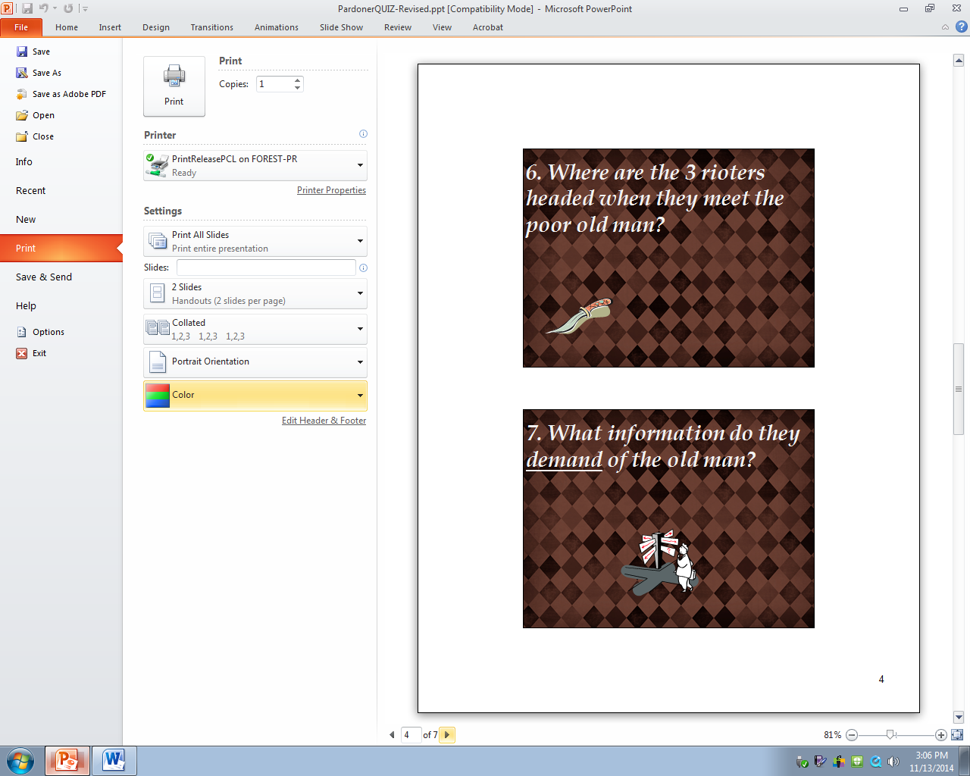

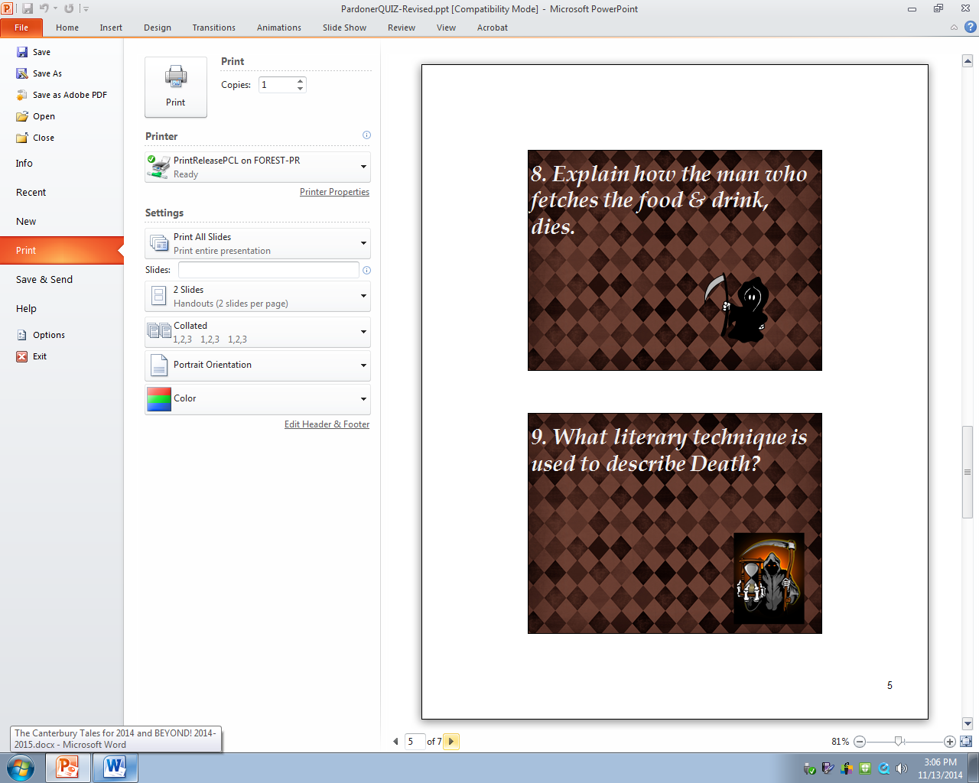

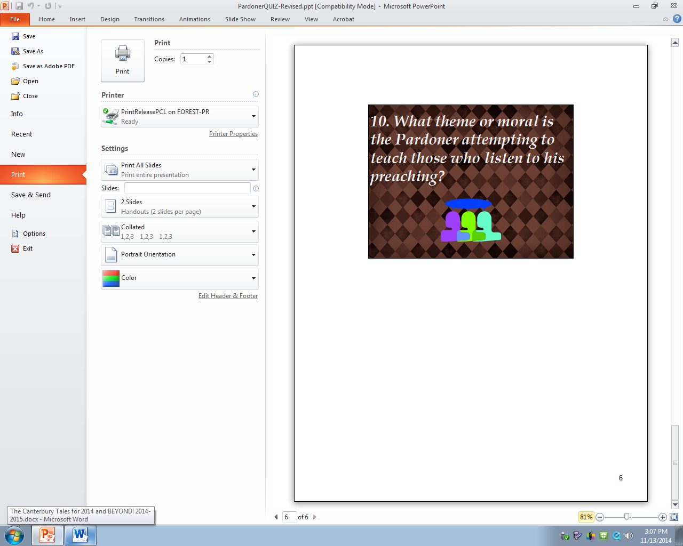

Works Cited

Angier, Natalie. “Almost Before We Spoke, We Swore.” The New York Times. September 20th 2005

Chaucer, Geoffrey. The Canterbury Tales. Penguin Classics, London: 2003

“ Geoffrey Chaucer- Biography”. BBC August 1st 2014, updated 2014

<http://www.bbc.co.uk/history/historic_figures/chaucer_geoffrey.shtml>

Justice, Donald. “Incident in a Rose Garden.” 1967

Oates, Joyce Carol. “The Deadly Sins/Despair; The One Unforgivable Sin.” The New York Times. July

25th 1993

Stossel, John. “Greed with John Stossel”. September 8th 2014, March 9th 2008

<http://stosselintheclassroom.org/resources/top_educ_titles/>

http://www.youtube.com/watch?v=F0VHiONkot8&list=PL223E81BB54E143E6