**Curriculum Area Project**

**East Meadow School District**

**Title: Grade 7 E.L.A. Aligning New York State Module 2A for Academically Challenged Students**

**Woodland Middle School and W. T. Clarke Middle School Grade 7**

**2014-2015**

**Project Facilitator: Anna Gallagher**

**Writers: Adrienne Bromberg, Carol Bracken, Susan Nicolello**

**Woodland Middle School**

**Superintendent: Mr. Louis De Angelo**

**Directors: Dr. Donald Sturz**

**Ms. Kelly O’Brien**

**Principals: Mr. James Lethbridge**

**Ms. Stacy Breslin**

**Subjects: English Language Arts 7 & 8 and Special Education**

**Table of Contents**

|  |  |
| --- | --- |
| Abstract | 5 |
| Rationale | 6 |
| Module 2A; Unit 1: Lesson 1 | 7-16 |
| Unit 1; Lesson 2 | 17-36 |
| Unit 1; Lesson 3 | 37-45 |
| Unit 1; Lesson 4 | 46-60 |
| Unit 1; Lesson 5 | 61-68 |
| Unit 1; Lesson 6 | 69-79 |
| Unit 1; Lesson 7 | 80-88 |
| Unit 1; Lesson 8 | 89-95 |
| Unit 1; Lesson 9 | 96-100 |
| Unit 1; Lesson 10 | 101-112 |
| Unit 1; Lesson 11 | 113-115 |
| Unit 1; Lesson 12 | 116-118 |
| Unit 1; Lesson 13 | 119-124 |
| Unit 1; lesson 14 | 125-137 |
| Unit 1; lesson 15 | 138-142 |
| Unit 1; Lesson 16 | 1143-153 |
| Unit 1; Lesson 17 | 154-157 |
| Unit 1; Lesson 18 | 158 |
| Unit 1; Lesson 19 | 159-167 |
| Unit 2; Lesson 1 | 168-173 |
| Unit 2; Lesson 2 | 174-182 |
| Unit 2; Lesson 3 | 183-186 |
| Unit 2; Lesson 4 | 187-188 see module |
| Unit 2; Lesson 5 | 189-191 |
| Unit 2; Lesson 6 | 192-194 |
| Unit 2; Lesson 7 | 195-196 |
| Unit 2: Lesson 8 | 197-202 |
| Unit 3; Resources | 203-213 |
| Unit 3; Lesson 1 | 214-219 |

**Abstract**

The curriculum area project *Aligning New York State Module 2A for Academically Challenged Students* is an adaptation of The New York State Grade 7 English Language Arts Module 2A. It has been developed to be used by any or all grade 7 English teachers, resource room teachers, and reading support staff who may find the adaptations appropriate for some or all of their students. The module and subsequent Curriculum Area Project incorporate New York State Learning Standards.

**Rationale**

*Aligning New York State Module 2A for Academically Challenged Students* is an adaptation of The New York State Grade 7 English Language Arts Module 2A. It is designed to facilitate struggling learners’ access to the general education curriculum (Module 2A) either fully or in part, and to be utilized at the discretion of English teachers, resource room teachers, and reading teachers as they deem appropriate.

Adaptations of the module include to varying degrees font size and type, added prompts, question omissions and additions, lesson omissions and additions, material and activity omissions and additions, and assessment adjustments and formatting.

|  |
| --- |
| **Grade 7: Module 2A: Unit 1: Lesson 1A**  **Entry Task Part I: Making Inferences**   1. **What is the setting (time and place) of this piece of evidence? How do you know?** |
|  |

**Name:_________________________________________ Date:____________________**

1. **What are you wondering about this piece of evidence?**

**____________________________________________________________________________________________________________________________________________________________________________________________________________________________________________________________________________________________________________________________________________________________**

1. **If this were a piece of a puzzle, what might the larger piece look like?**

**_______________________________________________________________________________________________________________________________________________________________________**

**Name:_______________________________________ Date:____________________**

**Grade 7: Module 2A: Unit 1: Lesson 1A**

**Entry Task Part 2: Interactive Slide Show**

|  |
| --- |
| 1. What patterns are you seeing? |
|  |

|  |
| --- |
| 2. What do you think the module is about? |
|  |

|  |
| --- |
| 3. What questions/times/places will we explore? |

Name:__________________________________________ Date:_____________________

**Grade 7: Module 2A: Unit 1: Lesson 1B**

**Chart Questions for Group Discussion**

1. Look at your piece of evidence.
2. Discuss the questions below.
3. Write your group’s ideas on the chart paper provided.

* What detail seems important to you?
* What is the setting (time and place) of this piece of evidence? How do you know?
* What are you wondering about this piece of evidence?
* What topic(s) does this relate to?

**Name:__________________________________________ Date:_____________________**

**Grade 7: Module 2A: Unit 1: Lesson 1C**

In these quotes from the text *Lyddie*, what problems and concerns are being discussed?

List problems that are being discussed

**Item 1:**

* ____________________________________________________________________________
* ____________________________________________________________________________
* ____________________________________________________________________________

**Item 2:**

* **____________________________________________________________________________**
* **____________________________________________________________________________**
* **____________________________________________________________________________**

**Item 3:**

* **___________________________________________________________________________**
* **___________________________________________________________________________**
* **___________________________________________________________________________**

**Item 4: Video**

**Compare the video with the text samples. What is different?**

* **___________________________________________________________________________**
* **___________________________________________________________________________**

**Name:__________________________________________ Date:_______________**

**Grade 7: Module 2A: Unit 1: Lesson 1D**

|  |  |  |  |
| --- | --- | --- | --- |
| **Category** | **Examples of PROBLEMS** | **Examples of FAIR WORKING CONDITIONS** | **QUESTIONS to research** |
| **Hours** |  |  |  |
| **Compensation (payment)** |  |  |  |
| **Health, Safety, and Environment (the physical place where someone works)** |  |  |  |
| **Treatment of Individual Workers (such as harassment and discrimination)** |  |  |  |
| **Treatment of Groups of Workers (unions- *organization formed by workers to protect their rights*)** |  |  |  |
| **Child and Forced Labor** |  |  |  |

**Name:___________________________________________ Date:________________________**

**Grade 7: Module 2A: Unit 1: Lesson 1D**

**Homework**

Directions: Read through the list of statements of working conditions. Decide which category each will fit into on our Working Conditions anchor chart. Choose the correct answer.

|  |
| --- |
| 1. A woman is paid less than a man even though they have the same job and an equal number of years of experience. |
| 1. hours C) health & safety 2. Treatment of individual workers D) child labor |

|  |  |  |
| --- | --- | --- |
| 1. A man works every day from 5 a.m. to 7 p.m.  |  | | --- | | 1. hours C) health & safety 2. treatment of individual workers D) child labor | |  | |

|  |  |
| --- | --- |
| 1. The owner of a company pays his workers over minimum wage.  |  | | --- | | 1. hours C) health & safety 2. treatment of individual workers D) compensation | |

|  |  |
| --- | --- |
| 1. A man is fired when he tries to meet with his fellow employees outside of work to talk about how much time off they have.  |  | | --- | | 1. compensation C) health & safety 2. treatment of groups (unions) D) child labor | |

|  |  |
| --- | --- |
| 1. One hundred people die in a shoe factory when the roof collapses.  |  | | --- | | 1. hours C) health & safety 2. treatment of individual workers D) child labor | |

|  |  |
| --- | --- |
| 1. Children younger than 10 are working in a factory sewing buttons.  |  | | --- | | 1. hours C) health & safety 2. treatment of individual workers D) child labor | |

|  |  |
| --- | --- |
| 1. A worker at a construction site develops a hearing problem because of the loud machines.  |  | | --- | | A) compensation C) health & safety  B) treatment of individual workers D) child labor | |
| 1. A woman is fired when she becomes pregnant, even though she can still   perform her job.   |  | | --- | | 1. hours C) health & safety 2. treatment of individual workers D) child labor | |

**Name:_________________________________ Date:_____________________**

**Grade 7: Module 2A: Unit 1: Lesson 2**

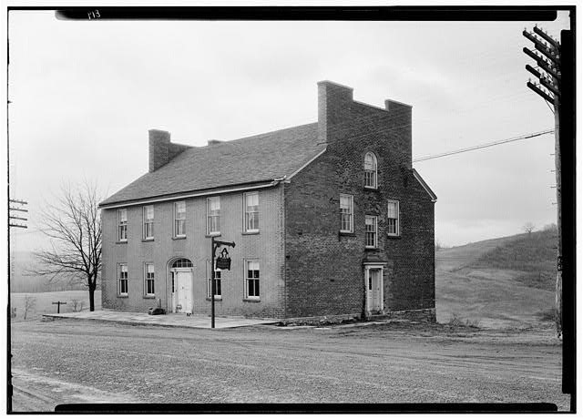**Setting A**

**Setting C**

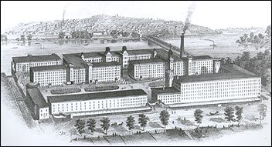

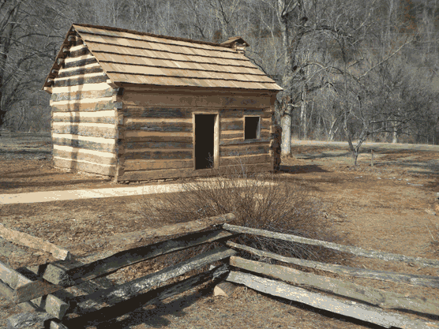**Setting B**

**Name_____________________________ Date__________________**

**Grade 7: Module 2a: Unit 1: Lesson 2**

Look carefully at the three pictures. Each picture shows a different setting in the book we are about to read. Read the descriptions of the settings in the book below. Next to each description, write the letter of the picture that matches it.

Cabin: At the beginning of the book, Lyddie lives on a farm in Vermont, with a small cabin on it.

Tavern: Next, Lyddie goes to live and work at a tavern in a village in Vermont. A tavern was a large house that served as a hotel and restaurant.

Lowell: Finally, Lyddie goes to live and work in the mills, factories that made cloth, in the town of Lowell, Massachusetts

**Name:________________________________________ Date:________________**

**Grade 7: Module 2A: Unit 1: Lesson 2**

**Reading Calendar**

The calendar below shows what is **due** on each day.

|  |  |  |
| --- | --- | --- |
| **Due at Lesson** | **Expected Due Date** | * **Read chapters listed.** * **Sometimes we will read the first part of a chapter in class, and**   **you will finish it for homework.** |
| 3 |  | 1-2 |
| 4 |  | 3-4 |
| 5 |  | 6-7 |
| 6 |  | 8 |
| 7 |  | 9-10 |
| 8 |  | 11 |
| 9 |  | 12-13 |
| 10 |  | 14 |
| 11 |  | 15-16 |
| 12 |  | 17 |
| 14 |  | 18-19 |

**Name:______________________________________________ Date:___________________**

|  |  |  |  |  |
| --- | --- | --- | --- | --- |
| **Chapter** | **Setting** | **Characters** | **Plot** | **How do setting, character, and/or plot interact?** |
| 1 |  |  |  | When Lyddie’s mother decides to go to her sister’s farm, what do Lyddie and Charlie do? What does this show about Lyddie’s relationship with her mother and her brother? |

|  |  |  |  |  |  |
| --- | --- | --- | --- | --- | --- |
| **Word/Phrase** | **Page** | **Definition** | **Word/Phrase** | **Page** | **Definition** |
| mighty | 2 | strong, big, impressive | charity | 6 | help or gifts given to people in need |
| anxious | 4 |  | beholden | 7 |  |
| queer | 5 |  |  |  |  |
| Other new words: |  |  |  |  |  |

|  |  |  |  |  |
| --- | --- | --- | --- | --- |
| **Chapter** | **Setting** | **Characters** | **Plot** | **How do setting, character, and/or plot interact?** |
| 2 |  |  |  | *What happened to Lyddie and Charlie’s father? How does that affect their plans?*      *Name two ways the Stevens family helps Lyddie and Charlie.* |

|  |  |  |  |  |  |
| --- | --- | --- | --- | --- | --- |
| **Word/Phrase** | **Page** | **Definition** | **Word/Phrase** | **Page** | **Definition** |
| dubious | 10 | doubtful or uncertain | loom | 14 | a machine that weaves thread into cloth can be run by hand or powered by a waterwheel, electricity, etc. |
| noxious | 13 | poisonous or harmful | fallow | 16 | unused |
| transaction | 14 |  | gaping | 17 |  |
| Other new words: |  |  |  |  |  |

Grade 7: Module 2A: Unit 1: Lesson 2

***Lyddie* Reader’s Notes, Chapter 1**

**Teacher’s Edition (for Teacher Reference)**

|  |  |  |  |  |
| --- | --- | --- | --- | --- |
| **Chapter** | **Setting** | **Characters** | **Plot** | **How do setting, character, and/or plot interact?** |
| 1 | Farm in Vermont, 1843 | Lyddie (13)  Her family:  Charlie, (10)  Rachel (6)  Agnes (4)  Mama  Bear  Clarissa and Judah | A bear comes into the cabin, and Lyddie keeps her family safe.  Mama, Rachel, and Agnes leave to live with Judah and Clarissa.  Lyddie and Charlie take care of themselves through the winter. They have a calf in the spring. Lyddie feels very hopeful.  Mama sends them a letter saying they must both go and work to pay off the debts on the farm. The farm is going to be rented to someone else. Lyddie is crushed. | *When Lyddie’s mother decides to go to her sister’s farm, what do Lyddie and Charlie do? What does this show about Lyddie’s relationship with her mother and with her brother?*  Lyddie decides to stay and take care of the farm against her mother’s wishes. This shows that Lyddie is very independent and her relationship with her mother is not typical. Because her mother is mentally unstable, Lyddie is the mother figure of the family.  Charlie decides to stay with Lyddie because he doesn’t want her to be alone on the farm. This shows they have a caring and close relationship. |

|  |  |  |  |  |  |
| --- | --- | --- | --- | --- | --- |
| **Word/Phrase** | **Page** | **Definition** | **Word/Phrase** | **Page** | **Definition** |
| mighty | 2 | strong, big, impressive | charity | 6 | help or gifts given to people in need |
| anxious | 4 | worried | beholden | 7 | to feel you have a duty to someone because they have done something for you |
| queer | 5 | strange, difficult to explain; “queer in the head” means slightly crazy |  |  |  |
| Other new words: |  |  |  |  |  |

|  |  |  |  |  |
| --- | --- | --- | --- | --- |
| **Chapter** | **Setting** | **Characters** | **Plot** | **How do setting, character, and/or plot interact?** |
| 2 | Lyddie’s farm in Vermont  The Stevens family farm | Lyddie  Charlie  The Stevens family (the Quaker family that lives next door): Mr. Stevens, Mrs. Stevens, sons, youngest son—Luke Stevens | Lyddie and Charlie decide to sell the calf to Mr. Stevens and save the money for their return to the farm.  Mr. Stevens gives them a good price for the calf, even though it was from his bull. He invites them to dinner and offers them a ride to the village.  While Luke is giving them a ride to the village, he offers to look after their house. Lyddie does not want to accept their help, but Charlie is grateful. Luke then tells Lyddie he’ll look after Charlie. | *What happened to Lyddie and Charlie’s father? How does that affect their plans?*  Their father was very unlucky. He made some bad business decisions but always worked hard. He left but promised to come back. Lyddie and Charlie want the farm to be successful when he comes back, so they save the money from the calf.  Name two ways the Stevens family helps Lyddie and Charlie.  Mr. Stevens give them a good price for the calf, even though it was from his bull.  Luke offers to look after their farm while they are gone.  Luke offers to look out for Charlie. |

|  |  |  |  |  |  |
| --- | --- | --- | --- | --- | --- |
| **Word/Phrase** | **Page** | **Definition** | **Word/Phrase** | **Page** | **Definition** |
| dubious | 10 | doubtful or uncertain | loom | 14 | a machine that weaves thread into cloth can be run by hand or powered by a waterwheel, electricity, etc. |
| noxious | 13 | poisonous or harmful | fallow | 16 | unused |
| transaction | 14 | business deal or action | gaping | 17 | very big and wide |
| Other new words: |  |  |  |  |  |

**Name_____________________________________________ Date___________________**

**Grade 7: Module 2a: Unit 1: Lesson 2: *Text Dependent Questions***

|  |  |  |  |  |  |
| --- | --- | --- | --- | --- | --- |
| **Questions** | | | **Answers** | | |
| 1. At the bottom of page 2, a sentence says: “Could he, in his frustration, take a *mighty* leap?” *Mighty* is a word that is in your Reader’s Dictionary (part of the Reader’s Notes). Find this entry in the dictionary. Use the definition to restate this sentence using a different word. | | |  | | |
| 2. Lyddie is the main character in this book. What have we learned about Lyddie from this story? | | |  | | |
| **Continue to use your Reader’s Dictionary as you answer these questions.** | | | | | |
| 3. On page 5, Lyddie describes her mother as “*queer* in the head.” What does *queer* mean? How do context clues help you figure it out? What word(s) might we use today to describe Lyddie’s mother? | | |  | | |
| 1. On page 6, the text states: “The only *charity* Lyddie dreaded more than Aunt Clarissa’s …” Use your Reader’s Dictionary to figure out what the word *charity* means. Then restate the sentence using a different word. How do we use the word *charity* today? How is this similar and different to how it is being used here? | | |  | | |
| 1. On page 7, the text says: “She minded mightily being *beholden*.” Notice the word *mightily*, which is the adverb form of *mighty*. What does *beholden* mean? How can you tell? What is the connection between *charity* and *beholden*? | | |  | | |
| **Questions** | | | **ANSWERS**  **Teacher Guide to Unit 1: Lesson 2: Text Dependent Questions** | | |
| 1. At the bottom of page 2, a sentence says: “Could he, in his frustration, take a *mighty* leap?” *Mighty* is a word that is in your Reader’s Dictionary (part of the Reader’s Notes). Find this entry in the dictionary. Use the definition to restate this sentence using a different word. | | | **(10 minutes)**   * Say to students: “Read in your heads while I read along with you aloud.” * Read pages 1–3 without pausing for questions. Let them hear the whole story of the bear without interruption. * After you have read these three pages, pause. * Ask the questions one at a time. For each question, ask students to think individually, skim the pages you just read aloud, and then raise their hands when they have an answer. When most of the class has a hand up, cold call several students to share out. * Listen for students to say:   1. (something like) Could he make a big jump?  2. Lyddie is in charge; Lyddie is brave; Lyddie is calm under pressure; Lyddie doesn’t want to disagree with her mother; Lyddie doesn’t have much money.   * Probing and scaffolding for Question 2:   + (For accurate but unsupported claims)   + “What in the story makes you say that?”   + (For students who are stuck)   + “Why did Lyddie tell everyone else what to do?”   + “Why did she go up the ladder last?” * Point out to students how rereading was helpful to them. Remind them that good readers often reread. | | |
| 1. Lyddie is the main character in this book. What have we learned about Lyddie from this story? | | |
| **Questions** | | **Teacher Guide** | | |
| 3. On page 5, Lyddie describes her mother as “*queer* in the head.” What does *queer* mean? How do context clues help you figure it out? What word(s) might we use today to describe Lyddie’s mother?  4. On page 6, the text states: “The only *charity* Lyddie dreaded more than Aunt Clarissa’s …” Use your Reader’s Dictionary to figure out what the word *charity* means. Then restate the sentence using a different word. How do we use the word *charity* today? How is this similar and different to how it is being used here?  5. On page 7, the text says: “She minded mightily being *beholden*.” Notice the word *mightily*, which is the adverb form of *mighty*. What does *beholden* mean? How can you tell? What is the connection between *charity* and *beholden*? | | **(10 minutes)**  Say to students: “Read silently in your heads as I read aloud.” Read from the bottom of page 3 to near the end of page 7 (break) aloud.  Consider pausing and rereading two or three paragraphs to model this strategy for the class. Reread the third paragraph on page 4 (“Her mother’s shoulders …”) and the third paragraph on page 6 (“She sent Charles along …”)  When you do this, think out loud about why you are rereading. You might say something like: “I’m a little confused here about what is happening with Lyddie’s mom. Everyone else was laughing, but that last sentence about Lyddie praying that she was laughing made me pause. I’m going to reread it to see if I can figure out what is going on.”  As you read aloud, pause at the end of each paragraph for which a question is written at left. Post the question and ask students to work on it with their seat partners. Direct them to reread the paragraph where the vocabulary word is found.  Note that all of the questions relate to vocabulary and are designed to help students use their Reader’s Dictionary correctly. For some questions, students are practicing using a given definition to restate an idea in their own words. For other questions, students are using context clues to determine the meaning of a word. Remind students to use clues both in the sentence itself and on the page (reading forward and backward) to figure out what words mean.  After students have briefly discussed a question with a partner, choose one or two pairs to share out, with a focus on making sure students hear clear and accurate thinking.  After each discussion, prompt students to make sure the entry in their Reader’s Dictionary is correct. | | |

|  |  |
| --- | --- |
| **Questions** | **Teacher Guide** |
|  | Listen for students to say:  3. Lyddie’s mother is a little unbalanced or not in touch with reality; the text refers to her as dazed, says she is “not so strange”; she doesn’t respond to Lyddie when she talks; “her spirit had gone away.”  4. (something like) The only help Lyddie didn’t want more than her aunt’s was to go to the town’s poor farm; today we use *charity* to mean an organization that helps people and to which we often give donations; it still has the meaning of helping, but now we use it more for an organization, and then it was used more for an idea.  5. Charlie just said she should ask neighbors for help, and she thinks she won’t be beholden, so *beholden* must have to do with getting help from someone and feeling like you owe them; so Lyddie might feel beholden if she takes charity from the neighbors. |

Name___________________________________________ Date_____________________ **Grade 7: Module 2A: Unit 1: Lesson 3: Reader’s Notes**

|  |  |  |  |  |
| --- | --- | --- | --- | --- |
| **Chapter** | **Setting** | **Characters** | **Plot** | **How do setting, character, and/or plot interact?** |
| 3 |  |  |  | *What do Triphena and Mistress Cutler think of Lyddie when she arrives?*    *What are the working conditions like in the tavern* |

Name:__________________________________________ Date:____________________________

**Grade 7: Module 2a: Unit 1: Lesson 3: Reader’s Notes Chapter 3,4, 5**

**Reader’s Dictionary, Chapter 3**

|  |  |  |  |  |  |
| --- | --- | --- | --- | --- | --- |
| **Word/Phrase** | **Page** | **Definition** | **Word/Phrase** | **Page** | **Definition** |
| tavern | 18 | A bar/restaurant that also has hotel rooms | servitude | 23 |  |
| homespun | 20 |  | comrade | 25 |  |
| garment | 23 |  |  |  |  |
| Other new words: |  |  |  |  |  |

**Name:_______________________________________ Date:____________________________**

**Grade 7: Module 2A: Unit 1: Lesson 3**

***Lyddie* Reader’s Notes, Chapter 4**

|  |  |  |  |  |
| --- | --- | --- | --- | --- |
| **Chapter** | **Setting** | **Characters** | **Plot** | **How do setting, character, and/or plot interact?** |
| 4 |  |  |  | *Describe Lyddie’s relationship with Triphena.*    *When Charlie comes to visit, how does Lyddie react?*    *How does spring change the work being done at the tavern?* |

**Reader’s Dictionary, Chapter 4**

|  |  |  |  |  |  |
| --- | --- | --- | --- | --- | --- |
| **Word/Phrase** | **Page** | **Definition** | **Word/Phrase** | **Page** | **Definition** |
| mean | 27 |  | anxieties | 31 |  |
| secretive | 29 |  | practiced skill | 32 |  |
| calicoes | 29 | lightweight cotton fabrics | fugitive | 33 |  |
| Other new words: |  |  |  |  |  |

***Lyddie* Reader’s Notes, Chapter 5**

*Note: We may not read Chapter 5 in detail. Therefore, the Reader’s Notes for this chapter are already partially completed for you.*

|  |  |  |  |  |
| --- | --- | --- | --- | --- |
| **Chapter** | **Setting** | **Characters** | **Plot** | **How do setting, character, and/or plot interact?** |
| 5 | * tavern * the road home to Lyddie’s cabin * Lyddie’s cabin | * Triphena * Lyddie * the woman whom Charlie is staying with—the Phinneys | Triphena tells Lyddie to take a vacation while the mistress is away. Lyddie decides to go to her cabin. Along the way, she stops to see Charlie. She’s disappointed because he isn’t home. However, the woman (Mrs. Phinney) is very kind to her. True to her independent nature, Lyddie refuses to stay for dinner and hurries on to the cabin. She wonders if Charlie thinks of these people as his new family. | *What events make it possible for Lyddie to visit the cabin? What does she plan to do there?*  Because the mistress has gone to Boston, Lyddie can take a vacation. She plans to bury her calf money there.  *How does Lyddie feel when she finds out Charlie is at school?*  She’s very disappointed. She also feels protective of Charlie and jealous of his relationship with this new family. |

***Lyddie* Reader’s Notes, Chapter 5**

**Reader’s Dictionary, Chapter 5**

|  |  |  |  |  |  |
| --- | --- | --- | --- | --- | --- |
| **Word/Phrase** | **Page** | **Definition** | **Word/Phrase** | **Page** | **Definition** |
| envious | 37 | jealous |  |  |  |
| mortified | 37 | extremely embarrassed |  |  |  |
| Other new words: |  |  |  |  |  |

***Lyddie* Reader’s Notes, Chapter 3: Answers**

**(Teacher Reference)**

|  |  |  |  |  |
| --- | --- | --- | --- | --- |
| **Chapter** | **Setting** | **Characters** | **Plot** | **How do setting, character, and/or plot interact?** |
| 3 | Cutler’s Tavern | Lyddie  the mistress (Mistress Cutler)  Triphena—the cook | Lyddie arrives at the tavern and is amazed by the things she sees: the huge building, a stagecoach, a woman dressed in a very fine dress, the kitchen.  Lyddie feels out of place because she’s dressed so poorly and the women are rude to her. | *What do Triphena and Mistress Cutler think of Lyddie when she arrives?*  Because Lyddie is dirty and dressed in her homemade clothes, Mistress Cutler mistakes her for a beggar. Triphena says she is ugly.  *What are the working conditions like in the tavern?* |

**Reader’s Dictionary, Chapter 3: Answers**

|  |  |  |  |  |  |
| --- | --- | --- | --- | --- | --- |
| **Word/Phrase** | **Page** | **Definition** | **Word/Phrase** | **Page** | **Definition** |
| tavern | 18 | A bar/restaurant that also has hotel rooms | servitude | 23 | being forced to obey someone else |
| homespun | 20 | made at home | comrade | 25 | friend, especially someone who shares difficult work or circumstances |
| garment | 23 | a piece of clothing |  |  |  |
| Other new words: |  |  |  |  |  |

|  |  |  |  |  |
| --- | --- | --- | --- | --- |
| **Chapter** | **Setting** | **Characters** | **Plot** | **How do setting, character, and/or plot interact?** |
| 4 |  |  |  | *Describe Lyddie’s relationship with Triphena.*    *When Charlie comes to visit, how does Lyddie react?*    *How does spring change the work being done at the tavern?* |

***Lyddie*** Reader’s Notes, Chapter 4

Teacher Reference

**Reader’s Dictionary, Chapter 4**

|  |  |  |  |  |  |
| --- | --- | --- | --- | --- | --- |
| **Word/Phrase** | **Page** | **Definition** | **Word/Phrase** | **Page** | **Definition** |
| mean | 27 | not generous; stingy | anxieties | 31 | Worries |
| secretive | 29 | keeping one’s thoughts, actions or intentions hidden | practiced skill | 32 | special skill or knowledge you learn by training or experience |
| calicoes | 29 | lightweight cotton fabrics | fugitive | 33 | someone who is hiding from the authorities |
| Other new words: |  |  |  |  |  |

***Lyddie* Reader’s Notes, Chapter 5**

(Teacher Reference)Answers

|  |  |  |  |  |
| --- | --- | --- | --- | --- |
| **Chapter** | **Setting** | **Characters** | **Plot** | **How do setting, character, and/or plot interact?** |
| 5 | tavern  the road home to Lyddie’s cabin  Lyddie’s cabin | Triphena  Lyddie  the woman whom Charlie is staying with—the Phinneys | Triphena tells Lyddie to take a vacation while the mistress is away. Lyddie decides to go to her cabin. Along the way, she stops to see Charlie. She’s disappointed because he isn’t home. However, the woman (Mrs. Phinney) is very kind to her. True to her independent nature, Lyddie refuses to stay for dinner and hurries on to the cabin. She wonders if Charlie thinks of these people as his new family. | *What events make it possible for Lyddie to visit the cabin? What does she plan to do there?*  Because the mistress has gone to Boston, Lyddie can take a vacation. She plans to bury her calf money there.  *How does Lyddie feel when she finds out Charlie is at school?*  She’s very disappointed. She also feels protective of Charlie and jealous of his relationship with this new family. |

**Reader’s Dictionary, Chapter 5**

|  |  |  |  |  |  |
| --- | --- | --- | --- | --- | --- |
| **Word/Phrase** | **Page** | **Definition** | **Word/Phrase** | **Page** | **Definition** |
| envious | 37 | jealous |  |  |  |
| mortified | 37 | extremely embarrassed |  |  |  |
| Other new words: |  |  |  |  |  |

Name____________________________________ Date_________________

Grade 7: Module 2a: Unit 1: Lesson 4:

***Check for Understanding******Entry Task****:*

*Chapters 3 & 4*

Use your Reader’s Notes from Chapters 3 and 4 of *Lyddie* to answer the questions below.

|  |
| --- |
| When Lyddie arrives at the tavern, she stands outside for a minute, thinking. “Once I walk in that gate, I ain’t free anymore.… No matter how handsome the house, once I enter I’m a servant girl” (18). Is this really true? What does Lyddie mean by this? Provide evidence for your answer. |
|  |
|  |
| Who comes to visit Lyddie? How does she feel after he leaves? Why? *(pgs. 29-31)* |
|  |
|  |
| Two men come to the inn. What do Lyddie and Triphena overhear them talking about? *(pgs. 32-33)* |
|  |
|  |
|  |
|  |

Name____________________________________________ Date___________________

Grade 7: Module 2a: Unit 1: Lesson 4: Reader’s Notes Chapters 6 & 7

|  |  |  |  |  |
| --- | --- | --- | --- | --- |
| **Chapter** | **Setting** | **Characters** | **Plot** | **How do setting, character, and/or plot interact?** |
| 6 |  |  |  | *Who is Ezekial, and what is he doing in Lyddie’s cabin?*  *How does the mistress of the tavern respond to Lyddie when she returns?* |

**Name:__________________________________________ Date:_____________________________**

**Grade 7: Module 2A: Unit 1: Lesson 4**

**Reader’s Dictionary, Chapter 6**

|  |  |  |  |  |  |
| --- | --- | --- | --- | --- | --- |
| Word/Phrase | Page | Definition | Word/Phrase | Page | Definition |
| manufacture | 39 | make or create | penniless | 42 |  |
| intrusion, intruder | 40 |  | grimaced | 44 | twisted her face to express an emotion |
| conveyed | 40 |  | impertinent | 44 |  |
| notions | 41 | ideas | burden | 44 |  |
| Other new words: |  |  | snare | 43 |  |

|  |  |  |  |  |
| --- | --- | --- | --- | --- |
| **Chapter** | **Setting** | **Characters** | **Plot** | **How do setting, character, and/or plot interact?** |
| 7 |  |  |  | *What does Lyddie think of the other passengers in the stagecoach? Why?*    *How does Lyddie help the stagecoach driver? How does he help her?* |

**Reader’s Dictionary, Chapter 7**

|  |  |  |  |  |  |
| --- | --- | --- | --- | --- | --- |
| **Word/Phrase** | **Page** | **Definition** | **Word/Phrase** | **Page** | **Definition** |
| obliged | 47 |  | Stout | 50 |  |
| alight | 49 | get down from | boardinghouse | 51 | a house in which the owner rents places to sleep and provides food |
| hapless | 49 |  | foreboding | 51 | giving a feeling that something bad will happen |
| Other new words: |  |  |  |  |  |

Name________________________________________ Date________________

Grade 7: Module 2A: Unit 1: Lesson 4: *Chapter 6: Text Dependent Questions*

|  |  |
| --- | --- |
| **Questions** | **Answers** |
| The text says: “‘It was half the Stevenses’ calf by rights,’ she said, trying to *diminish* for both of them the enormity (huge deal) of what she had done” (43).  Using context clues, what does the word *diminish* mean?  What word does “enormity” make you think of? | ________________________________________________________________________________________________________________________________  ________________________________________________________________________________________________________________________________  ________________________________________________________________________________________________________________________________  ________________________________________________________________________________________________________________________________  ________________________________________________________________________________________________________________________________  ________________________________________________________________________________________________________________________________ |
| “She felt leaden with sadness” (43).  What does the word leaden mean? How do you know?  What is making her feel “leaden with sadness”? | ________________________________________________________________________________________________________________________________  ________________________________________________________________________________________________________________________________  ________________________________________________________________________________________________________________________________  ________________________________________________________________________________________________________________________________ |
| Why did Lyddie give Ezekial the money?  What character trait(s) does this show? | ________________________________________________________________________________________________________________________________  ________________________________________________________________________________________________________________________________  ________________________________________________________________________________________________________________________________  ________________________________________________________________________________________________________________________________ |
| Select one person to be Lyddie and one person to be Ezekial. Practice reading the dialogue on page 43. You should use what you have learned from this close read to bring the characters to life. Your voices should convey the feelings and thoughts of the characters. | ________________________________________________________________________________________________________________________________  ________________________________________________________________________________________________________________________________  ________________________________________________________________________________________________________________________________  ________________________________________________________________ |

***Teacher Reference: Chapter 6: Text Dependent Questions/Answers***

|  |  |
| --- | --- |
| Questions | Answers |
| 1. The text says: “‘It was half the Stevenses’ calf by rights,’ she said, trying to diminish for both of them the enormity of what she had done” (43).   How do context clues help you figure out the meaning of the word diminish? | (7 minutes)  Direct the students to do Questions 1 and 2 with their partners. Invite the students to look back in the text to find the selections. Remind them to use clues both in the sentence itself and on the page (reading forward and backward) to figure out what words mean.  Pause after Question 2 to have some students share out their answers. Encourage them to correct their worksheets.  Listen for students to say:   1. Diminish means “to make smaller,” and enormity means “seriousness.” This helps us infer that the characters were both feeling embarrassed by Lyddie’s huge act of generosity. |
| “She felt leaden with sadness” (43).  What does the word leaden mean? How do you know?  What is making her feel “leaden with sadness”? | 2. Leaden means “weighed down.” Point out the root, lead, and how that contributes to the meaning of the word. Interestingly, it is when Lyddie realizes how far she and Charlie are from coming back to the farm that she feels sad. |

|  |  |
| --- | --- |
| Questions | Answers |
| Why did Lyddie give Ezekial the money?  What character trait(s) does this show? | (5 minutes)  Direct the students to complete Question 3. Call on several students to share. Use the probing questions to further develop the students’ understanding of the interaction of these two characters.  Listen for students to say: She gave him the money because she is generous, empathetic, committed to freedom, kind, etc.  Probing questions:  * “Does Lyddie have anything in common with Ezekial?”  * “Has Lyddie thought about freedom? |
| Select one person to be Lyddie and one person to be Ezekial. Practice reading the dialogue on page 43. You should use what you have learned from this close read to bring the characters to life. Your voices should convey the feelings and thoughts of the characters. | (5 minutes)  Remind the students to use their “6-inch” voice for this exercise. After the pairs have had a chance to practice, you may ask one pair to share their reading with the class. Invite the class to comment. |

Name_____________________________________________ Date_________________________

**Grade 7: Module 2A: Unit 1: Lesson 5**

Check for Understanding Entry Task: Chapters 6 & 7

Use your Reader’s Notes from Chapters 6 and 7 of *Lyddie* to answer the questions below.

|  |
| --- |
| 1. How does Lyddie react to being fired? Why? (*pgs. 44-45*) |
|  |
|  |
|  |
|  |

|  |
| --- |
| 1. The stagecoach driver calls Lyddie “a little chip of Vermont granite” (pg. *5 )* Granite is a type of rock. What does the driver mean when he says she’s like a rock? What happened in the chapter to make him say that? |
|  |
| *___* |
|  |

Name_____________________________________ Date________________

Grade 7: Module 2A: Unit 1: Lesson 5

Model Acrostic Poem

|  |  |
| --- | --- |
| C- caring | (he tells Lyddie not to worry about him) |
| H- honest | (he reminded Mr. Stevens the calf was half his) |
| A- able to laugh even when times are difficult | (he finds humor in the upsetting letter from Mama) |
| R- ready to take on adult responsibilities | (he takes Mama to the coach, sells the pig, and returns) |
| L- loves and trusts Lyddie | (he wanted to stay with her at the farm) |
| I-industrious | (he works hard on the farm and in the mill) |
| E- enjoying the opportunity to go to school | (the family at the mill sends him to school) |

Name_____________________________________________ Date______________

Grade 7: Module 2A: Unit 1: Lesson 5

Model Acrostic Poem

Planning Your Poem

Who is Lyddie?

|  |  |
| --- | --- |
| Strengths | Weaknesses |
|  |  |
| Hardships | Hopes |
|  |  |

Name______________________________ ______________ Date_________________

Grade 7: Module 2A: Unit 1: Lesson 5

Reader’s Notes Chapter 8

|  |  |  |  |  |
| --- | --- | --- | --- | --- |
| **Chapter** | **Setting** | **Characters** | **Plot** | **How do setting, character, and/or plot interact?** |
| 8 |  |  |  | *What does Amelia want Lyddie to do on the Sabbath? Why? How does Lyddie feel about this?*  *How does Mrs. Bedlow help Lyddie?* |

**Reader’s Dictionary, Chapter 8**

|  |  |  |  |  |  |
| --- | --- | --- | --- | --- | --- |
| **Word/Phrase** | **Page** | **Definition** | **Word/Phrase** | **Page** | **Definition** |
| din | 55 |  | complex | 58 |  |
| distress | 56 |  | imposing | 59 |  |
| conscientious | 57 |  | broadside | 60 | a sheet of paper printed on one or both sides; like a brochure but not folded |
| Other new words: |  |  |  |  |  |

**Reader’s Dictionary, Chapter 8: teacher’s Notes**

|  |  |  |  |  |  |
| --- | --- | --- | --- | --- | --- |
| **Word/Phrase** | **Page** | **Definition** | **Word/Phrase** | **Page** | **Definition** |
| din | 55 | a loud noise that goes on for a long time | complex | 58 | group of buildings |
| distress | 56 | unhappiness or worry | imposing | 59 | large, impressive |
| conscientious | 57 | very thorough in fulfilling responsibilities | broadside | 60 | a sheet of paper printed on one or both sides; like a brochure but not folded |
| Other new words: |  |  |  |  |  |

Name: ____________________________

Grade 7: Module 2A: Unit 1: Lesson 6

**Chapter 8 Entry Task**

Use your Reader’s Notes from Chapter 8 of *Lyddie* to answer the questions below.

List two things Lyddie appreciates or likes and two things she does not like about living in the boardinghouse.

|  |
| --- |
| *Lyddie likes* |
|  |
|  |
| *Lyddie does NOT like* |
|  |
|  |

Pictures for Entry Task for Lesson 6

**Picture A**

Kyle Von Kamp. Used with permission for

educational purposes.

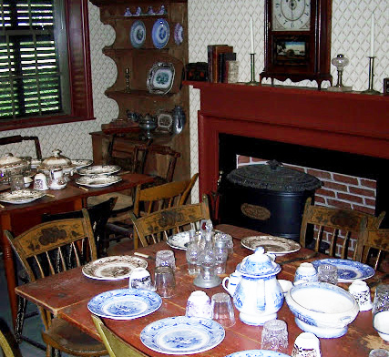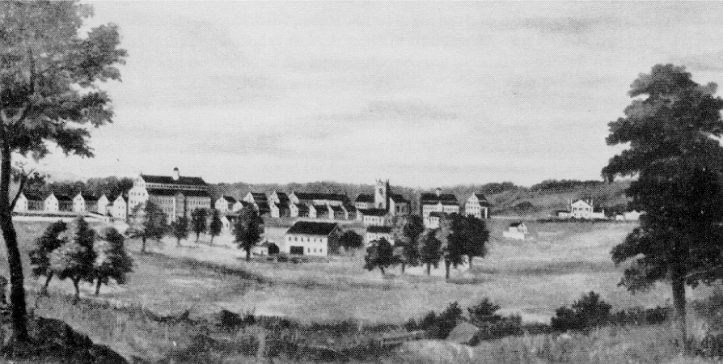

**Picture B**

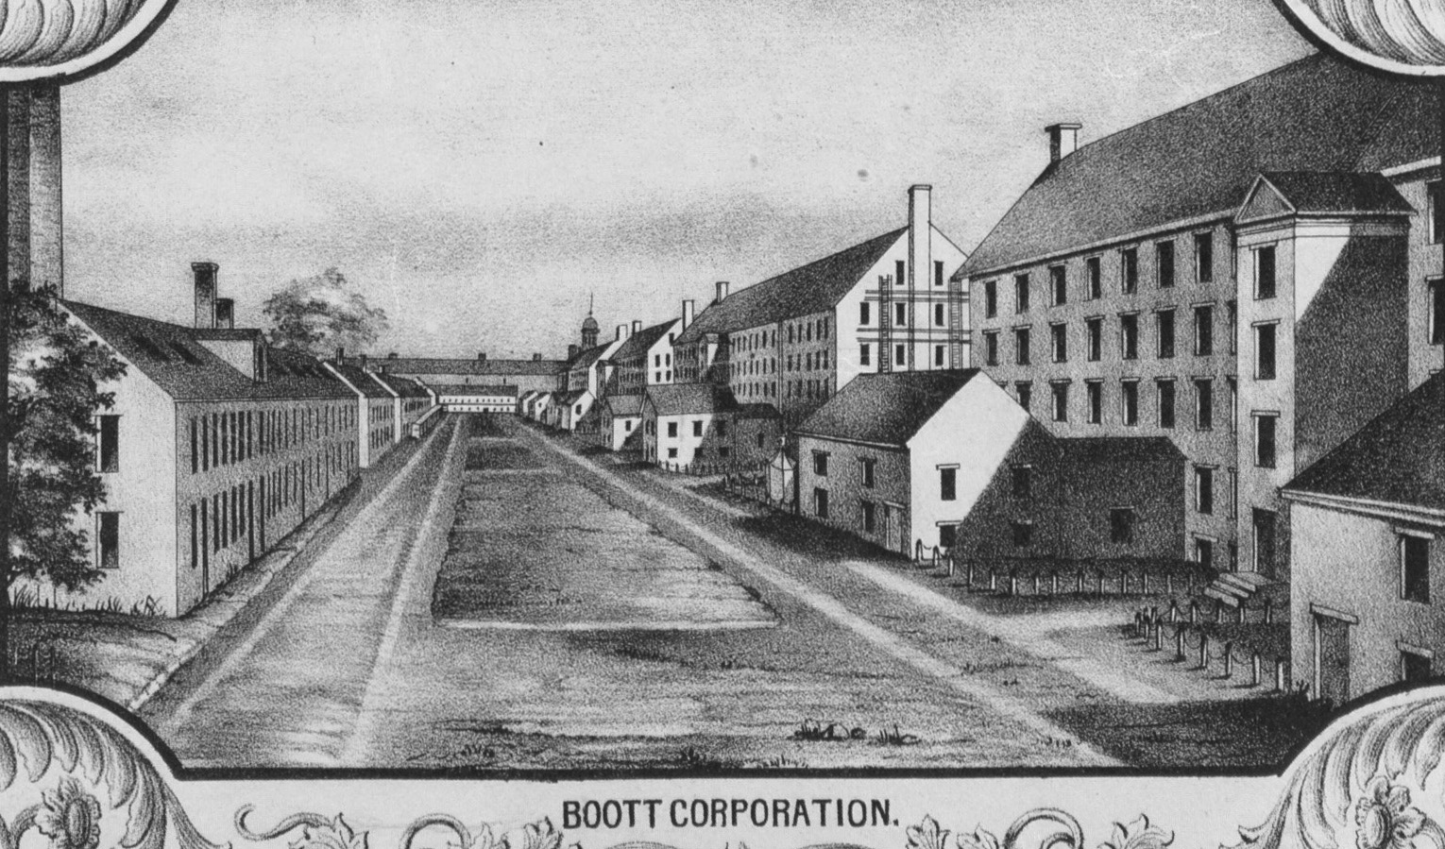Lowell in 1825, from left to right, Lowell Machine Shop, St. Anne’s Church, Merrimack Manufacturing Company and Kirk Boott’s mansion. Whistler House Museum of Art Collection

Picture C

Detail from “Plan of the City of Lowell, Massachusetts” by

Sidney & Neff, 1850.

Public Domain http://maps.bpl.org/id/1105

Name:____________________________________________ Date:_____________________________

Grade 7: Module 2A: Unit 1: Lesson 6

**Chapter 8 Entry Task Check for Understanding**

Look at the three pictures of places: A, B, and C. Read the three quotes below from the end of Chapter 7 and Chapter 8. Each quote refers to one of the places. Write the letter of the place next to the quote that describes it.

|  |  |  |
| --- | --- | --- |
| Picture | Quote from Lyddie | This quote is about the… |
|  | “The front gate and low south buildings—the counting house, offices and storerooms, as Mrs. Bedlow explained, formed part of the enclosure. The two slightly shorter sides were taller frame structures … and across the whole north end of the compound was the cotton mill itself, a gigantic six-story brick building” (p. 59). |  |
|  | “They crossed the bridge into the city later that afternoon.… It seemed to Lyddie that there were as many buildings crowded before her as sheep in a shearing shed.… They were huge and foreboding in the gray light of afternoon” (p. 51). |  |
|  | “Mrs. Bedlow urged her into the dining room, which was soon filled with a noisy army of almost thirty young women.… Mrs. Bedlow helped her up the four flights of stairs to the attic room” (p. 53). |  |

Name_________________________________ ___ Date_____________________

**Grade 7: Module 2A: Unit 1: Lesson 6:**

**Reader’s Notes Chapters 9 and 10**

|  |  |  |  |  |
| --- | --- | --- | --- | --- |
| **Chapter** | **Setting** | **Characters** | **Plot** | **How do setting, character, and/or plot interact?** |
| **9** |  |  |  | *List three things that Lyddie notices on her first day in the weaving room about the work and the working conditions.*    *Why do Lyddie’s roommates tell her she should not go and see Diana?*    *How does Diana help Lyddie?* |

**Reader’s Dictionary, Chapter 9**

|  |  |  |  |  |  |
| --- | --- | --- | --- | --- | --- |
| **Word/Phrase** | **Page** | **Definition** | **Word/Phrase** | **Page** | **Definition** |
| goods | 65 | cloth | decipher | 66 | read; make meaning of something that’s hard to understand |
| flaw | 65 |  | infamous | 69 |  |
| radical | 67 | someone working for change, especially as relates to society, the economy, or the government | operatives | 69 |  |
| Other new words: |  |  |  |  |  |

***Reader’s Notes Chapter 10***

|  |  |  |  |  |
| --- | --- | --- | --- | --- |
| **Chapter** | **Setting** | **Characters** | **Plot** | **How do setting, character, and/or plot interact?** |
| 10 |  |  |  | *How does Lyddie’s first full day in the weaving room affect her?*  *What does Betsy do for Lyddie?* |

**Reader’s Dictionary, Chapter 10**

|  |  |  |  |  |  |
| --- | --- | --- | --- | --- | --- |
| **Word/Phrase** | **Page** | **Definition** | **Word/Phrase** | **Page** | **Definition** |
| strenuous | 74 |  | commenced | 77 |  |
| laden | 75 |  | ravenous | 78 |  |
| inferno | 76 |  | fatigue | 78 |  |

**Reader’s Dictionary, Chapter 9: Teacher’s Notes: Answers**

|  |  |  |  |  |  |
| --- | --- | --- | --- | --- | --- |
| **Word/Phrase** | **Page** | **Definition** | **Word/Phrase** | **Page** | **Definition** |
| goods | 65 | cloth | decipher | 66 | read; make meaning of something that’s hard to understand |
| flaw | 65 | imperfection, mistake | infamous | 69 | well known for being bad |
| radical | 67 | someone working for change, especially as relates to society, the economy, or the government | operatives | 69 | workers, especially workers who operate machinery |
| Other new words: |  |  |  |  |  |

**Reader’s Dictionary, Chapter 10: Teacher’s Notes: Answers**

|  |  |  |  |  |  |
| --- | --- | --- | --- | --- | --- |
| **Word/Phrase** | **Page** | **Definition** | **Word/Phrase** | **Page** | **Definition** |
| strenuous | 74 | tiring or exhausting | commenced | 77 | began |
| laden | 75 | full of, heavily loaded with | ravenous | 78 | very hungry |
| inferno | 76 | large and dangerous fire | fatigue | 78 | very tired, exhausted |
| Other new words: |  |  |  |  |  |

Name___________________________________________ Date_____________________

**Grade 7: Module 2A: Unit 1: Lesson 6**

Three Quotes from Chapter 9

1. “No one seemed to mind the deafening din. How could they stand it?” (p. 62)
2. “How could she say she could hardly see anything in the morning gloom of the huge, barnlike room, the very air a soup of dust and lint?” (p. 63)
3. “She [Lyddie] took pride in her strength, but it took all of her might to yank the metal lever into place.… Still, the physical strength the work required paled beside the dexterity needed to rethread a shuttle quickly, or, heaven help her, tie one of those infernal weaver’s knots” (p. 65).

Name_______________________________________ Date_______________________

**Grade 7: Module 2A: Unit 1: Lesson 7:**

**Entry Task**

Use your Reader’s Notes from Chapters 9 and 10 of *Lyddie* to answer the questions below.

1. Lyddie’s roommates call Diana a *radical*; Diana says that she is *infamous*. What do these two words mean, and why do people use them to refer to Diana?

______________________________________________________________________________________________________________________________________________________________________________________________________________________________________________________________________________

1. After her first full day in the factory, Lyddie goes upstairs and Betsy reads out loud to her. The text says: “She fought sleep, *ravenous* for every word” (78). What does *ravenous* mean? What does this sentence show about Lyddie’s response to the book?

______________________________________________________________________________________________________________________________________________________________________________________________________________________________________________________________________________

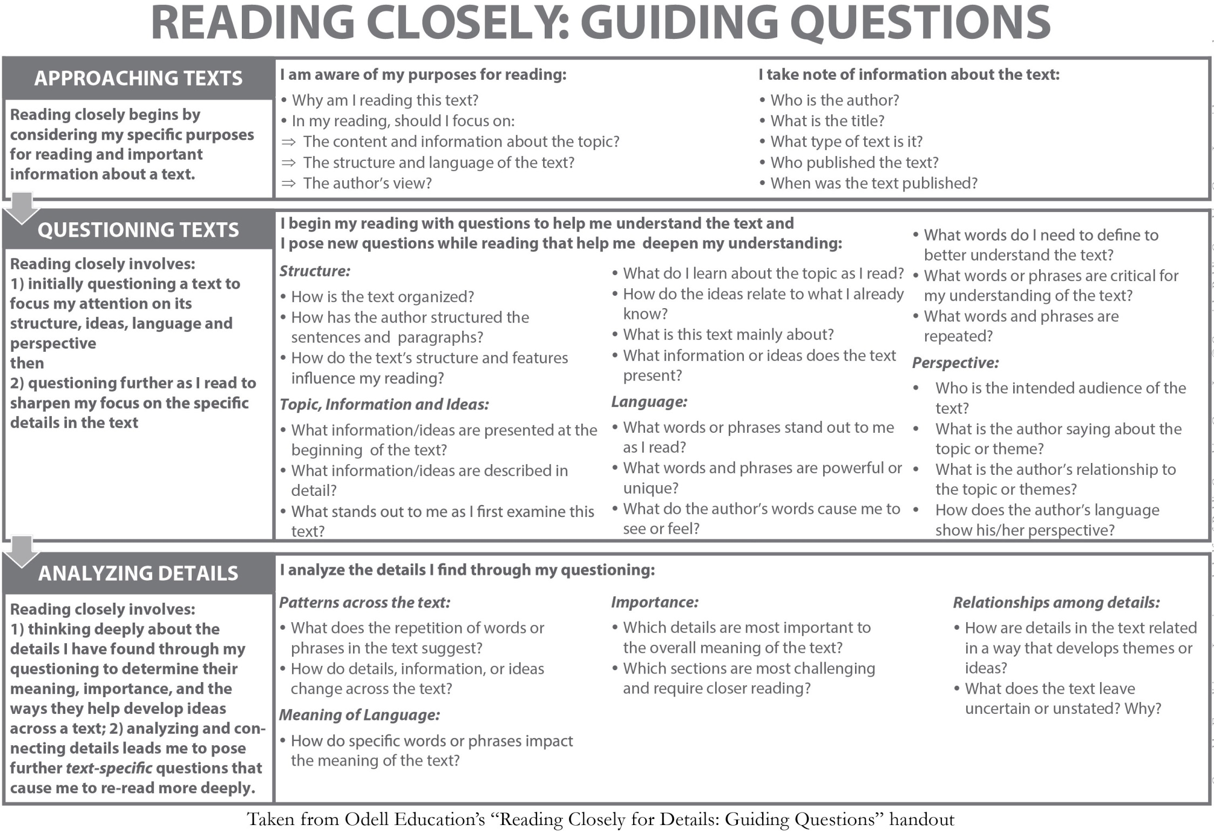

Name_____________________________________________ Date____________________

Grade 7: Module 2A: Unit 1: Lesson 7

Text Dependent Questions with Working Conditions Strips

**Teacher Directions**: copy this page and cut into rows/strips. Each pair of students needs one complete set of the three note cards.

|  |  |  |
| --- | --- | --- |
| The air in the factory was humid and dusty. | The looms were powerful and could injure workers if they weren’t careful. | Workers lived and ate in crowded, noisy boardinghouses. |
|  | | |
| The air in the factory was humid and dusty. | The looms were powerful and could injure workers if they weren’t careful. | Workers lived and ate in crowded, noisy boardinghouses. |
|  | | |
| The air in the factory was humid and dusty. | The looms were powerful and could injure workers if they weren’t careful. | Workers lived and ate in crowded, noisy boardinghouses. |

Name:_______________________________________________ Date: ___________________________

Grade 7: Module 2A: Unit 1: Lesson 7: Text Dependent Questions

|  |  |
| --- | --- |
| Questions | Answers |
| 1. The text says: “Now that she thought of it, she could hardly breathe, the air was so laden with moisture and debris” (75).   A. What does *laden* mean? How do you know?  B. What would it feel like to breathe air “laden with moisture and debris”?  C. Which Working Conditions note card best explains what this quote helps the reader understand about Lyddie’s life and work? | A.  B.  C.  __ |
| 1. The text says: “Even though Diana had stopped the loom, Lyddie stood rubbing the powder into her fingertips, hesitating to plunge her hands into the bowels of the machine” (75).   A. What does the phrase “bowels of the machine” mean?  B. Personifying is to give the characteristics of a person or animal to a non-living object. What is Paterson personifying?  C. Why does she do this?  D. Which Working Conditions note card best explains what this quote helps the reader understand about Lyddie’s life and work? | A.  B.  C.  D. |

Name___________________________________________ Date_______________

Grade 7: Module 2A: Unit 1: Lesson 7: Text Dependent Questions

|  |  |
| --- | --- |
| Questions | Answers |
| 1. “Her quiet meals in the corner of the kitchen with Triphena, even her meager bowls of bark soup with the seldom talkative Charlie, seemed like feasts compared to the huge, rushed, noisy affairs in Mrs. Bedlow’s house” (76).   A. What does the word meager mean? How do you know?  B. It’s contradictory to suggest a meager meal could be a feast. How could this be true for Lyddie?  C. Which Working Conditions note card best explains what this quote helps the reader understand about Lyddie’s life and work? | A.  B.  C. |

Lesson 7: Text Dependent Question **ANSWERS**

|  |  |
| --- | --- |
| Questions | Answers |
| 1. The text says: “Now that she thought of it, she could hardly breathe, the air was so laden with moisture and debris” (75).   What does *laden* mean? How do you know?  What would it feel like to breathe air “laden with moisture and debris”?  Which Working Conditions note card best explains what this quote helps the reader understand about Lyddie’s life and work? | Students should discuss the questions with their seat partners and record their answers on the Chapter 10 of *Lyddie* Text-Dependent Questions handout.  Pairs should work through these questions at their own pace. Some pairs may finish all three; others may only finish two.  As pairs work, circulate to listen in on their conversations and to ask prompting and probing questions.  1. Listen for students to say: “*Laden* means to be ‘filled with a great quantity.’”  Working Conditions note card: The air in the factory was humid and dusty.  Prompting and probing questions:  “What is the difference between *laden* and *full of*?”  “What feeling does the word *laden* give the sentence? How is it more effective than *full of*?” |

|  |  |
| --- | --- |
| Questions | Answers |
| 1. The text says: “Even though Diana had stopped the loom, Lyddie stood rubbing the powder into her fingertips, hesitating to plunge her hands into the bowels of the machine” (75).   What does the phrase bowels of the machine mean?  Personifying is to give the characteristics of a person or animal to a non-living object. What is Paterson personifying? Why does she do this?  Which Working Conditions note card best explains what this quote helps the reader understand about Lyddie’s life and work? | 2. Listen for students to say: “*Bowels of the machine* means the ‘innards’ of the machine. The author is talking about the physical location where Lyddie’s hands must go, but she is also comparing the loom to a beast. This helps give a sense of Lyddie’s nervousness and her worry that the machines might get the best of her.”  Working Conditions note card: The looms were powerful and could injure workers if they weren’t careful.  Prompting and probing questions:  “Bowels means ‘inner organs,’ like your intestines and stomach. Does a machine have organs? What might be inside it?”  “Why does Paterson use a word usually used to describe a person or animal to describe a machine?” |

|  |  |
| --- | --- |
| Questions | Answers |
| 1. “Her quiet meals in the corner of the kitchen with Triphena, even her *meager* bowls of bark soup with the seldom talkative Charlie, seemed like feasts compared to the huge, rushed, noisy affairs in Mrs. Bedlow’s house” (76).   What does the word meager mean? How do you know?  It’s contradictory to suggest a meager meal could be a feast. How could this be true for Lyddie?  Which Working Conditions note card best explains what this quote helps the reader understand about Lyddie’s life and work? | 3. Listen for students to say: “*Meager* means ‘deficient, scant, very little.’ A bowl of bark soup does not sound like a lot of food. *Feast* implies a meal that you relish and enjoy, and Lyddie enjoyed her quiet meals with less food more than the noisy, rushed meals with lots of food.”  Working Conditions note card: Workers lived and ate in crowded, noisy boardinghouses.  Prompting and probing questions:  (For students who are stuck)  “Three meals are being compared here. What are they? What does the word *“affairs”* mean here?”  “Which meal has the most food? Which meal does she enjoy the least?”  “Why does Paterson say “like feasts compared to” and not “better than”? How does that help you better understand Lyddie’s experience? |

Name:________________________________________ Date:___________________

Grade 7: Module 2A; Unit 1: Lesson 8

Use your Reader’s Notes from Chapter 11 of *Lyddie* to answer the questions below.

“July was halfway gone when she made her *momentous* decision. One fair evening as soon as supper was done, she dressed in her calico, which was nicer than her light summer cotton, put on her bonnet and good boots, and went out on the street. She was trembling when she got to the door of the shop, but she pushed it open. A little bell rang as she did so, and a gentleman who was seated on a high stool behind a slanting desktop looked up at her over his spectacles. ‘How may I help you, miss?’ he asked politely.” (83).

|  |
| --- |
| 1. If the word ***momentous*** is defined as “having great or lasting importance,” what was Lyddie’s momentous decision? |
|  |

|  |
| --- |
| 1. What makes it momentous? |
|  |

Name:_____________________________________________ Date:__________________________

Grade 7: Module 2A: Unit 1: Lesson 8

Working Conditions in Lyddie: Textual Evidence

|  |  |  |  |  |
| --- | --- | --- | --- | --- |
| Row number | **Working Condition Category** (from anchor chart)  ***Choose all that apply*** | **Detail/Evidence**  **Quote from Text (p. number)** | **Explanation**  **According to the text, what does this quote mean?** | **Analysis**  **What does this quote show about working conditions and how they affected workers?** |
| 1 | Hours  Compensation  Health, Safety, and Environment  Treatment of Individual Workers  Treatment of Groups  Child and Forced Labor | “No one seemed to mind the deafening din. How could they stand it?” (p. 62) | This quote is from the first time Lyddie goes into the weaving room. She is immediately struck by how loud it is—the looms and the machinery make a lot of noise. She also notices that the other workers don’t seem alarmed or scared by the noise. Lyddie is surprised that the other workers are not bothered by the noise, which she describes as an “assault.” | Noise could be considered a health hazard. It is so loud that Lyddie can barely hear Diana talk. This kind of noise can give workers headaches and damage their ears. |

|  |  |  |  |  |
| --- | --- | --- | --- | --- |
| Row number | **Working Condition Category** (from anchor chart)— **topic** | **Detail/Evidence**  **Quote from Text (p. number)** | **Explanation**  **What does this quote mean?** | **Analysis**  **What does this quote show about working conditions and how they affected workers?** |
| 2 | Hours  Compensation  Health, Safety, and Environment  Treatment of Individual Workers  Treatment of Groups  Child and Forced Labor | “How could she say she could see hardly anything in the morning gloom of the huge, barnlike room, the very air a soup of dust and lint?” (p. 63) |  |  |
| 3 | Hours  Compensation  Health, Safety, and Environment  Treatment of Individual Workers  Treatment of Groups  Child and Forced Labor | “She [Lyddie] took pride in her strength, but it took all of her might to yank the metal lever into place.… Still, the physical strength the work required paled beside the dexterity needed to rethread a shuttle quickly, or, heaven help her, tie one of those infernal weaver’s knots” (p. 65). |  |  |

|  |  |  |  |  |
| --- | --- | --- | --- | --- |
| Row number | **Working Condition Category** (from anchor chart)— **topic** | **Detail/Evidence**  **Quote from Text (p. number)** | **Explanation**  **What does this quote mean?** | **Analysis**  **What does this quote show about working conditions and how they affected workers?** |
| 4 | Hours  Compensation  Health, Safety, and Environment  Treatment of Individual Workers  Treatment of Groups  Child and Forced Labor | “Now that she thought of it, she could hardly breathe, the air was so laden with moisture and debris” (75). |  |  |
| 5 | Hours  Compensation  Health, Safety, and Environment  Treatment of Individual Workers  Treatment of Groups  Child and Forced Labor | “Within five minutes, her head felt like a log being split to splinters. She kept shaking it, as though she could rid it of the noise, or at least the pain, but both only seemed to grow more intense” (p. 75). |  |  |

|  |  |  |  |  |
| --- | --- | --- | --- | --- |
| Row number | **Working Condition Category** (from anchor chart)— **topic** | **Detail/Evidence**  **Quote from Text (p. number)** | **Explanation**  **What does this quote mean?** | **Analysis**  **What does this quote show about working conditions and how they affected workers?** |
| 6 | Hours  Compensation  Health, Safety, and Environment  Treatment of Individual Workers  Treatment of Groups  Child and Forced Labor | “Even though Diana had stopped the loom, Lyddie stood rubbing the powder into her fingertips, hesitating to plunge her hands into the bowels of the machine” (75). |  |  |

Name:___________________________________ Date:____________________

Grade 7: Module 2A: Unit 1: Lesson 9

**Mid-Unit Assessment**

Use your Reader’s Notes from Chapters 12 and 13 of *Lyddie* to answer the questions below.

|  |
| --- |
| 1. On page 88, Lyddie receives a letter from her mother. What does the letter say? |
|  |
|  |
|  |

|  |
| --- |
| 1. After she reads the letter, Lyddie thinks: “She must work harder. She must earn all the money to pay what they owed, so she could gather her family together back on the farm while she still had family left to gather” (p. 88). What does this passage tell you about what Lyddie fears?   ____________________________________________________________________________________________________________________________________________________________________________________________________________________________________________________________________   1. Betsy and Amelia are discussing a petition. How does fear affect Lyddie’s response to that petition? (pgs. 91-92) |
|  |
|  |
|  |

Use your Reader’s Notes from Chapters 12 and 13 of *Lyddie* to answer the questions below.

1. “The pay reflected her proficiency (her ability to complete her work quickly and well). While the other girls grumbled that their piece rates had dropped so that it had hardly been worth slaving through the summer heat, she kept her silence” (86).

What does this quote show about how Lyddie was paid compared to the other girls?

a. She was paid well because the overseer liked her.

b. She was paid a higher hourly wage because she had worked there longer.

c. She was paid by how many pieces she completed.

d. She was paid less than she had been paid in the tavern.

1. “So it was that when the Concord Corporation once again speeded up the machinery, she, almost alone, did not complain” (89).

Why didn’t Lyddie complain about the speed-up?

a. More than anything, she wanted to earn enough money to reunite her family and get the farm back and they were paid by the number of pieces they finished.

b. She didn’t care what the other girls thought of her.

c. She wanted to please Mr. Mardsen.

d. She wanted to earn more money, and the corporation lowered wages when it sped up the machinery

1. How does the speed-up in Chapter 13 affect Lyddie? (Refer to pages 97–99.)

a. She is mentally and physically exhausted.

b. She is worried about Betsy.

c. She eats more to keep up her energy.

d. She works harder so Mr. Mardsen can win a prize.

1. “What textual evidence supports your answer? **Circle two** pieces of evidence that directly supports your answer choice to question 3.

a. “Now she hardly noticed people anymore” (98).

b. “She ate the food set before her” (98).

c. “She did not want Betsy to go” (99).

d. “When Mr. Mardsen got up to stroll the room, he often stopped at her looms” (97).

e. “She was too tired at night now to copy out a page of *Oliver* to paste to her loom” (98).

f. “Lyddie did not attempt to go to church” (98).

g. “The harder we work, the bigger prize they get” (99).

h. “horror at what she was proposing”

1. “She wasn’t a slave. She was a free woman of the state of Vermont, earning her own way in the world. Whatever Diana, or even Betsy, might think, she, Lyddie, was far less a slave than most any girl she knew of” (94). Given what you have learned of Lyddie’s working conditions, to what extent do you think she is free? Explain one reason she is free and one reason she is not, supporting each reason with at least one detail from Chapters 12 and 13.

|  |  |
| --- | --- |
|  | Text Evidence |
| Lyddie is free in some ways |  |
| Lyddie is not free in some ways |  |

Name:_________________________________________ Date:_____________________

Grade 7: Module 2A: Unit 1: Lesson 10 (Ch. 12)

Text Dependent Questions

Use your Reader’s Notes from Chapter 12 of *Lyddie* to answer the questions below.

|  |  |
| --- | --- |
| Questions | Answers |
| 1. What about the working conditions makes Betsy think she should sign the petition?  Pgs. 91 -92 |  |
| 2. Lyddie says, “If we just work ten hours, we’d be paid much less” (91). What can you infer that the petition is calling for? What does Lyddie think will happen to her wages if the mill owners listen to the petition? |  |
| 1. Workers who signed the petition might be *blacklisted* (92). What does this mean? |  |
| 1. Lyddie says, “I got to have the money. I got to pay the debts before –“ (92) What does she mean? |  |

Name:______________________________________ Date:__________________________

Grade 7: Module 2A: Unit 1: Lesson 10b

**Lyddie’s Decision Anchor Chart**

Student Copy

Directions: Use statements A-F from *Lyddie* to fill-in the chart. Add more from the novel if you can.

|  |  |
| --- | --- |
| **Reasons to sign the petition** | **Reasons NOT to sign the petition** |
|  |  |
|  |  |
|  |  |
|  |  |

Grade 7; Module 2A: Unit 1: Lesson 10

Lyddie’s Decision Chart choices

|  |  |  |
| --- | --- | --- |
| Statement A |  | Statement D |
| Mr. Mardsen would be disappointed and she doesn’t want Mr. Mardsen to think less of her. |  | The workers, by being forced to work longer hours for less pay, are being treated more and more like slaves. |

|  |  |  |
| --- | --- | --- |
| Statement B |  | Statement E |
| Lyddie will earn less money and needs money to buy back her farm. |  | People she cares about are becoming sick from working long hours in the dust-filled air. |

|  |  |  |
| --- | --- | --- |
| Statement C |  | Statement F |
| Working longer than 10 hours a day is really hard. |  | Lyddie should sign the petition because if she signed it and worked fewer hours, she would have more time to read. |

Name: ___________________________________________ Date:_________________________

**Grade7: Module 2A: Unit 1: Lesson 10c**

|  |  |  |  |  |
| --- | --- | --- | --- | --- |
| **Chapter** | **Setting** | **Characters** | **Plot** | **How do setting, character, and/or plot interact?** |
| 15 |  |  |  | Why does Uncle Judah bring Rachel to Lyddie?  What about the boardinghouse rules make it hard for Lyddie to have Rachel with her? |

Reader’s Notes Chapters 15 & 16

|  |  |  |  |  |  |
| --- | --- | --- | --- | --- | --- |
| **Word/Phrase** | **Page** | **Definition** | **Word/Phrase** | **Page** | **Definition** |
| boasted | 118 | bragged | doff | 120 | to take full bobbins off spinning machines and replace them with empty ones |
| stout | 118 | strong | fortnight | 120 | two weeks |
| remand her to the asylum | 118 | to commit someone to a mental institution, usually against his/her will | distraught | 124 | very upset or worried |

|  |  |  |  |  |
| --- | --- | --- | --- | --- |
| **Chapter** | **Setting** | **Characters** | **Plot** | **How do setting, character, and/or plot interact?** |
| 16 |  |  |  | *What does Lyddie do for*  *Rachel?*  *What does Rachel do for*  *Lyddie?*  *What is Mr. Mardsen doing when Lyddie stomps his foot? What can you infer?* |

**Reader’s Dictionary, Chapter 16**

|  |  |  |  |  |  |
| --- | --- | --- | --- | --- | --- |
| **Word/Phrase** | **Page** | **Definition** | **Word/Phrase** | **Page** | **Definition** |
| begrudge | 127 | feel annoyed that you have to pay for something or give something to someone | thereafter | 129 | afterward |
| mind | 127 | pay attention | croon | 129 | sing or speak in a soft and gentle voice |

Reader’s Notes Chapters 17

|  |  |  |  |  |
| --- | --- | --- | --- | --- |
| 17 |  |  |  | How does Lyddie arrange for Rachel to stay?  What is her worry about Rachel? |

**Reader’s Dictionary, Chapter 17**

|  |  |  |  |  |  |  |
| --- | --- | --- | --- | --- | --- | --- |
| **Word/Phrase** | **Page** | | **Definition** | **Word/Phrase** | **Page** | **Definition** |
| despised | 131 | looked down on | | plaits | 134 | braids |
| obliged | 131 | having to do something because a situation or your duty makes it necessary | | ignorant | 135 | uneducated |
| monstrous | 132 | very | | skeptical | 136 | disbelieving or doubting |

Other new words:

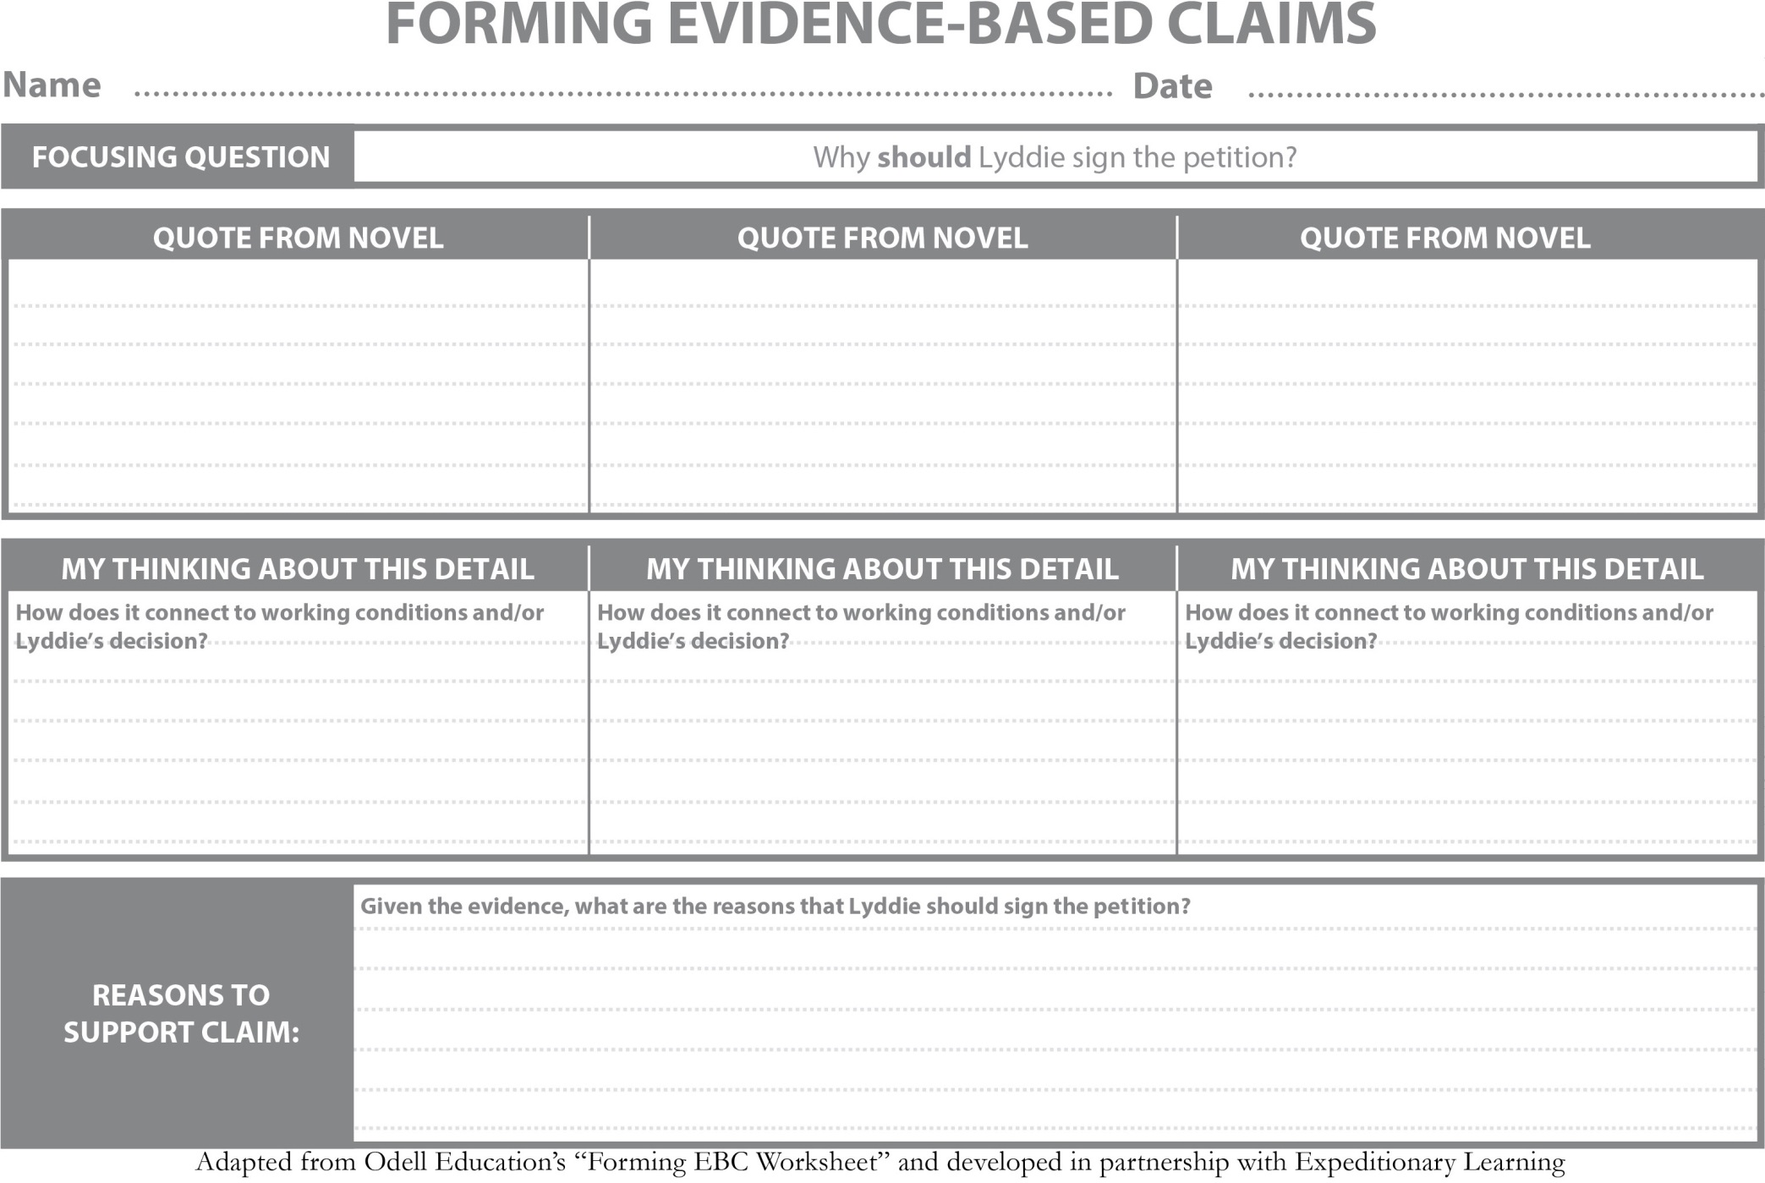

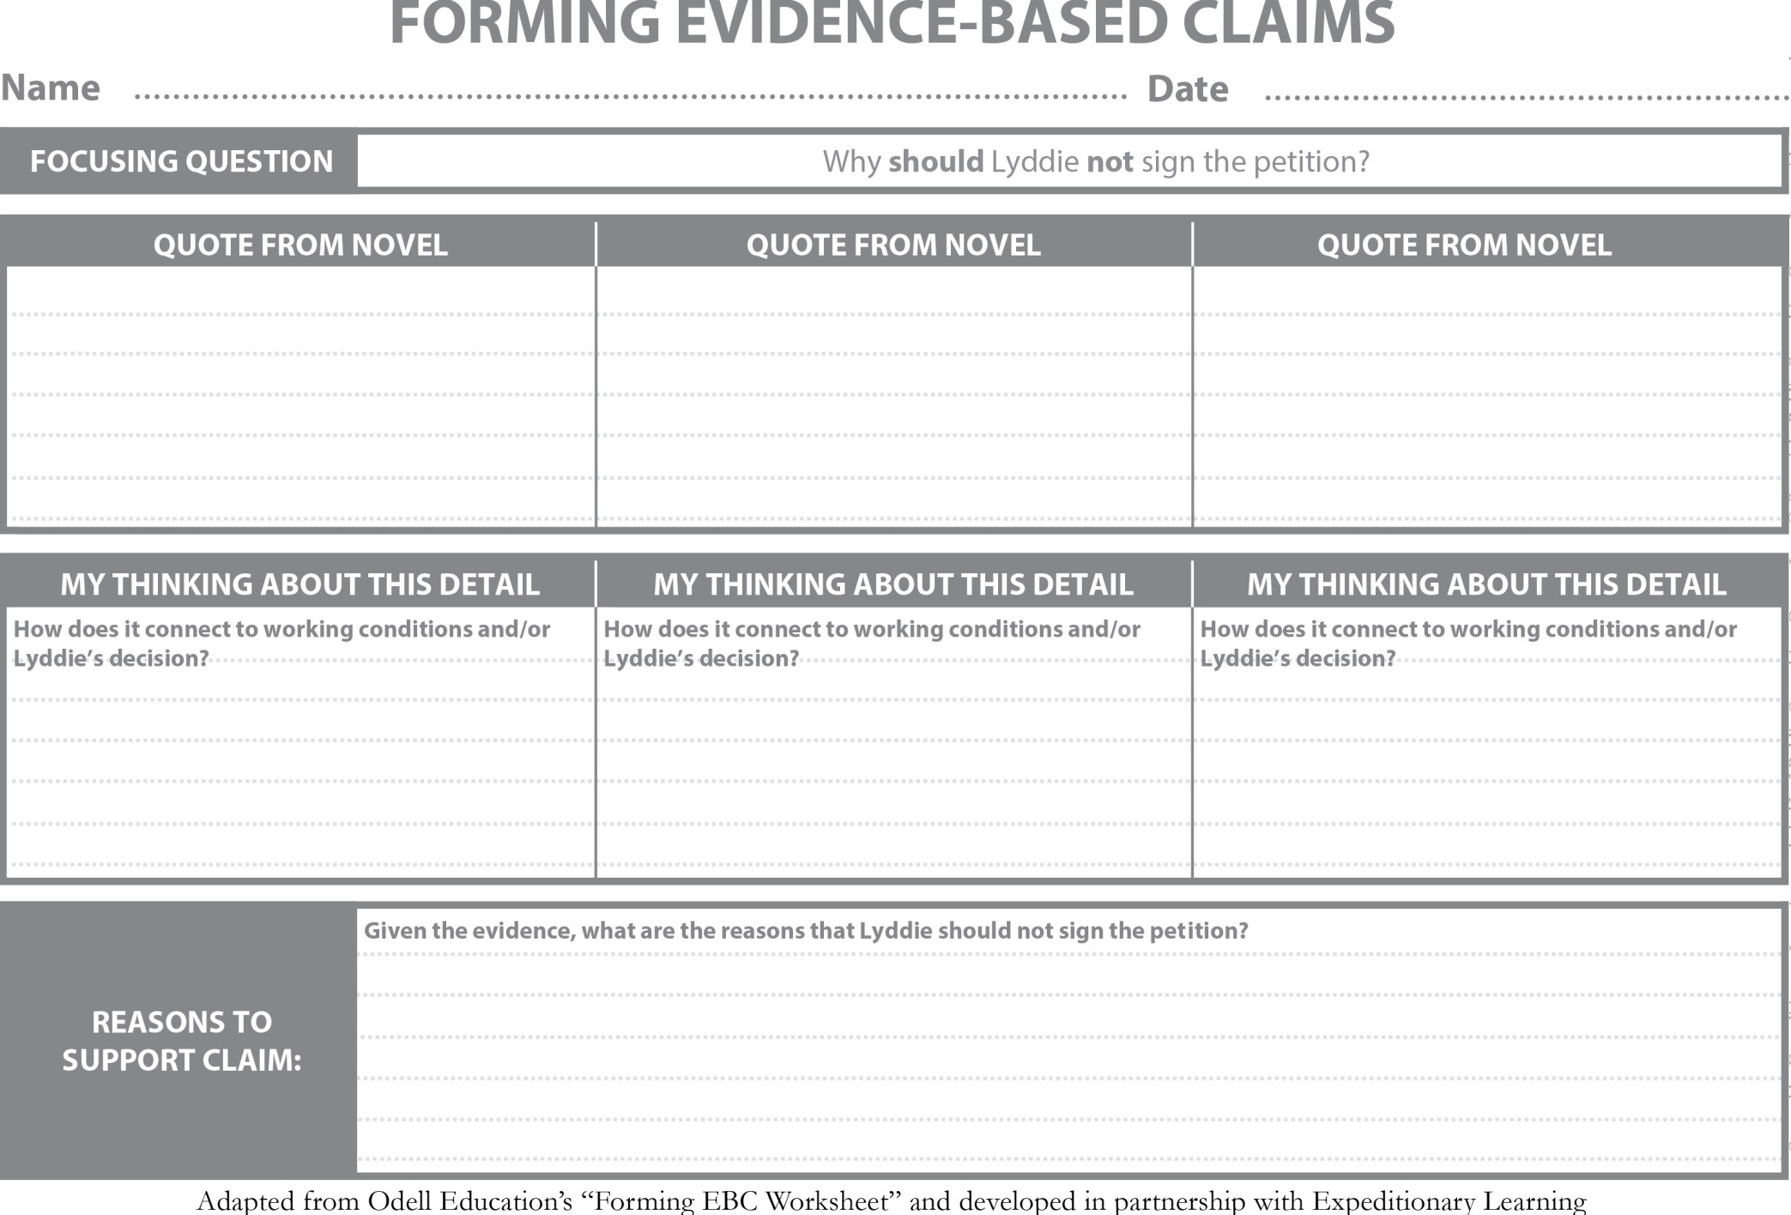

Name: ___________________________________________ Date:_________________________

**Grade7: Module 2A: Unit 1: Lesson 11a**

Entry Task: Quotes to discuss

Directions: Discuss each quote with your partner and record what you believe each means.

1. “She must work harder. She must earn all the money to pay what they owed, so she could gather her family together back on the farm while she still had a family let to gather.” (p. 88)

_______________________________________________________________________________________________________________________________________________________________________________________________________________________________________________________________________________________________________________________________________________________________________

2. “She was too tired now at night to copy out a page of Oliver to paste to her loom. It hardly mattered. When would she have time to study it?” (p. 98)

________________________________________________________________________________________________________________________________________________________________________________________________________________________________________________________________________________________________________________________________________________________________________

3. “She’ll never be strong enough again to work in a mill thirteen, fourteen hours a day. When I am ready to go myself, she thought, maybe I could sign that cussed petition. Not for me. I don’t need it, but for Betsy and the others. It ain’t right for this place to suck the strength of their youth, then cast them off like dry husks to the wind.” (p. 113)

______________________________________________________________________________________________________________________________________________________________________________________________________________________________________________________________________________

Name:____________________________________________ Date:_________________________

**Grade 7: Module 2A: Unit 1: Lesson 11 (Ch. 17)**

|  |  |  |  |  |
| --- | --- | --- | --- | --- |
| **Chapter** | **Setting** | **Characters** | **Plot** | **How do setting, character, and/or plot interact?** |
| 17 |  |  |  | *How does Lyddie arrange for Rachel to stay?*  *What is her worry about Rachel?* |

Reader’s Dictionary, Chapter 17

|  |  |  |  |  |  |
| --- | --- | --- | --- | --- | --- |
| **Word/Phrase** | **Page** | **Definition** | **Word/Phrase** | **Page** | **Definition** |
| despised | 131 | to greatly dislike | ignorant | 135 |  |
| obliged | 131 |  | skeptical | 136 | Doubting or not believing |
| monstrous | 132 |  |  |  |  |
| Other new words |  |  |  |  |  |

Name:__________________________________________ Date:__________________________

**Grade 7: Module 2A: Unit 1: Lesson 12**

**Entry Task , Chapter 17**

Directions: Use your Reader’s Notes from Chapter 17 of Lyddie to answer the question below.

“How dry her life had been before Rachel came. It was like springs of water in the desert to have her here.” (p. 138)

According to the quote, how does Lyddie feel about having Rachel live with her?

______________________________________________________________________________________________________________________________________________________________________________________________________________________________________________________________________________

How does having Rachel live with her change Lyddie?

_____________________________________________________________________________________________________________________________________________________________________________________________________________________________________________________________________________

Name:____________________________________________ Date:_________________________

**Grade 7: Module 2A: Unit 1: Lesson 12 (Ch. 18)**

|  |  |  |  |  |
| --- | --- | --- | --- | --- |
| **Chapter** | **Setting** | **Characters** | **Plot** | **How do setting, character, and/or plot interact?** |
| 18 |  |  |  | *Lyddie helps Rachel get ready to go on the train and feels envy (jealous).*  *Why does she feel envious of Rachel?*  *How does she react after reading Luke’s letter?* |

Reader’s Dictionary, Chapter 18

|  |  |  |  |  |  |
| --- | --- | --- | --- | --- | --- |
| **Word/Phrase** | **Page** | **Definition** | **Word/Phrase** | **Page** | **Definition** |
| In vain | 141 | without success | craves | 142 |  |
| Slack | 142 |  | miserly | 144 |  |
| Other new words |  |  |  |  |  |

Name:________________________________ Date:______________________________

Module 2A: Unit 1: Lesson 13

***Lyddie* Model Essay** Focusing Question:

Should Lyddie go to work in the mills in Lowell, MA?

In Katherine Paterson’s novel *Lyddie*, the main character faces several difficult decisions as she tries to take care of her family after her father disappears from their small mountain farm in Vermont. When there is not enough food, her mother and younger sisters go to an uncle’s house while Lyddie and her brother Charlie spend a winter alone on the farm trying to keep it so the family can come home one day. In the spring, Lyddie and Charlie have to leave also. He is apprenticed to a miller, and she takes a job at a local tavern. Eventually, however, she starts thinking about going south to Lowell, Massachusetts, to work in the textile mills. Some would say that this is a foolish move for Lyddie because it takes her far away from the home and family she loves. This is the right decision for her to make because by leaving she at least stands a chance of improving her situation and making enough money to buy back the farm.

One of the reasons that Lyddie has made the right decision to leave her job at Cutler’s Tavern to go to work in the mills is that it will be a better life than the one she is leading at the tavern. While working at the tavern in Chapter 3, Lyddie has to endure difficult living conditions. She “slept under the eaves in a windowless passage, which was hot and airless even in late spring. She was ordered to bed late and obliged to rise early for the mistress was determined that no paying guest in the windowed rooms across the narrow passageway should know that they shared the floor with the kitchen girl” (24). This shows that Lyddie is treated badly, without even a bed to sleep in or a room of her own. She also works very hard and has no friends or companions. The only person who notices her at all is the old cook, who becomes a sort of protector. Even though Lyddie is not far from where her brother lives, she only sees him once in the year she works at the tavern and she never sees her mother and sisters. Making the decision to go south to Massachusetts is the right one for Lyddie because her situation at the tavern is harsh and lonely. Working in the mills offers the possibility of a better life.

The other good reason for Lyddie to leave the tavern for a mill job is that it will pay her much better. Ever since her family had to give up the farm, she has had the dream of buying it back. She wants to save her pay to do that, but she is only paid $.50 week at Cutler’s and that money is sent directly to her mother, not given to her. In Chapter 3 when Lyddie meets a factory girl who is traveling through town and stays at Cutler’s, she is amazed at how well dressed and rich the girl is. The girl tells Lyddie that because she is a good worker, she would do well in the mill and could “clear at least two dollars a week” (25) as well as being independent. This means that if Lyddie could make that much money, she will be able to save enough to one day buy back the farm and unite her family. She wants that so much that she is brave enough to leave Vermont, ride on a coach, and face a big, strange city. Lyddie does the right thing by becoming a mill girl in order to make a real living wage.

Even though there are reasons Lyddie should not have gone to Massachusetts to work in the mills, her decision to go is the right one for her. It will allow Lyddie to improve her life by living more comfortably in a boarding house, making friends with girls her own age, and learning more about the world. The job will also pay her a living wage so that she can save money to help her family. Although she isn’t sure when she gets on that coach headed south to the mills, she is going toward the freedom to make her own way in the world, and this is clearly the best decision for her.

Work Cited

Paterson, Katherine. *Lyddie*. New York: Puffin Books, 1991.

Name:_________________________________________ Date:_________________________

Grade 7: Module 2A: Unit 1: Lesson 13

**Writer’s Glossary -**

*Lyddie* Argument Essay

This glossary is for academic words related to the writing process and products.

**The words here are from Module 2, Unit 1, Lessons 13–20**

|  |  |
| --- | --- |
| WORD/PHRASE | Definition |
| appropriate  (opposite: inappropriate) | correct or suitable for a particular time, situation, or purpose  Ex: *Nice pants and a nice shirt are appropriate to wear to a job interview.* |
| argument | reasoned thinking that supports a specific claim or position  Ex: *The lawyer made the argument that cell phones were a distraction to drivers, using many statistics about cell phone-related accidents..* |
| claim | A statement that a speaker or writer is trying to prove, usually by using evidence  Ex: *In the trial, the defendant presented a claim that she was innocent.* |
| coherent  (opposite: incoherent) | when something such as a piece of writing is easy to understand because its parts are connected in a clear and reasonable way  opposite: when something is hard to understand or does not make sense |
| reason | a justification of a claim; an explanation  Ex: *The reason teenagers should drink milk is that the calcium in milk builds strong bones.* |
| relevant evidence | details or quotes from a text that directly relate to the subject or problem being discussed or considered  Ex: *Sally used relevant evidence in her essay on the theme of survival in Hunger Games.* |
| irrelevant | not related to the subject being discussed |
| counterclaim | the opposing viewpoint or the opposite of the main claim in an essay |
| well-chosen evidence | evidence that is relevant and specific |
| illustrates | to give the reader a clear picture in his mind |

Name:___________________________________________ Date:_______________________

Grade 7: Module 2A: Unit 1: Lesson 13

**Exit Ticket for Lesson 13 or Entry Ticket for Lesson 14**

**Directions:** Reread the essay prompt.

After reading through Chapter 17 of *Lyddie*, write an argument essay that addresses the question: Should Lyddie sign the petition that Diana Goss is circulating? Support your position with evidence from the novel. Be sure to acknowledge competing views, and refer only to information and events in the book, not what you know because you live in 2013.

|  |
| --- |
| 1. Explain the meaning of the prompt: What must you do in this essay? |
|  |
|  |
|  |

**Focusing Question:**

**“Should Lyddie sign the petition that Diana Goss was circulating?”**

After reading through Chapter 17 of *Lyddie*, write an argumentative essay that addresses the question:

Should Lyddie sign the petition that Diana Goss is circulating?

Support your position with evidence from the novel. Be sure to acknowledge competing views, and refer only to information and events in the book, not what you know because you live in the 21st century.

Name:___________________________________________ Date:_______________________

Grade 7: Module 2A: Unit 1: Lesson 14

**Checking for Understanding,**

**Chapters 18 and 19 Entry Task**

Use your Reader’s Notes from Chapters 18–19 of *Lyddie* to answer the questions below.

Consider this quote from the book:

“She worked hard because work was all she knew, all she had. Everything else that had made her know herself as Lyddie Worthen was gone. Nothing but hard work — so hard that her mind became as calloused as her hands—work alone remained.” (148).

|  |
| --- |
| 1. What does the word *calloused* mean? How is a calloused hand different from a calloused mind? |
|  |

|  |
| --- |
| 2. Lyddie thinks work is all that she has left because she loses many things that are important to her in Chapters 18 and 19. List at least three of them. |
|  |

Name:___________________________________________ Date:_______________________

Grade 7: Module 2A: Unit 1: Lesson 14

**Take a Stand Statements**

Given what I know about Lyddie, is this a compelling reason to her?

1.

|  |  |  |
| --- | --- | --- |
| Statement A |  | Statement B |
| Lyddie should sign the petition because the people she cares about are becoming sick from working long hours in the dust-filled air. | **OR** | Lyddie should sign the petition because working longer than 10 hours a day is really hard. |

2.

|  |  |  |
| --- | --- | --- |
| Statement A |  | Statement B |
| Lyddie should not sign the petition because she will earn less money and needs money to buy back her farm. | **OR** | Lyddie should not sign the petition because Mr. Mardsen would be disappointed and she doesn’t want Mr. Mardsen to think less of her. |

3.

|  |  |  |
| --- | --- | --- |
| Statement A |  | Statement B |
| Lyddie should sign the petition because the workers, by being forced to work longer hours for less pay, are being treated more and more like slaves. | **OR** | Lyddie should sign the petition because if she signed it and worked fewer hours, she would have more time to read. |

Name:__________________________________________ Date:____________________________

**GRADE 7: MODULE 2A: Unit 1: LESSON 14**

**EXIT TICKET**

Circle your claim about Lyddie’s decision.

**Lyddie should sign the petition.**

**OR**

**Lyddie should not sign the petition.**

List **at least** 3 reasons to support your claim:

1.

2.

3.

Name:________________________________________________ Date:_____________________

Grade 7: Module 2A: Unit 1: Lesson 14

***Lyddie* Reader’s Notes**

Chapter 20

|  |  |  |  |  |  |
| --- | --- | --- | --- | --- | --- |
| **Word/Phrase** | **Page** | **Definition** | **Word/Phrase** | **Page** | **Definition** |
| **scrupulous** | **155** |  | **tumult** | **159** |  |
| **yoke** | **156** |  | **sedate** | **159** |  |
| **begrudge** | **158** | **to feel angry or upset with someone because they have something you feel they don’t deserve.** | **hulking** | **160** |  |

Name:___________________________________________ Date:__________________________

Grade 7: Module 2A: Unit 1: Lesson 14

***Lyddie* Reader’s Notes**

Chapter 21

|  |  |  |  |  |
| --- | --- | --- | --- | --- |
| **Chapter** | **Setting** | **Characters** | **Plot** | **How do setting, character, and/or plot**  **interact?** |
| **20** |  |  |  | *In Chapters 20 and 21, she and Brigid become closer friends. What are some ways that Lyddie helps Brigid? How does this affect Lyddie? How does it affect Brigid?* |
| **21** |  |  |  | *Why was Lyddie fired?*  *According to the agent and the overseer?*  *According to her?*  *What does this encounter tell you about*  *workers’ rights in the mills?* |

|  |  |  |  |  |  |
| --- | --- | --- | --- | --- | --- |
| **Word/Phrase** | **Page** | **Definition** | **Word/Phrase** | **Page** | **Definition** |
| searing | 162 |  | cackle | 164 |  |
| trespassed | 164 |  | solemn | 167 |  |

**Name:_________________________________________ Date:__________________________**

Grade 7: Module 2A: Unit 1: Lesson 14

***Lyddie* Reader’s Notes**

Chapter 22

|  |  |  |  |  |  |  |  |  |  |
| --- | --- | --- | --- | --- | --- | --- | --- | --- | --- |
| **Chapter** | **Setting** | | | **Characters** | **Plot** | | | **How do setting, character, and/or plot interact?** | |
| 22 |  | | |  |  | | | *How does Lyddie respond to being fired? What does she do to protect Brigid?*  *Why is Mrs. Bedlow surprised that Lyddie was fired?*  *What is moral turpitude?* | |
| **Word/Phrase** | | **Page** | **Definition** | | | **Word/Phrase** | **Page** | | **Definition** | |
| incredulous | | 170 |  | | | dilute | 173 | |  | |
| parcels | | 171 |  | | | vile | 171 | | immoral or evil; can also be used informally to mean very unpleasant or bad. | |
| gingerly | | 174 |  | | |  |  | |  | |

**Name:_________________________________________ Date:_______________________**

Grade 7: Module 2A: Unit 1: Lesson 14

***Lyddie* Reader’s Notes**

Chapter 23

|  |  |  |  |  |  |  |  |  |  |
| --- | --- | --- | --- | --- | --- | --- | --- | --- | --- |
| **Chapter** | **Setting** | | **Characters** | | **Plot** | | **How do setting, character, and/or plot interact?** | | |
| 23 |  | |  | |  | | *Why does Lyddie return to the tavern?*  *Why does Lyddie go back to the farm? What connection do you think it will have to her future? Why?* | | |
| **Word/Phrase** | | **Page** | | **Definition** | | **Word/Phrase** | | **Page** | **Definition** |
| monstrosities | | 177 | |  | | content | | 179 |  |
| pang | | 177 | |  | | crinkled | | 182 |  |
| homely | | 179 | |  | | crumpled | | 182 |  |

**Name:________________________________________________ Date:__________________________**

Grade 7: Module 2A: Unit 1: Lesson 15

**Analyzing Structure in the Model Essay – Finding Quotes in an Essay**

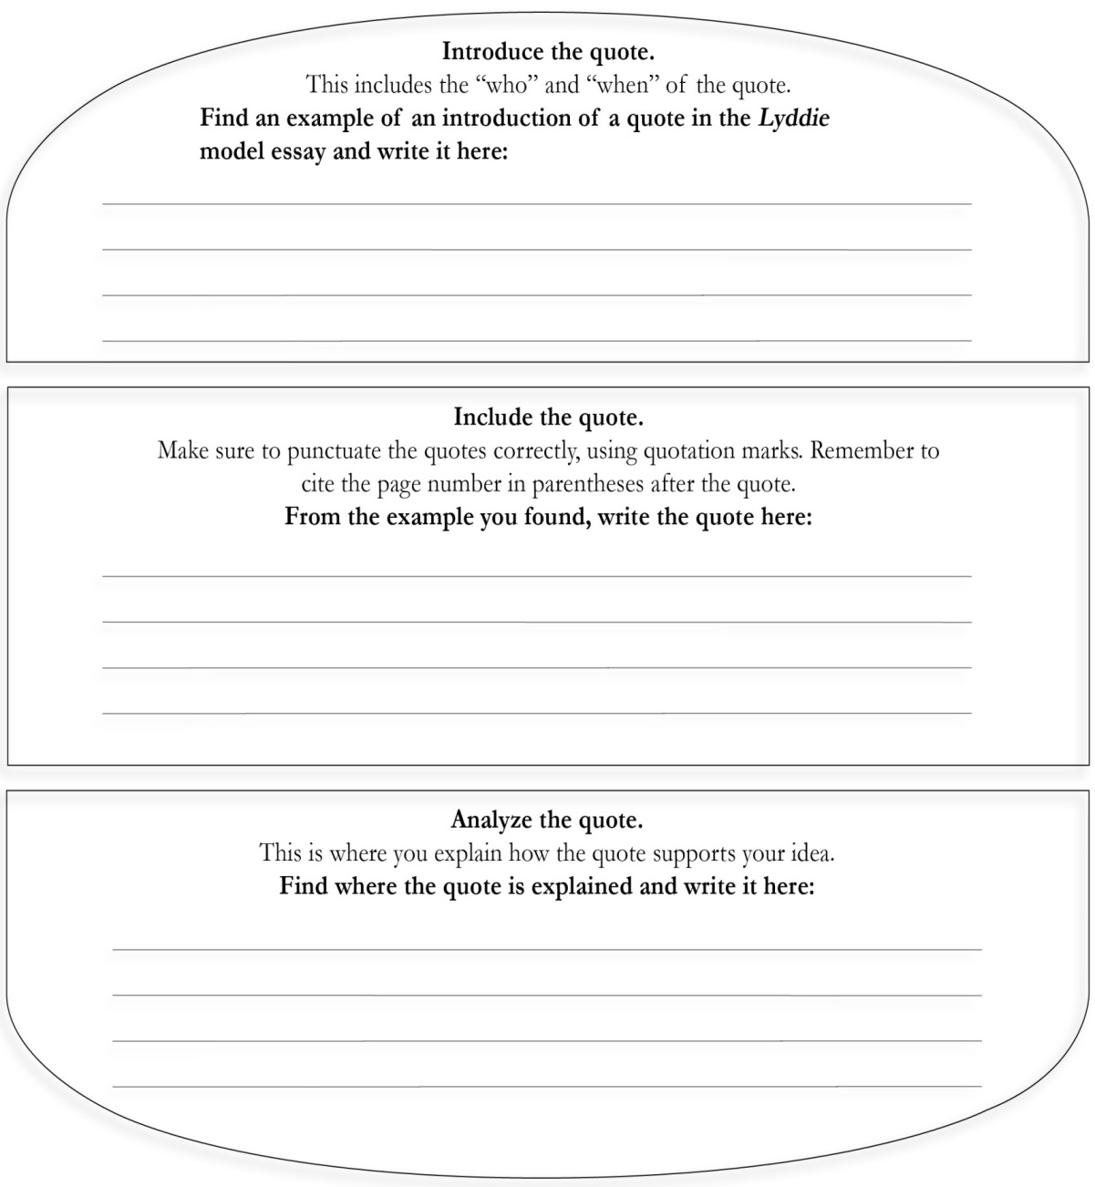

Grade 7: Module 2A: Unit 1: Lesson 15

**Analyzing Structure in the Model Essay (adapted)**

What is the claim/thesis of the model essay?

*Lyddie makes the right decision for her because by leaving enough money to buy back the farm.*

|  |  |
| --- | --- |
| **I agree with her that working in the mills offers the possibility of a better life.** | |
| A. Topic sentence | *One of the reasons that Lyddie decides to leave her job at Cutler’s Tavern to go to work in the mills is that it will be a better life than the one she is leading at the tavern.* |
| B. Evidence 1 | *Lyddie had to endure difficult living conditions. She “slept under the eaves in a windowless passage, which was hot and airless even in late spring. She was ordered to bed late and obliged to rise early, for the mistress was determined that no paying guest in the windowed rooms across the narrow passageway should know that they shared the floor with the kitchen girl” (24).* |
| C. Analysis of Evidence 1 | *This shows that Lyddie is treated badly, without even a bed to sleep in or a room of her own.* |
| D. Evidence 2 |  |
| E. Analysis of Evidence 2 |  |
| F. Concluding Sentence | *I agree with her that working in the mills offers the possibility of a better life.* |

|  |  |
| --- | --- |
| **Body Paragraph 2**: First reason to support claim | |
| A. Topic sentence |  |
| B. Evidence 1 | *She is paid only $.50 week at Cutler’s, and that money is sent directly to her mother, not given to her.* |
| C. Analysis of Evidence 1 | *Fifty cents a week is not enough money for Lyddie to be able to buy her family’s farm back.* |
| D. Evidence 2 |  |
| E. Analysis of Evidence 2 |  |
| H. Concluding Sentence | *I think that she does the right thing by becoming a mill girl in order to make a real living wage.* |

What counterclaims does the author acknowledge?

__________________________________________________________________________________________

__________________________________________________________________________________________

__________________________________________________________________________________________

__________________________________________________________________________________________

What are the counterclaims on this essay?

__________________________________________________________________________________________

__________________________________________________________________________________________

__________________________________________________________________________________________

__________________________________________________________________________________________

__________________________________________________________________________________________

Name:__________________________________________ Date:______________________

Grade 7: Module 2A: Unit 1: Lesson 15

**Exit Ticket**

**Directions:** Reread the conclusion from the model essay on *Lyddie*.

1. Underline the claim.

2. Circle the reasons restated in this conclusion.

*Even though there are reasons why Lyddie should not have gone to Massachusetts to work in the mills, her decision to go is the right one for her. It will allow Lyddie to improve her life by living more comfortably in a boarding house, making friends with girls her own age, and learning more about the world. The job will also pay her a living wage so that she can save money to help her family. Although she isn’t sure when she gets on that coach headed south to the mills, she is going toward the freedom to make her own way in the world, and this is clearly the best decision for her.*

Name:______________________________________________ Date:_____________________

Grade 7: Module 2A: Unit 1: Lesson 16

***Lyddie* Essay Planner**

**Focusing Question**: Should Lyddie sign the petition that Diana Goss circulates?

|  |  |
| --- | --- |
| **I. Introduction** | |
| A. Hook to capture the reader’s interest and attention |  |
| B. Name the book and author |  |
| C. Give brief background information to the reader about the book (characters, plot overview, etc) |  |
| D. Claim |  |

|  |  |
| --- | --- |
| **II. Body Paragraph 1**: First reason to support claim | |
| First reason to support your claim |  |
| Topic sentence |  |
| Evidence 1 |  |
| Analysis of Evidence 1 |  |
| Evidence 2 |  |
| Analysis of Evidence 2 |  |
| Concluding Sentence |  |

|  |  |
| --- | --- |
| **III. Body Paragraph 2**: First reason to support claim | |
| Second reason to support your claim |  |
| Topic sentence |  |
| Evidence 1 |  |
| Analysis of Evidence 1 |  |
| Evidence 2 |  |
| Analysis of Evidence 2 |  |
| Concluding Sentence |  |

|  |  |
| --- | --- |
| **IV. Conclusion** | |
| 1. Restate claim |  |
| 1. Summarize reasons |  |
| 1. Explain why your view is worth consideration by the reader |  |

|  |  |
| --- | --- |
| **Counterclaim** | |
| 1. What counterclaim(s) will you include in your essay? |  |
| 1. Where in your essay will you acknowledge the counterclaim(s)? |  |

Name:________________________________________ Date:___________________________

Grade 7: Module 2A: Unit 1: Lesson 16

**Writing Improvement Tracker**

|  |  |
| --- | --- |
| **Strategies to Improve Writing** | |
| * Revise my writing (or my planning) multiple times | * Ask myself, “Does this make sense?” |
| * Look at other models | * Read the necessary texts closely |
| * Read other people’s work | * Talk through my ideas with an adult |
| * Ask questions when I have them | * Use quote sandwiches |
| * Take a break and reread with fresh eyes | * Have another student write the gist of your paragraphs and make sure they match what you thought they were |

**Directions: Look at the first two rows of the Argument Essay Rubric.**

|  |
| --- |
| 1. What did I do well in my essay? |
|  |
|  |
|  |
|  |
| 2. What do I need to improve? |
|  |
|  |
|  |
|  |
| 3. Look at the list of strategies at the top of this tracker. What one or two strategies will I use in the future? |
|  |
|  |
|  |
|  |

Name: ____________________________________________ Date:_____________________________

Grade 7: Module 2A: Unit 1: Lesson 16

**Exit Ticket**

|  |
| --- |
| 1. What part of planning is hard for you? |
|  |
|  |

|  |
| --- |
| 1. What help do you need to finish your plan? |
|  |
|  |

Name:__________________________________________ Date:_____________________________

Grade 7: Module 2A: Unit 1: Lesson 17

**Peer Critique Expectations and Directions**

|  |  |
| --- | --- |
| **Expectations** | |
| **Be Kind:** | Treat others with dignity and respect. |
| **Be Specific:** | Focus on *why* something is good or what, particularly, needs improvement. |
| **Be Helpful:** | The goal is to help everyone improve their work. |
| **Participate:** | Support each other. Your feedback is valued! |
| **Directions for Peer Critique Partners** | |
| Review Claim and Evidence Criteria from Rows 1 and 2 of *Lyddie* argument rubric. | |
| Give your partner your quote sandwich and point out the feedback question you would most like suggestions about. | |
| Read over your partner’s quote sandwich. | |
| One person shares his/her feedback using phrases like:  a. I really liked how you…  b. I wonder….  c. Maybe you could change… | |
| Author writes it on his/her Peer Critique Recording Form. | |
| Author: Says, “Thank you for _______________. My next step will be ____________.” | |
| Switch roles and repeat | |

Grade 7: Module 2A: Unit 1: Lesson 17

**Peer Critique Recording Form (may be used for quote sandwich or any essays)**

**Name: ____________________________________________________**

**Paper to be critiqued: ______________________________________**

The best thing about _______________________________________ is…

_______________________________________________________________________________________________

_______________________________________________________________________________________________

_______________________________________________________________________________________________

I wonder about…

_______________________________________________________________________________________________

_______________________________________________________________________________________________

_______________________________________________________________________________________________

I suggest…

_______________________________________________________________________________________________

_______________________________________________________________________________________________

Name:_____________________________________________ Date:_________________________

**GRADE 7: MODULE 2A: UNIT 1: LESSON 18**

**End of Unit 1 Essay**

**Focusing Question:**

**“Should Lyddie sign the petition that Diana Goss was circulating?”**

After reading through Chapter 17 of *Lyddie*, write an argumentative essay that addresses the question:

Should Lyddie sign the petition that Diana Goss is circulating?

Support your position with evidence from the novel. Be sure to acknowledge competing views, and refer only to information and events in the book, not what you know because you live in the 21st century.

Name: __________________________________________ Date:_______________________

Grade 7: Module 2A: Unit 1: Lesson 19

**Checking for Understanding Entry Task,**

**Chapters 20–23**

1. What led to Lyddie’s dismissal from the mills? In modern terms, what would we call Mr. Mardsen’s behavior?

|  |
| --- |
|  |
|  |

1. How did Lyddie initially react to being fired? How did she react later? What character traits do these reactions illustrate?

|  |
| --- |
|  |
|  |

1. Diana calls Lyddie’s story a “reason to celebrate.” After reading the end of the book, do you agree?

|  |
| --- |
|  |
|  |

Name:____________________________________________ Date:_______________________

Grade 7: Module 2A: Unit 1: Lesson 19

**World Café Questions**

1. The book opens with Lyddie staring down a real bear. This foreshadows the way she deals with the symbolic bears she encounters throughout the novel.

Consider these symbolic bears:

She calls the loom machines her “bears” (97).

When Rachel comes to live with her, she dreams of the “bear” (95).

When she rescues Brigid, she hears “the noise of an angry bear.” (161).

When she is fired, she feels like “the bear won” (169).

**What do these symbolic “bears” have in common with the real bear?**

**____________________________________________________________________________________________________________________________________________________________________________________________________________________________________________________________________________________________________________________________________________________________**

**What character traits does Lyddie have that let her successfully “stare down” each “bear” she encounters? Include specific examples from different parts of the book to support your thinking.**

**________________________________________________________________________________________________________________________________________________________________________________________________________________________________________________________________________________________­____________________________________________________________________**

**______________________________________________________________________________________________________________________________________________________________________________**

2. Over the course of the book, Lyddie tells Ezekial, her co-workers, and herself that she “ain’t a slave.” Yet, at times, she doubts if this is true.

**Is Lyddie free at the factory? (skim pages 94, 91, and 58 for help)**

**____________________________________________________________________________________________________________________________________________________________________________________________________________________________________________________________________________________________________________________________________________________________**

**Is Lyddie free at the end of the book? (Skim pages 178 and 182 for help)**

**____________________________________________________________________________________________________________________________________________________________________________________________________________________________________________________________________________________________________________________________________________________________**

**_______________________________________________________________________________________**

**What does freedom mean to Lyddie? Does her definition change throughout the book?**

**____________________________________________________________________________________________________________________________________________________________________________________________________________________________________________________________________________________________________________________________________________________________**

3. After Rachel and Diane leave, Lyddie feels a heavy heart (148). But she tells herself it is better “not to carry the burden of debt or, what was worse, the welfare of other persons” (156). At the end she reminds herself, “Don’t you know better than to tie yourself to some other living soul?” (181)

**How has Lyddie tied herself to other characters (i.e., Brigid, Charlie, Rachel, Luke, her co-workers)? How has she refused?**

**____________________________________________________________________________________________________________________________________________________________________________________________________________________________________________________________________________________________________________________________________________________________**

**Do you think Lyddie should sacrifice some of her independence and tie herself to others in the future?**

**_____________________________________________________________________________________________________________________________________________________________________________________________________________________________________________________________________**

**_______________________________________________________________________________________**

**Why or why not?**

**__________________________________________________________________________________________**

Grade 7: Module 2A: Unit 1: Lesson 19

**Discussion Assessment Tracker**(for Teacher Reference or Student Use)

|  |  |
| --- | --- |
| Student Name and date:  Notes/Comments: | Criteria:  Contributes to discussion.  Takes turns speaking.  Gives full attention to speaker.  Uses evidence from the text.  Stays on topic.  Asks questions when appropriate. |

|  |  |
| --- | --- |
| Student Name and date:  Notes/Comments: | Criteria:  Contributes to discussion.  Takes turns speaking.  Gives full attention to speaker.  Uses evidence from the text.  Stays on topic.  Asks questions when appropriate. |

Name:__________________________________________ Date:_____________________________

Grade 7: Module 2A: Unit 1: Lesson 19

**Lyddie’s Character:**Exit Ticket and Homework

Today in class, we discussed Lyddie’s character. List some of her character traits here:

______________________________________ ______________________________________

______________________________________ ______________________________________

______________________________________ ______________________________________

Choose **1question** below and answer in a well-written paragraph. Make sure to refer to specific details from the text.

1. What is one of Lyddie’s character traits that you would like to improve in yourself? Why? How did it help Lyddie? How would it help you in today’s world?

2. What is one of Lyddie’s character traits that you would not like to develop? Why? How did it hurt Lyddie? How would it hurt you in today’s world?

3. The author of *Lyddie*, Katherine Patterson, wrote this book with a teenage audience in mind. What do you think she wanted teenagers today to learn from Lyddie’s experiences?

Name:_______________________________________________ Date:_______________________

GRADE 7: MODULE 2A: UNIT 2: LESSON 1

Building Background Knowledge: Who Changes Working Conditions?

HISTORIC WORKING CONDITIONS

[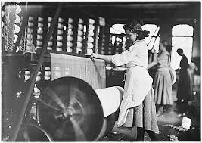](http://www.google.com/url?sa=i&rct=j&q=&esrc=s&frm=1&source=images&cd=&cad=rja&uact=8&docid=qe_APRrA1gakFM&tbnid=63uIz2-O0vDfyM:&ved=0CAUQjRw&url=http://altextbook.wikispaces.com/Kids+at+Work&ei=ikDaU6L-LoOwyASHlIHABQ&bvm=bv.72185853,d.aWw&psig=AFQjCNHHGXtShVEzzRLXWajN8mUkTza3ow&ust=1406898636545926)

[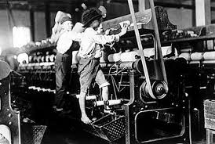](http://www.google.com/url?sa=i&rct=j&q=&esrc=s&frm=1&source=images&cd=&cad=rja&uact=8&docid=ScATK0eOFLUI0M&tbnid=FthYUp7gn39OFM:&ved=0CAUQjRw&url=http://tomakeaprairie.wordpress.com/2014/01/27/steering-the-ship-more-teaching-moves-to-support-critical-thinking-meaning-making/&ei=uUDaU-CQDouxyASmooCIBQ&bvm=bv.72185853,d.aWw&psig=AFQjCNHHGXtShVEzzRLXWajN8mUkTza3ow&ust=1406898636545926)

[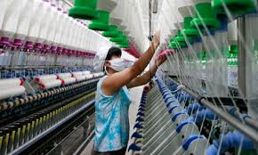](http://www.google.com/url?sa=i&rct=j&q=&esrc=s&frm=1&source=images&cd=&cad=rja&uact=8&docid=xOKuixxf6oGdtM&tbnid=lhUTYbLk1cTjVM:&ved=0CAUQjRw&url=http://www.theguardian.com/sustainable-business/blog/rising-costs-social-trend-fashion&ei=5z3aU8TJO5KpyASHpYDoCA&bvm=bv.72185853,d.aWw&psig=AFQjCNFwoYBXH2jKTLHFJb3jbPLgT42_pQ&ust=1406897956116781)

MODERN FACTORY

Name: _______________________________ Date:_________________________

**GRADE 7: MODULE 2A: UNIT 2: LESSON 1**

Entry Task

Working Conditions: Then and Now

**Directions: Study the three images of working conditions and answer the question below.**

|  |
| --- |
| 1. Clearly, working conditions in textile mills have changed since the 1800s. What specific changes do you see in these photos? What remains similar? |
|  |  |
|  |
|  |
|  |

|  |
| --- |
| 1. Why have working conditions changed? |
|  |  |
|  |
|  |
|  |
| 1. Who is responsible for changing working conditions? |
|  |  |
|  |

Name:___________________________________________________ Date:_______________________

**GRADE 7: MODULE 2A: UNIT 2: LESSON 1**

**Anchor Chart**

Agents of Change

Think about the following questions to help you get started:

What were the mill girls in *Lyddie* trying to do?

How did the response of the owners to their petitions affect working conditions?

**Agents of Change (**a person who works to change a situation)

**For Working Conditions**

|  |  |
| --- | --- |
| How can **workers** be agents of change? | How can the **government** be an agent of change? |
|  |  |
| **Consumers –** people who buy the products  How can **consumers** be agents of change? | How can **businesses** be agents of change? |

|  |  |
| --- | --- |
| A. Early Life | |
| Childhood |  |
| Young adult |  |
| B. Organizing United Farm Workers | |
| Why he formed it |  |
| What success the UFW Had |  |
| C. Lasting Legacy | |
|  | |

Name:_________________________________________________ Date:___________________________ Date

**GRADE 7: MODULE 2A: UNIT 2: LESSON 1**

Build Background Knowledge Worksheet

César Chávez – recommended option: *Harvesting Hope*

Refer to Grade 7; Module 2A; Unit 2; Lessons 2-6: Chavez’s speech .

|  |  |
| --- | --- |
| “At companies where farmworkers are protected by union contracts, we have made progress in overcoming child labor, in overcoming miserable wages and working conditions, in overcoming sexual harassment of women workers, in overcoming discrimination in employment, in overcoming dangerous pesticides …”  **union- organization formed by workers to protect their rights** | “That is why we are asking Americans, once again, to join the farmworkers by boycotting California grapes. The newest Harris Poll revealed that 17 million Americans boycotted grapes.”  **boycotting- refusal to buy goods or services** |
| “Hispanics began running for public office in greater numbers … (and) our people started asserting or standing up for their rights on a broad range of issues and in many communities across this land.”  scissors | “The very fact of our existence forces an entire industry … to spend millions of dollars year after year on increased wages, on improved working conditions, and on benefits for workers.” |

GRADE 7: MODULE 2A: UNIT 2: LESSON 2

Quote Cards

|  |  |
| --- | --- |
| “At companies where farmworkers are protected by union contracts, we have made progress in overcoming child labor, in overcoming miserable wages and working conditions, in overcoming sexual harassment of women workers, in overcoming discrimination in employment, in overcoming dangerous pesticides …”  **union- organization formed by workers to protect their rights** | “  That is why we are asking Americans, once again, to join the farmworkers by boycotting California grapes. The newest Harris Poll revealed that 17 million Americans boycotted grapes.”  **boycotting- refusal to buy goods or services** |
| “Hispanics began running for public office in greater numbers … (and) our people started asserting or standing up for their rights on a broad range of issues and in many communities across this land.”  scissors | “The very fact of our existence forces an entire industry … to spend millions of dollars year after year on increased wages, on improved working conditions, and on benefits for workers.” | |
| “At companies where farmworkers are protected by union contracts, we have made progress in overcoming child labor, in overcoming miserable wages and working conditions, in overcoming sexual harassment of women workers, in overcoming discrimination in employment, in overcoming dangerous pesticides …”  **union- organization formed by workers to protect their rights** | “That is why we are asking Americans, once again, to join the farmworkers by boycotting California grapes. The newest Harris Poll revealed that 17 million Americans boycotted grapes.”  **boycotting- refusal to buy goods or services** | |
| “Hispanics began running for public office in greater numbers … (and) our people started asserting or standing up for their rights on a broad range of issues and in many communities across this land.”  scissors | “The very fact of our existence forces an entire industry … to spend millions of dollars year after year on increased wages, on improved working conditions, and on benefits for workers.” | |

Name:__________________________________________ Date:_________________________

**GRADE 7: MODULE 2A: UNIT2: LESSON 2**

Graphic Organizer for Paragraphs 1-7 (option 1)

Claim:

**Chávez asserts that farmworkers face difficult and unfair living and working conditions.**

Provide 2 pieces of evidence to support the claim:

1. __________________________________________________________________________________________

__________________________________________________________________________________________

__________________________________________________________________________________________

__________________________________________________________________________________________

__________________________________________________________________________________________

2. __________________________________________________________________________________________

__________________________________________________________________________________________

__________________________________________________________________________________________

__________________________________________________________________________________________

__________________________________________________________________________________________

Name:_____________________________________________ Date:_________________________

**GRADE 7: MODULE 2A: UNIT 2: LESSON** 2

Graphic Organizer for Paragraphs 1-7 (option 2)

Claim:

**Chávez decided to organize the union to empower the workers in particular and the Chicano people in general.**

Provide 2 pieces of evidence to support the claim:

1. __________________________________________________________________________________________

__________________________________________________________________________________________

__________________________________________________________________________________________

__________________________________________________________________________________________

2. ________________________________________________________________________________________

__________________________________________________________________________________________

__________________________________________________________________________________________

__________________________________________________________________________________________

__________________________________________________________________________________________

Name:__________________________________________ Date:_____________________________

**GRADE 7: MODULE 2A: UNIT 2: LESSON 2**

**Commonwealth Club Address**

**Guiding Questions:**

What is happening in this section?

What is the purpose of this section?

How does this one section contribute to or add to the text as a whole?

Why would Chávez put his central claim here, in the middle of the speech?

Why not at the beginning or the end?

How do paragraphs ______ connect to Chávez’s overall claim?

Is he talking about current conditions or about the past?

Why would he talk about the way things used to be?

Name:____________________________________________ Date:______________________________

**GRADE 7: MODULE 2A: UNIT 2: LESSON 3**

**ENTRY TASK**

**Please look at the images and then answer the questions below.**

|  |
| --- |
| 1. What do you notice/wonder about these pictures? |
|  |  |
|  |
|  |

|  |
| --- |
| 1. How do these pictures connect with the Chávez speech you began reading yesterday? |
|  |  |
|  |
|  |

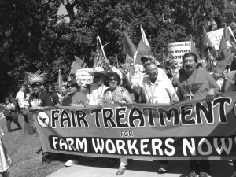[](http://www.google.com/url?sa=i&rct=j&q=&esrc=s&frm=1&source=images&cd=&cad=rja&uact=8&docid=0obyU2Soy5OO7M&tbnid=CRwoJb2HylRX6M:&ved=0CAUQjRw&url=http://media-activism.wikia.com/wiki/Culture_Jamming&ei=SGfaU4D7OcWvyASUroG4BQ&bvm=bv.72185853,d.aWw&psig=AFQjCNH0_p5XhtDBlZ_ZTsLC9R8uJHk1sQ&ust=1406908399321411)

[](http://www.google.com/url?sa=i&rct=j&q=&esrc=s&frm=1&source=images&cd=&cad=rja&uact=8&docid=C7rJ_PkYd6FN_M&tbnid=fwrBmg2Xy-h57M:&ved=0CAUQjRw&url=http://laslatinitas.com/girls/cesar-chavez&ei=fWjaU8brCo-gyATNjYGgDw&bvm=bv.72185853,d.aWw&psig=AFQjCNEIYgr0gnsDMdNUav2YNlqNf-T3xg&ust=1406908820952298)

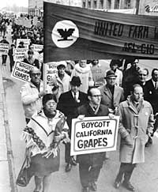



Name:__________________________________________________ Date:_____________________

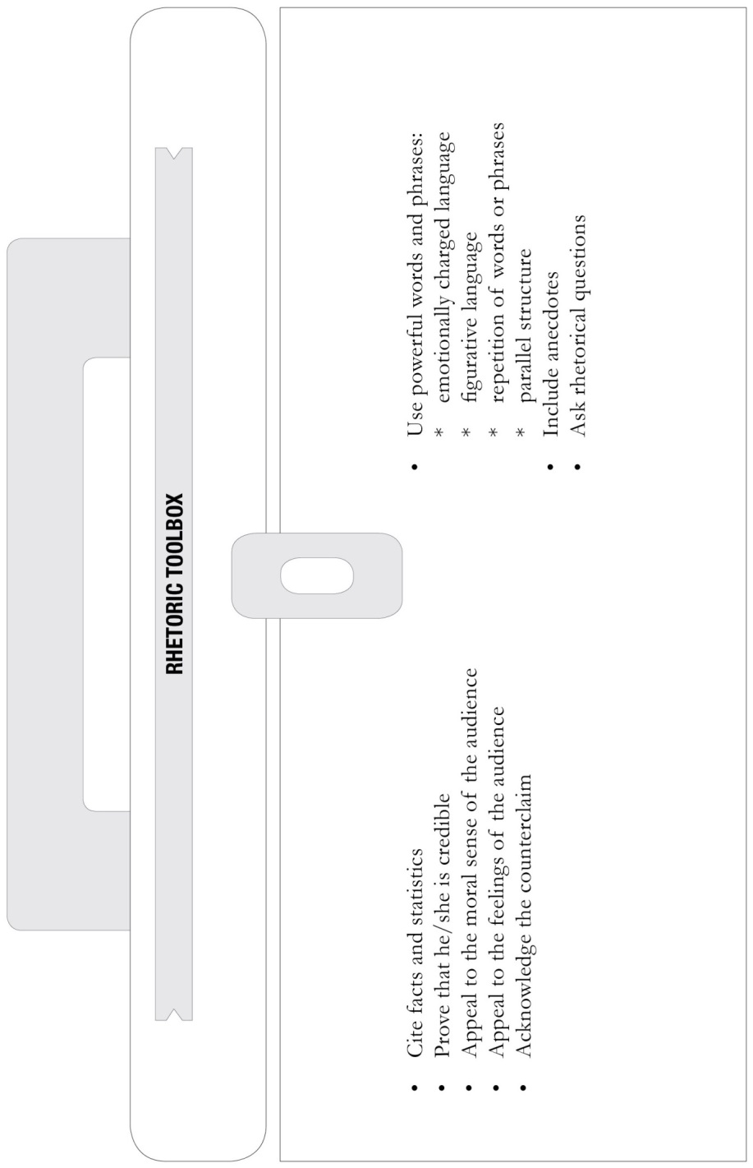**GRADE 7: MODULE 2A: UNIT 2: LESSON 3**

RHETORIC TOOLBOX ANCHOR CHART

Name:_____________________________________________ Date:_________________________

**GRADE 7: MODULE 2A: UNIT2: LESSON 4**

Graphic Organizer for Paragraphs 8-15

**rhetoric**– the art of trying to persuade someone

Speakers use a variety of tools to develop their claims.

credible – believable anecdote – detailed piece of a story

counterclaim - opposite idea rhetorical question – a question used to prove your point

Claim:

**The UFW has improved the lives of the farmworkers.**

Provide 2 additional pieces of evidence to support the claim:

1. The UFW has improved the lives of union and nonunion farmworkers.

2. _________________________________________________________________________________________

__________________________________________________________________________________________

__________________________________________________________________________________________

__________________________________________________________________________________________

3. _________________________________________________________________________________________

__________________________________________________________________________________________

(See Grade 7; Module 2A; Unit 2; Lesson 4: Graphic Organizer)

Name:_____________________________________________ Date:____________________________

**GRADE 7: MODULE 2A: UNIT 2: LESSON 5**

**Mid-Unit Assessment**

**Directions: After reading the selection (Paragraphs 18 and 19) from César Chávez’s Commonwealth Club Address, answer the following questions.**

**1. Which statement best expresses Chávez’s view of Governor Deukmejian? (RI.7.2)**

a. He causes problems for the farmworkers because he proposes unfair laws.

b. He supports the farmworkers’ cause.

c. He is more interested in supporting the growers than in enforcing laws that they break.

d. He’s a politician who should be voted out of office because he got money illegally.

**2. Which lines from the passage best reflect the main idea of this section of Chávez’s speech? (RI.7.1)**

1. “Ask the farm workers who see their lives eaten away by poverty and suffering” (line 151).
2. “It means the short life expectancy and the inhuman living and working conditions will continue” (lines 141 and 142).
3. “Are these make-believe threats?” (line 143)
4. “Since he took office, Deukmejian has paid back his debt to the growers with the blood and sweat of California farm workers” (lines 127 and 128).

**3. How does Paragraph 19 relate to Paragraph 18? (RI.7.5)**

a. P18 presents a problem, and P19 gives more examples to illustrate the problem.

b. P18 presents the evidence of a problem, and P19 contradicts that evidence.

c. P18 presents a problem, and P19 explains a possible solution.

d. P18 gives the background on the problem, and P19 gives the solution.

**4. What is Chávez’s overall purpose in this section of his speech? (RI.7.5)**

a. To get Governor Deukmejian out of office

b. To illustrate the negative effects for workers when laws aren’t enforced

c. To find possible solutions to the problems facing farmworkers

d. To explain the history behind the UFW movement

5. **Chávez claims there are many negative effects when Governor Deukmejian doesn’t enforce the law against growers. Which of the negative effects below does he NOT name? (RI.7.3)**

1. Malnutrition among children will continue.
2. Farmworkers are not getting paid on time.
3. Farmworkers are threatened if they support the union.
4. Farmworkers will go to jail for striking

6. **In lines 147–150, Chávez talks about a man named Rene Lopez. How does this contribute to the main idea of this section of the speech? (RI.7.5)**

1. Because he and Rene are friends and he wants people to know Rene will lead the union.
2. Because he wants people to know how important it is to vote.
3. Because he wants to illustrate in a personal way how farmworkers are being threatened.
4. Because he wants to explain what he means when he claims that farmworkers are poor.

**WORKING CONDITIONS TIMELINE**

|  |  |
| --- | --- |
| **1835** | The workday is limited to 10 hours. |
| **1864** | Slavery is abolished. |
| **1866** | The National Labor Union, the first national labor organization, is founded. |
| **1935** | The Wagner Act is passed, guaranteeing workers the right to form unions, negotiate contracts as a group, and go on strike. |
| **1938** | The Fair Labor Standards Act establishes a 40-hour workweek and a federal minimum wage. |
| **1966** | United Farm Workers is formed. |
| **1970** | The Occupational Health and Safety Act, designed to make sure workers have safe working conditions, is passed. |

Name:______________________________________________ Date:___________________________

**GRADE 7: MODULE 2A: UNIT 2: LESSON 6**

Working Conditions Timeline

**Where on the timeline would Lyddie and Chávez fit in?**

____________________________________________________________________________________________

__________________________________________________________________________________________

__________________________________________________________________________________________

What important laws did the government pass that affected working conditions after Lyddie and before Chávez?

______________________________________________________________________________________________________________________________________________________________________________________________________________________________________________________________________________

What laws have been passed since Chávez started the UFW?

______________________________________________________________________________________________________________________________________________________________________________________________________________________________________________________________________________

Name:______________________________________________ Date:______________________

**GRADE 7: MODULE 2A: UNIT 2: LESSON 7**

Rhetoric Tool Matching Game

Directions: Review terms in rhetoric tool box. Match the sentence strip with its tool card.

Example:

Sentence Strip: There are now 1.1 million Spanish-surname registered voters in California. (P22)

Tool Card: cite statistic

Sentence Strip: For generations, they have subjugated entire races of dark-skinned farm workers… (P26)

Tool Card: Appeal to moral sense of audience

|  |  |
| --- | --- |
| **Sentence Strips** | **Tool Cards** |
| It means that the right to vote in free elections is a sham. It means the right to talk freely about the union among your fellow workers on the job is a cruel hoax. It means the right to be free from threats and intimidation by growers is an empty promise. (P18) | Cite statistic |
| The newest Harris Poll revealed that 17 million Americans boycotted grapes. (P20) | Includes personal anecdote |
| Today the growers are like a punch-drunk old boxer who doesn’t know he’s past his prime. (P26) | Rhetorical questions |
| These are the sins of the growers, not the farm workers. (P26) | Appeal to moral sense of audience |
| Are these make-believe threats? Are they exaggerations? (P19) | Figurative language |
| … and ask the family of Rene Lopez, the young farm worker from Fresno who was shot to death last year because he supported the union as he came out of a voting booth. (P19) | Repetition of words and phrases |
| We didn’t abuse and exploit the people who work the land. (P26)  scissors | Emotionally charged language |

Name:__________________________________________ Date:__________________________-

GRADE 7: MODULE 2A: UNIT 2: LESSON 8

END OF UNIT 2 ASSESSMENT: Analyzing the Structure of Chavez’s Wrath of Grapes Speech

Wrath of Grapes Speech

César Chávez, May 1986 (excerpted)

SECTION A

P1. I am speaking to you about our Wrath of Grapes boycott.

P2. Because I believe our greatest court, the court of last resort, is the American people. And I believe that once you have taken a few moments to hear this message, you will **concur** in this verdict along with a million other North Americans who are already committed to the largest grape boycott in history.

P3. The worth of humans is involved here.

P4. I see us as one family. We cannot turn our backs on each other and our future. We farm workers are closest to food production. We were the first to recognize the serious health hazards of agriculture pesticides to both consumers and ourselves.

SECTION B

P5. Twenty years ago, over 17 million Americans united in a grape boycott campaign that transformed the simple act of refusing to buy grapes into a powerful and effective force against poverty and injustice. Through the combined strengths of a national boycott, California farm workers won many of the same rights as other workers—the right to organize and negotiate with growers.

P6. But we also won a critical battle for all Americans. Our first contracts banned the use of **DDT, DDE, Dieldrin** on crops, years before the federal government acted.

SECTION C

P7. Twenty years later, our contracts still seek to limit the spread of poison in our food and fields, but we need your help once again if we are to succeed.

P8. A powerful self-serving alliance between the California governor and the $14 billion agricultural industry has resulted in a systematic and **reckless** poisoning of not only California farm workers but of grape consumers throughout our nation and Canada.

P9. The hard-won law **enacted** in 1975 has been trampled beneath the feet of self-interest. **Blatant** violations of California labor laws are constantly ignored. And worst of all, the **indiscriminate** and even illegal use of dangerous pesticides has radically increased in the last decade, causing illness, permanent disability, and even death.

SECTION D

P10. Human lives are worth more than grapes and the innocent-looking grapes on the table may disguise poisonous **residues** hidden deep inside, where washing cannot reach.

P11. Of the 27 legal restricted toxic poisons currently used on grapes, at least five are potentially as dangerous or more hazardous to consumers and grape workers than deadly Aldicarb and Orthene.

P12. Here are five major threats to your health that cling to the California table grapes.

Parathion and Phosdrin are highly poisonous **insecticides**, similar to **nerve gas**, and are responsible for the majority of deaths and serious poisoning of farm workers. They cause birth defects and are **carcinogens**.

P13. How do we comfort the mother of maimed and stillborn infants, the parents who watch their teenage children sicken or die?

P14.What report can be cited at the hospital beds I visit, at growing numbers of **wakes** I attend?

P15.What court will hear the case of 32-year-old Juan Chaboya, murdered by deadly chemicals in the freshly sprayed fields outside San Diego? His dead body dumped by the growers 45 miles away at a Tijuana clinic? What excuse for justice will we offer his four children and his widow if we do nothing?

SECTION E

P16.Now is the time for all of us to stand as a family and demand a response in the name of decency. Too much is at stake. This is a battle that none of us can afford to lose because it is a fight for the future of America. It is a fight we can win, and it is a fight that everyone can join.

P17.I am asking you to join us now and be counted to join the growing family of individuals who will boycott grapes until the demands of decency have been met.

*****

P18. My friends, the wrath of grapes is a **plague** born of selfish men that is indiscriminately and undeniably poisoning us all. Our only protection is to boycott the grapes, and our only weapon is the truth. If we unite, we can only triumph for ourselves, for our children, and for their children.

Name:________________________________________________ Date:______________________________

GRADE 7: MODULE 2A: UNIT 2: LESSON 8

END OF UNIT 2 ASSESSMENT: Analyzing the Structure of Chavez’s Wrath of Grapes Speech

**Directions:** Read the “Wrath of Grapes” speech carefully. Use the text to answer the questions below.

1. César Chávez’s central purpose for this text is to convince his audience to boycott the grapes. Identify the line in the speech where he articulates this purpose. (RI.7.1)

|  |
| --- |
|  |
|  |
|  |
|  |
|  |

2. Identify two reasons Chávez gives to join the boycott. (RI.7.2)

|  |
| --- |
|  |
|  |

**3.** Reread the speech. How does each part develop the central claim? (RL7.5)

|  |  |  |
| --- | --- | --- |
| Section | What is the main claim in this part of the speech? | How does this claim develop the central claim of the speech? |
| A | Consumers will support the boycott because we are all one people, and we have a common purpose. Consumers and farmworkers share the same interest. | Chávez is calling on consumers to join a boycott, so he begins by referring to their sense of justice and assuring them that they have a common cause with the farmworkers. |
| B |  |  |
| C |  |  |
| D |  |  |
| E |  |  |

4. Reread Section D. In what ways does Chávez create sympathy for his cause? (RI.7.5)

a. He illustrates the problem with specific, personal examples.

b. He names the poisons that are used on the grapes.

c. He gives the background of the boycott.

d. He summarizes all the horrible things that have happened to farmworkers.

5. How is this different from what he is trying to do in Sections B and C? (RI.7.5)

|  |
| --- |
|  |
|  |
|  |
|  |

Name:__________________________________________ Date:_____________________

GRADE 7: MODULE 2A: UNIT 3

**'Prison-like' conditions for workers making IBM, Dell, HP, Microsoft and Lenovo products**

[Rebecca Thomson](http://www.computerweekly.com/contributor/Rebecca-Thomson) Tuesday 17, February 2009 13:00

**Chinese factory workers are working in prison-like conditions for 41 cents an hour to make computer parts for IBM, Microsoft, Hewlett-Packard, Lenovo and Dell, a** [**report**](http://www.nlcnet.org/admin/media/document/China/2009_meitai/HIGHTECH_MISERY_CHINA_WEB.pdf) **claims.**

US organization the [National Labor Committee](http://www.nlcnet.org/index.php) (NLC) found 2,000 workers at the Meitai factory work an average of 74 hours a week, for a base wage of 64 cents an hour. This drops to 41 cents an hour after room and board is removed.



The workers, mostly young women aged from 18 to their mid-20s, are not allowed to talk, listen to music, look around them, put their hands in their pockets, or go to the toilet unless it is an official break.

Workers are encouraged to monitor each other and are *fined* if they break rules. These include being one minute late for a shift or putting personal items on a work desk.

On the assembly line, a keyboard passes each worker every 7.2 seconds. The worker has to snap six or seven keys into place in that time.

**Prison sentence**

The NLC visited the factory between June and September 2008 and in January this year. One worker said, *"I feel like I am serving a prison sentence. We are really livestock and should not be called workers."*

The Meitai Plastics and Electronics factory in Dongguan City, Guangdong Province, China, makes keyboards and other equipment for Dell, HP, IBM, Microsoft, and Lenovo.

The companies said they would investigate conditions at the factory but none said they would cancel contracts linked to the factory.

Microsoft said the factory supplies one of its contracted manufacturers. A spokesperson said, "We are working closely with our industry partners and contracted supplier to conduct an investigation and make any necessary improvements to *comply* with all guidelines and regulations."

**Actively investigating**

Lenovo also said it does not deal directly with the factory, which has links with one of its suppliers. The company said the factory will be audited by the Electronic Industry Citizenship Coalition. It also said its supplier would be investigating the factory.

A spokesperson for HP said, "The factory named in the report is not one of HP's direct suppliers, but is a supplier to two of our suppliers. HP will *audit* this facility through a validated industry *audit*. This will be conducted promptly by a third-party audit firm on behalf of the Electronic Industry Citizenship Coalition. Based on the results of the audit, we will work together with our supplier to develop corrective actions where appropriate."

Dell said it was "actively investigating" the issues in the report. A spokesperson said, "I can tell you that any reports of poor working conditions in Dell's supply chain are investigated and appropriate action is taken."

Charles Kernaghan, report author and director at the NLC, said, "The $200 personal computer and the $22.99 keyboard may be seen as a great bargain, but in the long run they come at a terrible cost."

"Through the (Electronic Industry Citizenship Coalition (EICC), of which IBM is a founding member, a joint-audit is being conducted to assemble the facts and address this issue with the supplier/or suppliers involved."

*fined –* charged money

*livestock* – farm animals

*comply* - obey

*audit* - examine

http://www.computerweekly.com/news/2240088431/Prison-like-conditions-for-workers-making-IBM-Dell-HP-Microsoft-and-Lenovo-products

Name:____________________________________________ Date:______________________

**GRADE 7: MODULE 2A: UNIT 3**

Resources

# Nightline's Look into Apple's Foxconn Factories

Tuesday February 21, 2012 8:29 pm PST by Arnold Kim

ABC aired their Nightline [special](http://www.macrumors.com/2012/02/18/apple-grants-abcs-nightline-access-to-foxconn-factories-in-china/) tonight where they took an inside look at Apple's Foxconn factories. Apple allowed Nightline access to the Foxconn factories that produce iPhones and iPads. Foxconn is the world's largest electronics manufacturing company that has contracts with most major U.S. electronics companies.

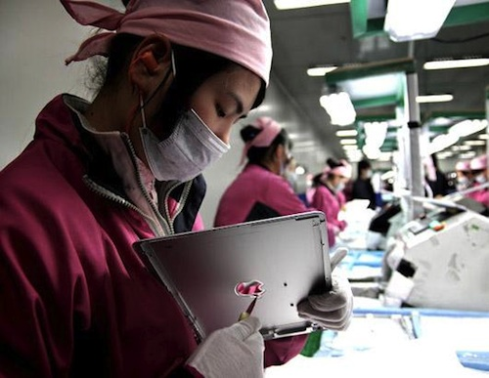

Overall, the report held no real surprises. They summarized many of the events leading up to the bad press surrounding Foxconn's working conditions. The cluster of suicides was mentioned over the past few years that led to the installation of suicide netting to discourage *impulsive* suicide attempts. Nightline did note that the suicide rate at Foxconn was still below the Chinese national average. Tim Cook, then Apple's COO, flew to China during that time to help coordinate the response. Beyond the suicide netting, pay was increased and counseling offices were set up.   
  
Work on the factory line is described as *monotonous* with 12 hour shifts with two hour long meal breaks. When questioned, workers complained about *cramped* dorms and low pay, but the jobs were in high demand with thousands coming to Foxconn for work. Nightline traveled to a nearby village to compare those living conditions which didn't seem any better. The families who remained in the village told Nightline that their living conditions were better with the "young people" working in the factories.   
  
[The Verge](http://www.theverge.com/2012/2/22/2815654/abc-nightline-apple-foxconn-factories) compiled some interesting statistics from the report:

- It takes 141 steps to make an iPhone, and the devices are essentially all handmade   
- It takes five days and 325 hands to make a single iPad   
- Foxconn workers pay for their own food — about $.70 per meal, and work 12 hour shifts   
- Workers who live in the dorms sleep six to eight a room, and pay $17.50 a month to do so   
- Workers make $1.78 an hour

Nightline's visit coordinated with Fair Labor Association who is compiling their own report on the factories.   
  
Overall, the report was fair-to-positive making it seem like Apple was being very *responsive* to the concerns.

*impulsive* – acting without thinking

*monotonous* - boring

*cramped* - overcrowded

*responsive* – open

http://www.macrumors.com/2012/02/22/nightlines-look-into-apples-foxconn-factories/

GRADE 7: MODULE 2A: UNIT 3

Resources

**A Trip to The iFactory: 'Nightline' Gets an Unprecedented Glimpse Inside Apple's Chinese Core**

Feb. 20, 2012

By BILL WEIR, REPORTER'S NOTEBOOK via [Nightline](http://abcnews.go.com/nightline)

View videos: Apple's Chinese Factories: Exclusive, Apple's Controversial Supplier Foxconn

<http://abcnews.go.com/International/trip-ifactory-nightline-unprecedented-glimpse-inside-apples-chinese/story?id=15748745>

Name:____________________________________________ Date:_______________________

**GRADE 7: MODULE 2A: UNIT 3**

Resources

# Workers' rights *'flouted'* at Apple iPhone factory in China

New, cheaper device being produced illegally, non-profit organization China Labor Watch claims.



Apple iPhones advertised at a shop in China, where it is claimed cheaper versions are being produced under illegal and abusive conditions. Photograph: Kim Kyung-Hoon/Reuters

The new cheaper [iPhone](http://www.theguardian.com/technology/iphone) that [Apple](http://www.theguardian.com/technology/apple) will *unveil* to a global audience on Tuesday is being produced under illegal and abusive conditions in Chinese factories owned by one of America's largest manufacturing businesses, investigators have claimed.

Workers are asked to stand for 12-hour shifts with just two 30-minute breaks, six days a week, the non-profit organization [China](http://www.theguardian.com/world/china) Labor Watch [has claimed](http://www.chinalaborwatch.org/news/new-463.html). Staff are *allegedly* working without *adequate* protective equipment, at risk from chemicals, noise and lasers, for an average of 69 hours a week. Apple has a self-imposed limit of 60 working hours a week.

The problems were uncovered at a plant in Wuxi, near Shanghai, where Apple's first low-cost handset, *dubbed* the iPhone 5C, is being produced. The plant is owned by Florida-based [Jabil Circuit](http://www.jabil.com/about_us/jabil_overview/), a US company with 60 plants in 33 countries including Scotland, and a turnover of $17bn (£11bn) a year. Jabil said it had uncovered problems last month and was taking immediate steps to investigate the *allegations*. Apple said its experts were "already on site" to look into the claims.

"It is the duty of national governments to *regulate* the conduct of their companies abroad," China Labor Watch argued. "The US government also shares in the responsibility for labor abuses committed by US companies manufacturing in China."

Jabil has 30,000 employees at Wuxi, where cases for the colorful iPhone 5C are being . The majority are hired indirectly through [employment](http://www.theguardian.com/global-development/employment) agencies, the investigators claim. Local laws set a limit of 30% agency workers in any company's workforce to prevent the *exploitation* of staff.

In order to be recruited, staff are asked to sign two-year contracts and pay significant sign-up fees, and are also charged to process identification documents, open a bank account for wages, and for *intrusive* medical examinations.

The report, published on Thursday, is based on interviews with about 90 employees and evidence from an undercover investigator who worked at Wuxi for a month. It also claims that female workers were asked to take pregnancy tests, which would be both against Chinese law and a *breach* of the code of practice imposed last year by Apple on all its suppliers.

Apple has made efforts to improve conditions in the factories where its products are assembled after uproar over the treatment of workers at the vast Foxconn factories, where iPhones are assembled.

The Jabil factory arranges accommodation for workers in dormitory blocks where some sleep eight to a room, suffering disturbed rest because the rooms are shared by a mixture of day- and night-shift staff. The report claims the base wage at Jabil is 1,500 RMB (£160) a month, half the average monthly wage in the city of Wuxi. Only by working 100 hours of overtime a month can employees secure an income that matches the average.

Because of the poor pay and 12-hour shift patterns "married workers have no choice but to leave their children in their rural homes with grandparents", the report states. Strict secrecy is imposed to protect the Apple products they are helping to create. Staff sign confidentiality agreements and undergo security checks on entering the plant and when leaving their work station for a toilet break.

"The factory provides protective equipment," the report states, "but some workers either fail to receive it or use it in the wrong way due to a lack of risk awareness and monitoring.

"Despite this, the mechanisms for protecting important information related to products and the company are mature and well-developed, receiving a lot of attention from management."

Jabil said it had uncovered issues at Wuxi during an internal audit in August and was again sending a team to investigate.

It stated: "Jabil is committed to ensuring every employee is provided a safe working environment where they are treated fairly, with dignity and respect. We take seriously any *allegation* that we are not fulfilling that commitment and are taking immediate action to ensure recent *allegations* are thoroughly investigated and, if found to be credible, corrected."

Apple said in a statement it was "committed to providing safe and fair working conditions" adding: "We lead the industry with far-reaching and specialized audits, the most transparent reporting and educational programs that enrich the lives of workers who make our products.

Apple is the first and only technology company to be admitted to the Fair Labor Association, and we are dedicated to protecting every worker in our supply chain.

"We are proud of the work we do with our suppliers to improve conditions for workers. Our program goes far beyond monitoring by *ensuring* corrective actions where they are needed and aggressively enforcing our supplier code of conduct wherever Apple products are made. We believe in transparency and accountability, both for our suppliers and ourselves."

Jabil was founded in 1966 in a garage in Detroit by William Morean and James Golden, who combined their first names – James and Bill – to christen their company. As American companies such as Apple exported their manufacturing to countries with lower wages, Jabil followed, opening its first plant outside the US in Scotland in 1993. Operations have now expanded to China, Brazil, India and Vietnam.

*unveil* – reveal

*flouted* – ignored

*allegedly* – supposedly

*adequate* – acceptable

*dubbed* – called

*allegations* – charges

*regulate* – control

*exploitation* – misuse

*intrusive* – upsetting

*breach* - break

*ensuring* - guaranteeing

http://www.theguardian.com/technology/2013/sep/05/workers-rights-flouted-apple-iphone-plant

Name:______________________________________________ Date:_______________________________

**Grade 7: Module 2A: Unit 3: Lesson 1a**

Comparing Modern Day Labor conditions

|  |  |  |
| --- | --- | --- |
| Category | Apple’s Chinese Factories Exclusive  Video | Wegman’s employee website  Wegmans.com (about us/diversity/careers) |
| Hours |  |  |
| Compensation |  |  |
| Health, Safety, and Environment |  |  |
| Treatment of Individual Workers (Harassment and Discrimination |  |  |
| Treatment of Groups of Workers (Unions) |  |  |
| Child and Forced Labor |  |  |

Name:___________________________________ Date:____________________

**Grade 7: Module 2A: Unit 3: Lesson 1b**

Beginning Research

Research Question:

***How can working conditions be described in the modern day technology industry?***

Use at least three of the five different sources of information given to investigate working conditions in the modern day technology industry.

A Researcher’s Notebook page for each source must be completed.

Name:____________________________________________ Date:_________________________

**Grade 7: Module 2A: Unit 3: Lesson 1c**

Researcher’s Notebook

Research Question: ___________________________________________________________________________

__________________________________________________________________________________________

Source Title: _________________________________________________________________________________

__________________________________________________________________________________________

Author:____________________________________________________

Publisher:__________________________________________________ Date:__________________________

|  |  |
| --- | --- |
| **SOURCE NOTES (Copied)** | **SOURCE NOTES PARAPHRASED (In Your Own Words)** |
|  |  |
|  |  |
|  |  |
| **SOURCE NOTES (Copied)** | **SOURCE NOTES PARAPHRASED (In Your Own Words)** |
|  |  |
|  |  |
|  |  |
|  |  |
|  |  |
|  |  |
|  |  |
|  |  |
|  |  |
|  |  |
|  |  |
|  |  |