East Meadow School District
CURRICULUM AREA PROJECT
2014 - 2015
Grade 9 Social Studies
Common Core Classroom Activities

East Meadow High School
Superintendent Louis R. DeAngelo
Principal Richard Howard
Writers: Michelle Barnhill (Facilitator), Judi Trocchio

Table of Contents
Abstract | 3
Rationale | 3
Common Core Unit: Golden Ages | 4
Common Core Unit: Religions | 9
Common Core Unit: Turning Points | 13
Common Core Unit: Global Vocabulary | 19
Common Core Unit: Trade Networks | 25
Common Core Unit: Cultural Diffusion | 31

ABSTRACT
This Social Studies Common Core CAP is intended to create lessons that align with the Common Core. It will make use of text and writing tasks that correlate with the Ninth Grade Global History curriculum. The CAP will focus on independent work and group activities to be completed by students. These activities will include: vocabulary tasks, reading tasks, discussion tasks, writing tasks, and essential questions. Students will be required to cite specific textual evidence to support their analysis of the text. Each lesson will commence with an assignment that allows the teacher to evaluate student comprehension of the material.
This CAP will focus on the Common Core standards that have been laid out for History/Social Studies. The reading standards focus on citing textual evidence from readings, analyzing the author’s point of view, and as well as comparing and contrasting readings. The writing standards focus on writing arguments with the use of factual evidence from readings, using technology to attain additional information which relates to assigned readings, as well as planning, revising, editing, and rewriting written pieces.

RATIONALE
The Common Core State Standards have been adopted by 43 states, including New York. The purpose of the Common Core is to ensure students are sufficiently prepared for success in postsecondary education and the workforce. In order for these standards to be met units that focus on the skills that students are required to achieve must be developed. This CAP consists of unit plans that are designed to meet the standards set forth by the Common Core.

Unit: Golden Age
Aim: Why is the Pax Romana considered a golden age?

Common Core Objectives:
- CCSS.ELA-Literacy.RH.9-10.1 Cite specific textual evidence to support analysis of primary and secondary sources, attending to such features as the date and origin of the information.
- CCSS.ELA-Literacy.RH.9-10.2 Determine the central ideas or information of a primary or secondary source; provide an accurate summary of how key events or ideas develop over the course of the text.
- CCSS.ELA-Literacy.RH.9-10.4 Determine the meaning of words and phrases as they are used in a text, including vocabulary describing political, social, or economic aspects of history/social science.
- CCSS.ELA-Literacy.RH.9-10.5 Analyze how a text uses structure to emphasize key points or advance an explanation or analysis.
- CCSS.ELA-Literacy.RH.9-10.7 Integrate quantitative or technical analysis (e.g., charts, research data) with qualitative analysis in print or digital text.

Social Studies Standards:
Standard 2: World History
Students will use a variety of intellectual skills to demonstrate their understanding of major ideas,
eras, themes, developments, and turning points in world history and examine the broad sweep of
history from a variety of perspectives.

Standard 5: Civics, Citizenship, and Government
Use a variety of intellectual skills to demonstrate their understanding of the necessity for
establishing governments; the governmental system of the U.S. and other nations; the U.S.
Constitution; the basic civic values of American constitutional democracy; and the roles, rights, and
responsibilities of citizenship, including avenues of participation.

Materials:
Leaning Packet “ The Pax Romana”

Do Now: Describe 3 characteristics of a golden age

Lesson: Students will read documents pertaining to various changes that occurred during the Pax Romana and answer questions.

Summary: Students will pair up and answer the central question: “Which two achievements do you think were the greatest and why?
Name ______________________ Date _______

The Pax Romana
The Pax Romana was a period of time when Rome underwent many changes. In this packet, you will learn about only a few of the changes that occurred during this era. You will rad the information, answer the questions and eventually access whether or not these changes altered Rome for the better.
ROADS
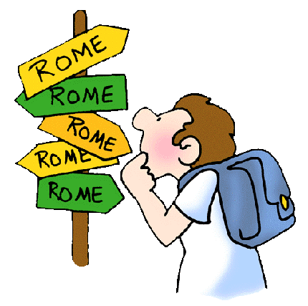
There is an old expression, "All roads lead to Rome." In ancient Rome, Rome was the heart of the empire. Each time a new city was conquered, a road was built from that city back to Rome.
Roman roads were constructed unlike any other. The center of the road was slightly raised so that rain water would naturally run off the middle and fall into the gutters, which were located at the sides of the roads. Roman roads also had speed bumps that could be used as walkways during rainstorms, because they were raised. Along the side of road, the Romans built road signs called milestones. Milestones did not give any information about other towns in the area. Milestones told how far it was back to Rome.
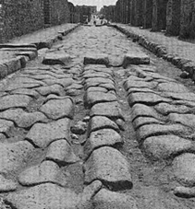
Up until about a hundred years ago, people were still using these roads! In recent years, instead of building new roads, modern engineers simply covered many of the old Roman roads with a coat of asphalt. The Romans did a wonderful job building roads!
Can you see the “speed bump”, the gutters, the bowing in the middle?
Explain the expressions “all roads lead to Rome.”
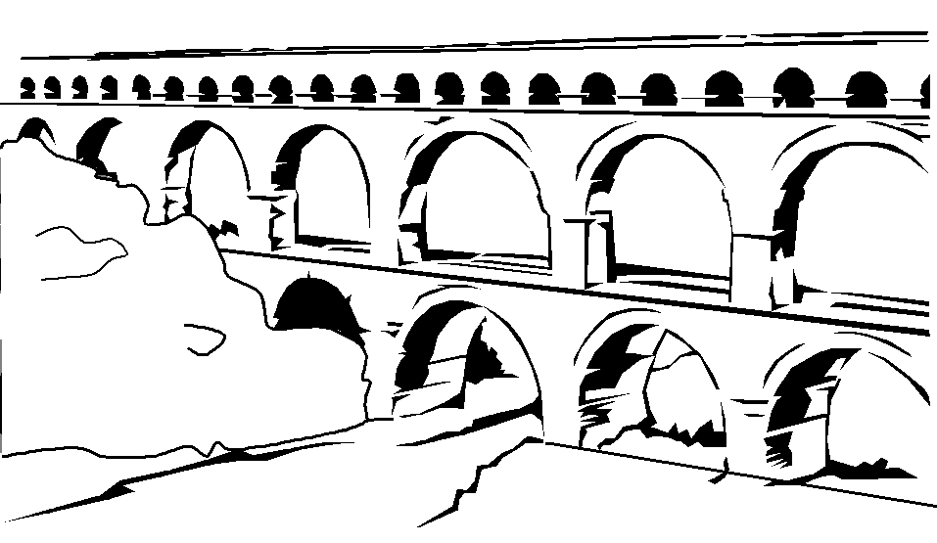
_______________________________________________________________________________________________________________________________________________
AQUEDUCTS
As cities grew, the ancient Romans needed more fresh water. To solve this problem, they built aqueducts. These were massive construction projects. An aqueduct, properly speaking, is the entire conduit - from a fresh water-spring to a town. (CONDUIT—A natural or artificial channel through which fluids may be conveyed).
Where aqueducts had to cross valleys, some were built above ground, on arches. Most of the time, they were underground conduits, and sometimes conduits lying right on the ground. These conduits could be made of clay or wood, covered or encrusted with stone. The pipes inside the conduits, that carried the water, were made of lead, which in turn required vast mining enterprises and then transportation to get all these pipes out into the field all over the empire, and most of the lead was mined in Spain.
What is extraordinary about the aqueducts is the planning that must have gone into their construction. Since the ancient Romans didn't use pumps, aqueducts had to be positioned at a relatively constant slope for dozens of miles. You try building something that drops by only 100 feet in 40 miles....and you'll begin to understand why scholars refer to the ancient Romans as such great builders!
Why were aqueducts so important to the growth of the Roman Empire?____________________ _________ ____________________________________________________________________

THE PANTHEON
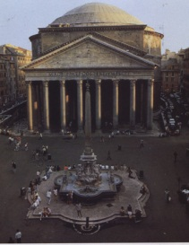
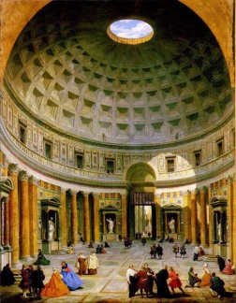

The Emperor Hadrian who reigned from 117-138 AD was responsible for the Pantheon, one of the most influential buildings in western architecture. In what has been called an architectural revolution, the architects of Hadrian transformed the traditional Roman temple plan into a structure with curved architecture and concrete. It best shows the importance of space in Roman architecture. Hadrian, who was strongly influenced by Greek culture, dedicated the temple to "All Gods" using a Greek (Pan=All; Theon: Gods) rather than Latin name. With its curved dome and orderly division of the interior walls into different levels, the Pantheon becomes an architectural example of the Greek idea of cosmos (heavens). The dome with its central oculus (opening) and original bronze rosettes was understood as the vault of heaven. The universal aspects of this design and dedication appealed to Hadrian's conception of the Empire as embracing all the lands under the heavens.
What is the Pantheon?____________________________________________________________ ______________________________________________________________________________
Why is the Pantheon a marvel of architecture? ________________________________________
______________________________________________________________________________

What is the symbolism behind the construction of the Pantheon?__________________________
______________________________________________________________________________

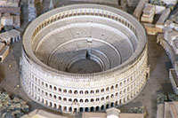
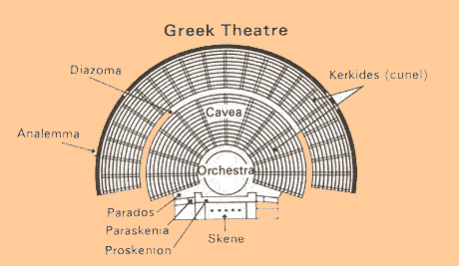
GLADIATOR FIGHTS/COLOSSEUM BUILDING
The Romans took the Greek version of a theater and enclosed it, making it a full circle (compare the images to the right and left) - this is called an “amphitheater.” Emperor Vespasian, started construction of the Colosseum, the largest amphitheater in the empire in AD 72. It was completed in AD 80, the year after Vespasian's death. The huge amphitheater was built in the center of Rome. The Colosseum could accommodate some 55,000 spectators who could enter the building through no less than 80 entrances. Above the ground are four stories, the upper story contained seating for lower classes and women. The lowest story was preserved for prominent citizens. Below the ground were rooms with mechanical devices and cages containing wild animals. The cages could be hoisted, enabling the animals to appear in the middle of the arena. The Colosseum was covered with an enormous awning known as the velarium. This protected the spectators from the sun. It was attached to large poles on top of the Colosseum and anchored to the ground by large ropes. A team of some 1,000 men was used to install the awning.
Emperors used the Colosseum to entertain the public with free games. Those games were a symbol of prestige and power and they were a way for an emperor to increase his popularity. Games were held for a whole day or even several days in a row. They usually started with comical acts and displays of exotic animals and ended with fights to the death between animals and gladiators or between gladiators. These fighters were usually slaves, prisoners of war or condemned criminals. Sometimes free Romans and even Emperors took part in the action. The southern side of the Colosseum was felled by an earthquake in 847. Parts of the building - including the marble facade - were used for the construction of later monuments, including the St. Peter's Basilica.

What purposes did the Colosseum serve to the Romans?_________________________________
______________________________________________________________________________
______________________________________________________________________________

DAILY LIFE
ROME’S GREAT GOLDEN AGE: 27 BCE-180CE
Contributing Cause: The vast Roman Empire included all lands around the Mediterranean Sea and most of Northwest Europe. Roman life was comfortable for many. Cities had water and sewage systems, theaters, and public baths. The wealthy had villas with central heating systems.
Developments during Pax Romana
*** Roman culture spread throughout the empire.***
Government: | Law: | Engineering:
1. Rome became an empire ruled by an emperor.  2. Full-time workers were hired to carry out the emperor's polices.  3. Government in the provinces improved. | 1.One set of laws governed the empire  2.The system of laws included all branches of public/private law that exist today  3. Lawyers interpreted the laws. | 1. The system of roads greatly improved. APPIAN WAY  2. Aqueducts brought water from the mountains to Roman cities.

How did daily life improve for the average Roman during the Pax Romana?
____________________________________________________________________________________________________________________________________________________________

SUMMARY
Based on today's lesson, do you think that the "Pax Romana" altered Rome for the better? Could it be considered a golden age? Using information found in this packet, give two reasons supporting why.

____________________________________________________________________________________________________________________________________________________________________________________________________________________________________________________________________________________________________________________________________________________________________________________________________________________________________________________________________________________

UNIT: Religions
Aim: To what extent did, and does, the Hindu caste system affect Indian life?
Common Core Objectives:
- CCSS.ELA-Literacy.RH.9-10.1 Cite specific textual evidence to support analysis of primary and secondary sources, attending to such features as the date and origin of the information.
- CCSS.ELA-Literacy.RH.9-10.2 Determine the central ideas or information of a primary or secondary source; provide an accurate summary of how key events or ideas develop over the course of the text.
- CCSS.ELA-Literacy.RH.9-10.4 Determine the meaning of words and phrases as they are used in a text, including vocabulary describing political, social, or economic aspects of history/social science.
- CCSS.ELA-Literacy.RH.9-10.5 Analyze how a text uses structure to emphasize key points or advance an explanation or analysis.
- CCSS.ELA-Literacy.RH.9-10.7 Integrate quantitative or technical analysis (e.g., charts, research data) with qualitative analysis in print or digital text.

Social Studies Standards:
Standard 2: World History
- Students will use a variety of intellectual skills to demonstrate their understanding of major ideas, eras, themes, developments, and turning points in world history and examine the broad sweep of history from a variety of perspectives.

Standard 5: Civics, Citizenship, and Government
- Use a variety of intellectual skills to demonstrate their understanding of the necessity for establishing governments; the governmental system of the U.S. and other nations; the U.S. Constitution; the basic civic values of American constitutional democracy; and the roles, rights, and responsibilities of citizenship, including avenues of participation.

Materials:
- Worksheets
  - “Do Now”
  - “The Caste System”
  - “Hinduism & the Caste System”
- Video: “The Indian Caste System-An Introduction”
- Pen/Pencil
- Lined Paper
- Access to the Internet

Do Now:
Students will work in pairs to complete the “Do Now” worksheet, which is a quote taken from the Rig Veda. This quote is the basis of the caste system. Students will have to analyze the quote and label the different castes on the human body, as per the text. Then we will discuss the meaning of the quote.

Lesson:
1. Discuss the “Do Now” as a class. Ask the student’s questions like “why would the Brahmin be the mouths of the man, why would shudras be the feet? What roles do you think they may play in Hindu society?
2. Students will now have a chance to put their theories to the test and see if their analysis of the quote is correct when they read the handout entitled “The Caste System”. This handout clearly explains all of the castes in India and what their roles are in society. As they read, students will be expected to complete a graphic organizer/ social pyramid of the caste system.
3. Students will also be asked to write three extra questions about the reading, with their answers on the bottom of the paper. They will be instructed to keep the central focus of the lesson in mind when they write their questions. After they are done, the students are to remove the answers from their sheet and give the questions to someone else in the class, who will then answer the question and give the answers back to the question-writer for grading. Informal Assessment
4. Students should be able to answer the questions on the worksheet (everyone should fill them out on paper, and should be able to answer when class goes over worksheet)
5. Formal Assessment
6. The students should be able to apply castes throughout the unit. There will be an exam at the end of the unit

Summary:
- Play “The Indian Caste System” for the class and discuss the implications of the caste system on Indian society both then and now.
- Exit card- write an essay question based on today’s lesson.

Worksheet #1
Name _____________________ “DO NOW” Date _______________________
.Background: The Purusha-sukta is described as a hymn of creation shown through the story of Purusha, the primitive god, and how the world was created through him. The Purusha was immortal, mighty and infinite. All creatures are one fourth of him and the rest of his body is spread in the heavens. From him came the Vedas (a sacred text), all of the gods, and all animals and man. The four castes were also created from different parts of his body.
Directions: Read the excerpt below and label the image appropriately.
"When they divided Purusa, how many ways did they apportion (distribute) him? What was his mouth? What were his arms? What were his thighs, his feet declared to be? His mouth was the Brahmin [caste], his arms were the Rajanaya [Kshatriya caste], his thighs the Vaisya [caste]; from his feet the Shudra [caste] was born."
--Rig Veda concerning the origin of the members of the Caste system

Questions:
1. Which caste (s) do you think would be the most “important”? Why? ______________________________________________________________________________
______________________________________________________________________________

2. What roles (jobs) might each caste play in society? Why do you think this?
____________________________________________________________________________
The Caste System

About 1500BC, powerful nomadic warriors known as Aryans appeared in northern India. The warriors were from Central Asia, but managed to get over the Hindu-Kush Mountain range by finding lower passes in the mountains, such as the Khyber Pass in modern-day Pakistan. The Aryans conquered India and soon divided their society into separate classes called “castes”. Castes are a rigid class system. This means that a person is born into their caste and never changes or mixes with members of other castes. Caste members live, eat, marry, and worked with their own group.
At the top of the caste system are the Brahmin – the priests, teachers, and judges. Next comes the Kshatriya (KUH SHAT REE YUHZ), the warrior caste. The Vaisya (VEEZ YUHZ) caste are the farmers and merchants, and the Sudras, are craftworkers and laborers.
The untouchables are the outcastes, or people below the caste system. Their jobs or habits involved “polluting activities” including:
• Any job that involved ending a life, such as fishing.
• Killing or disposing of dead cattle or working with their hides.
• Any contact with human emissions such as sweat, urine, or feces. This includes
occupational groups such as sweepers and washermen.
• People who ate meat.
Untouchables were often forbidden to enter temples, schools and wells where higher castes drew water. In some parts of southern India, even the sight of untouchables was thought to be polluting. The untouchables were forced to sleep during the day and work at night. Many untouchables left their rigid social structure by converting to Islam, Buddhism, or Christianity.
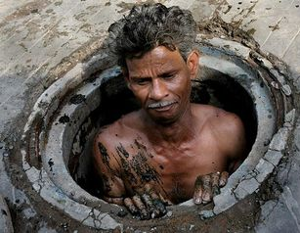
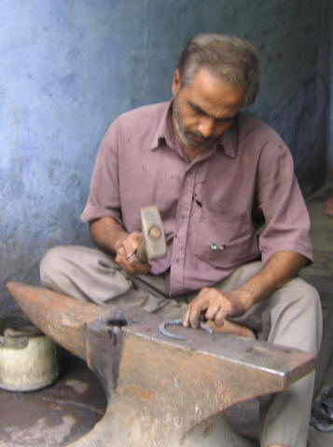
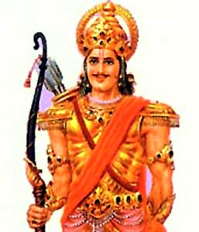
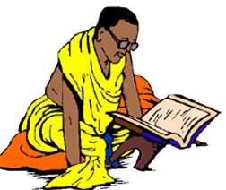
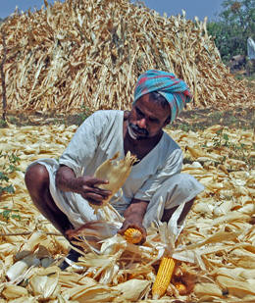
The Caste System has been illegal in India for more than fifty years, but it continues to shape people’s lives. The Indian government has provided the Harijan a term now popularly used in place of untouchable, with specific employment privileges, and granted them special representation in the Indian parliament. Despite such measures, the Harijan continue to have fewer educational and employment opportunities than Indians from higher castes.

UNIT: Turning Points
Aim: What lead to the Crusades?
Common Core Standards:
- CCSS.ELA-Literacy.RH.9-10.1 Cite specific textual evidence to support analysis of primary and secondary sources, attending to such features as the date and origin of the information.
- CCSS.ELA-Literacy.RH.9-10.2 Determine the central ideas or information of a primary or secondary source; provide an accurate summary of how key events or ideas develop over the course of the text.
- CCSS.ELA-Literacy.RH.9-10.4 Determine the meaning of words and phrases as they are used in a text, including vocabulary describing political, social, or economic aspects of history/social science.
- CCSS.ELA-Literacy.RH.9-10.5 Analyze how a text uses structure to emphasize key points or advance an explanation or analysis.
- CCSS.ELA-Literacy.RH.9-10.7 Integrate quantitative or technical analysis (e.g., charts, research data) with qualitative analysis in print or digital text.

Social Studies Standards:
Standard 2: World History
- Students will use a variety of intellectual skills to demonstrate their understanding of major ideas, eras, themes, developments, and turning points in world history and examine the broad sweep of history from a variety of perspectives.

Materials:
Worksheets:
1- “Different Perspectives: The Crusades”
2- “Crusades: Causes and Effects”

Do Now: Ask students: “Have you ever had a situation when things didn’t turn out as you had hoped?” Have students share answers. Then ask students if they had an experience when, at first, they thought the outcome was a calamity, but eventually ended up benefiting them in the long run?

Lesson:
1- Discuss students’ answers to the “Do Now”. Explain that a series of wars during the Middle Ages was very similar to what we have been discussing. At first, the outcome seemed to be a disaster, but in reality it helped Europe in more ways than could have been imagined. That’s why the Crusades are often referred to as history’s most “successful failure”.
2- Students will analyze the various primary sources on their own and complete the graphic organizer.
3- Students will then “pair share” their answers to insure that all of the important information from the documents has been interpreted and recorded properly.

Summary:
Students will work in pairs to analyze worksheet #2: “Crusades and Effects”. Have the students analyze the causes and effects of the Crusades and have them investigate why the Crusades is known as history’s most successful failure. They must write their answer in paragraph form and include two pieces of evidence from worksheet #2 and one from worksheet #1.

In the crusades, both Christians and Muslims believed that God was on their side. They both felt justified in using violence to win or to keep the Holy Land. The following excerpts show their belief in God’s approval for their deeds. The quotation from Norman Cantor explains where this attitude has led.

Speech:

Pope Urban II
In 1095 Pope Urban II gave one of the most influential speeches of history when he issued a plea that resulted in the First Crusade. The pope assured his listeners that God was on their side.

“Let the holy resting place of our lord and savior, which is possessed by the unclean nations, especially stimulate you… This royal city [Jerusalem], situated at the center of the earth, is now held captive by the enemies of Christ and is subjected, by those who do not know God, to the worship of the heathen. Accordingly undertake this journey eagerly for the remission (reduction) of your sins, with the assurance of the reward of everlasting glory in the kingdom of heaven.”

Letter:

Saladin
The German emperor Frederick I (Barbarossa) wrote the Muslim leader Saladin a letter threatening him if Saladin should attack Jerusalem. The following is an excerpt of Saladin’s reply, written after he had recaptured Jerusalem.

“Whenever your armies are assembled… we will meet you in the power of God. We will not be satisfied with the land on the seacoast, but we will cross over with God’s good pleasure and take from you all your lands in the strength of the Lord…. And when the Lord, by His power, shall have given us victory over you, nothing will remain for us to do but freely to take your lands by His power and His good pleasure…. By the power of God we have taken possession of Jerusalem and its territories; and of the three cities that still remain in the hands of the Christians… we shall occupy them also.”
Turn Page Over

Historical Account:

William of Tyre
William of Tyre was a Christian bishop who drew upon eyewitness accounts of the capture of Jerusalem by the Crusaders in writing his account.

“It was impossible to look upon the vast numbers of the slain without horror; everywhere lay fragments of human bodies, and the very ground was covered with the blood of the slain. It was not alone the spectacle of headless bodies and mutilated limbs scattered in all directions that aroused horror in all who looked upon them. Still more dreadful it was to gaze upon the victors themselves, dripping with blood from head to foot, an ominous sight which brought terror to all who met them. It is reported that within the temple enclosure alone, about ten thousand infidels perished (rotted), in addition to those who lay slain everywhere throughout the city in the streets and squares, the number of whom was estimated as no less.”

Historian’s Commentary

Norman Cantor
Historian Norman Cantor explains the lasting legacy of the Crusades- even today when nation fights nation, each sincerely believes that God is on its side.

“The most important legacy of the crusading movement was the sanctification (making holy) of violence in pursuit of ideas. This was not a new concept, but it took on new force when the pope and the flower of Christian chivalry acted it out in holy wars. The underlying concept outlived its religious origin… and the state gradually replaced the church as a holy cause.

PERSON | SUMMARY OF THEIR PERSPECTIVE ON THE CRUSADES

Pope Urban II
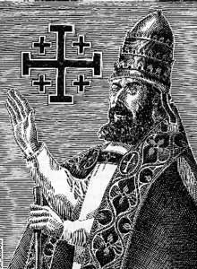
Saladin
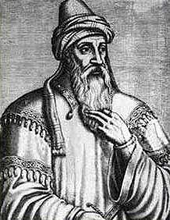
William of Tyre
Norman Cantor

Complete the following activities on a separate sheet of paper

COMPARE: Use specific phrases or passages from Pope Urban II’s speech and from Saladin’s letter that show how their attitudes are similar.

CONNECT TO TODAY: Describe how some groups today feel morally justified in using violence.

Causes
- Muslims control Palestine (the Holy Land) and threaten Constantinople.
- Byzantine emperor calls for help.
- Pope wants to reclaim Palestine and reunite Christendom.
- Pope appeals to Christian knights.
- Knights feel religious enthusiasm and want land, riches and adventure.
- Italian cities desire commercial power.

Effects
- Byzantine Empire is weakened.
- Pope’s power declines.
- Power of feudal nobles weakens.
- Kings become stronger.
- Religious intolerance grows.
- Italian cities expand and grow rich.
- Muslims increasingly distrust Christians.
- Trade grows between Europe and the Middle East.
- European technology improves as Crusaders learn from Muslims.

Unit: Introduction to Global History
Topic: Vocabulary
Aim: What are some important vocabulary terms we should understand for Global History?
Common Core Objectives:
RH.9-10.4- Determine the meaning of words and phrases as they are used in a text, including vocabulary describing political, social, or economic aspects of history/social science.
WHST.9-10.9- Draw evidence from informational texts to support analysis, reflection, and research.
Do Now:
Students will read The Royal Commentaries of Peru and answer the questions that follow the reading.

Motivation:
Have the students on the right side of the room take three minutes and pretend they are Pizarro and write a paragraph from the point of view of Pizarro in which he describes the encounter from the “Do Now”. At the same time, have the students on the left side of the room write the same account from an Incan perspective who saw the entire event unfold. Have a few select students share their writing. How and why do these two accounts of the same event differ? What factors might have influenced de la Vega’s account of the event?
Tie in the following terms (and have the students copy the definitions onto the vocabulary sheet):

Primary Source- document, speech, or other sort of evidence written, created, or otherwise produced during the time under study (diary, journal, license, photographs/film etc.).

Secondary Source- accounts written after the fact with the benefit of hindsight (textbooks, almanacs, encyclopedias).

Bias- prejudice in favor of or against one thing, person, or group compared with another, usually in a way considered to be unfair.

Perspective- a particular attitude toward or way of regarding something; a point of view.

What are some things we must “look out for” when learning about history?

Lesson:
Students will work in their assigned groups to read a paragraph and based on their understanding of the reading, determine what the vocabulary word which relates to the story means.
After the students complete this task, groups will offer their definitions to the class and they will be written on the board. Students will correct their work as necessary.
Summary:
Students will be given a piece of paper with a vocabulary word from the lesson on it. They will be asked to create an example of the word they were given. These papers will be collected and the teacher will read the examples to the class and the class will give the word that is being described.

Date: ____________________

Aim #_____- __________________________________________________________________
______________________________________________________________________________

Do Now: Read the paragraphs below and answer the questions that follow in complete sentences.

The Royal Commentaries of Peru
Historical Context: In 1527, Francisco Pizarro entered Peru, where, with his small band
of 175 men armed with a cannon, they took over the entire Incan Empire.

Quickly after Pizarro landed on the shores he began to advance toward the Empire's
capitol. As Pizarro's group advanced, they were confronted by roughly fifty-thousand
Incan warriors within the town square of the capitol city who were bent on destroying
Pizarro's band. However, the Inca did not attack, rather, Pizarro asked the Inca's leader,
Atahualpa, to meet with him and his bodyguards unarmed. Pizarro knew that if he had the
Emperor he would have the entire Incan Empire, and all the gold which it held shortly
after meeting with Pizarro, Atahualpa's gold headband was torn from his head, and with
the blast of a cannon, Pizarro's men slaughtered all of the Inca's within the town square.
Atahualpa attempted to bargain with Pizarro for his life, offering him a room filled with
gold, but shortly after Atahualpa showed Pizarro the room he was murdered.

The Some natives who became literate went on to learn how to write, helping them to
speak directly to European readers. Garcilaso de la Vega, an Inca, modeled his histories
on European examples; his narratives were translated from Spanish into English.

The Royal Commentaries of Peru
By Garcilaso de la Vega (1539-1616)

Questions:

- How did Pizarro trick Atahualpa and his army?

- What did Pizarro’s men do in order to win the battle?

Vocabulary Word | What do you think this word means? | Where you correct? (If not, complete the next box.) | Definition
Primary Source
Secondary Source
Bias
Perspective
Culture
Cultural Diffusion
Ethnocentrism
Xenophobic

Culture
Below is a sampling of questions an anthropologist (someone who studies culture) wanted to find out about with regards to a group he was studying:
- What are the religious beliefs of this group? Is there a house of worship and, if so, how often do people attend?
- Generally, which family members share a home? How large is the typical family? At what age do people generally get married? Is this a matriarchal (when the mother or oldest female heads the family and descent and relationship are determined through the female line) , patriarchal (when the father or oldest male heads the family and descent and relationship are determined through the male line), or an egalitarian (equal) society?
- How do people dress? Does dress differ by gender? Does dress differ by age? Are there any rules of modesty pertaining to dress?
- What are some common jobs that people have? How are people paid? Is pay determined by gender or age?
- What do people do in their free time? Are sports important? Is art important?

Cultural Diffusion
Below are some examples of cultural diffusion related to world history.
- A Chinatown is an area with people from China, Taiwan, Hong Kong, and Macao and these exist all over the world.
- The spread of music throughout the world shows cultural diffusion. For example, jazz started as a blend of the music of Africa and the Caribbean.
- The popularity of sushi in the United States, shows diffusion of Japanese cuisine.
- Over two million persecuted Jews fled Eastern Europe between 1881 and 1914 to live in Britain or the United States. They brought with them their food, dress, and beliefs.
- The English language is a good example of diffusion, as it contains many words from other languages.
- Judaism, Christianity, and Islam all started in the Middle East and have spread all over the world.
- An example of forced diffusion is the Spanish, French, English and Portuguese forcing the native population of the Americas to become Christian.
- Paper, gunpowder, and the mechanical clock were all first made in China and soon spread to other parts of the world.
- Trade has been a means of cultural diffusion over the centuries. One example is the Silk Road, over which caravans would travel and exchange goods between Europe and Asia.
- Coca-Cola products are found all over the world, although Coca-Cola is an American company.

Ethnocentrism
Below are different examples of ethnocentrism that relate to culture and history.
- An extreme example of ethnocentrism in recent history is Nazi Germany. This empire was built involved the belief that certain types of people were superior to others. In fact, German dictator Adolf Hitler so despised the Jewish people, he had millions of them exterminated in concentration camps.
- A Westerner thinking that using chopsticks to eat is a strange way to eat.
- Missionaries often believe that their religion is the “right one” and try to get people to follow their way of thinking.
- The Chinese have referred to themselves as the “Middle Kingdom” throughout history, implying culture comes from Chinese civilization and spreads to others.
- The Romans called non-Romans barbarians, because they believed that the non-Romans were not nearly as civilized.
- When the British ruled India, English became the mandatory subject in school and traditional Indian classes were no longer taught.

Xenophobic
Below are examples of xenophobic behavior throughout history.
- An example of xenophobia was the state-imposed racial segregation (apartheid) of South African history (1948-1994). Blacks were denied citizenship, access to quality healthcare, public services, education and all amenities which had long been declared as basic human rights. The discrimination continued till the African National Party, led by Nelson Mandela, passed the anti-apartheid legislation.
- Human zoos used to be a popular attraction in the West in the 19th and 20th centuries. These ‘public exhibits’ of human beings (caged, sometimes with exotic animals) introduced the West to the ‘barbarians’ of the East. Particularly popular exhibits were those of Africans, tribal pygmies, and the Philippines.
- China feared trading with the West for much of its history because they did not want their culture altered.

Unit: Trade Networks
Topic: Trade Networks and their Impact
Aim: How has trade promoted cultural diffusion and interdependence?
Common Core Objectives:
RH.9-10.5- Analyze how a text uses structure to emphasize key points or advance an explanation or analysis.
WHST.9-10.9- Draw evidence from informational texts to support analysis, reflection, and research.
Social Studies Standards:
9.4 RISE OF TRANSREGIONAL TRADE NETWORKS: During the classical and postclassical eras, transregional trade networks emerged and/or expanded. These networks of exchange influenced the economic and political development of states and empires.
(Standards: 2, 3, 4; Themes: ID, MOV, GEO, ECO, TECH, EXCH)
Do Now:
How has Long Island been economically and socially affected by its location in the Atlantic Ocean?
Teacher will have students share their responses and write the answers given on the board.
Motivation:
Brief discussion: Has trade in the modern world brought humanity together or torn humanity apart? (Discuss oil trade/political decisions, technology (computers, phones) /making friends around the world, etc…)

Lesson:
Students will independently use the maps and readings provided to answer questions relating to the four trade networks (Silk Road, Trans-Saharan Trade, Mediterranean Trade, Trans-Atlantic Slave Trade) being studied. After the questions relating to each specific network have been answered, students will work as a group to answer questions relating to all four of the trade networks.
Summary: Students will independently complete “exit cards” answering the aim.

SILK ROAD
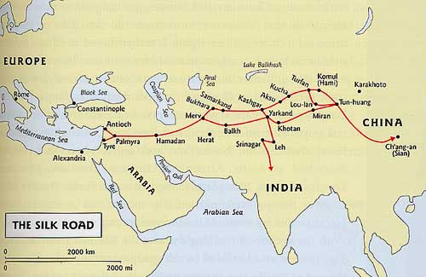
The Silk Road was a trade route that connected China to the Middle East and Rome, it was most heavily used between 500 BCE to 1453. Over these routes, China exported silk, iron, and bronze in exchange for gold, glass, ivory and animals (horses, cattle). Dangerous deserts and mountains had to be crossed by traders (using camels) to reach China. Why were people ready to risk their lives? It was the "silk" that made the “Silk Road” worth the risks to traders hoping for riches. At the time, this beautiful fabric could be found only in China. The Chinese have been plucking silk worms from the green leaves of the mulberry tree for more than 4,000 years. Each spring, peasants collect the milky-white centipedes, lay them out in bamboo baskets and separate them with fine feather brushes to prevent bruising. Over a period of several days, the larvae spin cocoons by moving their heads in figure eights while ejecting a continuous stream of silk from two sacs running along the sides of their bodies.
Why was silk so valuable? The law of supply and demand was what made silk so valuable. There was a great demand for this fabric and the only people who knew the secret of how to produce it were the Chinese. They were able to protect the secret for more than two thousand years. Today, China still produces most of the world's silk.
Contacts along the Silk Road led to the introduction of Buddhism to China from India. The Silk Road was used by numerous Chinese Dynasties, but was probably most popular during the time of the Han Dynasty.
Independent questions to answer regarding China’s Silk Road:
  - Why were traders willing to risk death to travel along the Silk Road?

  - Why was silk so valuable and how did this benefit the Chinese?

  - Use the map to list the places which the Silk Road connected.

TRANS-SAHARAN TRADE
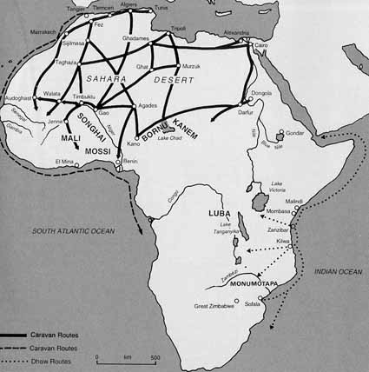
Much of North Africa is occupied by the Sahara Desert. Below the desert is savanna or grasslands. The Sahara acted as a barrier that separated the peoples of sub-Saharan Africa from the Mediterranean world and the rest of Eurasia. This isolation led sub-Saharan African tribes or ethnic groups to develop their own customs and beliefs. However, despite this separation, trade across the desert was never cut off completely. Merchants, traveling on camels able to go several days without water, crossed the Sahara.
While North Africa had abundant supplies of salt, West Africa lacked salt. Salt is vital for human survival. Merchants, moving in caravans across the desert, picked up large blocks of salt on their journey to exchange for gold. West Africa had abundant supplies of gold. A thriving trade developed around 750 that lasted for almost 900 years, the trade was based on this salt for gold trade. Three West African Kingdoms were known for participating in this gold for salt trade, they were Ghana (750-1200), Mali (1240-1400), and Songhai (1464-1600). Trade with North Africa also led to the introduction of Islam into West Africa.
Independent questions to answer regarding Africa’s Trans-Saharan Trade:
- Why were West Africans willing to give up their gold for salt?

- Why was this trade between North and West Africa so dangerous?

MEDITERRANEAN TRADE
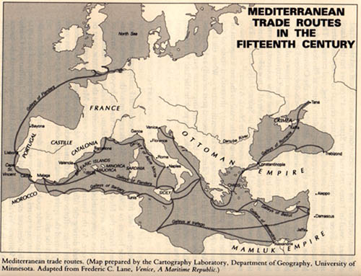
The Mediterranean trade routes were very important because it connected three continents: Africa in the south, Asia in the East, and Europe in the north. This was very convenient because that is where most of the Western population was centered around. The Mediterranean trade route was a great source for trading wealth. The caravan routes of the Middle East and the shipping lanes of the Mediterranean provided the world's oldest trading system. The Saharan caravans link the Mediterranean markets to the north with the supply of African raw materials to the south. Other trade routes often were linked to Mediterranean trade. For example, The Silk Road and the trans-Saharan salt-gold trade all were linked to the Mediterranean trade network. Spices were in high demand during the post classical period. They were very expensive. Things that were categorized into the spice trade were spice, incense, herbs, drugs and opium. The Mediterranean was one of the few regions that developed major transportation networks for trade. These transportation's include; ships, pipeline and rail transport. Pipeline Transport is when you transport goods through a pipe. Rail Transport is transporting of goods with the help of wheeled vehicles that run on rail tracks. People also traded goods and other material using ships. The Egyptians are believed to have begun using the Mediterranean to trade around 3000 B.C.E. and it continues to be used today.

Independent questions to answer regarding Mediterranean trade routes:
- Why would the Mediterranean be called a “lake of civilization"?

- Spices were trade through the Mediterranean. Where might these spices have come from? How would this support the idea that the Mediterranean was a link between South Asia and Europe?
TRANS-ATLANTIC SLAVE TRADE
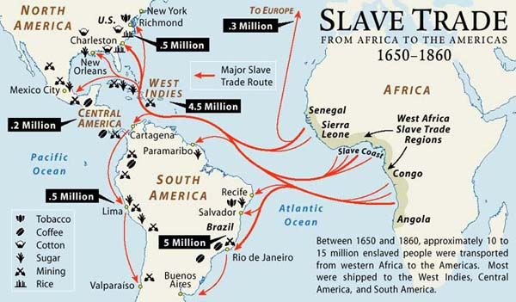
Slavery had existed in Africa long before the arrival of the Europeans. However, the transatlantic slave trade expanded slavery on a massive scale. Over a four hundred year period from 1441 to 1888, European and American slave traders removed millions of Africans. Many of the captives died during the voyage from Africa to the Americas known as the “Middle Passage” due to the horrible conditions on board the ships. The enslaved Africans that survived found themselves prisoners in a strange land. Generally, enslaved people were captured by warring African tribes or ethnic groups and traded to European and American slave traders in exchange for guns and other goods. The transatlantic slave trade encouraged tribes to go to war with each other to obtain slaves to trade for European guns and other goods. It created a legacy of violence and bitterness. As Europeans settled more colonies, the slave trade grew. Slaves worked the Spanish sugar plantations in the Caribbean Islands of Cuba and Haiti. They also worked the Portuguese sugar plantations in Brazil. The English forced slaves to work in the southern colonies of North America. The transatlantic slave trade was a highly profitable maritime business. Slaves made possible the taming of the wilderness, construction of cities, excavation of mines, and the establishment of powerful plantation economies. Historians do not agree on the exact number of Africans who were forcibly transported across the Atlantic, although it is generally accepted that the number exceeds ten million.
Independent questions to answer regarding the Trans-Atlantic Slave Trade:
- Why were African slaves brought to the Americas (be specific as to where they were brought and what their jobs were)?

- Why can it be said that America was built on the backs of African slaves?

Complete the following chart and four questions as a group.
Trade Route | Years | Items sold (and to which regions/countries) | Items bought (and to which regions/countries) | Who profited from this trade? | Did anyone suffer as a result of this trade? (Explain)
Silk Road
Trans-Saharan
Mediterranean
Trans-Atlantic

- In what ways has trade in the past brought people together?

- In what ways has trade in the past torn people apart?

- Which trade route do you think was the most valuable? Explain.

- What are some important trade networks today?

Unit: Cultural Diffusion
Topic: Impact of Cultural Diffusion
Aim: Has cultural diffusion united humanity or has it exploited our differences?
Common Core Objectives:
WHST.9-10.1- Write arguments focused on discipline-specific content.
WHST.9-10.6- Use technology, including the Internet to produce, publish, and update individual or shared writing products, taking advantage of technology’s capacity to link to other information and to display information flexibly and dynamically.
Social Studies Standards:
9.2 BELIEF SYSTEMS: RISE AND IMPACT: The emergence and spread of belief systems influenced and shaped the development of cultures, as well as their traditions and identities. Important similarities and differences between these belief systems are found in their core beliefs, ethical codes, practices, and social relationships.
(Standards 2, 3; Themes: ID, SOC)
9.5c Periods of stability and prosperity enabled cultural, technological, and scientific achievements and innovations that built on or blended with available knowledge and often led to cultural diffusion.
Do Now:
Cultural diffusion is when an idea or cultural trait is spread from where it originates to other regions or counties in the world.
Think of THREE examples of cultural diffusion that impact your life personally.
Motivation:
Review student responses to the “do now” and guide them to discuss if their examples have benefited their lives or hampered it.
Lesson:
Students will complete the question sheet to the best of their ability prior to the lesson.
Students will work in groups to check their answers to the homework questions and gather any missing information.
Students will work in pairs to complete an essay that answers the following question: Has cultural diffusion united humanity or has it exploited our differences?

Summary: Class discussion of the aim. Each student will be expected to participate and contribute at least one point to the discussion.

Names of group members: _______________________________________________________
Date:________________________
Directions: In pairs, review your answers to the following questions. Any additional questions, information that needs to be resolved, etc. should be directed towards the teacher. These questions will be used to answer the aim: Has cultural diffusion united humanity or has it exploited our differences?
First, we will look at the spread of religions and how it has impacted society.
- ISLAM IN INDIA
- Where did Islam begin?
__________________________________________________________________________________________________________________________________________

- What is the major religion in India?
__________________________________________________________________________________________________________________________________________

- How did Islam spread to India?
__________________________________________________________________________________________________________________________________________
__________________________________________________________________________________________________________________________________________

- What have relations between Hindus and Muslims been like historically in India (be sure to mention Pakistan)?
__________________________________________________________________________________________________________________________________________
__________________________________________________________________________________________________________________________________________
__________________________________________________________________________________________________________________________________________

- BUDDHISM IN CHINA
- Where did Buddhism begin?
__________________________________________________________________________________________________________________________________________

- What other belief systems have existed in China through history?
__________________________________________________________________________________________________________________________________________

- How did Buddhism spread to China?
__________________________________________________________________________________________________________________________________________
__________________________________________________________________________________________________________________________________________

- What is the role of Buddhism in China since it became a communist nation?
__________________________________________________________________________________________________________________________________________
__________________________________________________________________________________________________________________________________________
__________________________________________________________________________________________________________________________________________

Second, we will look at technological achievements and how it has impacted society.
- FIREWORKS FROM CHINA
- Describe how fireworks work.
__________________________________________________________________________________________________________________________________________
__________________________________________________________________________________________________________________________________________

- How did the Chinese use fireworks?
__________________________________________________________________________________________________________________________________________

- How was the firework technology used by Europeans?
__________________________________________________________________________________________________________________________________________

- AQUEDUCTS FROM ROME
- Describe how aqueducts work.
__________________________________________________________________________________________________________________________________________
__________________________________________________________________________________________________________________________________________

- How did aqueducts aid in the expansion of the Roman Empire?
__________________________________________________________________________________________________________________________________________

- How has this technology been improved upon for modern societal use?
__________________________________________________________________________________________________________________________________________
__________________________________________________________________________________________________________________________________________

Lastly, we will look at how intellectual discoveries have impacted society.
- ARABIC NUMERALS FROM INDIA
- Describe Arabic numerals.
__________________________________________________________________________________________________________________________________________
__________________________________________________________________________________________________________________________________________

- Why were Arabic numbers an improvement over Roman numerals?
__________________________________________________________________________________________________________________________________________
__________________________________________________________________________________________________________________________________________

- How are Arabic numerals used in today’s society?
__________________________________________________________________________________________________________________________________________
__________________________________________________________________________________________________________________________________________

- SMALLPOX VACCINE FROM INDIA
- How does the smallpox vaccine work?
__________________________________________________________________________________________________________________________________________
__________________________________________________________________________________________________________________________________________

- How has this vaccine changed society?
__________________________________________________________________________________________________________________________________________
__________________________________________________________________________________________________________________________________________

- What role does smallpox have in our society today?
__________________________________________________________________________________________________________________________________________
__________________________________________________________________________________________________________________________________________

Names____________________________________
Assignment: With your partner, answer the following:
- What are some instances in which cultural diffusion was positive for humanity, bringing us together?

- What are some instances in which cultural diffusion was negative for humanity, bringing people apart?

- Overall, does cultural diffusion unite people or tear them apart? Explain.

***When you complete this task you may begin working on a combined position paper with your partner, if you have different opinions and would prefer to write individual papers that are acceptable. This is to be completed on the computer; you are welcome to use the internet for further research. Be sure all work is reviewed by your partner (even if you chose to complete separate papers).

