Grade 2 Spiral Test 3

Name Date

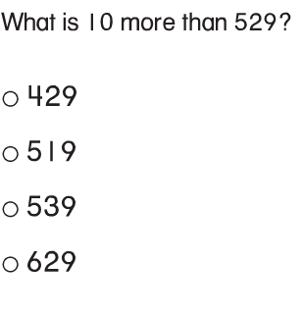

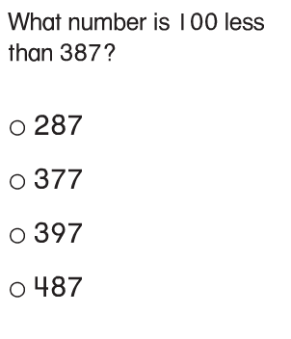

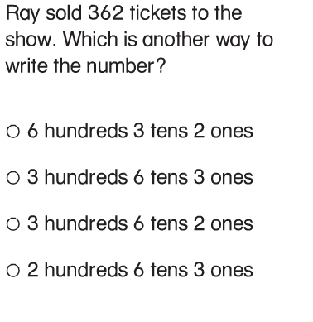

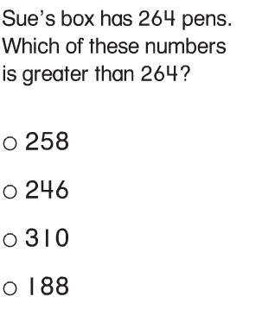

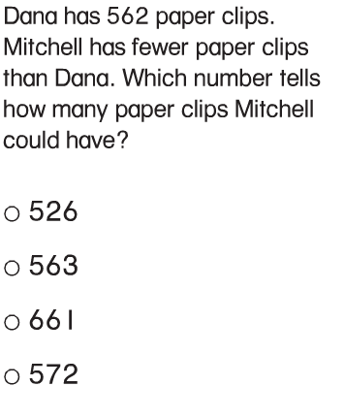

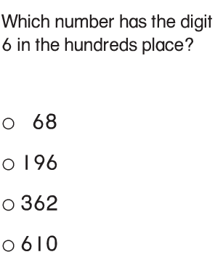

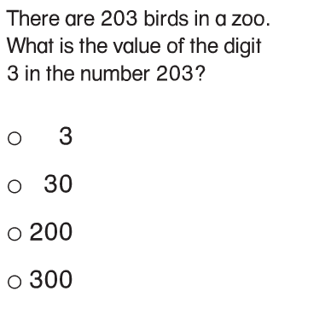

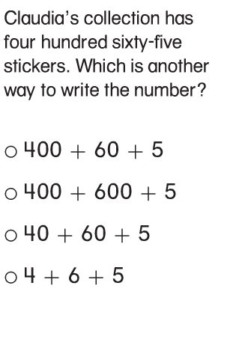

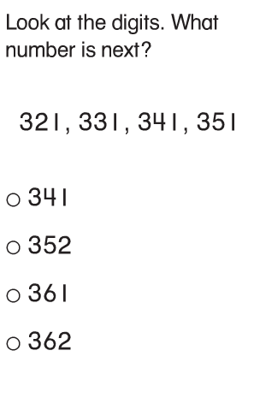
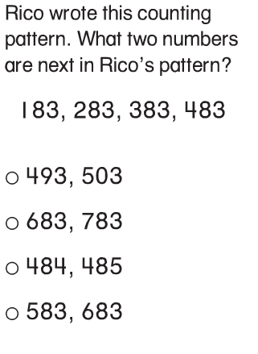

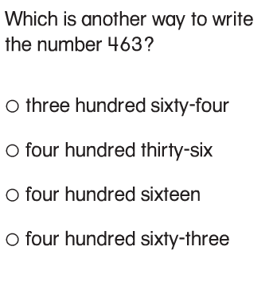

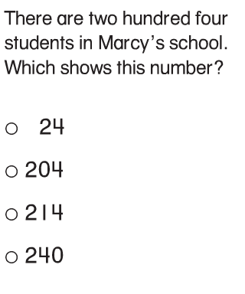

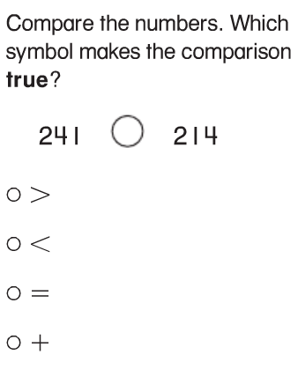

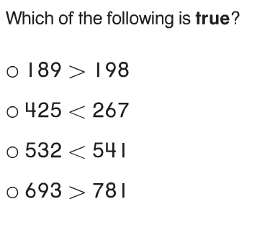

Order the following numbers from least to
greatest.

436, 297, 805

Mrs. Ortiz has 21 students in her second grade
class. All of them have 10 toes and 10 fingers.

- Write the total number of toes of the students using
hundreds, tens, and ones. Explain using words,
pictures, or numbers.

- One day, three students are absent. How many
students are in Mrs. Ortiz’s class that day? Skip-
count to show the number of their toes. Explain
using words, pictures, or numbers.

- Use <, >, or = to:
- Compare the total number of students’ fingers with the total number of students’ toes in the classroom on a day when all the students are present.

- Compare the number of toes when 3 students are absent with how many there are when all the students are in class. Explain using words, pictures, or numbers.

- 10 parents are visiting the classroom.
- How many toes do the students and parents have
in all? Explain using words, pictures, or numbers.

