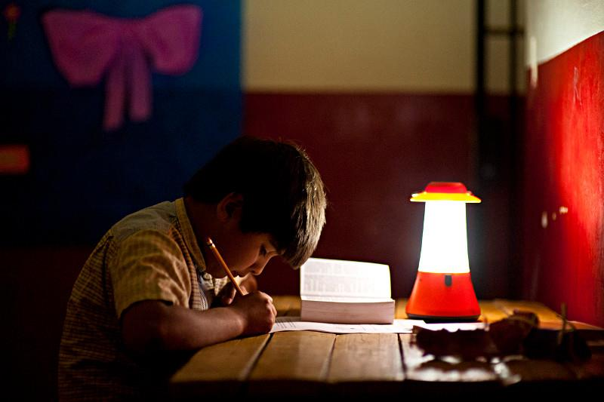

One Million Students Program

Middle School Packet

Dear Educator,

We would like to invite you to be a part of an exciting new initiative called One Million Students. This program provides hands-on, engaging and ready-made lessons on environmental studies for K-12 students.

We are very excited to reach out to schools to encourage environmental education with an emphasis on solar. Each day we face new and difficult decisions regarding environmental issues; the next generation will face even more complicated decisions as the world’s population increases and natural resources diminish.

One Million Students Program brings a global perspective and supports the following goals:
- Educate and inspire students to make smart energy choices
- Help students understand the impact of solar lighting on people living without electricity
- Educate students about solar technology and its diverse application

What’s in it for you?
- Ready-made lesson plans that could fit into an existing curriculum for science, environmental science or social science
- Guest teachers who conduct the lesson for you
- Inspired and engaged students!

There are 1.3 billion people in this world who do not have access to clean energy. One Million Lights’ mission is to improve the daily lives of children and adults around the world by replacing dangerous and polluting kerosene lamps through the distribution of safe, rechargeable solar lights. One Million Students brings into the classrooms within our own community engaging exercises in solar energy and inspiring stories about solar energy’s global applications.

Please feel free to contact us or visit www.OneMillionStudents.Org to learn more. While there, register on the site to get started on bringing this program to your school or to volunteer.

Sincerely,
Table of Contents

Title | Page Number
Overview | 4
Middle School Lesson Package | 5
Lesson 1: Solar Energy, and Introduction | 6
Lesson 2: Solar Energy And Its Global Application | 9
Lesson 3: Solar Lab | 13
Handout Reference List | 18
Evaluation Form | 19
Contacts | 20

OVERVIEW
The world currently relies a lot on coal, oil and natural gas for its energy. Fossil fuels are non-renewable, that is, they draw on finite resources that will eventually dwindle, become too expensive or too environmentally damaging to retrieve. In contrast, the many types of renewable energy resources – such as wind, water and solar are available everywhere and can be constantly replenished.
The intrinsic qualities of solar design afford it great utility for both the homes in the developed nations and underdeveloped regions too. Sunlight or Solar energy can be used directly for heating, lighting homes, generating electricity for water heating or solar cooking. Solar power is good for the environment, as it replaces the traditional, and in effect harmful, methods of energy production.
Our Middle School lesson curriculum aims to provide students with an in depth knowledge about the science behind solar technology and its diverse application around the world. We give students the chance to enjoy a hands on experience with a solar lab.
The OMS program is a win-win for both the students and the teachers. Students find the content refreshing and the projects challenging. The teachers find it very helpful to have the materials handy and ready to go. Teachers also appreciate our pool of volunteers that can teach the curriculum when needed.
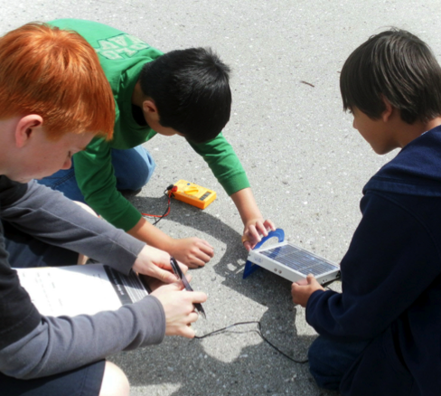
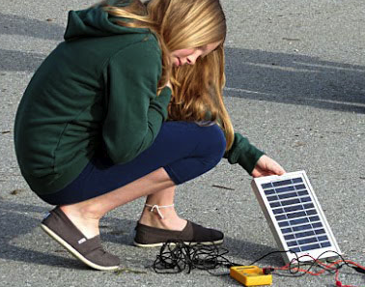
OMS Program in Action!

MIDDLE SCHOOL LESSON PACKAGE
The curriculum consists of the following lesson plans: -
 | Lessons | Duration | Materials | Activity/Handout List
1. | Solar Energy: An Introduction  - Discuss the difference between non-renewable and renewable energy  -Highlight the need for renewable energy like solar | 45 mins | a. Poster Paper  b. Markers  c. Projector  d. Solar Panel/light | Activity: Discussion on energy sources  Presentation: Need for Solar energy
2. | Solar Technology And Its Global Application  - Inspire students through stories about the application of solar technology around the world | 60 mins | a. Solar Stories  b. Solar Lanterns 4-10  c. Projector | Activity: Create groups  Presentation/Videos
3. | Solar Energy Lab: Science behind how it is created  - Knowing what conditions maximize and minimize solar energy output | 90 mins | a. Solar kit  b. Presentation  c. Worksheet  d. Calculator | Activity: Create Groups  Worksheet: Solar Lab
* All lessons can be modified to fit into your school schedule.

LESSON 1

SOLAR ENERGY: AN INTRODUCTION
GOALS
- Discuss the different sources of energy: renewable and non-renewable
- Highlight the importance of light and need for renewable energy like solar
- Excite students about the possibilities of solar power
- Inspire students to take action

MATERIALS
a. Poster paper/ Markers
b. Solar Kit: Projector, Solar Panel, LED, Electrical Wires

BENEFITS
a. Help teachers by introducing a curriculum that supports CA education standards.
b. Allow students to engage in teamwork and public speaking activity
c. Enable students to have empathy for the environment and for the people living without electricity.

ADVANCE PREPARATION
Review the presentation and lesson materials ahead of time.
HANDOUT LIST
  - Presentation: What’s so great about Solar Energy?
  - One Million Lights (OML) and OMS (One Million Students) Overview Presentation

PROCEDURE
Duration: 45 minutes
Targeted Students: 3-6 Grade

Lesson Agenda:
- Introduction (15 minutes)
- Discussion: Classroom discussion on energy sources (15 minutes)
- Demonstration & Explanation: Solar panels in action (5 minutes)
- Review Questions (5 minutes)
- Student Questions (5 minutes)

1. Introduction: (use Power Point Presentations)
Share with students an overview of One Million Lights (OML) and OMS (One Million Students)

2. Discussion: (use Power Point Presentations)
- Questions for the class
  - What are the things that we use electricity/energy for in our daily life?
  - What sources of energy do we use now?
    - Hints: Cars, Locomotives, Dams, etc.
  - How much of the energy in the US comes from each category?
  - Do you think there are differences between California and the United States? Why?
    - Draw a rough pie chart on the whiteboard from answers
    - Show real pie chart
- Presenting the Problem
  - Scarcity of resources
    - Demand for oil and gasoline will eventually be insatiable
    - Variety is important so will not become reliant on select sources
  - Global Warming
- Solar Energy as Solution
  - Energy from the Sun is not scarce
  - Natural and Eco-friendly energy source
  - Readily available
  - Sustainable

3. Classroom Demonstration:

- Show that the solar panel can light up an LED light
- How does this happen:
  - Materials in panel “absorb” energy from the sunlight and convert it into electricity
- Solar at a larger scale
  - Hundreds of panels, much larger, can power cities

4. Review Questions:

- How many people lack access to electricity around the world?
Answer: 1.3 billion people
- What are some of the benefits of solar lighting?
Answers:
  - Higher Productivity
  - Increase income
  - Savings
  - Decrease in respiratory diseases
  - Additional study hours for students

- Why should we use solar?
Answers:
  - The Sun will not “run out”. It is renewable and will last for a long time
  - The Sun is eco-friendly and does not harm the Earth.
  - There are no carbon emissions that are leading to global warming.
  - The Sun is easily available and accessible.
  - The Sun is clean and healthy. It does not harm human beings with toxic fumes.

5. Student Questions:

Time allocated for students to ask questions regarding the lesson.

LESSON 2
SOLAR TECHNOLOGY AND ITS GLOBAL APPLICATION

GOALS
- Educate students about where solar energy comes from and how it works
- Provide a global perspective on solar technology application
- Inspire students through stories to take action

MATERIALS
a. Printed stories and worksheet for each student and group
b. Projector for slide show/videos

BENEFITS
a. Students engage in a discussion about solar energy, its source and its application in both developed and developing communities
b. Students learn about the diverse application of solar technology around the world
c. Provide students with changes they can implement at home to help save energy

ADVANCE PREPARATION
Review the presentation and lesson materials ahead of time.
HANDOUT REFERENCE LIST
- Solar Stories: All 10
- Energy Action Checklist
- Presentation: Solar Energy Explained

PROCEDURE
Duration: 60 minutes
Targeted Students: 6-8 Grade

Lesson Agenda:
- Introduction (5 minutes)
- Presentation: Solar Energy Explained (15 minutes)
- Activity: Solar technology around the world stories (20 minutes)
- Class discussion and Presentations: Solar Lighting and Development (15 minutes)
- Presentation: Energy Action Checklist (2 minutes)
- Review Questions (5 minutes)
- Student Questions (5 minutes)

1. Introduction:
If you are a guest speaker please introduce yourself, `One Million Lights’ and
`One Million Students’ Program. Show one of the OML videos.

2. Presentation: Use the presentation `Solar Energy Explained’

Discussion Points- Slide #2:
(Optional discussion on elements)

Here is a periodic table of elements, Have any of you studied this before?

The periodic table is made up of chemicals both naturally and manmade that are used in our daily lives.

For solar, we need to know about Hydrogen, Helium, Boron, Phosphorus, and Silicon.

Who can tell me about Hydrogen?
(Hydrogen is the most common element. Mostly found in stars. Used to make water, can be used as an energy carrier)

What do you know about Helium?
(makes your voice squeaky, balloons float, 2nd most common element, gas, in the sun)
Have you heard of Boron? What is it?
(makes things strong, reinforces cell wall, plants, pyrex dishes have boron in them, used to make glass, cleaning material, insecticide)

What about Phosphorus?
(glows when in contact with oxygen, used in fertilizers, used in the military for smoke screens and other explosives, free agent, helps plants grow, )

What is Silicon?
(sand, used in building materials, semi-conductor, solid, gives up and shares electrons, used in electronics)

Discussion Points Slide #3-6:

1. hydrogen and helium make up the sun
2. Sun radiates energy
3. The energy come from nuclear fusion, Do you know what nuclear fusion is?
(It's when atoms run into each other, for our purposed hydrogen and helium is the most common)

Discussion Points Slide #7:
- Of all of that energy About 15 percent of the radiant energy that reaches the earth is reflected back into space.
- Another 30 percent is used to evaporate water, which is lifted into the atmosphere and produces rainfall. The energy is also absorbed by plants, the land, and the oceans.

Should we use all of that energy that come to earth for our daily use? YES!!!
How?

Discussion Points Slide #8: After read the slide... Where have you seen PV cells in your life?

Discussion Points Slide #9: some examples

Discussion Points Slide#10-13: (show solar panel) Solar panels are made up of Silicon (glass). There are 2 layers: a negative and a positive. The positive side has Boron on it, it attracts electrons. Boron makes things strong... The Negative side has Phosphorus, it gives up electrons easily.

Why do we need a negative and a positive layer?
(so a circuit can be made, just like a battery, the movement of the electons from the 2 layers create energy, the energy can be used for electricity)

Discussion Points Slide #14: Why should we use Solar?
Answers:
  - The sun will not run out, it is renewable and will last a long time
  - Sun is eco-friendly and does not harm the earth
  - There are no carbon emissions that are leading to global warming
  - Sun is easily available and accessible
  - Sun is clean and healthy, it does not harm human beings with toxic fumes

3. Activity: Solar Technology Around The World Stories and Videos
The purpose of the activity is to transition students from how solar technology works to its global application. Split the class up into groups. Dim the classroom lights. Have one person from each group get a solar light, story and worksheet. Each story is about solar technology and how it is being applied around the world. Each group will have 10 minutes to read the story and have a discussion about the story in their group. If there is time, then each group could read more stories.

4. Group Presentation: Each group will share with the group about their specific story, who their person is, what they do and how solar as affected their lives. Great place for a discussion about the experience with reading using a solar light too.

5. Class Discussion: Solar lighting in the developing regions
You can select a student volunteer to come up and write on the board the list of impacts solar lighting is having on the developing communities. Lead a class discussion:
Instructions for the students:
  - Think about living in a rural community that is completely un-electrified. No computers, no switches, no outlets, no televisions, no lights, no microwaves. The only light you have after the sun goes down is a kerosene lantern.
  - Class Question: What benefits do you think a solar light would have in that community?
  - Example: Provide the example of how students are dependent on kerosene lanterns to study in the evening. There are a number of problems associated with kerosene like strain on the eye, smoke inhalation and the danger of fire if it is knocked over. A solar light provides clean and better illumination for additional hours of study.
  - Additional benefits include:

- Education: additional study hours for students
- Health:
- Decrease smoke inhalation, respiratory illness
- Allows for improved service at primary health clinics
- Midwives use solar lights to deliver babies
- Safety: transportation at night
- Bio-Conservation: deter wild animals from approaching
crops/fields
- Livelihood: communities that produce handicrafts are able to produce more goods and generate a higher income
- Savings

6: Review Questions:

  - Where does solar energy come from?
Answer: Sun, Electrons
  - How is solar technology being used around the world?
Answers: Space, farms, to light and to power homes
3. What are the benefits of solar lighting?
Answers:
a. Education: additional study hours for students
b. Health:
- Decrease smoke inhalation, respiratory illness
- Allows for improved service at primary health clinics
- Midwives use solar lights to deliver babies
c. Safety: transportation at night
d. Bio-Conservation: deter wild animals from approaching
crops/fields
e. Livelihood: communities that produce handicrafts are able to produce more goods and generate a higher income
f. Savings

7: Student Questions:

Time allocated for students to ask questions regarding the lesson.

LESSON 3

SOLAR ENERGY LAB

GOALS
- Understand the science behind solar energy
- Knowing what conditions maximize and minimize solar energy output
- Calculate the impact of solar energy

MATERIALS
a. Solar Kits (Solar panels, Multi-meters, Alligator Clips and Wires and LED lights)
b. Data graphing programs or plain paper
c. Solar Energy Lab: Worksheet

BENEFITS
a. Create scientists by working on hand’s on experiments, using the Scientific Method
b. Inspire students to be scientifically curious and interested

ADVANCE PREPARATION
Review the presentation and lesson materials ahead of time.
HANDOUT LIST
- Solar Lab PPT
- How much Solar Energy do we need? -presentation

PROCEDURE
Duration: 90 minutes
Targeted Students: 6-8 Grade

Lesson Agenda:
- Introduction: Background and Review Information on Solar Energy (10 minutes)
- Group Lab Work: Maximizing solar panel output (30 minutes)
- Analysis, Discussion and Calculation (15 minutes)
- Review Questions: What did you learn? (5 minutes)
- Student Questions (15 minutes)

1. Introduction:

Who can tell me about solar?

What are solar panels made of?
(silicon with positive and negative side)

How does a solar panel work?
(radiant energy acivates the electrons who run into each and make energy)

How do solar panels harness the energy of the Sun?
  - Diagram to draw on the board to help explain:
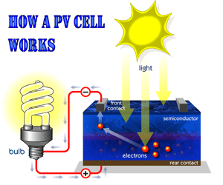
2. LED Demonstration

(hook up a solar panel to an LED and show how it works using ambient light, show how it works only if the negative and positive sides are lined up correctly)

3. Group Lab-Work: Maximizing Solar Panel Output

Question: What is the optimal direction and angle for a solar panel to be in order to have the highest voltage output?

Hypothesis:
(Ask students to guess)

Experiment:
- Students are divided into small groups. Each group receives a kit and handout.
- Students collect data on the current and voltage generated by their solar panel outside of the classroom. They use three different variations to measure the current and voltage.
  - Three different variations are: -
    - Light intensity
      - Shade, direct sunlight, inside the classroom
    - Angle from sun (perpendicular, 45 degree, etc.)
      - Angle to the ground: 0,45,90
    - Orientation
      - North, East, South, West
Reminder: Consider the time of day and position of the sun
- Graph data in terms of the variations in groups using the supplied worksheet, If graphing is too hard, then any format of showing what they found is acceptable= example all data facing North - 0, 30, 45, 60, 90)
(Need to give examples of possible graphs to use,
  - How does the set up affect the current and voltage generated?
- Using Solar Energy to Power Lights:
  - Connect circuit to power an LED light.

3. Analysis, Discussion and Calculations:
- Each group presents their data:
  - How did the set up affect the voltage and current? Why?
  - Have each group share what was their conclusion. You will get lots of answers, ask the students why the answers are so different-

(Possible Answers: Each group was in a different location, too many variables, inaccurate experience with the equipment, Sun is constantly shifting with the Earth Rotating....)
- Come to a consensus as a class for a Conclusion
(Possible Conclusion, more date is needed, too many variables involved)

- Instructor Lead:
  - How can we maximize solar panel output at a larger scale?
  - In which countries would this technology prove to be favorable?

Additional Activity: How Much Sunshine is required to power California?
* Support with a Presentation - How much solar energy do we need?--- Could use new data here...

Duration: 10 minutes

  - Step 1: How much energy does California use in a day?
    - Hint: Used 288,245,000 megawatt hours in 2005
    - Answer: around 780,000 megawatts a day
(288,245,000 divided by 365- though this is still not correct answer but close)
  - Step 2: How much energy does one square mile of sunlight produce in 24 hours?
    - Hints;
      - One square yard of land receives 5 kilowatts of energy a day
      - Convert to square miles (1760 yards in a mile: 3,097,600 square yards in a square mile) (3,097,600*5)
      - Most recent solar technology is at most 30% efficiency (multiply by 0.2)
      - Convert to megawatts (divide by 1000)
    - Answer: 3,098 megawatts of energy
  - Step 3: How many square miles of solar plants will produce enough energy for California?
    - Hint: Use answers to previous two steps
    - Answer: 251 square miles (780,000 divided by 3098)
  - Step 4: How much is 250 square miles?
    - Ex: comparison to Death Valley (more than 2000 square miles)
  - Step 5: Think about it!

4. Review:

Class discussions. Have students share:
  - How does the solar panel work?
  - What did they learn about the variation in solar energy output?

Student Questions:

Time allocated for students to ask questions regarding the lesson.

COMPLETE HANDOUT REFERENCE LIST

  - Presentation: Lesson 1: OML overview and energy sources
  - Presentation: Lesson 2: Solar Energy Explained
  - Presentation: Lesson 3: Solar Lab
  - Energy Action Check List
3. Solar Stories
4. Solar Stories Worksheet
5. Solar Lab Worksheet
6. Solar Energy – Talking points for the instructor
7. Videos: http://100people.org/100people_under_the_sun_australia.php

EVALUATION FORM
Name:
Title: | Teacher Volunteer Other
School: |  |  | Grade:
Location:
How many students in the class?
Email Address:

Please email this completed form to jen.greene@onemillionlights.org, after your teaching experience.

1. What activities and lessons did you use in the classroom?

2. Did you have any problems presenting the information?

3. Were the students interested?

4. What was the most successful part of the lesson you taught?

5.What was the least successful part of the lesson you taught?

6. Any recommendation for One Million Lights?

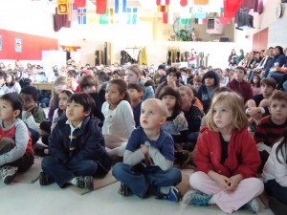
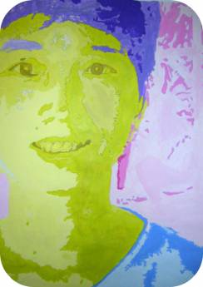
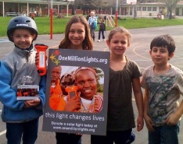
CONTACTS

For further questions on the program, please contact

Jennifer Greene
Jen.greene@onemillionlights.org
Appendix

