Title: ________________________________________________________

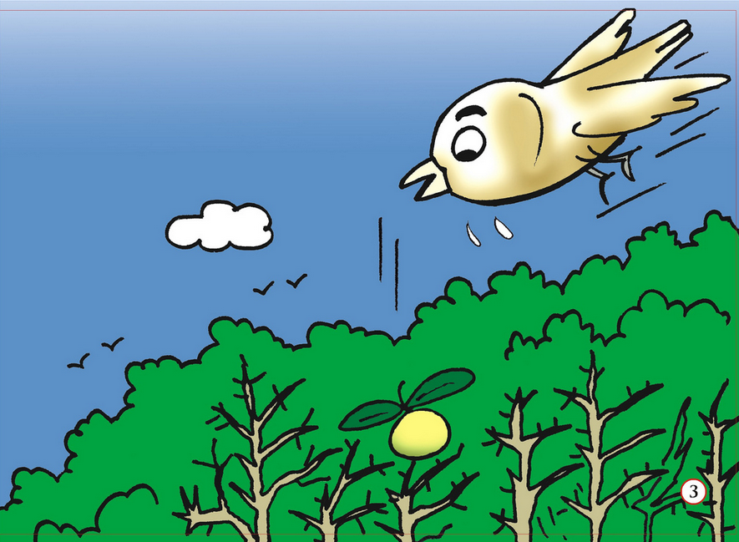

_____________________________________________________________________________________

_____________________________________________________________________________________

_____________________________________________________________________________________

_____________________________________________________________________________________

_____________________________________________________________________________________

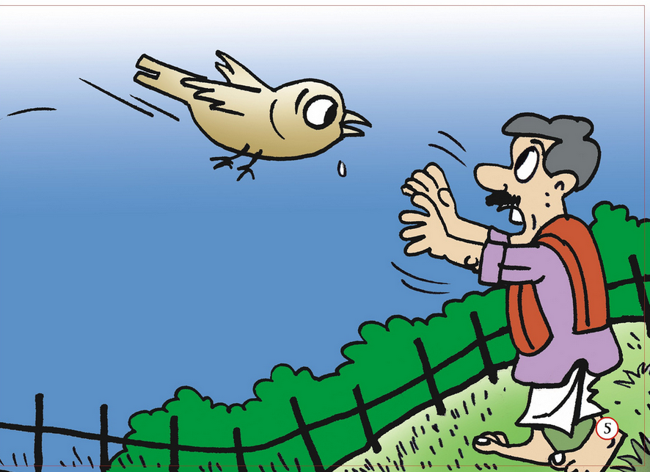

_____________________________________________________________________________________

_____________________________________________________________________________________

_____________________________________________________________________________________

_____________________________________________________________________________________

_____________________________________________________________________________________

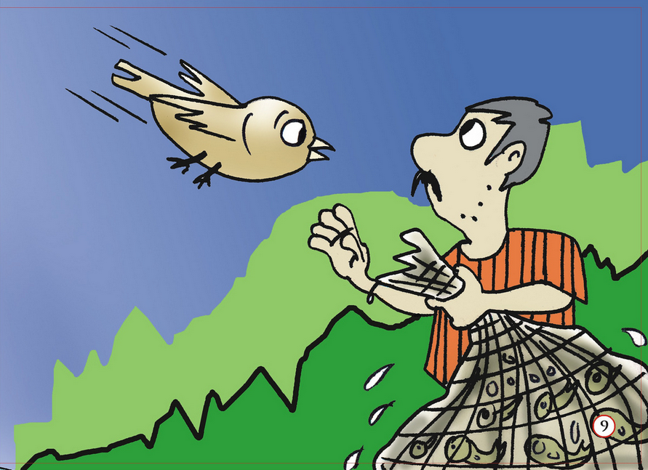

_____________________________________________________________________________________

_____________________________________________________________________________________

_____________________________________________________________________________________

_____________________________________________________________________________________

_____________________________________________________________________________________

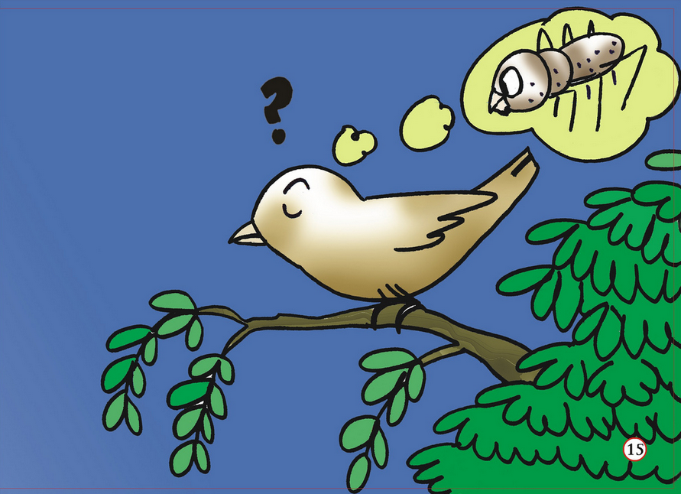

_____________________________________________________________________________________

_____________________________________________________________________________________

_____________________________________________________________________________________

_____________________________________________________________________________________

_____________________________________________________________________________________

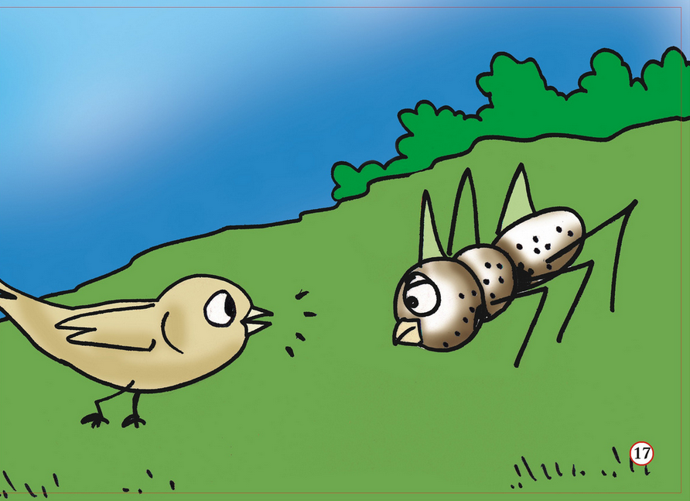

_____________________________________________________________________________________

_____________________________________________________________________________________

_____________________________________________________________________________________

_____________________________________________________________________________________

_____________________________________________________________________________________

All images courtesy of Pratham Books. Licensed Creative Commons Non Commercial, Share Alike.

