Riding Freedom

This novel study is meant to parallel fifth grade Module 1 Unit 2. The students will need the background and foundational skills from Unit 1 to complete Unit 2. Instead of reading Esperanza Rising, this group of students will be reading, Rising Freedom, a text also written by Pam Munoz Ryan but at a lower reading level. Therefore these lessons can be used with struggling readers as while the more proficient readers are working with the module.
Each lesson follows the same structure as the Module lessons, just with the alternate text.

Lesson 1
- I can define historical fiction.
- I can describe the geographical setting of Riding Freedom.
I can describe the historical setting of Riding Freedom

Read Aloud “In the Beginning”
Have students visualize what the setting looks like. Ask “ What is it like where Charlotte lives?”
“ Does anyone know where New Hampshire is located?”
“What are ‘steep hills crowded with boulders’?”

Jigsaw Protocol
- Tell students that in order to understand the setting—both the geographical place and historical time period—of the novel, they will spend a little time today building background knowledge about America in 1850’s.
- To do this, they will be using a simple Jigsaw protocol. This protocol allows small groups to engage in an effective, time-efficient comprehension of a longer text. Students don’t always have to read every page or section of a reading. The Jigsaw structure lets students divide up the text, become an expert in one section, and hear oral summaries of the others and still gain an understanding of the material.
- Divide students into groups of three and ask the triads to sit together. Give each triad a folder with all the materials for the Jigsaw protocol, including the Background Texts about America in 1850’s
- Assign one topic to each member of the triad:
- Orphans and orphanages
- Transportation
- Women’s Rights
- Be sure that students also see the accompanying pictures.
- Tell students that they will each read about one topic, and then will share with the other members of their triad. Reassure them that they are not expected to understand everything about their excerpt or pictures. The goal is simply to begin to build basic background knowledge about America. They will keep learning more throughout this unit.
- Jigsaw, Part 1:
Give students 15 minutes to independently read their assigned topic, review the pictures, and take notes about their assigned topic on their Jigsaw note-catcher. (Be sure the class understands that during Part 1 of the Jigsaw, each student will be reading and taking notes on a DIFFERENT topic from the other two members in their triad.) Have students look for key points and new information as they read their section and examine accompanying pictures. Students should record their learning on the Jigsaw note-catcher.
- Jigsaw, Part 2:
Still in triads, ask students to now take 10 minutes to share with each other what they learned. Each member in turn shares the important points and summary from the pictures and text she/he read. As each group member shares, the other students in the group take notes.
- Listen in for patterns during students’ comments, to bring up whole group during the debrief.

Begin reading chapter 1 together. Assign what was not finished for homework.

Riding Freedom
Lesson 1
Homework
Reread Chapter “ In the Beginning” and Chapter 1

As you read, think about these questions. Use your evidence flags to mark specific passages in the text to discuss with your group. You do not need to write out answers as part of your homework; just keep track of your thinking with your evidence flags.

- Describe the geographical setting of Riding Freedom. What is it like where Charlotte lives? Use details from the text to support your answer.

- What is Charlotte’s life like in the orphanage?

Riding Freedom
Lesson 1
Background Texts about America in the 1850’s
- Orphans and orphanages:
Many children were placed in orphanages during 1820’s and later. This was due to immigration and homelessness. As well, some children were orphaned when their parents died from yellow fever, the flu or accidents. During those years, orphanages were few in number and often overcrowded. Children typically received minimal food, education and attention. Charles Loring Brace believed children in these orphanages would be better off in homes out west and started the “orphan train”. Children were placed on trains going west to meet families that might want them. They would stop at towns where people would come out to view them. These people would inspect the children and question them before they filled out the paperwork to claim that child.
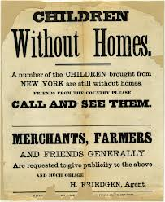

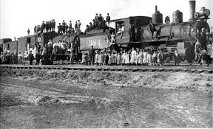

Washington Post

- Transportation in 1850’s
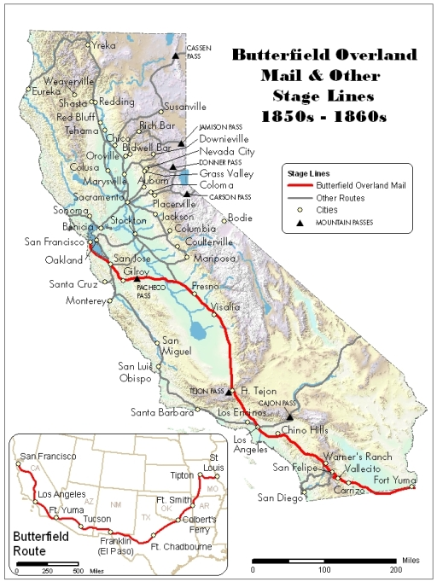
In the 1840’s and 50’s the railroad had not yet been built in California. However, gold had been discovered and many people were moving out there to “strike it rich”. As a result, many stage coach companies were created to transport people. The Wells Fargo company was one of the many stage coach companies. . Most of its stagecoaches were Concords, manufactured in Concord, New Hampshire. Each carried fifteen passengers, nine inside and six outside, including the driver and a Wells Fargo messenger, and was drawn by six horses. Its primary objectives were banking and transportation. These stage coaches carried passengers, mail and other packages from one town to the next. It was actually cheaper than the US mail. In its earliest days Wells Fargo did not operate its own stagecoaches, rather, they sub-contracted with those already in business. The company; however, staked its reputation on protecting its cargo, and a Wells Fargo "shotgun messenger” sat beside the driver, often protecting a treasure chest under his seat
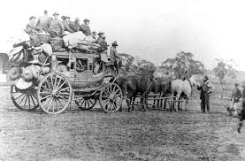

- Women’s Rights in the 1850’s: www.hastingspress.co.uk/history/19/taylor.htm

In society beliefs about the role of women were firmly fixed. A woman was considered to be very much inferior to the male and was looked upon as his 'property'. The husband was the head of the household and had the final word.
(a) In a middle-class household the wife was seen as a child-bearer and was allowed to have no career. She spent her day in genteel pursuits, for example, embroidery and knitting - household chores would be done by servants. Furthermore she had hardly any legal rights. Any property or money she had owned when single, automatically became the possession of her husband on marriage. In law the children of the family were also the property of the husband.
(b) Life in a working-class family was desperately hard for the wife. She was expected to bear children, bring them up and go out to work. Families of seven or eight were commonplace. The working-class wife also had to endure the same lack of rights as her middle-class counterpart. The working-class female would be most likely to enter domestic service, work as a factory-operative, or be an agricultural labourer.
(c) Finally, women were unable to enter the professions (for example, medicine or law) at this time and they were excluded from public life and voting in any form of election. The role of the woman was neatly summed up by the Saturday Review which claimed that 'married life is a woman's profession'.
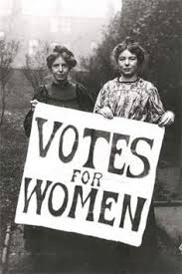
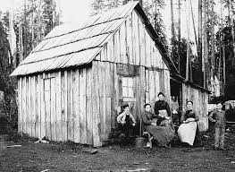

Lesson 1
Jigsaw Note-catcher for Background Texts about America in 1850’s

Section | Key Points | Questions
Orphans and Orphanages
Transportation
Women’s Rights

