Science & Performing Arts Connection
2nd, 3rd, 4th, and 5th Grades

Students in 2nd, 3rd, 4th, and 5th grade completed units of study in Science topics. For a Performing Arts Connection, the students worked with a choreographer, using their science curriculum to develop representative movements matching respective standards. Compositions by Lindsey Stirling were used for each grade level.

As an example, third grade focused on the solar system for their dance. Incorporated into their dance were shooting stars, planets with rings, rotation of planets and their orbit of the sun. Each grade level underwent the same process in order to choreograph their piece.

Costuming was based on salient aspects of the dance themes, i.e. fourth grade focused on the rock cycle and their costuming involved differentiating between igneous, sedimentary, and metamorphic rock.

Interpretive Dance representing, “Life Cycles”
2nd grade
Music: “Song of the Caged Bird” by Lindsey Stirling
Description: the dance showed various animal and plant life cycles.

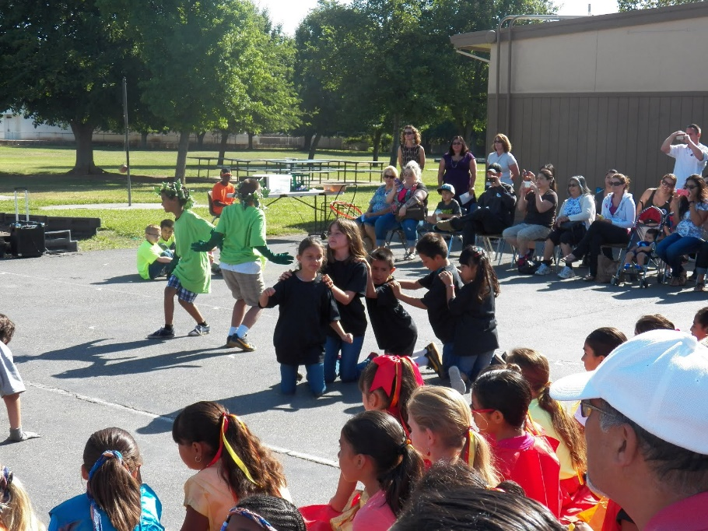

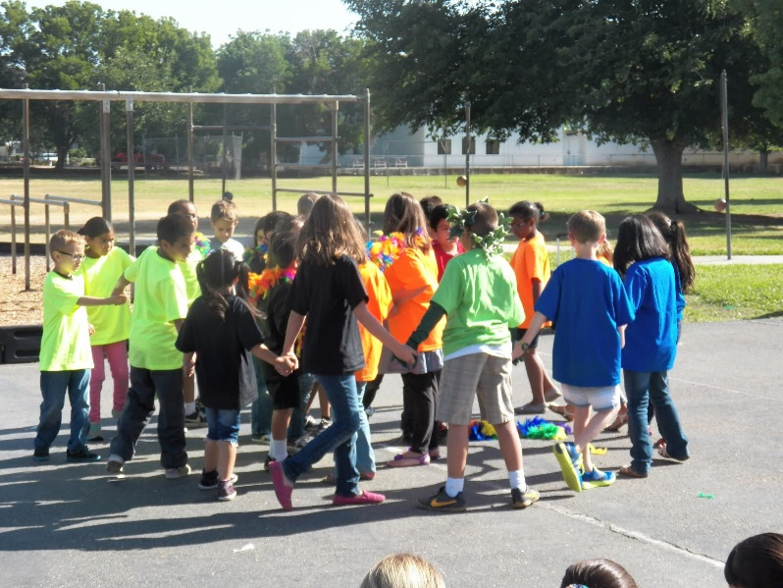

Interpretive Dance representing, “The Solar System”
3rd grade:
Music: “Moon Trance” by Lindsey Stirling
Description: small groups of students represented shooting stars, planets with rings, rotation of planets and their orbit of the sun.

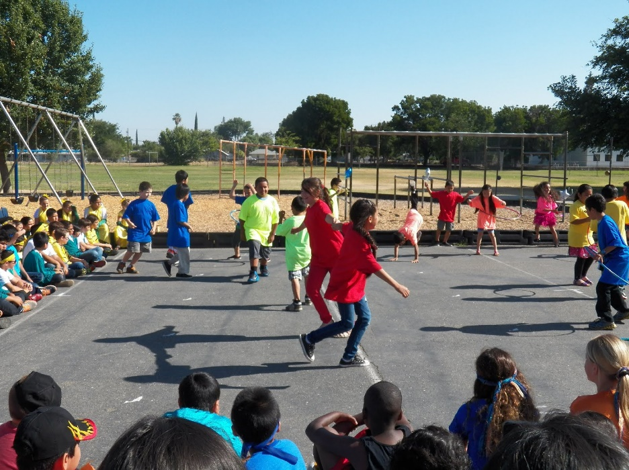

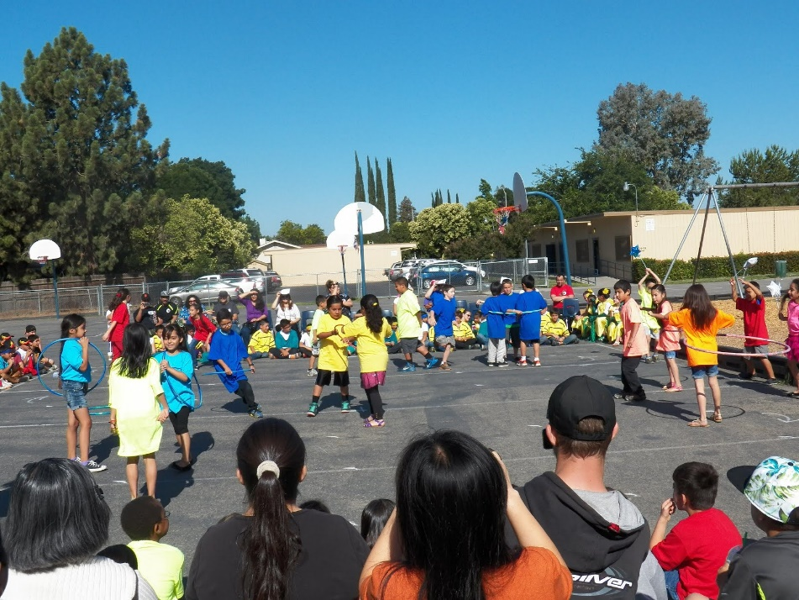

Interpretive Dance representing, “The Rock Cycle: Igneous, Sedimentary, and Metamorphic”
4th grade
Music:”Crystallize” by Lindsey Stirling
Description: three groups of students represented the three parts of the Rock Cycle and the changes that take place.

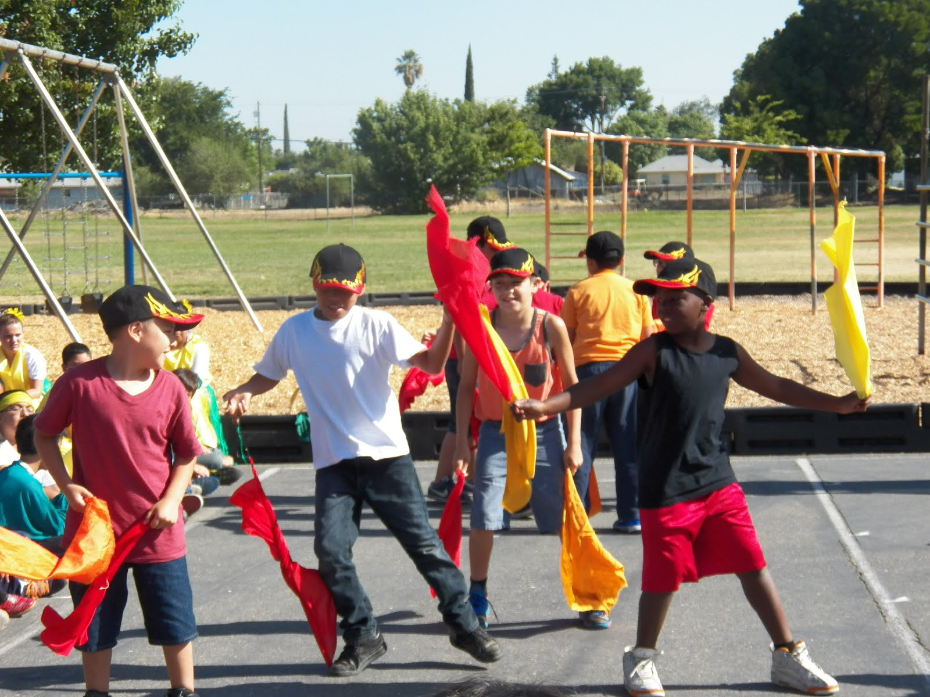

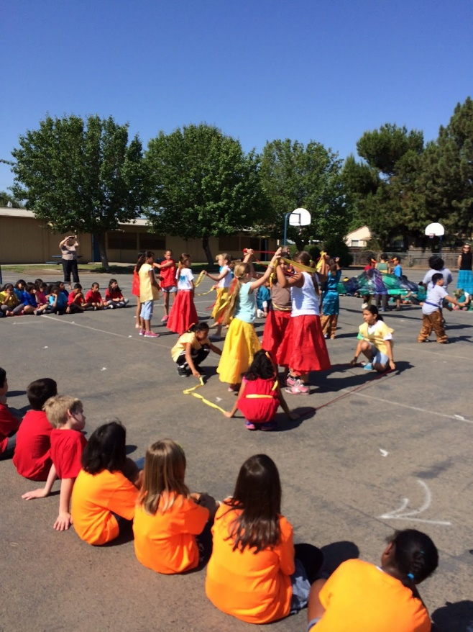
Interpretive Dance representing, “Plant Life”
5th grades
Music: “Electric Daisy” by Lindsey Stirling

