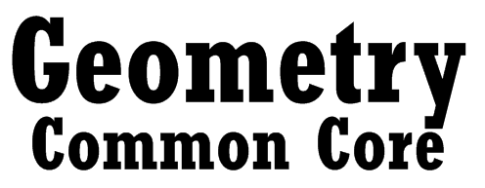

**C:\Users\jmorris\AppData\Local\Microsoft\Windows\Temporary Internet Files\Content.IE5\COC33TJ9\MC900055588[1].wmf**

**Spring 2014**

** Bellmore-Merrick**

**Central High School District**

**Bellmore-Merrick**

**Central High School District**

**BOARD OF EDUCATION**

**Susan Schwartz JoAnn DeLauter**

*President Vice President*

*Trustees*

**Marion Blane**

**Janet Goller**

**George Haile**

**Dr. Nancy Kaplan**

**Nina Lanci**

**Dr. Matthew Kuschner**

**ADMINISTRATION**

**John DeTommaso**

*Superintendent of Schools*

**Cynthia Strait Régal**

*Deputy Superintendent, Business*

**Dr. Mara Bollettieri**

*Assistant Superintendent, Personnel*

**Caryn Blum**

*Assistant Superintendent, Instruction*

**Geometry Common Core**

*Written by*

**Dan Bloomfield**

**Taryn Haruthunian**

**Susan Necroto**

*Spring 2014*

*Supervised by*

**James Morris – Calhoun High School**

In this course, students will explore more complex geometric situations and deepen their explanations of geometric relationships, moving towards formal mathematical arguments. They will establish triangle congruence criteria based on analyses of rigid motion and formal constructions, prove theorems, and solve problems about triangles, quadrilaterals, and other polygons. They will identify criteria for similarity of triangles, and apply similarity in right triangles to understand right triangle trigonometry. Students’ experience with two-dimensional and three-dimensional objects is extended to include informal explanations of circumference, area and volume formulas. Students will also prove basic theorems about circles, and use a rectangular coordinate system to verify geometric relationships. All students will take a Regents examination in June.

148 days have been accounted for in this curriculum guide. The *Prior Knowledge* section was included in each chapter so teachers could prepare students in advance by incorporating those topics into “Do Now” problems, homework assignments, and review lessons. Teachers may wish to combine lessons and objectives in order to allow for additional review and/or testing within a unit. The remaining time should be used to review for the Regents exam.

**Table of Contents**

**Module Page**

Module 1 11

Module 2 28

Module 3 44

Module 4 48

Module 5 57

**Sequence of Geometry Modules Aligned with the Standards**

**Module 1**: Congruence, Proof, and Constructions (45 days)

**Module 2**: Similarity, Proof, and Trigonometry (45 days)

**Module 3**: Extending to Three Dimensions (10 days)

**Module 4**: Connecting Algebra and Geometry through Coordinates (25 days)

**Module 5**: Circles with and Without Coordinates (25 days)

**Summary of Year**

The fundamental purpose of the course in Geometry is to formalize and extend students’ geometric experiences from the middle grades. Students explore more complex geometric situations and deepen their explanations of geometric relationships, moving towards formal mathematical arguments. Important differences exist between this Geometry course and the historical approach taken in Geometry classes. For example, transformations are emphasized early in this course. Close attention should be paid to the introductory content for the Geometry conceptual category found in the high school CCSS. The Mathematical Practice Standards apply throughout each course and, together with the content standards, prescribe that students experience mathematics as a coherent, useful, and logical subject that makes use of their ability to make sense of problem situations.

**Recommended Fluencies for Geometry**

* Triangle congruence and similarity criteria.
* Using coordinates to establish geometric results.
* Calculating length and angle measures.
* Using geometric representations as a modeling tool.
* Using construction tools, physical and computational to draft models of geometric phenomenon.

**High School Geometry**

An understanding of the attributes and relationships of geometric objects can be applied in diverse contexts—interpreting a schematic drawing, estimating the amount of wood needed to frame a sloping roof, rendering computer graphics, or designing a sewing pattern for the most efficient use of material.

Although there are many types of geometry, school mathematics is devoted primarily to plane Euclidean geometry, studied both synthetically (without coordinates) and analytically (with coordinates). Euclidean geometry is characterized most importantly by the Parallel Postulate, that through a point not on a given line there is exactly one parallel line. (Spherical geometry, in contrast, has no parallel lines.)

During high school, students begin to formalize their geometry experiences from elementary and middle school, using more precise definitions and developing careful proofs. Later in college some students develop Euclidean and other geometries carefully from a small set of axioms.

The concepts of congruence, similarity, and symmetry can be understood from the perspective of geometric transformation. Fundamental are the rigid motions: translations, rotations, reflections, and combinations of these, all of which are here assumed to preserve distance and angles (and therefore shapes generally). Reflections and rotations each explain a particular type of symmetry, and the symmetries of an object offer insight into its attributes—as when the reflective symmetry of an isosceles triangle assures that its base angles are congruent.

In the approach taken here, two geometric figures are defined to be congruent if there is a sequence of rigid motions that carries one onto the other. This is the principle of superposition. For triangles, congruence means the equality of all corresponding pairs of sides and all corresponding pairs of angles. During the middle grades, through experiences drawing triangles from given conditions, students notice ways to specify enough measures in a triangle to ensure that all triangles drawn with those measures are congruent. Once these triangle congruence criteria (ASA, SAS, and SSS) are established using rigid motions, they can be used to prove theorems about triangles, quadrilaterals, and other geometric figures.

Similarity transformations (rigid motions followed by dilations) define similarity in the same way that rigid motions define congruence, thereby formalizing the similarity ideas of "same shape" and "scale factor" developed in the middle grades. These transformations lead to the criterion for triangle similarity that two pairs of corresponding angles are congruent.

The definitions of sine, cosine, and tangent for acute angles are founded on right triangles and similarity, and, with the Pythagorean Theorem, are fundamental in many real-world and theoretical situations. The Pythagorean Theorem is generalized to non-right triangles by the Law of Cosines. Together, the Laws of Sines and Cosines embody the triangle congruence criteria for the cases where three pieces of information suffice to completely solve a triangle. Furthermore, these laws yield two possible solutions in the ambiguous case, illustrating that Side-Side-Angle is not a congruence criterion.

Analytic geometry connects algebra and geometry, resulting in powerful methods of analysis and problem solving. Just as the number line associates numbers with locations in one dimension, a pair of perpendicular axes associates pairs of numbers with locations in two dimensions. This correspondence between numerical coordinates and geometric points allows methods from algebra to be applied to geometry and vice versa. The solution set of an equation becomes a geometric curve, making visualization a tool for doing and understanding algebra. Geometric shapes can be described by equations, making algebraic manipulation into a tool for geometric understanding, modeling, and proof. Geometric transformations of the graphs of equations correspond to algebraic changes in their equations.

Dynamic geometry environments provide students with experimental and modeling tools that allow them to investigate geometric phenomena in much the same way as computer algebra systems allow them to experiment with algebraic phenomena.

**Module 1**

**Congruence, Proof, and Construction (45 days)**

**Experiment with transformations in the plane**

**G-CO.1** Know precise definitions of angle, circle, perpendicular line, parallel line, and line segment, based on the undefined notions of point, line, distance along a line, and distance around a circular arc.

**G-CO.2** Represent transformations in the plane using, e.g., transparencies and geometry software; describe transformations as functions that take points in the plane as inputs and give other points as outputs. Compare transformations that preserve distance and angle to those that do not (e.g., translation versus horizontal stretch).

**G-CO.3** Given a rectangle, parallelogram, trapezoid, or regular polygon, describe the rotations and reflections that carry it onto itself.

**G-CO.4** Develop definitions of rotations, reflections, and translations in terms of angles, circles, perpendicular lines, parallel lines, and line segments.

**G-CO.5** Given a geometric figure and a rotation, reflection, or translation, draw the transformed figure using, e.g., graph paper, tracing paper, or geometry software. Specify a sequence of transformations that will carry a given figure onto another.

**Understand congruence in terms of rigid motions**

**G-CO.6** Use geometric descriptions of rigid motions to transform figures and to predict the effect of a given rigid motion on a given figure; given two figures, use the definition of congruence in terms of rigid motions to decide if they are congruent.

**G-CO.7** Use the definition of congruence in terms of rigid motions to show that two triangles are

congruent if and only if corresponding pairs of sides and corresponding pairs of angles are congruent.

**G-CO.8** Explain how the criteria for triangle congruence (ASA, SAS, and SSS) follow from the definition of congruence in terms of rigid motions.

**Prove geometric theorems**

**G-CO.9** Prove and apply theorems about lines and angles. Theorems include: vertical angles are congruent; when a transversal crosses parallel lines, alternate interior angles are congruent and corresponding angles are congruent; points on a perpendicular bisector of a line segment are exactly those equidistant from the segment’s endpoints.

**G-CO.10** Prove and apply theorems about triangles. Theorems include: measures of interior angles of a triangle sum to 180°; base angles of isosceles triangles are congruent; the segment joining midpoints of two sides of a triangle is parallel to the third side and half the length; the medians of a triangle meet at a point.

**G-CO.11** Prove and apply theorems about parallelograms. Theorems include: opposite sides are congruent, opposite angles are congruent, the diagonals of a parallelogram bisect each other, and conversely, rectangles are parallelograms with congruent diagonals.

**Make geometric constructions**

**G-CO.12** Make formal geometric constructions with a variety of tools and methods (compass and straightedge, string, reflective devices, paper folding, dynamic geometric software, etc.). Copying a segment; copying an angle; bisecting a segment; bisecting an angle; constructing perpendicular lines, including the perpendicular bisector of a line segment; and constructing a line parallel to a given line through a point not on the line.

**G-CO.13** Construct an equilateral triangle, a square, and a regular hexagon inscribed in a circle.

**Module 2:**

**Similarity, Proof, and Trigonometry (45 days)**

**Understand similarity in terms of similarity transformations**

**G-SRT.1** Verify experimentally the properties of dilations given by a center and a scale factor:

a. A dilation takes a line not passing through the center of the dilation to a parallel line, and leaves a line passing through the center unchanged.

b. The dilation of a line segment is longer or shorter in the ratio given by the scale factor.

**G-SRT.2** Given two figures, use the definition of similarity in terms of similarity transformations to decide if they are similar; explain using similarity transformations the meaning of similarity for triangles as the equality of all corresponding pairs of angles and the proportionality of all corresponding pairs of sides.

**G-SRT.3** Use the properties of similarity transformations to establish the AA criterion for two triangles to be similar.

**Prove theorems involving similarity**

**G-SRT.4** Prove and apply theorems about triangles. Theorems include: a line parallel to one side of a triangle divides the other two proportionally, and conversely; the Pythagorean Theorem proved using triangle similarity.

**G-SRT.5** Use congruence and similarity criteria for triangles to solve problems and to prove relationships in geometric figures.

**Define trigonometric ratios and solve problems involving right triangles**

**G-SRT.6** Understand that by similarity, side ratios in right triangles are properties of the angles in the triangle, leading to definitions of trigonometric ratios for acute angles.

**G-SRT.7** Explain and use the relationship between the sine and cosine of complementary angles.

**G-SRT.8** Use trigonometric ratios and the Pythagorean Theorem to solve right triangles in applied problems.★

**Apply geometric concepts in modeling situations**

**G-MG.1** Use geometric shapes, their measures, and their properties to describe objects (e.g., modeling a tree trunk or a human torso as a cylinder).★

**G-MG.2** Apply concepts of density based on area and volume in modeling situations (e.g., persons per square mile, BTUs per cubic foot).★

**G-MG.3** Apply geometric methods to solve design problems (e.g., designing an object or structure to satisfy physical constraints or minimize cost; working with typographic grid systems based on ratios).★

**Module 3:**

**Extending to Three Dimensions (10 days)**

**Explain volume formulas and use them to solve problems**

The (+) standard on the volume of the sphere is an extension of G-GMD.1. It is explained by the teacher in this grade and used by students in G-GMD.3. Note: Students are not assessed on proving the volume of a sphere formula until Precalculus.

**G-GMD.1** Give an informal argument for the formulas for the circumference of a circle, area of a circle, volume of a cylinder, pyramid, and cone. Use dissection arguments, Cavalieri’s Principle, and informal limit arguments.

**G-GMD.3** Use volume formulas for cylinders, pyramids, cones, and spheres to solve problems.★

**Visualize relationships between two-dimensional and three-dimensional objects**

**G-GMD.4** Identify the shapes of two-dimensional cross-sections of three-dimensional objects, and identify three-dimensional objects generated by rotations of two-dimensional objects.

**Apply geometric concepts in modeling situations**

**G-MG.1** Use geometric shapes, their measures, and their properties to describe objects (e.g., modeling a tree trunk or a human torso as a cylinder).★

**Module 4:**

**Connecting Algebra and Geometry through Coordinates (25 days)**

**Use coordinates to prove simple geometric theorems algebraically**

**G-GPE.4** Use coordinates to prove simple geometric theorems algebraically. For example, prove or disprove that a figure defined by four given points in the coordinate plane is a rectangle; prove or disprove that the point (1, √3) lies on the circle centered at the origin and containing the point (0, 2).

**G-GPE.5** Prove the slope criteria for parallel and perpendicular lines and use them to solve geometric problems (e.g., find the equation of a line parallel or perpendicular to a given line that passes through a given point).

**G-GPE.6** Find the point on a directed line segment between two given points that partitions the segment in a given ratio.

**G-GPE.7** Use coordinates to compute perimeters of polygons and areas of triangles and rectangles, e.g., using the distance formula.★

**Module 5:**

**Circles with and Without Coordinates (25 days)**

**Understand and apply theorems about circles**

**G-C.1** Prove that all circles are similar.

**G-C.2** Identify and describe relationships among inscribed angles, radii, and chords. Include the relationship between central, inscribed, and circumscribed angles; inscribed angles on a diameter are right angles; the radius of a circle is perpendicular to the tangent where the radius intersects

the circle.

**G-C.3** Construct the inscribed and circumscribed circles of a triangle, and prove and apply properties of angles for a quadrilateral inscribed in a circle.

**Find arc lengths and areas of sectors of circles**

**G-C.5** Derive using similarity the fact that the length of the arc intercepted by an angle is proportional to the radius, and define the radian measure of the angle as the constant of proportionality; derive the formula for the area of a sector

**Translate between the geometric description and the equation for a conic section**

**G-GPE.1** Derive the equation of a circle of given center and radius using the Pythagorean Theorem; complete the square to find the center and radius of a circle given by an equation.

Use coordinates to prove simple geometric theorems algebraically

**G-GPE.4** Use coordinates to prove simple geometric theorems algebraically. For example, prove or disprove that a figure defined by four given points in the coordinate plane is a rectangle; prove or disprove that the point (1, √3) lies on the circle centered at the origin and containing the point (0, 2).

**Apply geometric concepts in modeling situations**

**G-MG.1** Use geometric shapes, their measures, and their properties to describe objects (e.g., modeling a tree trunk or a human torso as a cylinder).★

**Extensions to the Geometry Course**

The (+) standards below are included in the Geometry course to provide coherence to the curriculum. They can be used to effectively extend a topic or to introduce a theme/concept that will be fully covered in the Precalculus course. Note: None of the (+) standard below will be assessed on the Regents Exam or PARRC Assessments until Precalculus.

**Module 2**

These standards can be taught as applications of similar triangles and the definitions of the trigonometric ratios.

**Apply trigonometry to general triangles**

**G-SRT.9** (+) Derive the formula A = 1/2 ab sin(C) for the area of a triangle by drawing an auxiliary line from a vertex perpendicular to the opposite side.

**G-SRT.10** (+) Prove the Laws of Sines and Cosines and use them to solve problems.

**G-SRT.11** (+) Understand and apply the Law of Sines and the Law of Cosines to find unknown measurements in right and non-right triangles (e.g., surveying problems, resultant forces).

**Module 3**

This standard on the volume of the sphere is an extension of G-GMD.1. In this course, it is explained by the teacher and used by students in G-GMD.3.

**Explain volume formulas and use them to solve problems**

**G-GMD.2** (+) Give an informal argument using Cavalieri’s principle for the formulas for the volume of a sphere and other solid figures.

**Module 5**

This standard is an immediate extension of G-C.2 and can be given as a homework assignment (with an appropriate hint).

**Understand and apply theorems about circles**

**G-C.4** (+) Construct a tangent line from a point outside a given circle to the circle.

**Module 1:**

**Congruence, Proof, and Constructions (45 days)**

In previous grades, students were asked to draw triangles based on given measurements. They also have prior experience with rigid motions—translations, reflections, and rotations—and have strategically applied a rigid motion to informally show that two triangles are congruent. In this module, students establish triangle congruence criteria, based on analyses of rigid motions and formal constructions. They build upon this familiar foundation of triangle congruence to develop formal proof techniques. Students make conjectures and construct viable arguments to prove theorems—using a variety of formats—and solve problems about triangles, quadrilaterals, and other polygons. They construct figures by manipulating appropriate geometric tools (compass, ruler, protractor, etc.) and justify why their written instructions produce the desired figure.

* Students will review previously learned geometry facts and definitions
* Students will learn how to construct an equilateral triangle
* Students will learn how to bisect and angle
* Students will learn how to copy an angle
* Students will learn how to construct a perpendicular bisector
* Students will construct an equilateral triangle, a square, and a regular hexagon inscribed in a circle
* Students will understand the criteria for two or more points to be concurrent
* Students will solve for angles using auxiliary lines
* Students will write unknown angle proofs using known facts
* Students will review previously learned material regarding transformations (rotations, reflections, and translations)
* Students will learn how to rotate a figure about a center of rotation for a given number of degrees and in a given direction.
* Students will learn how to determine the angle of rotation and the center of rotation for a given figure and its image.
* Students will precisely define a reflection and construct reflections using a perpendicular bisector.
* Students will learn the relationship between a reflection and a rotation
* Students will examine rotational symmetry within an individual figure
* Students will learn the precise definition of a translation and perform a translation by construction
* Students will construct a line parallel to a given line through a point not on that line using a rotation by 
* Students will understand congruence in terms of rigid motions
* Students will how the criteria for triangle congruence (ASA, SAS, and SSS) follow from the definition of congruence in terms of rigid motions.
* Students will prove theorems about lines and angles *(vertical angles are congruent; when a transversal crosses parallel lines, alternate interior angles are congruent and corresponding angles are congruent; points on a perpendicular bisector of a line segment are exactly those equidistant from the segment’s endpoints)*
* Students will prove theorems about triangles *(measures of interior angles of a triangle sum to 180°; base angles of isosceles triangles are congruent; the segment joining midpoints of two sides of a triangle is parallel to the third side and half the length; the medians of a triangle meet at a point)*
* Students will prove theorems about parallelograms *(opposite sides are congruent, opposite angles are congruent, the diagonals of a parallelogram bisect each other, and conversely, rectangles are parallelograms with congruent diagonals)*
* Students will understand that corresponding parts of congruent triangles are congruent
* Students will learn why any two triangles that satisfy the AAS or HL congruence criteria must be congruent.
* Students learn why any two triangles the meet the AAA or SSA criteria are not necessarily congruent.
* Students will understand the relationships created by the mid-segment of a triangle
* Students will understand the relationships created by the medians of a triangle (centroid)
* Students will understand the relationships created by the angle bisectors of a triangle (incenter)
* Students will understand the relationships created by the perpendicular bisectors of a triangle (circumsenter)
* Students will understand the relationships created by the altitudes of a triangle (orthocenter)

**Experiment with transformations in the plane**

**G-CO.1** Know precise definitions of angle, circle, perpendicular line, parallel line, and line segment, based on the undefined notions of point, line, distance along a line, and distance around a circular arc.

**G-CO.2** Represent transformations in the plane using, e.g., transparencies and geometry software; describe transformations as functions that take points in the plane as inputs and give other points as outputs. Compare transformations that preserve distance and angle to those that do not (e.g., translation versus horizontal stretch).

1. What term describes a transformation that does not change a figure’s size or shape?

(A) similarity

(B) isometry

(C) collinearity

(D) symmetry

For questions 2–5, determine if the described transformation(s) is/are an isometry.

2. A reflection is an isometry.

(A) True

(B) False

3. A composition of two reflections is an isometry.

(A) True

(B) False

4. A dilation is an isometry.

(A) True

(B) False

5. A composition of a rotation and a dilation is an isometry.

(A) True

(B) False

7. Which transformation does NOT preserve the orientation of a figure?

(A) dilation

(B) reflection

(C) rotation

(D) translation

8. A figure is transformed in the plane such that no point maps to itself.

What type of transformation must this be?

(A) dilation

(B) reflection

(C) rotation

(D) translation

For questions 9–10, determine the truth of the statements about rotations.

9. Rotations preserve the orientation of a figure.

(A) True

(B) False

10. Under a rotation, no point can map to itself.

(A) True

(B) False

**G-CO.3** Given a rectangle, parallelogram, trapezoid, or regular polygon, describe the rotations and reflections that carry it onto itself.

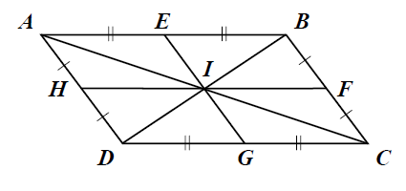For questions 1–3, use the diagram showing parallelogram *ABCD*.

1. A reflection across  carries parallelogram *ABCD* onto itself.

(A) True

(B) False

2. A rotation of 90° about *I* carries parallelogram *ABCD* onto itself.

(A) True

(B) False

3. A rotation of 180° about *I* carries parallelogram *ABCD* onto itself.

(A) True

(B) False

4. A regular polygon with *n* sides is carried onto itself by a positive

rotation about its center that is a multiple of 60°, but less than 360°.

Which could NOT be the value of *n*?

(A) 3

(B) 4

(C) 5

(D) 6

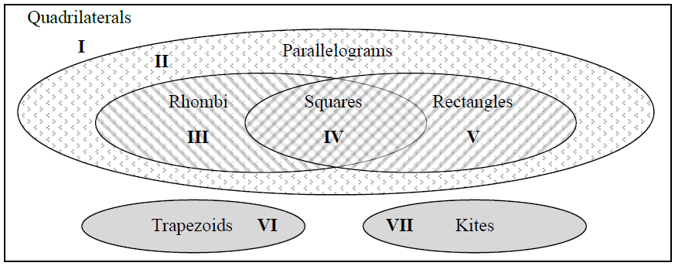5. Use the Venn diagram shown.

A quadrilateral *ABCD* has 4 lines

of symmetry. Identify the area of

the diagram in which *ABCD* resides.

(A) III

(B) IV

(C) V

(D) VII

**G-CO.4** Develop definitions of rotations, reflections, and translations in terms of angles, circles, perpendicular lines, parallel lines, and line segments.

1. Which of these is equivalent to a translation?

(A) a reflection across one line

(B) a composition of two reflections across intersecting lines

(C) a composition of two reflections across parallel lines

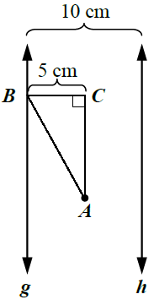

2. In the diagram, g and *B* lies on line *g*.

The figure *ABC* is reflected across line *g*, and its image

is reflected across line *h*. What is the distance

from line *g* to the final image of point *A*?

(A) 5 cm

(B) 15 cm

(C) 20 cm

(D) 25 cm

**G-CO.5** Given a geometric figure and a rotation, reflection, or translation, draw the transformed figure using, e.g., graph paper, tracing paper, or geometry software. Specify a sequence of transformations that will carry a given figure onto another.

1. A figure is rotated about the origin by 180°, then is translated 4 units right

and one unit up. Which describes the results of the two transformations?

(A) 

(B) 

(C) 

(D) 

2. The point *A*(4, 3) is rotated –90° about the origin. In which quadrant is *A'* ?

(A) I

(B) II

(C) III

(D) IV

3. A figure is reflected across the line *y* = 2, then reflected across the line *y* = 4.

Which single transformation results in the same image?

(A) a reflection across the line *y* = 3

(B) a reflection across the line *y* = 6

(C) a translation 2 units up

(D) a translation 4 units up

4. Point  is the image of point *A* under a transformation *T*. Line  is the

perpendicular bisector of  at point *M*. Which describes the transformation *T*?

(A) a reflection across 

(B) a 90° rotation about *M*

(C) a translation by the vector from *A* to *M*

(D) a dilation about *M* with scale factor 2

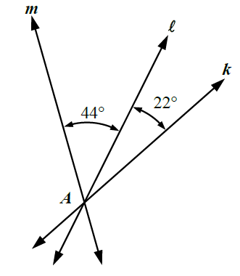

5. Use the diagram.

Which series of reflections would result in

a rotation of –44° about *A*?

(A) reflect across *k*¸ then reflect across 

(B) reflect across ¸ then reflect across *k*

(C) reflect across ¸ then reflect across *m*

(D) reflect across *m*¸ then reflect across 

6. After a figure is rotated,  Which statement(s) could be true?

(A) The center of rotation is *P*.

(B) The angle of rotation is a multiple of 360°.

(C) Either A or B or both.

(D) Neither A nor B.

For questions 7–8, a transformation *S* is defined as .

7. The pre-image of  under *S* is .

(A) True

(B) False

8. *S* is an isometry.

(A) True

(B) False

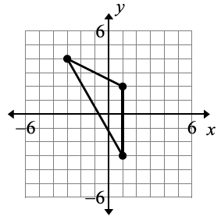9. Use the figure.

A transformation *T* is defined as 

Which shows the image of figure under *T*?

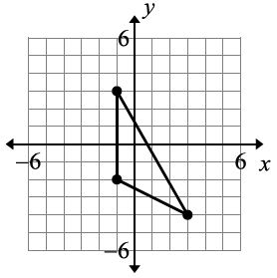

A)

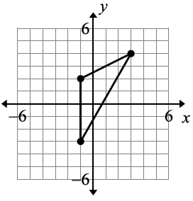

B)

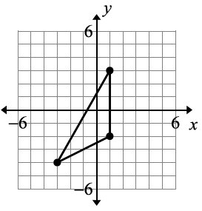

C)

10. Given point *A* is located at (1, 3). What is the final image

of *A* after this series of transformations?

(1) Reflect *A* across the *y* axis.

(2) Translate the image such that 

(A) (–1, –3)

(B) (–3, 5)

(C) (–3, –1)

(D) (–5, 5)

For questions 11–12, use the diagram which shows *ABC* has been reflected

across an unknown line , then reflected across line *m* to produce  .

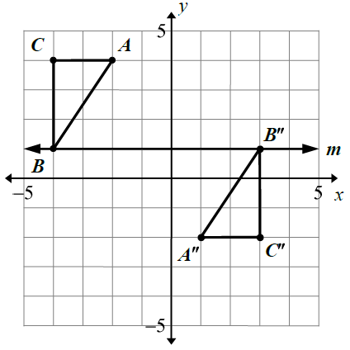

11. The equation of line  is *x* = – 0.5.

(A) True

(B) False

12. If *ABC* were reflected across line *m* first, then reflected across line to produce ,

the equation of line would be *x* = – 0.5.

(A) True

(B) False

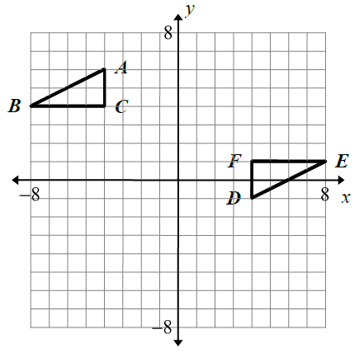13. Use the diagram shown.

(a) Transform  by reflecting it across

the *y*-axis to produce ..

(b) Describe a transformation, or composition of

transformations, that maps  to 

(c) Describe a single transformation that

maps to 

14. Draw the image of when

reflected across line *m*.

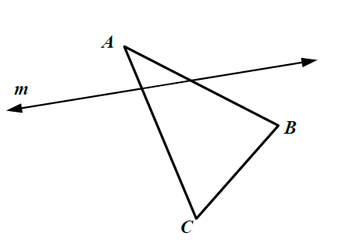

15. is the image of when a reflected about line . Construct line .

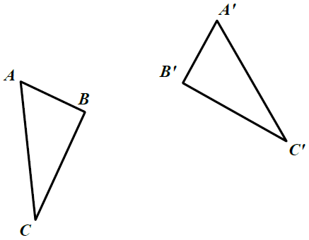

16. is the image of when rotated about point *O*.

Construct point *O* and compute the angle of rotation.

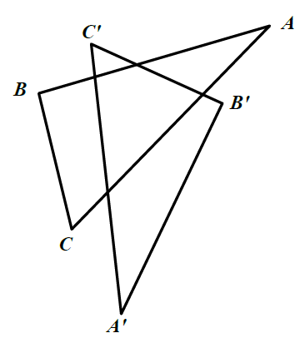

**Understand congruence in terms of rigid motions**

**G-CO.6** Use geometric descriptions of rigid motions to transform figures and to predict the effect of a given rigid motion on a given figure; given two figures, use the definition of congruence in terms of rigid motions to decide if they are congruent.

1. Look at the figure below.

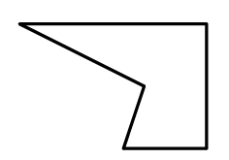

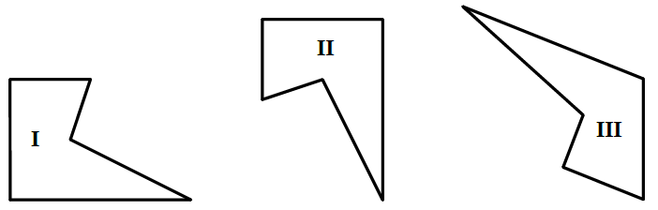 Now, look at these 3 figures.

Which figures are congruent to the first figure?

(A) I only

(B) II only

(C) I and II only

(D) I, II, and III

For questions 2–4, evaluate whether the image of a figure under the described transformation is congruent to the figure.

2. A transformation *T* follows the rule  The

image of a figure under *T* is congruent to the figure.

(A) True

(B) False

3. A transformation *T* follows the rule  The

image of a figure under *T* is congruent to the figure.

(A) True

(B) False

4. A transformation *T* follows the rule  The

image of a figure under *T* is congruent to the figure.

(A) True

(B) False

**G-CO.7** Use the definition of congruence in terms of rigid motions to show that two triangles are

congruent if and only if corresponding pairs of sides and corresponding pairs of angles are congruent.

1. On the coordinate plane, draw triangles and  such that:

(1) 

(2)  has been rotated 90°.

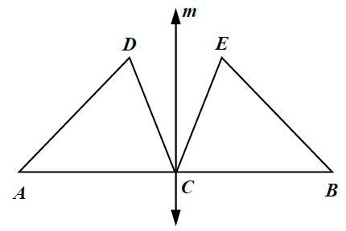

2. In the diagram, *m* is the perpendicular

bisector of  at *C*, and .

Prove 

**G-CO.8** Explain how the criteria for triangle congruence (ASA, SAS, and SSS) follow from the definition of congruence in terms of rigid motions.

For questions 1–3, consider a triangle  that has been transformed through rigid motions and its image compared to  Determine if the given information is sufficient to draw the provided conclusion.

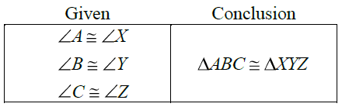

1.

(A) True

(B) False

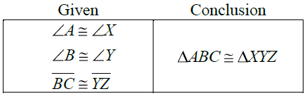2.

(A) True

(B) False

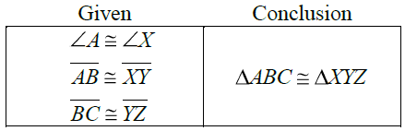

3.

(A) True

(B) False

**Prove geometric theorems**

**G-CO.9** Prove theorems about lines and angles. Theorems include: vertical angles are congruent; when a transversal crosses parallel lines, alternate interior angles are congruent and corresponding angles are congruent; points on a perpendicular bisector of a line segment are exactly those equidistant from the segment’s endpoints.

For questions 1–4, use the diagram where *B* is the reflection of *A* across  .

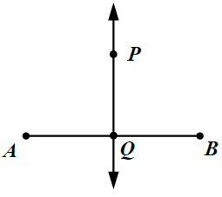1. *PA* = *PB*

(A) True

(B) False

2. 

(A) True

(B) False

3. *AQ* = *QB*

(A) True

(B) False

4. 

(A) True

(B) False

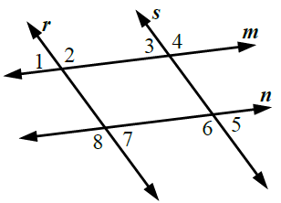

5. Use the diagram.

Which statement would be used to

prove lines *r* and *s* are parallel?

(A)  and  are congruent

(B)  and  are complementary

(C)  and  are congruent

(D)  and  are supplementary

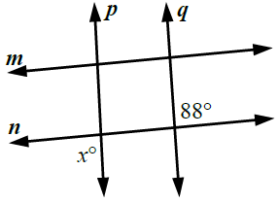6. In the diagram,  and .

What is the value of *x*?

(A) 44

(B) 88

(C) 92

(D) 176

**G-CO.10** Prove theorems about triangles. Theorems include: measures of interior angles of a triangle sum to 180°; base angles of isosceles triangles are congruent; the segment joining midpoints of two sides of a triangle is parallel to the third side and half the length; the medians of a triangle meet at a point.

1. In ,  *M* is the midpoint of  and *N* is the midpoint of 

For which type of triangle is 

(A) equilateral only

(B) isosceles only

(C) scalene only

(D) any triangle

For questions 2–3, consider where *AB* = *BC* and 

2. 

(A) True

(B) False

3. 

(A) True

(B) False

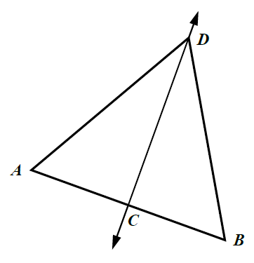4. In the diagram,  is the perpendicular bisector of .

Prove: 

**G-CO.11** Prove theorems about parallelograms. Theorems include: opposite sides are congruent, opposite angles are congruent, the diagonals of a parallelogram bisect each other, and conversely, rectangles are parallelograms with congruent diagonals.

For questions 1–3, use the diagram where *ABCD* is a quadrilateral

with  and  Diagonals  and  intersect at *E*.

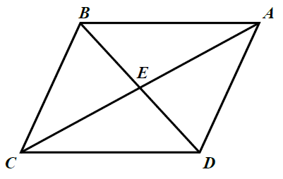1. 

(A) True

(B) False

2. 

(A) True

(B) False

3. 

(A) True

(B) False

**Make geometric constructions**

**G-CO.12** Make formal geometric constructions with a variety of tools and methods (compass and straightedge, string, reflective devices, paper folding, dynamic geometric software, etc.). Copying a segment; copying an angle; bisecting a segment; bisecting an angle; constructing perpendicular lines, including the perpendicular bisector of a line segment; and constructing a line parallel to a given line through a point not on the line.

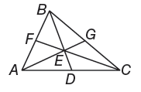

1. If point E is the centroid of ,

BD = 12, EF = 7, and AG = 15, find ED.

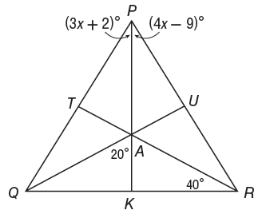

2. Point *A* is the incenter of 

Find each measure below.

a. ∠*ARU*

b. *AU*

c. ∠*QPK*

3. Find the coordinates of the orthocenter of each triangle

whose coordinates are *S*(1, 0), *T*(4, 7), *U*(8, −3)

**G-CO.13** Construct an equilateral triangle, a square, and a regular hexagon inscribed in a circle.

**Module 2:**

**Similarity, Proof, and Trigonometry (45 days)**

Students apply their earlier experience with dilations and proportional reasoning to build a formal understanding of similarity. They identify criteria for similarity of triangles, make sense of and persevere in solving similarity problems, and apply similarity to right triangles to prove the Pythagorean Theorem. Students attend to precision in showing that trigonometric ratios are well defined, and apply trigonometric ratios to find missing measures of general (not necessarily right) triangles. Students model and make sense out of indirect measurement problems and geometry problems that involve ratios or rates.

* Students will be able to identify similarity transformations and verify properties of similarity.
* Students will be able to use the Side-Splitter Theorem and the Triangle-Angle-Bisector Theorem.
* Students will be able to use the Pythagorean Theorem and its converse.
* Students will be able to apply HLLS and SAAS
* Students will be able to find the sum of the measures of the interior angles of a polygon.
* Students will be able to find the sum of the measures of the exterior angles of a polygon.
* Students will be able to determine whether a quadrilateral is a parallelogram.
* Students will be able to define and classify special types of parallelograms.
* Students will be able to use properties of diagonals of parallelograms, rhombuses and rectangles.
* Students will be able to determine whether a parallelogram is a rhombus or rectangle.
* Students will be able to verify and use properties of trapezoids.
* Students will be able to identify and apply similar polygons.
* Students will be able to use the AA~ Postulate and the SAS~ and SSS~ Theorems.
* Students will be able to use similarity to find indirect measurements.
* Students will be able to find and use relationships in similar right triangles.
* Students will be able to use the sine, cosine, and tangent ratios to determine side lengths and angle measures in right triangles.
* Students will be able to use geometric shapes, their measures, and their properties to describe objects (e.g., modeling a tree trunk or a human torso as a cylinder)
* Students will be able to apply concepts of density based on area and volume in modeling situations.

**Understand similarity in terms of similarity transformations**

**G-SRT.1** Verify experimentally the properties of dilations given by a center and a scale factor:

a. A dilation takes a line not passing through the center of the dilation to a parallel line, and leaves a line passing through the center unchanged.

b. The dilation of a line segment is longer or shorter in the ratio given by the scale factor.

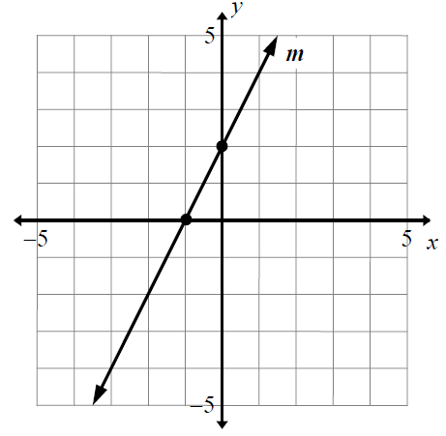

1. Use the diagram shown.

Dilate line *m* about the origin with scale factor 2.

What is the equation of the line’s image?

(A) 

(B) 

(C) 

(D) 

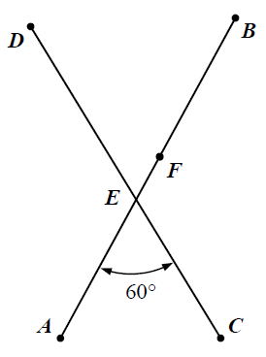

2. In the diagram, segments and intersect at *E*,

*F* lies on , and 

The two segments are dilated about *F* with a scale factor of .

What is ?

(A) 30

(B) 60

(C) 90

(D) 120

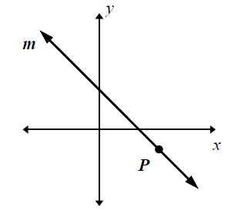3. Use the diagram shown.

Dilate line *m* by about *P*.

Which shows the result of this dilation?

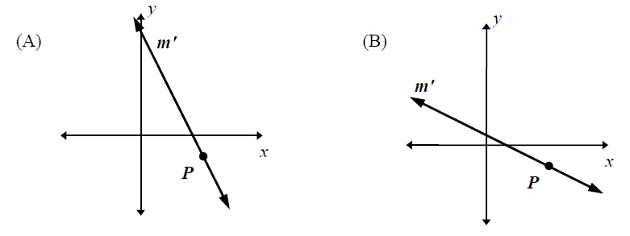







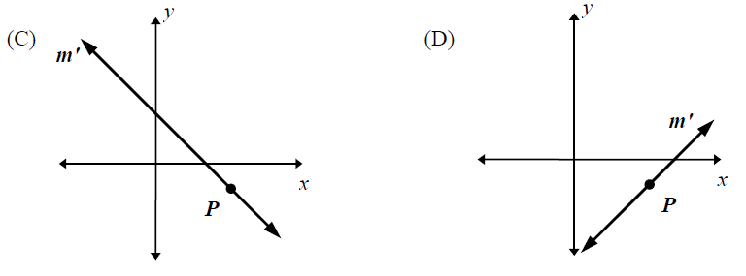

4. One vertex of a polygon is  If the polygon is dilated

about the point  with scale factor , what is the location of 

(A) 

(B) 

(C) 

(D) 

For questions 5 – 7, use the diagram shown.

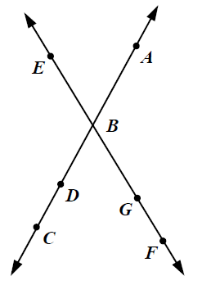

Let the figure be dilated with scale factor *k*, where and 

5. 

(A) True

(B) False

6. is between 

(A) True

(B) False

7. 

(A) True

(B) False

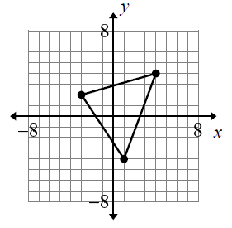

8. Use the figure shown at right.

Which shows the figure dialted about the origin with scale factor 1.5?

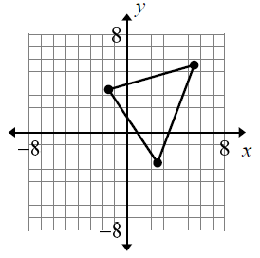

(A)

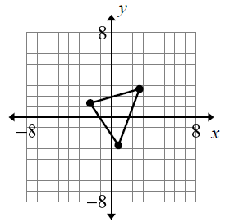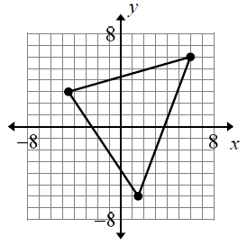

(B) (C)

9.  is the image of  after a dilation of scale factor 3.

Where is the center of dilation?

(A) 

(B) 

(C) 

(D) 

10. The equation of line *h* is  Line m is the image of line *h* after a dilation

of scale factor 4 with respect to the origin. What is the equation of the line *m*?

(A) 

(B) 

(C) 

(D) 

11. Suppose we apply a dilation of scale factor 2, centered at the point P, to the figure below.

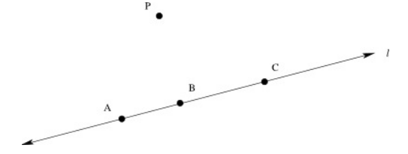

(a) In the picture, locate the images of the points A, B, and C

under this dilation.

(b) Based on your picture in part (a), what do you think happens to the line l

when we perform the dilation?

(c) Based on your picture in part (a), what appears to be the relationship between the

distance and the distance *AB*? How about the distances and *BC*?

(d) Can you prove your observations in part (c)?

**G-SRT.2** Given two figures, use the definition of similarity in terms of similarity transformations to decide if they are similar; explain using similarity transformations the meaning of similarity for triangles as the equality of all corresponding pairs of angles and the proportionality of all corresponding pairs of sides.

1. Triangle One has vertices  Triangle Two is similar

to Triangle One and has two of its vertices at 

(a) Draw Triangle One and Triangle Two on the coordinate plane and label the vertices.

(b) Draw and label a third triangle that is similar to Triangle One, has two

Vertices at  but is not congruent to Triangle Two.

2. Triangle *ABC* has vertices  The triangle is

dilated about the point  with scale factor 4. What is the location of 

(A) 

(B) 

(C) 

(D) 

3. Which is NOT a criterion for triangle similarity?

(A) angle-angle

(B) angle-side-angle

(C) side-angle-side

(D) side-side

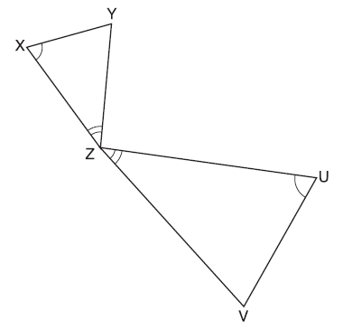

4. In the diagram shown, triangles XYZ and UVZ

are drawn such that  and 

Describe a sequene of similarity transformations

that shows is similar to 

5. In the diagram,  is a dilation of 

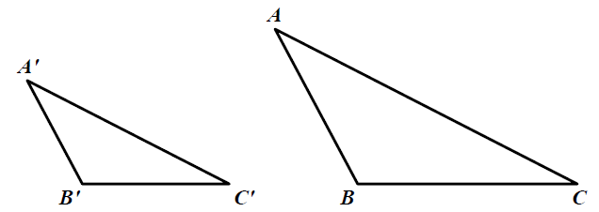

(a) Find the center of dialtion *O*.

(b) Compute the scale factor of the dilation.

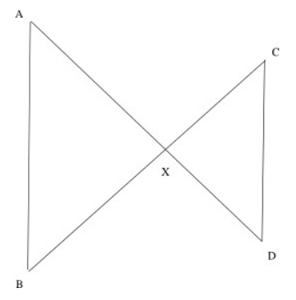

6. In the picture shown, line segments *AD* and *BC*

intersect at *X*. Line segments *AB* and *CD* are

drawn, forming two triangles *AXB* and *CXD*.

In each part (a)-(d) below, some additional

assumptions about the picture are given. In each

problem, determine whether the given

assumptions are enough to prove that the two

triangles are similar; and if so, what the correct

correspondence of vertices is. If the two triangles

must be similar, prove this result by describing a

sequence of similarity transformations that maps

one triangle to the other. If not, explain why not.

(a) The lengths *AX* and *XD* satisfy the eqution 

(b) The lengths *AX*, *BX*, *CX*, and *DX* satisfy the equation 

(c) Lines *AB* and *CD* are parallel.

(d) Angle *XAB* is congruent to angle *XCD*.

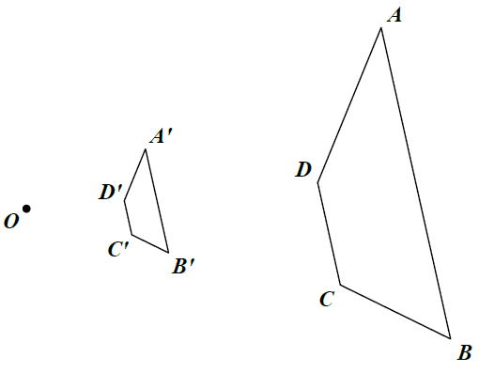7. In the diagram, *ABCD* is dilated with Center *O*

to produce , and 

What is 

(A) 

(B) 

(C) 2

(D) 3

**G-SRT.3** Use the properties of similarity transformations to establish the AA criterion for two triangles to be similar.

1. Sally constructs a triangle where two of the angles measure  and  Tom constructs a

triangle where two of the angles measure and  What is true about the two triangles?

1. The triangles *cannot be* similar.
2. The triangles *could be* similar.
3. The triangles *must be* similar.

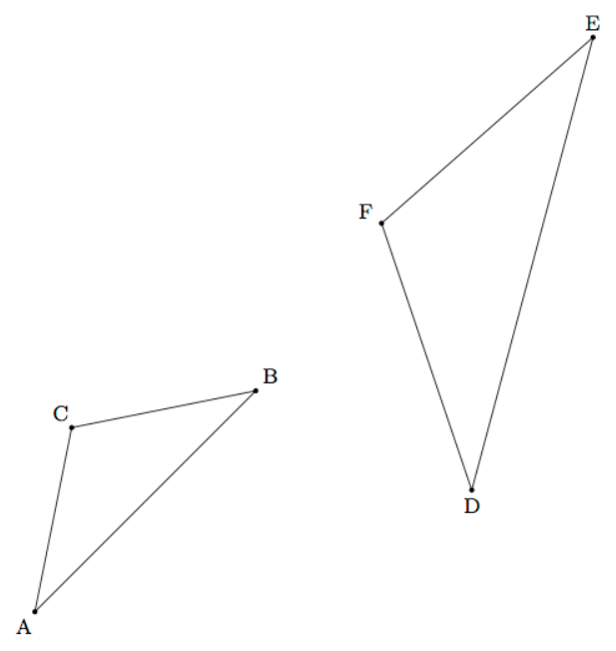

2. In the two triangles shown at right,

and 

Using a sequence of translations,

rotations, reflections, and/or

dilations, show that  is

similar to 

**Prove theorems involving similarity**

**G-SRT.4** Prove and apply theorems about triangles. Theorems include: a line parallel to one side of a triangle divides the other two proportionally, and conversely; the Pythagorean Theorem proved using triangle similarity.

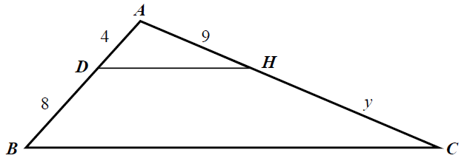1. In the diagram shown, 

What is the value of *y*?

(A) 13

(B) 18

(C) 27

(D) 30

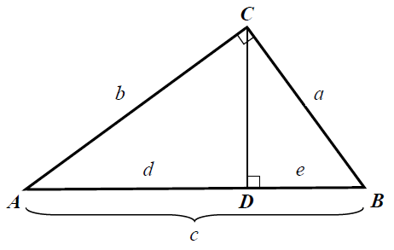

2. In the diagram,  is a right triangle

with right angle *C*, and  is an altitude

of .

Use the fact that 

to prove 

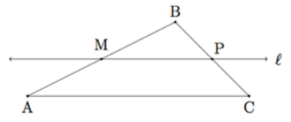3. Suppose *ABC* is a triangle. Let *M* be the

midpoint of  and  the line through *M*

parallel to 

(a) Show that  and that

 Conclude that



(b) Use part (a) to show that *P* is the midpoint of 

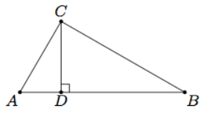4. Shown is right triangle *ABC* with right

angle *C* along the point *D* so that



(a) Show that 

(b) Use part (a) to conclude that 

­­­­­­­­­­­­­­­­­­­­­­­­­­­­­

**G-SRT.5** Use congruence and similarity criteria for triangles to solve problems and to prove relationships in geometric figures.

1. Prove that any two isosceles right triangles are similar.

2. Right triangle PQR has sides of length 6 units, 8 units, and 10 units. The triangle is

dilated by a scale factor of 4 about point Q. What is the area of triangle 

(A) 96 square units

(B) 192 square units

(C) 384 square units

(D) 768 square units

3. The ration of the side lengths of a triangle is 3 : 6 : 8. A second triangle is similar

to the first and its shortest side measures 8.0 centimeters. What is the length of

the longest side of the second triangle?

(A) 3.0 cm

(B) 10.7 cm

(C) 13.0 cm

(D) 21.3 cm

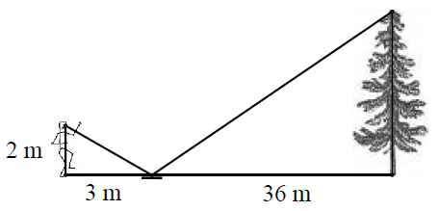

4. In the diagram, a stduent has placed a mirror on level goround, then

stands so that the top of a nearby tree is visible in the mirror.

What is the height of the tree?

(A) 24 m

(B) 35 m.

(C) 41 m

(D) 59 m

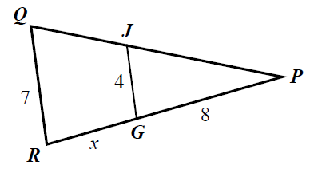5. In the diagram 

What is the value of *x*?

(A) 11

(B) 6

(C) 5

(D) 3

6. Which figure contains two similar triangles that are NOT congruent?

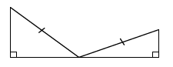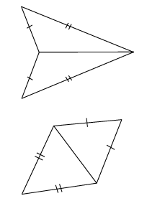

(A) (C)

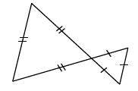

(B) (D)

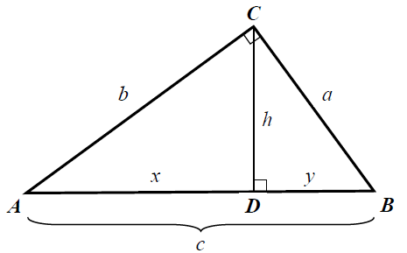

7. Use the diagram shown at right.

Which is equal to *h*?

(A) 

(B) 

(C) 

(D) 

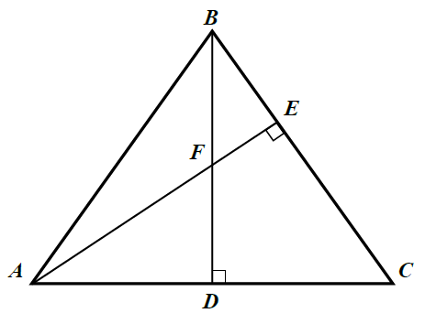8. Use the diagram shown at right.

Given: 



Prove: 

9. In rectangle *ABCD*,  and *G* is the midpoint of 

Segment *AB* is extended 2 units beyond *B* to point *E*, and *F* is the

intersection of  What is the area of *BFDG*?

10. Rhianna has learned the SSS and SAS congruence tests for triangles and she

wonders if these tests might work for parallelograms.

(a) Suppose *ABCD* and *EFGH* are two parallelograms all of whose corresponding

sides are congruent, that is 

Is it always true that *ABCD* is congruent to *EFGH*?

(b) Suppose ABCD and EFGH are two parallelograms with a pair of corresponding

sides  Suppose also that the included angles are

congruent,  Are *ABCD* and *EFGH* congruent?

**Define trigonometric ratios and solve problems involving right triangles**

**G-SRT.6** Understand that by similarity, side ratios in right triangles are properties of the angles in the triangle, leading to definitions of trigonometric ratios for acute angles.

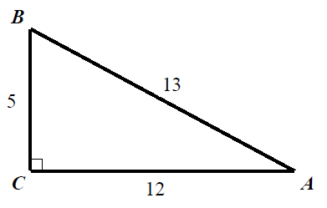

1. Use the diagram shown. Which statement is true?

(A) 

(B) 

(C) 

2. In  where C is a right angle,  What is 

(A)  (C) 

(B)  (D) 

3. In , the sine of angle *G* equals  is a dilation about G

with a scale factor of 2. What is the sine of angle 

(A) 

(B) 

(C) 

(D) 1

**G-SRT.7** Explain and use the relationship between the sine and cosine of complementary angles.

1. Explain why  for *x* such that 

2. Let  Which statement is true?

(A) 

(B) 

(C) 

(D) 

3. Let 

(a) Does ?

(A) True

(B) False

(b) Does ?

(A) True

(B) False

**G-SRT.8** Use trigonometric ratios and the Pythagorean Theorem to solve right triangles in applied problems.★

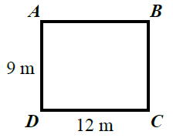1. Fred stands at corner *A* of a rectangular field shown.

He needs to get to corner *C*. What is the shortest distance

From *A* to *C*?

(A) 9 m

(B) 13 m

(C) 15 m

(D) 21 m

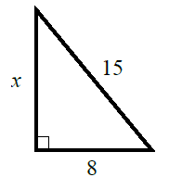

2. Use the right triangle. What is the value of *x*?

(A) 

(B) 

(C) 7

(D) 17

3. What is 

(A) 

(B) 

(C) 

(D) 

4. What is 

(A) 

(B) 

(C) 

(D) 

5. Use the diagram shown. Which is the value of *x*?

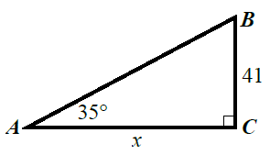

(A) 

(B) 

(C) 

(D) 

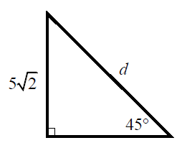6. Use the diagram shown. What is the value of *d*?

(A) 5

(B) 

(C) 10

(D) 

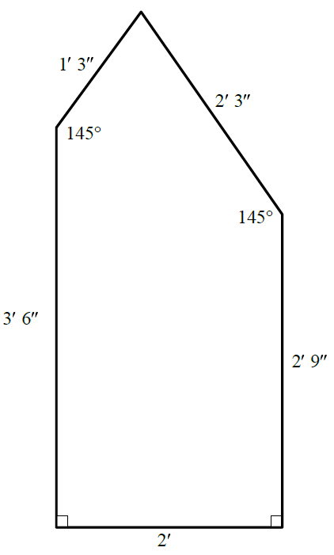

7. The diagram shows a model of a closet floor on

which Kim is laying a carpet. (measurements

are approximate)

(a) What is the area of the closet?

(b) The carpet Kim is using is cut by the

carpet store in rectangular pieces from a

4-foot wide roll. What is the shortest

length of carpet Kim would need to

cover the closet floor in a sngle piece?

Justify your answer.

8. As shown below, a canow is approaching a lighthouse on the coastline of a lake.

The front of the canoe is 1.5 feet above the water and an observer in the lighthouse

is 112 feet above the water.

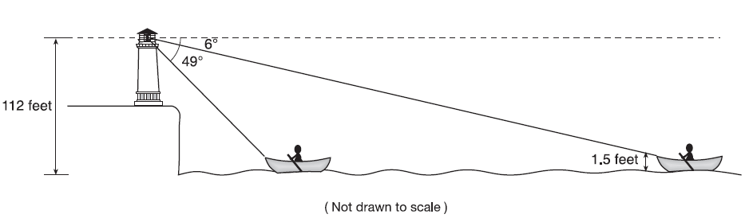

At 5:00, the observer in the lighthouse measured the angle of depression to the front

of the canoe to be  Five minutes later, the observer measured and saw the angle

of depression to the front of the canoe had increased by  Determine and state,

to the nearest foot per minute, the average speed at which the canoe traveled toward

the lighthouse.

**Apply geometric concepts in modeling situations**

**G-MG.1** Use geometric shapes, their measures, and their properties to describe objects (e.g., modeling a tree trunk or a human torso as a cylinder).★

**G-MG.2** Apply concepts of density based on area and volume in modeling situations (e.g., persons per square mile, BTUs per cubic foot).★

1. Trees that are cut down and stripped of their branches for timber are approximately

cylindrical. A timber company specializes in a certain type of tree that has a typical

diameter of 50 cm and a typical height of about 10 meters. The density of the wood

is 380 kilograms per cubic meter, and the wood can be sold by mass at a rate of

$4.75 per kilogram. Determine and state the minimum number of whole trees that

must be sold to raise at least $50,000.

**G-MG.3** Apply geometric methods to solve design problems (e.g., designing an object or structure to satisfy physical constraints or minimize cost; working with typographic grid systems based on ratios).★

**Module 3:**

**Extending to Three Dimensions (10 days)**

Students’ experience with two-dimensional and three-dimensional objects is extended to include informal explanations of circumference, area and volume formulas. Additionally, students apply their knowledge of two-dimensional shapes to consider the shapes of cross-sections and the result of rotating a two-dimensional object about a line. They reason abstractly and quantitatively to model problems using volume formulas.

**Explain volume formulas and use them to solve problems**

The (+) standard on the volume of the sphere is an extension of G-GMD.1. It is explained by the teacher in this grade and used by students in G-GMD.3. Note: Students are not assessed on proving the volume of a sphere formula until Precalculus.

**G-GMD.1** Give an informal argument for the formulas for the circumference of a circle, area of a circle, volume of a cylinder, pyramid, and cone. Use dissection arguments, Cavalieri’s Principle, and informal limit arguments.

**G-GMD.3** Use volume formulas for cylinders, pyramids, cones, and spheres to solve problems.★

**Visualize relationships between two-dimensional and three-dimensional objects**

**G-GMD.4** Identify the shapes of two-dimensional cross-sections of three-dimensional objects, and identify three-dimensional objects generated by rotations of two-dimensional objects.

**Apply geometric concepts in modeling situations**

**G-MG.1** Use geometric shapes, their measures, and their properties to describe objects (e.g., modeling a tree trunk or a human torso as a cylinder).★

* Students will understand the area of a region remains the same no matter how it is separated into disjoint regions whose union is the original region. (The area of a region can be found if it can be separated into simpler shapes such as triangles, rectangles, etc.)
* Students will explore a justification of the formula for the circumference of a circle that is based on an informal limit argument.
* Students will be able to describe the cross-sections of three-dimensional figures
* Students will be able to sketch and describe the figure that is generated by a rotating a two-dimensional figure around a line.
* Students will understand that if two solids have the same height and the same cross-sectional area at every level, then the solids have the same volume (Cavalieri’s Principle)
* Students will learn how to justify the essential volume formulas ()

(students will not have to justify volume of a sphere until Algebra 2)

* Students will solve problems using the formulas for cylinders, pyramids, cones, and spheres.

Slicing 3-dimensional solids: <http://www.youtube.com/watch?v=7-QYUu7MabQ>

1. A circle is cut into increasingly larger numbers of sectors and rearranged as shown.

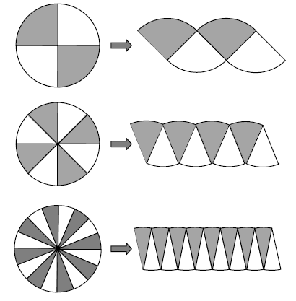

Explain how this process can be used to develop the formula for the area of a circle.

2. In the diagram, *ABCD* is a trapezoid where  ,

angles *B* and *C* are right angles, and 

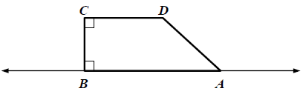

The trapezoid is rotated 360° about . Which

describes the resulting three-dimensional figure?

(1) The union of a cylinder and a cone.

(2) The union of two cones.

(3) The union of a prism and a pyramid.

(4) The union of two pyramids.

3. A cube is intersected by a plane. Which shape could NOT be the resulting cross-section?

(A) triangle

(B) pentagon

(C) hexagon

(D) octagon

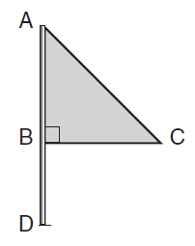

4. Triangle *ABC* represents a metal flag on pole *AD*, as shown in the

accompanying diagram. On a windy day the triangle spins around the

pole so fast that it looks like a three-dimensional shape.

Which shape would the spinning flag create?

(1) sphere

(2) pyramid

(3) right circular cylinder

(4) cone

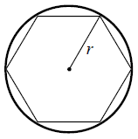

5. Use the diagram shown.

A regular hexagon is inscribed inside a circle of radius *r*.

What is the difference between the circumference of the

circle and the perimeter of the hexagon?

(1) 

(2) 

(3) 

(4) 

6. Complete the description of Cavalieri’s principle.

If two solids have the same ___(i)___ and the same cross-sectional area at

every level, then the two solids have the same ___(ii)___ .

(1) i. height ii. volume

(2) i. radius ii. volume

(3) i. height ii. surface area

(4) i. radius ii. surface area

7. The diameter of a golf ball is approximately 40 millimeters.

The diameter of a billiard ball is approximately 60 millimeters.

The volume of a billiard ball is approximately how many times the volume of a golf ball?

(1)  (3) 

(2)  (4) 

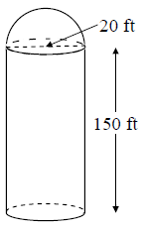

8. A grain storage silo consists of a cylinder and a hemisphere.

The diameter of the cylinder and the hemisphere is 20 feet.

The cylinder is 150 feet tall.

What is the volume of the silo?

(1)  (3) 

(2)  (4) 

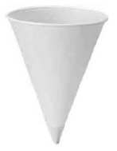

9. A cone-shaped paper cup (see picture) with radius 1.5 inches and height

of 4 inches has a capacity of 154 milliliters. If the cup currently holds

77 milliliters of water, what is the height of the water?

(1)  inches

(2)  inches

(3) 2 inches

(4) 3 inches

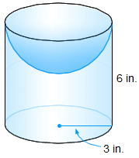

10. The composite solid shown consists of a

hemisphere and a cylinder. Find the volume of

the composite solid to the nearest hundredth.

**Module 4:**

**Connecting Algebra and Geometry through Coordinates (25 days)**

Building on their work with the Pythagorean theorem in 8th grade to find distances, students analyze geometric relationships in the context of a rectangular coordinate system, including properties of special triangles and quadrilaterals and slopes of parallel and perpendicular lines, relating back to work done in the first module. Students attend to precision as they connect the geometric and algebraic definitions of parabola. They solve design problems by representing figures in the coordinate plane, and in doing so, they leverage their knowledge from synthetic geometry by combining it with the solving power of algebra inherent in analytic geometry.

* Students will be able to use algebra and coordinates to prove or disprove a parallelogram, a rectangle, a rhombus, a square and a trapezoid.
* Students will be able to use algebra and coordinates to prove or disprove various types of triangles.
* Students will understand the properties of special right triangles 
* Students will be able to prove that parallel lines have equal slopes and use that to solve geometric problems
* Students will be able to prove that perpendicular lines have negative reciprocal slopes and use that to solve geometric problems
* Students will be able to write an equation parallel or perpendicular to a given line that passes through a given point.
* Students will be able to prove or disprove that lines are parallel, perpendicular or neither to each other.
* Students will be able to find the point on a directed line segment between two points that partitions the segment in a given ratio.
* Students will be able to use algebra and coordinates to compute the perimeters of polygons using the distance formula and other methods

**Use coordinates to prove simple geometric theorems algebraically**

**G-GPE.4** Use coordinates to prove simple geometric theorems algebraically. For example, prove or disprove that a figure defined by four given points in the coordinate plane is a rectangle; prove or disprove that the point (1, √3) lies on the circle centered at the origin and containing the point (0, 2).

1. Is the quadrilateral with vertices  a rectangle?

Justify your answer.

2. The diagonals of quadrilateral *EFGH* intersect at  *EFGH* has

vertices at  What must be the coordinates of *G* and *H*

to ensure that *EFGH* is a parallelogram?

3. Jillian and Tammy are considering a quadrilateral *ABCD*.

Their task is to prove *ABCD* is a square.

Jillian says, “We just need to show that the slope of  equals the slope

of , and the slope of  equals the slope of ”

Tammy says, “We should show that  and that 

Which method of proof is valid?

(A) Only Jillian’s is valid

(B) Only Tammy’s is valid

(C) Both are valid

(D) Neither is valid

4.  has vertices 

Is scalene, isosceles, or equilateral? Justify your answer.

5. A student says that the quadrilateral with vertices 

is a rhombus because the diagonals are perpendicular. What is the student’s error?

6. (a) Describe two ways you can show whether a quadrilateral in the coordinate plane is a square.

(b) Which method is more efficient? Explain.

7. ***(To be done after students learn how to graph a circle in Module 5)***

On a sheet of graph paper, complete each part.

(a) Graph the circle 

(b) Plot the points where the circle intersects the *x*-axis. Label them *A* and *B*.

(c) Plot the point  Prove  is a right triangle using coordinate geometry.

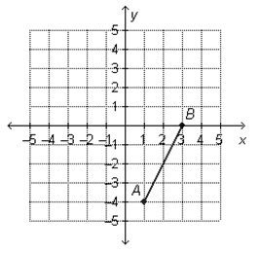

8. Which point lies on the perpendicular bisector of 

(A) 

(B) 

(C) 

(D) 

9. Which point lies farthest from the origin?

(A)  (C) 

(B)  (D) 

10. The perimeter of an equilateral triangle is 18.

What is the area of this triangle?

11. Find the missing sides of the following six triangles



(a) (b) (c)

 (d) (e) (f)



12. In the figure shown, what is the length of ?

(A) 8 (C) 24

(B) 16 (D) 32

13. In the figure shown, is an isosceles right triangle.

What is the length of side ?

(A) 1 (C) 

(B)  (D) 

Use the diagram shown for questions 14 and 15.

If  and 



14. What is the length of ?

(A) 10

(B) 

(C) 

(D) 

15. What is the length of ?

(A) 

(B) 

(C) 

(D)  Note: Figure not drawn to scale

**GPE.5** Prove the slope criteria for parallel and perpendicular lines and use them to solve geometric problems (e.g., find the equation of a line parallel or perpendicular to a given line that passes through a given point).

1. Which equation describes a line passing through  and is parallel to 

(A) 

(B) 

(C) 

(D) 

2. Line  contains and  and line  contains and 

What value of *k* makes  and  parallel?

3. What is an equation of the line perpendicular to 

that contains the point 

4. Which equation below has a linear graph that

is perpendicular to the graph 

(A) 

(B) 

(C) 

(D) 

5. Which statement about the graphs of  is true?

(A) The graphs of *f* and *g* are both increasing.

(B) The graphs of *f* and *g* are both decreasing.

(C) The graphs of *f* and *g* are perpendicular.

(D) The graphs of *f* and *g* are parallel.

6. A triangle has vertices 

Write an equation for the line perpendicular to  that contains point *N*.

**G-GPE.6** Find the point on a directed line segment between two given points that partitions the segment in a given ratio.

1. The point *P* divides  in a ratio of 4:1, where 

If , where is *P*?

(A)  (C) 

(B)  (D) 

2. The slope of  is  Point *M* lies  of the way from *P* to *Q* on .

What is the slip of 

(A) 

(B) 

(C) 

(D) 

3. Given 

(a) Find the point P on  such that .

(b) Translate the figure by 

(c) Prove  is a parallelogram.

(d) Prove the area of  is 3 times the area of 

4. The segment  has endpoints at 

Where is *M*, the midpoint of ?

(A) 

(B) 

(C) 

(D) 

5. Three collinear points on the coordinate plane are



What is 

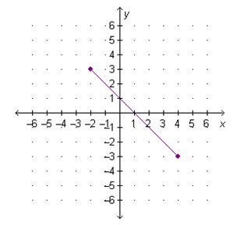6. If the perpendicular bisector of the segment

shown is drawn on the graph, at what point

will the two lines intersect?

7. The endpoints of  are 

Find the coordinates of the points that divide 

into the given number of congruent segments:

(a) 4 (b) 6

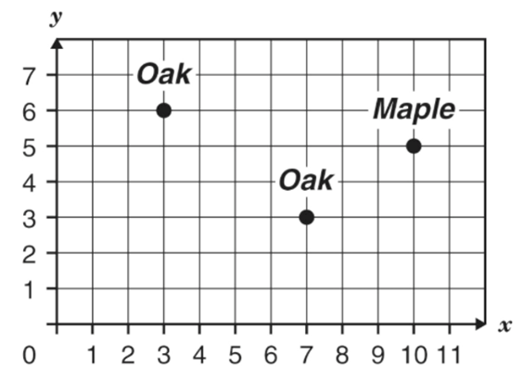

8. Sarah used a coordinate grid to show where

the trees were in her backyard.

She wants to put a birdbath exactly halfway

between the two oak trees. What are the

coordinates of the place where the birdbath

should be located?

9. Point C divides into two segments with lengths that form which ratio?

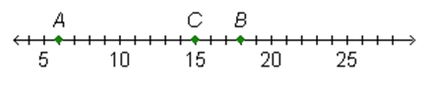

(A) 1 : 4 (C) 1 : 2

(B) 3 : 4 (D) 3 : 1

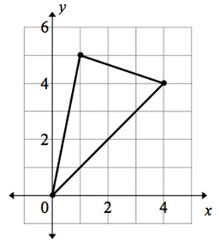**G-GPE.7** Use coordinates to compute perimeters of polygons and areas of triangles and rectangles, e.g., using the distance formula.★

1. Use the diagram shown.

What is the perimeter of the triangle,

to the nearest whole unit?

(A) 12

(B) 14

(C) 16

(D) 18

2. On a sheet of graph paper, complete each part.

(a) Graph the line with the equation 

(b) Define and graph the line *m* perpendicular to and goes through the point 

(c) Label the following points:

* Lines and *m* intersect at point *K*.
* Line has a *y*-intercept at point *B*.
* Line *m* has an *x*-intercept at point *A*.
* The origin is point *O*.

(d) Compute the perimeter of *AOBK*.

3. Find the perimeter and area of  with vertices



4. Find the area of the triangle with vertices at 

(A) 8 

(B) 10 

(C) 12 

(D) 20 

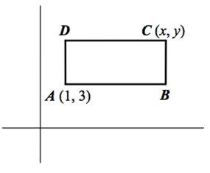5. Use the diagram shown.

ABCD is a rectangle where the slope of  is 0.

What is the area of the rectangle?

(A) *xy*

(B) 

(C) 

(D) 

6. Find the area of the triangle enclosed by the lines 

7. Vanessa is making a banner for the game. She has 20 square feet

of fabric. What shape will she use most or all of the fabric?

(A) a square with a side of length 4.

(B) a rectangle with a length of 4 feet and a width of 3.5 feet.

(C) a circle with a radius of 2.5 feet.

(D) a right triangle with legs of 5 feet each.

**Module 5**

**Circles (25 days)**

In this module students prove and apply basic theorems about circles, such as: a tangent line is perpendicular to a radius theorem, the inscribed angle theorem, and theorems about chords, secants, and tangents dealing with segment lengths and angle measures. They study relationships among segments on chords, secants, and tangents as an application of similarity. In the Cartesian coordinate system, students explain the correspondence between the definition of a circle and the equation of a circle written in terms of the distance formula, its radius, and coordinates of its center. Given an equation of a circle, they draw the graph in the coordinate plane, and apply techniques for solving quadratic equations. Students visualize, with the aid of appropriate software tools, changes to a three-dimensional model by exploring the consequences of varying parameters in the model.

* Students will be able to define basic terms associated with a circle.
* Students will be able to prove any two circles are similar.
* Students will be able to convert from degree to radian measure, and radian to degree measure.
* Students will be able to find the area of a sector of a circle.
* Students will be able to apply theorems regarding tangent lines and chord relationships in a circle.
* Students will be able to apply theorems regarding inscribed angles and intersecting chords of a circle.
* Students will be able to find the measures of angles of a circle formed by chords, tangents, and secants.
* Students will be able to find the lengths of segments formed by intersecting tangents and segments of a circle.
* Students will be able to graph a circle on the coordinate plane.
* Students will be able to determine the center and radius of a circle, given its equation.

(students will apply the method of completing the square to problems, as well).

***G-C 4******(*OPTIONAL*)****: Construct a tangent line from a point outside a circle to a circle.*

**Understand and apply theorems about circles**

**G-C 1**: Prove that all circles are similar.

1. Draw two circles of different radii. Prove the circles are similar.

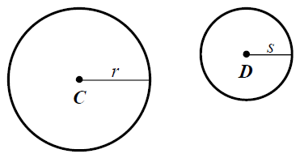2. To show circle *C* is similar to circle *D*,

one would have to translate circle *C* by the

vector  Then, circle  would have

to be dilated by what factor?

(A) 

(B) 

(C) 

(D) 

**G-C 2**: Identify and describe relationships among inscribed angles, radii and chords *(include relationships involving central, inscribed, circumscribed angles; inscribed on a diameter is a right angle; radius perpendicular to a tangent where radius intersects circle)*

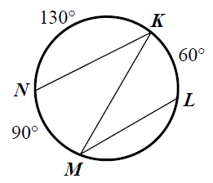1. Use the diagram.

What is 

(A) 

(B) 

(C) 

(D) 

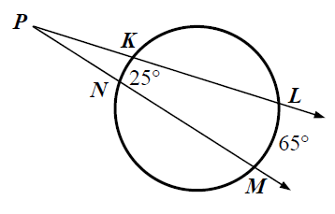2. In the diagram, 

What is 

(A) 

(B) 

(C) 

(D) 

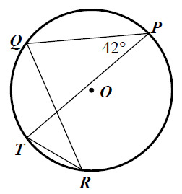3. In circle *O*, 

What is 

(A) 

(B) 

(C) 

(D) 

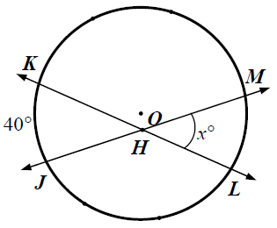

4. In circle *O*,  .

What is 

(A) 

(B) 

(C) 

(D) 

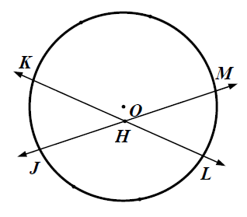

5. In circle *O*, 

What is the value of *x*?

(A) 8.25

(B) 9.25

(C) 17

(D) 18

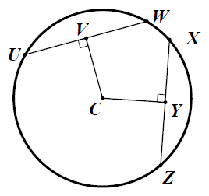

6. In circle *C*, *UW* = *XZ*, *VW* = 2*x* + 14, and *YZ* = 6*x* +2

What is the value of *x*?

(A) 2

(B) 3

(C) 4

(D) 5

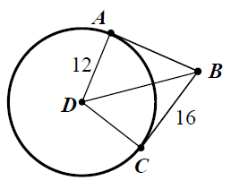7. With respect to circle *D*,  is tangent at *A*,

and  is tangent at *C*.

What is the length of ?

(A) 11

(B) 14

(C) 16

(D) 20

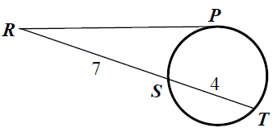8. Use the figure shown.

What is the length of ?

(A) 9

(B) 11

(C) 

(D) 

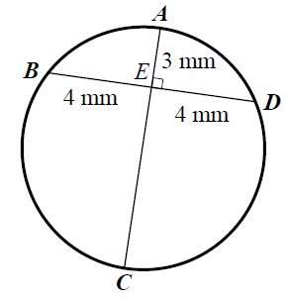9. Use the figure shown.

What is *AC*?

(A) mm

(B) 8 mm

(C) mm

(D) 16 mm

**G-C 3**: Construct the inscribed and circumscribed circles of a triangle and prove properties of angles for a quadrilateral inscribed in a circle.

1. Inscribe a circle in the triangle below by construction.

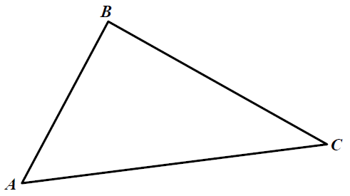

2. Circumscribe a circle in the triangle below by construction.



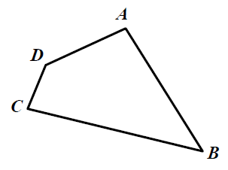

3. Quadrilateral *ABCD* is to be circumscribed by a circle.

What must be true?

(A) Opposite angles are supplementary.

(B) One of the angles is a right angle.

(C) Both must be true.

(D) Neither must be true.

In questions 4–6, use the diagram of a scalene where *M* is the midpoint of  .

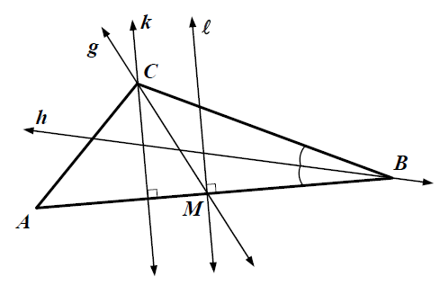

4. The circumcenter of  lies on which line?

(A) *g*

(B) *h*

(C) *k*

(D) 

5. The incenter of lies on which line?

(A) *g*

(B) *h*

(C) *k*

(D) 

6. The centroid (center of mass) of lies on which line?

(A) *g*

(B) *h*

(C) *k*

(D) 

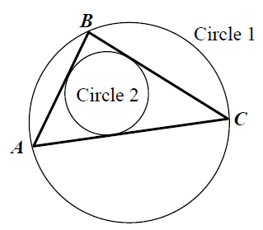

In questions 7 – 8, use the diagram where Circle 1 is

circumscribed about  and Circle 2 is

inscribed in .

7. To find the center of Circle 1,

what would be constructed on ?

(A) altitudes

(B) angle bisectors

(C) medians

(D) perpendicular bisectors

8. To find the center of Circle 2, what would be constructed on ?

(A) altitudes

(B) angle bisectors

(C) medians

(D) perpendicular bisectors

**Find arc lengths and areas of sectors of circles**

**G-C 5**: Find arc lengths and areas of sectors of circles: Derive using similarity the fact that the length of the arc intercepted by an angle is proportional to the radius, and define the radian measure of an angle as a constant of proportionality; derive the formula for the area of a sector.

1. Which angle is equivalent to  radians?

(A) 

(B) 

(C) 

(D) 

2. Which angle is equivalent to  ?

(A)  (C) 

(B)  (D) 

3. On a circle of radius *r*, a central angle of *x* radians subtends

an arc of length *r*. What is the value of *x*?

(A)  (C) 1

(B)  (D) 3.14

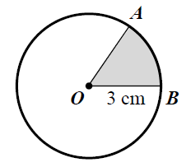4. Use the diagram.

What is the area of the shaded region

if 

(A)  (C) 

(B)  (D) 

**Translate between the geometric description and the equation for a conic section**

**G-GPE 1**: Derive the equation of a circle of given center and radius using Pythagorean Theorem; complete the square to find the center and radius of a circle by the equation.

1. Describe the relationship between the distance formula,

the Pythagorean Theorem, and the equation of a circle.

2. A circle is centered at  The point  is on the circle.

What is the equation of the circle?

(A) 

(B) 

(C) 

(D) 

3. What is the radius of the circle 

(A) 

(B) 7

(C) 

(D) 63

4. Which is the equation of a circle that passes through  and centered at 

(A) 

(B) 

(C) 

(D) 

5. A circle passes through the points 

(a) Write an equation of the circle.

(b) Name one other point on the circle.

6. Which equation represents 

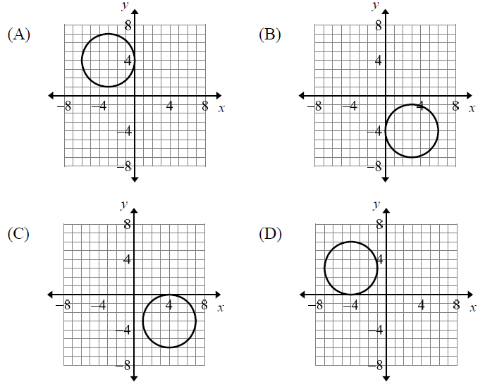

7. What is the center and the radius of the circle:



**Use coordinates to prove simple geometric theorems algebraically**

**G-GPE.4**: Use coordinates to prove simple geometric theorems algebraically. For example, prove or disprove that a figure defined by four given points in the coordinate plane is a rectangle; prove or disprove that the point  lies on the circle centered at the origin and containing the point 

**Apply geometric concepts in modeling situations**

**G-GPE 5**: Prove the slope criteria for parallel and perpendicular lines and use them to solve geometric problems (find the equation of a line parallel or perpendicular to a given line that passes through a given point)

1. What is the equation of the line tangent to the circle

 at 