Variations on “Oh Deer!”
adapted from Candace Parker, http://www.beaconlearningcenter.com/documents/313_01.pdf
and the original activity that appears in the Project WILD Teacher’s Guide

Cathy Stierman
Clarke University

Game instructions:

1. Mark two parallel lines on the ground 10 to 20 yards a part. Ask students to count off in fours. The ones become the “deer” and line up behind one line with their backs to the other students. The other students become habitat components necessary to survive (food, water, and shelter) and line up behind the other line with their backs to the “deer”.

2. Explain that the deer need to find food, water, and shelter in order to survive in their environment. If they do not then they will die.

3. In this activity when the “deer” is looking for food, it should clamp its hands over its stomach. When a “deer” is looking for water, it should put its hand over its mouth. When a “deer” is looking for shelter, it holds its hands together over its head.

4. A “deer” can choose to look for any one of its needs during each round of the activity. A “deer” cannot change what it is looking for during a round. It can only change what is looking for at the beginning of each round.

5. The other students are the food, water, and shelter. Students get to choose what they want to be at the beginning of the round. They show their choice in the same way as the “deer” have. Emphasize to these students that they cannot change what component they are during a round. They can only change at the beginning of each round.

6. The teacher should begin the first round by asking all students to make their signs—playing their hands over their stomach, mouth, or head. Students should choose and create one of these symbols BEFORE turning around to face the other group.

7. When the students are ready tell them to “GO!” At this time each “deer” and each “habitat
component” turns to face the opposite group continuing to hold their sign clearly.

8. When the “deer” see the “habitat component” that matches what they need, they are to run to it. Each “deer” must hold the sign of what it is looking for until getting to the matching “habitat component.”

9. Once the “deer” find their correct component they should take it back to their line, and the “habitat component” becomes a “deer”. Any “deer” who fails to find its “habitat component” dies becomes a “habitat component” on the other side and becomes available as food, water, or shelter to the “deer” who are still alive.

10. “Habitat components” not taken by a “deer” continue to be “habitat components”.

11. The activity should consist of 12-15 rounds. Be sure to record the number of “deer” at the
beginning of the activity and at the end of each round so that students can graph the results. Other environmental influences such as hunters, predators, drought and forest fires can be added.

STUDENT HANDOUT IS THE LAST PAGE IN THIS PACKET

Alternate version for small groups or indoor play:

Play the game as above except that each student has three cards in front of them – one with each of the three symbols. All students select which component they will be and turn over the corresponding card. The teacher then empties an envelope containing a set number of cards with pictures of each component. Students must quickly obtain the component they need in order to stay alive. Those who don’t find what they need die and do not play for one round/year. Some years will also contain event cards such as reproducing, being killed by a hunter, experiencing a drought, etc. As before, record the number of “deer” at the beginning of the activity and at the end of each round so that students can graph the results. Play continues for at least fifteen, but preferably twenty rounds/years before the results are graphed and interpreted. Post the data in a manner accessible to students, such as in a Google document. If desired, assign a different scale to each student in order to see the effects of scale variation on data interpretation.

The list of cards below is set up for 4-6 students, adjust accordingly. Package the number of cards into envelopes with the number of the year (round) listed.

Cards Version
Year | Shelter | Water | Food | Other | Population | Year
1 | 2 | 2 | 2 | - |  | 1
2 | 1 | 3 | 2 |  |  | 2
3 | 2 | 1 | 3 |  |  | 3
4 | 0 | 3 | 3 |  |  | 4
5 | 0 | 0 | 0 | 6 Reproduce |  | 5
6 | 4 | 4 | 4 |  |  | 6
7 | 0 | 6 | 0 | 6 Run, forest fire! |  | 7
8 | 2 | 4 | 6 |  |  | 8
9 | 2 | 2 | 2 | 6 It’s a hunter. Bang, you’re dead! |  | 9
10 | 4 | 4 | 4 |  |  | 10
11 | 3 | 3 | 6 |  |  | 11
12 | 0 | 0 | 0 | 12 Reproduce |  | 12
13 | 8 | 8 | 8 |  |  | 13
14 | 6 | 6 | 6 | 6 Yikes, it’s a wolf. Help! |  | 14
15 | 10 | 6 | 8 |  |  | 15
16 | 8 | 8 | 8 |  |  | 16
17 | 6 | 6 | 0 | 12 Whoops, ate some grass contaminated with chronic wasting disease (CWD), a form of spongiform encephalopathy or “mad cow” disease. |  | 17
18 | 6 | 4 | 14 |  |  | 18
19 | 6 | 0 | 6 | 12 Drought. Whew, I’m thirsty! |  | 19
20 | 8 | 8 | 8 |  |  | 20
Totals | 78 | 78 | 90

13 shelters per page, print 6 pages and cut into individual tiles

13 water drops per page, print 6 pages and cut into individual tiles

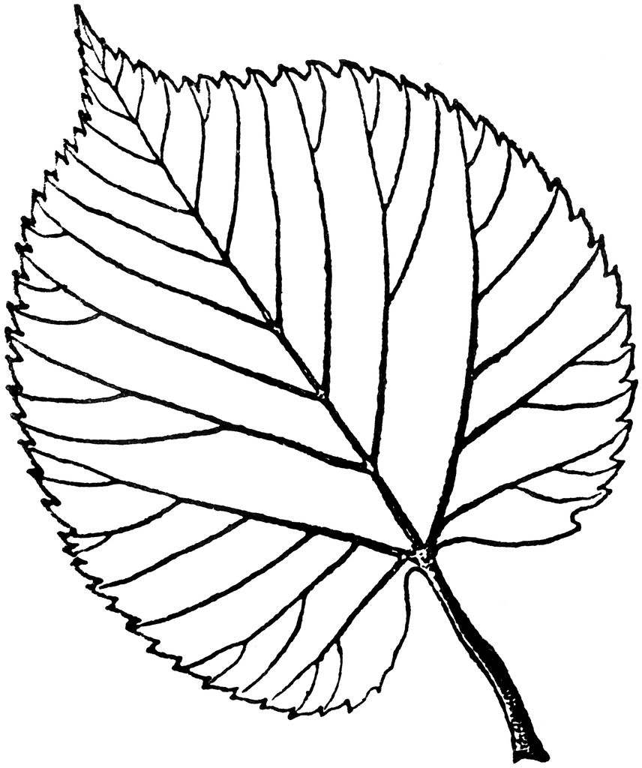

20 leaves per page, print 5 but remove 10 leaves when cutting into individual tiles

Reproduce
Reproduce
Reproduce

Reproduce
Reproduce
Reproduce

6 repro cards per page, print 3 and cut into individual tiles

Run, forest fire, run!
Run, forest fire, run!
Run, forest fire, run!

Run, forest fire, run!
Run, forest fire, run!
Run, forest fire, run!

6 forest fire, print 1 and cut into individual tiles

Bang, bang, you’re dead!

Bang, bang, you’re dead!

Bang, bang, you’re dead!

Bang, bang, you’re dead!

Bang, bang, you’re dead!

Bang, bang, you’re dead!

6 hunter, print 1 and cut into individual tiles

Yikes, it’s a wolf!

Yikes, it’s a wolf!

Yikes, it’s a wolf!

Yikes, it’s a wolf!

Yikes, it’s a wolf!

Yikes, it’s a wolf!

6 wolf, print 1 cut into individual tiles

Whoops, ate some grass contaminated with chronic wasting disease!

Whoops, ate some grass contaminated with chronic wasting disease!

Whoops, ate some grass contaminated with chronic wasting disease!

Whoops, ate some grass contaminated with chronic wasting disease!

Whoops, ate some grass contaminated with chronic wasting disease!

Whoops, ate some grass contaminated with chronic wasting disease!

6 CWD, print 2 and cut into individual tiles

Drought. Whew, I’m thirsty!

Drought. Whew, I’m thirsty!

Drought. Whew, I’m thirsty!

Drought. Whew, I’m thirsty!

Drought. Whew, I’m thirsty!

Drought. Whew, I’m thirsty!

6 drought, print 2 and cut into individual tiles

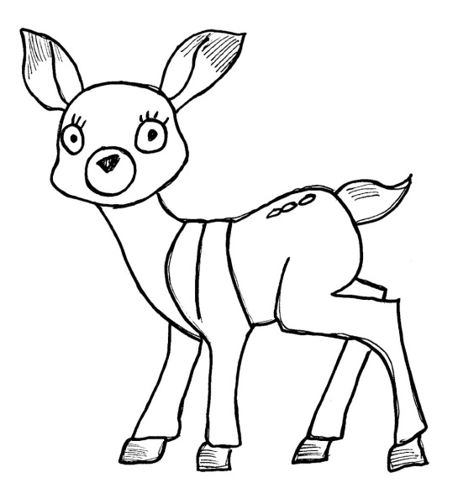

6 deer, print 4 and cut into individual tiles

Interpreting the “Oh Deer!” Data

Now that you’ve played “Oh Deer!”, let’s take some time to analyze the data.

- If you haven’t done so already, copy/paste the data into the table below.

Data Table
Year | Number of Deer | Notes
1
2
3
4
5
6
7
8
9
10
11
12
13
14
15
16
17
18
19
20

- In preparation for creating a line graph of the years versus the number of deer on the grid provided, answer the following:
- What will be the title of your graph?
Oh Deer! (or something similar)
- What is the dependent variable? Which axis is this variable plotted on?
The number of deer; the Y axis
- What is the independent variable? Which axis is this variable plotted on?
The year; the X axis
- Scale is important, so consider it carefully. We will coordinate this as a class so that you can see the influence the scale can have on the interpretation of your data.
Have some students use the same scale for both axes, others might use 2:1 ratio on the X and a 1:1 on the Y, etc. [The more stretched out the X axis scale is and/or the smaller the Y axis scale, the more difficult it is to see the effects of the activities within in the game.]

The graphs will vary depending upon the results of your particular game and the scales that were selected. In general, one would expect to see decreases in the population with disturbances such as a drought or a predator and increases with events such as reproduction.

- Reflection Questions
- What are the three essential components of this deer habitat? (What did the animals need to survive?)
i. Food
ii. Water
iii. Shelter

- Select one of the three components and explain its influence on the carrying capacity of the deer population.
A decrease in any of the components will likely decrease the carrying capacity while an increase in any component will likely allow for an increase in the carrying capacity – at least temporarily.

- Identify at least three significant trend(s) seen in the graph of your data and explain why they might have occurred.
i.
ii.
iii.
These will vary depending upon the results of your particular game and the scales that were selected. In general, one would expect to see decreases in the population with disturbances such as a drought or a predator and increases with events such as reproduction.

- What was/were the limiting factor(s) in the playing of this game and how did it/they affect the population of deer?
Limiting factors might include the number of people playing the game, how well the players followed the instructions, the number of players who selected the same components at the same/different times, how many players “died” at the same time, etc.

- Locate and copy/paste or attach another population graph. Explain the background of the graph and the trends seen. Please be sure to include the source.

This will vary depending upon the student’s selection. One particularly good population graph/story is that of the snowshoe hares and lynx derived from the number of pelts collected by the Hudson Bay trappers in the late 1800’s to early 1900’s.
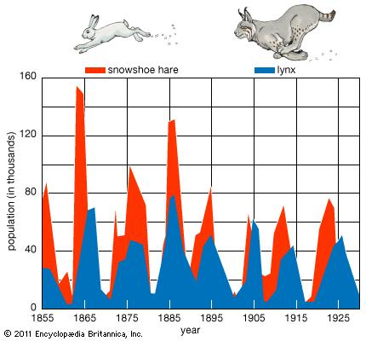

Interpreting the “Oh Deer!” Data

Now that you’ve played “Oh Deer!”, let’s take some time to analyze the data.

- If you haven’t done so already, copy/paste the data into the table below.

Data Table
Year | Number of Deer | Notes
1
2
3
4
5
6
7
8
9
10
11
12
13
14
15
16
17
18
19
20

- In preparation for creating a line graph of the years versus the number of deer on the grid provided, answer the following:

- What will be the title of your graph?

- What is the dependent variable? Which axis is this variable plotted on?

- What is the independent variable? Which axis is this variable plotted on?

- Scale is important, so consider it carefully. We will coordinate this as a class so that you can see the influence the scale can have on the interpretation of your data.

- Reflection Questions
- What are the three essential components of this deer habitat? (What did the animals need to survive?)
i.
ii.
iii.

- Select one of the three components and explain its influence on the carrying capacity of the deer population.

- Identify at least three significant trend(s) seen in the graph of your data and explain why they might have occurred.
i.

ii.

iii.

- What was/were the limiting factor(s) in the playing of this game and how did it/they affect the population of deer?

- Locate and copy/paste or attach another population graph. Explain the background of the graph and the trends seen. Please be sure to include the source.

