Think Central Notes
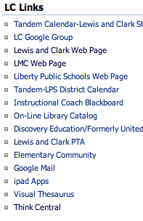
From the LMC page

From Inside

Think Central Log In Page:
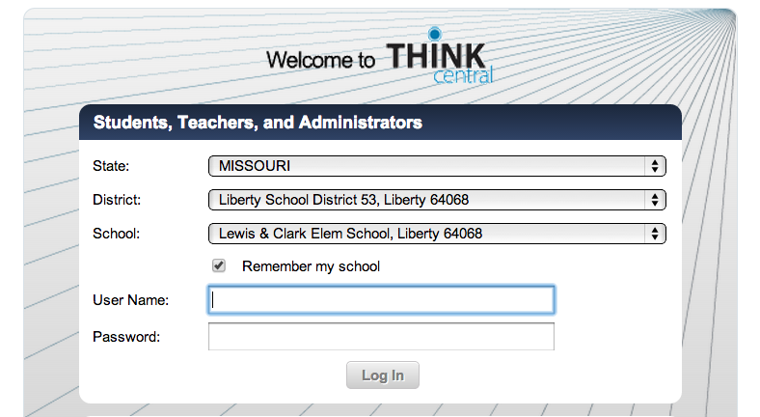
Check this to save time later! (device specific)
Use your regular school username and password (kids too)
We’ll look here today. It’s what we use most. Click view to see all resources. Remember it’s Journeys & GO Math together.
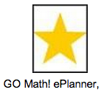
This is your friend. It sorts by unit and then links to every digital resource. You’ll see every option available for that specific learning goal.

These are the visual tutorials you can project to help teach a skill. There are practice questions and a quiz at the end. After you’ve made a class, you can assign these as well.
K – 2 looks like this

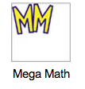
This is the link to all of the math games. They are sorted by topic, then skill. It’s easier to find them using the ePlanner, but kids can access this on their own and play as they choose.

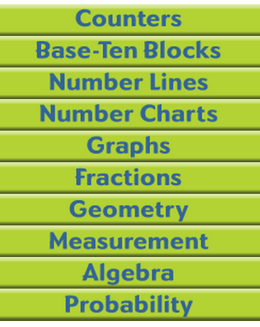
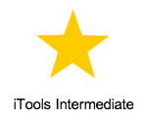
This is the online manipulatives to project to the class or have kids access at home.

categories of manipulatives

We’ll offer PD later about making a class, creating assignments, etc. For now, see what you can use to enhance your current units! 2nd & 3rd teachers have piloted this year, and 1st has dabbled in the online components as well, so ask them if you need any help!

