Visual Thesaurus-Elementary PD www.liberty.visualthesaurus.com
You do need to log in from home or to save word lists… district email and password! 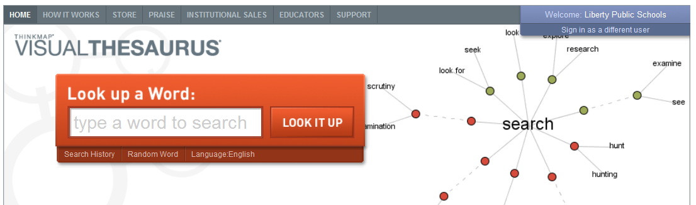
Feature | Notes/Ideas
Look Up a Word | - Words are connected to meanings with solid lines  - Words connected to the same meaning are synonyms  - Meanings are represented by color-coded circles (nouns-red, adjectives-yellow, verbs-green, adverbs-purple)  - Antonyms are connected by red dashes  - Black dashes indicate connections to other meanings  - Settings can make words bigger and have fewer connections if needed
Word of the Day | - Check daily or have it emailed to you daily for a vocabulary builder
Word Lists | - Great for storing content vocabulary so students can further explore the meaning  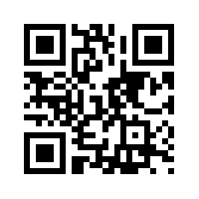
VocabGrabber | - Copy/Paste text and see all of the words- content material, student writing, internet pages with too high vocabulary  - Shows repeated words larger  - Sort by meaning  - Look up synonyms
Educators’ Tab | - Video tutorial to help (short)  - Vocabulary activities  - Weekly worksheets  - Lesson plans for 3rd & up  - Useful links (I found DocsTeach)
Spelling Bee | - Input spelling words  - Share with others  - It pronounces the word (and shows definition), students have to spell  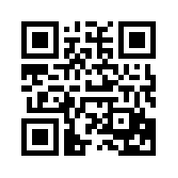

Lesson Ideas

