EAST MEADOW U.F.S.D.

Curriculum Area Project

Gr. 9-12 Technology and the Common Core
2013 - 2014

Facilitator:
Evelyn Sideri
Writers:
Anne Marie Collins
Mary Kudla
Evelyn Sideri

East Meadow High School

Mr. Louis R. DeAngelo, Superintendent of Schools
Mr. Richard Howard, Principal
Dr. Franklin Cacciutto, English Department Chair
Department of English

Table of Contents

- Abstract and Rationale...........................................................................1

- Censorship: Persuasive Writing Assignment......................................2-13

- Frankenstein Lesson Plan................................................................14-15

- The Canterbury Tales Powerpoint Project.........................................16-17

- Evaluation Using the Common Core and Turnitin.com....................18-21

- Works Cited..........................................................................................22

Abstract
This CAP addresses the incorporation of technology for implementation of the Common Core Standards. The lessons contained are for grades 10, 11 and 12. The Turnitin.com lessons and evaluation resources can be implemented from grades 9-12. There are lessons that include the use of Prezi as a presentation tool. It also includes the implementation of Google Docs for shared and cooperative assessments. Throughout this CAP there are several levels and scaffolded activities that cut across grade level, reading and writing activities that are found in The Common Core Standards.

NYS Common Core Standards for Literacy Assessed:
Reading
- RS. 7.8 Trace and evaluate the argument and specific claims in a text, assessing whether the reasoning is sound and the evidence is relevant and sufficient to support the claims.
Writing
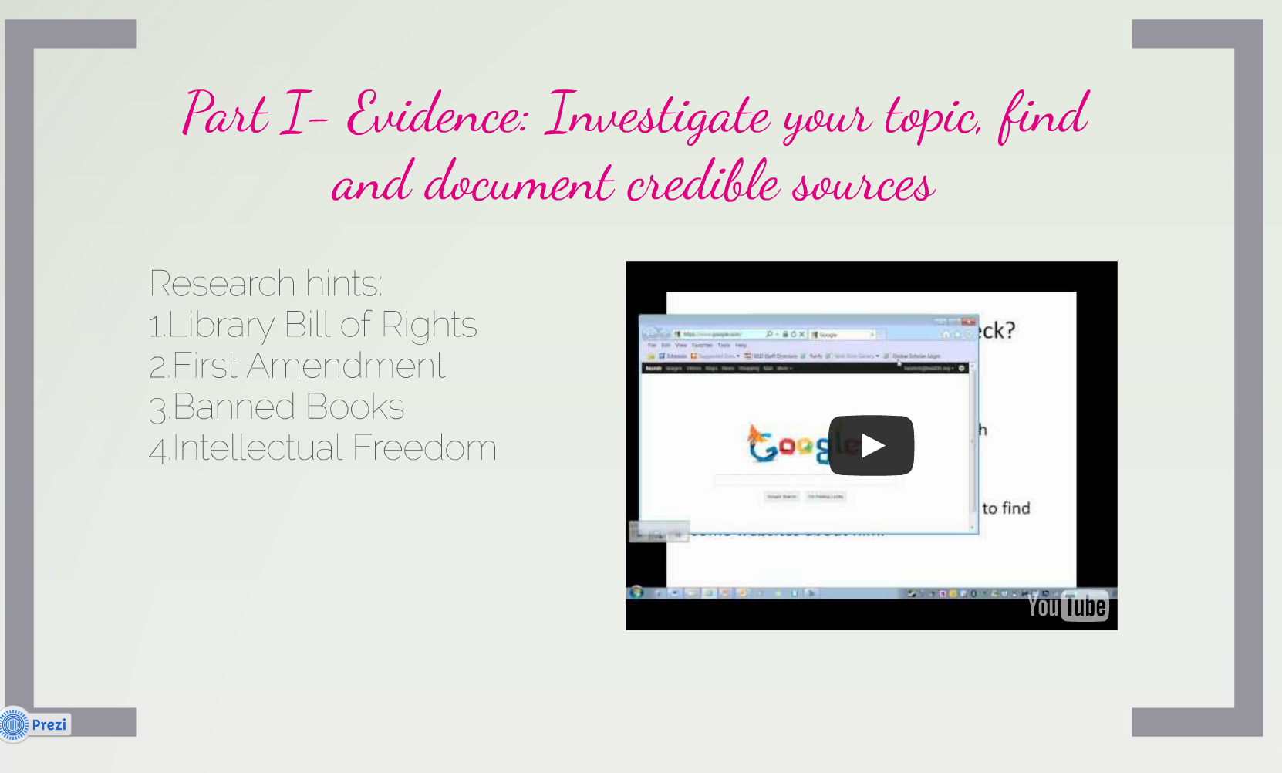
WS. 7. 1 Write arguments to support claims with clear reasons and relevant evidence.
- Introduce claim(s), acknowledge alternate or opposing claims, and organize the reasons and evidence logically.
- Support claim(s) with logical reasoning and relevant evidence, using accurate, credible sources and demonstrating an understanding of the topic or text.
- Use words, phrases, and clauses to create cohesion and clarify the relationships among claim(s), reasons, and evidence.
- Establish and maintain a formal style.
- Provide a concluding statement or section that follows from and supports the argument presented.

Language
L.7.3a. Choose language that expresses ideas precisely and concisely, recognizing and eliminating wordiness and redundancy.

Rationale
Students need education on the incorporation of technology into reading and writing tasks dictated by the Common Core in order to make them college ready as well as make them more marketable as they seek employment post graduation.
Censorship: Persuasive Writing Assignment
Performance Task – persuasive/argumentative censorship letter

Essential Question:

How does writing express ones perspective?
How can writing be used to convince others?

Guiding Questions:

- Why does one need a thesis/claim?
- What makes a credible source?
- How does one find credible sources?
- How does one review and record details that provide evidence?
- What is the organizational structure of persuasive letter writing?

Enduring Understanding

- Persuasive writing often serves as a call to action
- Word choice creates a desired effect
- How you speak is determined by with whom you speak

NYS Common Core Standards for Literacy Assessed:

Reading
- RS. 7.8 Trace and evaluate the argument and specific claims in a text, assessing whether the reasoning is sound and the evidence is relevant and sufficient to support the claims.
Writing
WS. 7. 1 Write arguments to support claims with clear reasons and relevant evidence.
- Introduce claim(s), acknowledge alternate or opposing claims, and organize the reasons and evidence logically.
- Support claim(s) with logical reasoning and relevant evidence, using accurate, credible sources and demonstrating an understanding of the topic or text.
- Use words, phrases, and clauses to create cohesion and clarify the relationships among claim(s), reasons, and evidence.
- Establish and maintain a formal style.
- Provide a concluding statement or section that follows from and supports the argument presented.

Language
L.7.3a. Choose language that expresses ideas precisely and concisely, recognizing and eliminating wordiness and redundancy.

Diagnostic Assessments:

- Students will respond to the essential question at the start of the unit and at the end of the unit in order to share any change.

Formative Assessments:

- Class work
- Class discussions
- Writer’s graphic organizers for evidence collection; scaffolding of persuasive letter

Summative Assessments:

- Over the years there have been many high school books that have been challenged due to their subject matter. Many people argue that students are too young and must be protected from inappropriate material. Create a letter detailing your position on this argument providing evidence such as facts or data, to support your claim. As a concerned citizen create a persuasive letter to the editorial section of our school paper.

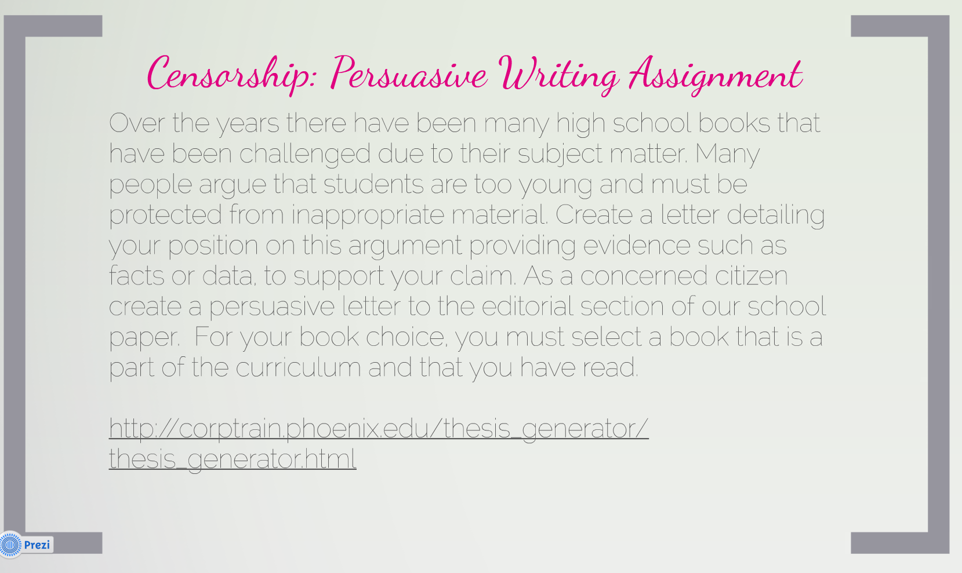
Each of the following tasks will be organized in a Prezi presentation which will provide links to facilitate the entire project:

http://prezi.com/w81lzptkpgvc/untitled-prezi/

Support:  Support claim with logical reasoning and relevant evidence | KUDOS!  Your evidence and examples are well thought out with a skillful blend of facts and reasoning! | -GOOD JOB!  Your evidence and examples are supported with facts and reasons | Okay!  Provides some evidence and examples but may include inaccurate details | Ouch!  You provide minimal, irrelevant or no evidence or examples
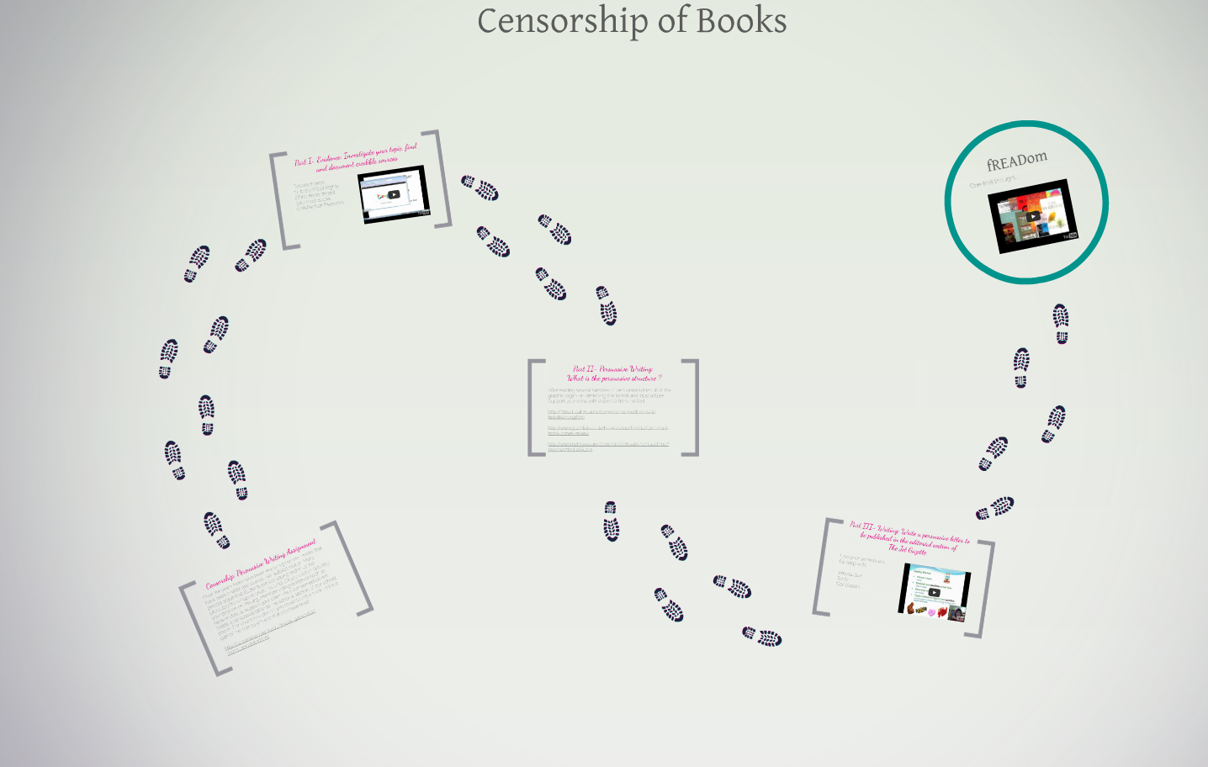

Censorship: Persuasive Writing Assignment

Topic: Should _____________________ be taught in public schools?

(Book Title/Author)

Over the years there have been many high school books that have been challenged due to their subject matter. Many people argue that students are too young and must be protected from inappropriate material. Create a letter detailing your position on this argument providing evidence such as facts or data, to support your claim. As a concerned citizen create a persuasive letter to the editorial section of our school paper. For your book choice, you must select a book that is a part of the curriculum and that you have read.

Hypothesis/Thesis statement: The purpose of persuasive writing is to assert an opinion which you are going to defend
Link to thesis generator: http://corptrain.phoenix.edu/thesis_generator/thesis_generator.html

Part I- Evidence: Investigate your topic, find and document credible sources
You tube video on credible sources: http://www.youtube.com/watch?v=tCTnH4gqxhU
Research hints:
- Library Bill of Rights
- First Amendment
- Banned Books
- Intellectual Freedom

Part II- Persuasive Letter Format: What is the structure of a persuasive letter?

http://teenink.com/opinion/social_issues_civics/article/131038/Against-Banning-Books/http://712educators.about.com/cs/bannedbooks/a/bookbanning.htm
http://www.nytimes.com/2011/01/07/books/07huck.html?pagewanted=all&_r=0

Directions: Select one persuasive letter and fill in the graphic organizer. Support your ideas with evidence from the text. This means you must cite specific lines.

Dimensions | Exceptional | Capable | Developing | Emerging
Claims:  Introduce claims and acknowledge alternate or opposing claims | Brilliant!  Your position is clear, convincing, and original!  You expertly anticipate the opposing argument! | Great!  Your position is clear and convincing  You acknowledged the opposing argument | Hmm!  Your position is mostly clear but could be more convincing  You may/may not have acknowledge the opposing argument | Uh oh!  Your position is unclear and does little to convince your audience  You did not acknowledge the opposing argument
Support:  Support claim with logical reasoning and relevant evidence | Fantastic!  Your evidence and examples are well thought out with a skillful blend of facts and reasoning! | -Wonderful!  Your evidence and examples are supported with facts and reasons | Okay!  Provides some evidence and examples but may include inaccurate details | Ouch!  You provide minimal, irrelevant or no evidence or examples
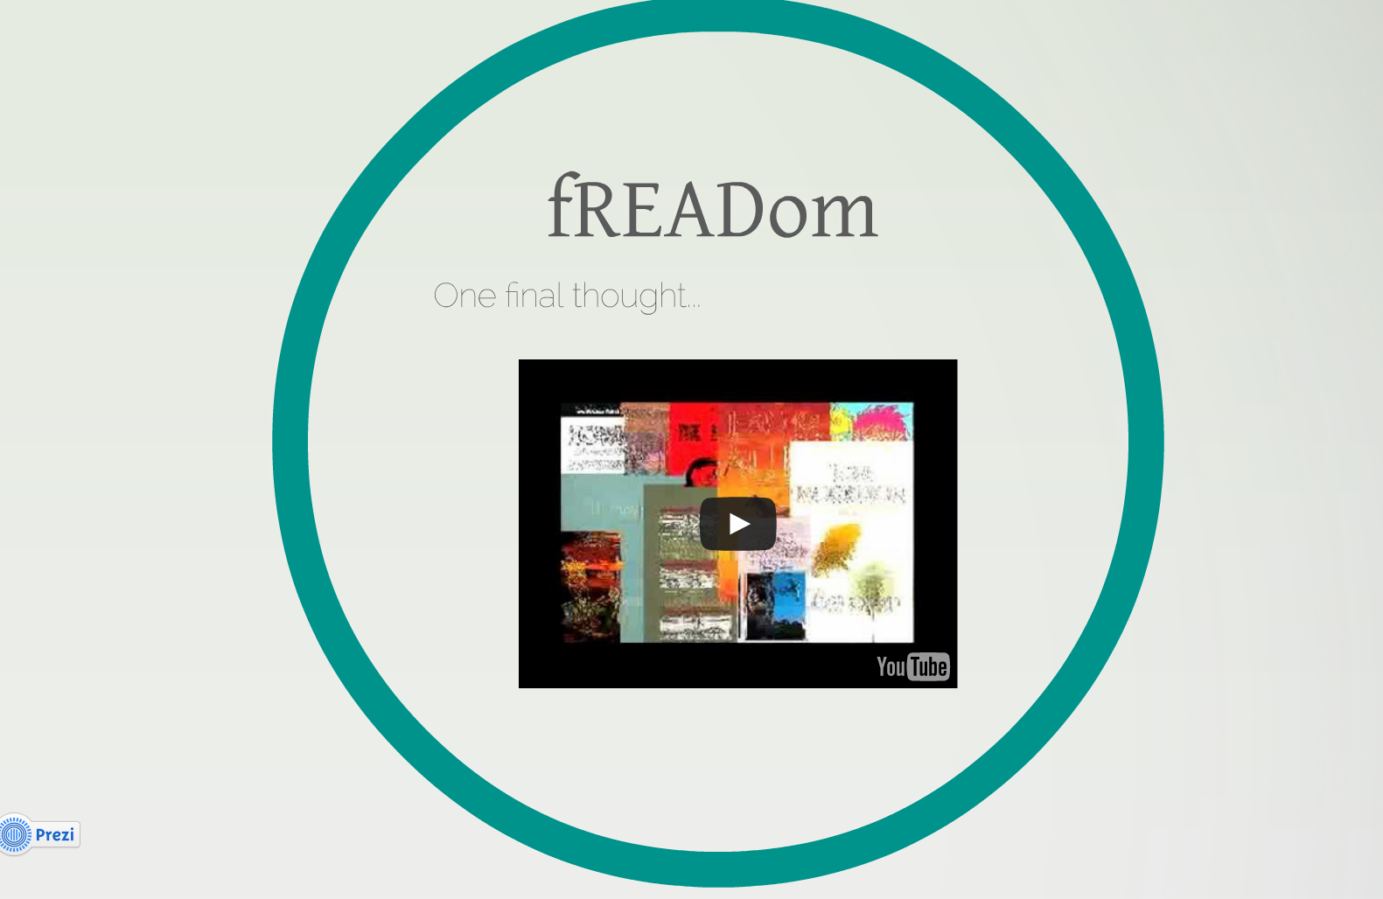
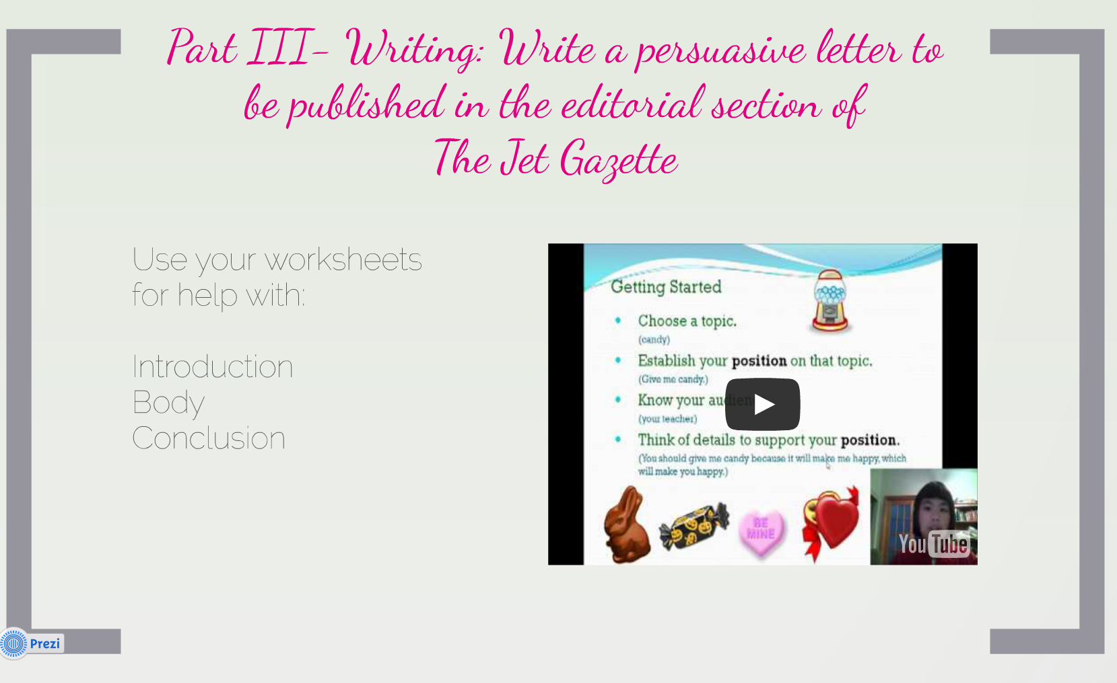

What is the hook?  How does the author try to grab your attention? | 1.  2.  3.
What is the author’s position/thesis?  Is a counter claim included? | 1.  2.  3.
What is the evidence or data used to strengthen the author’s argument? | 1.  2.  3.
Why is this important?  What negative/positive impact does it have? | 1.  2.  3.
SCORING

Your response will be scored on: Part III- Writing: Write a persuasive letter to be published in the editorial section of The Jet Gazette, concerning ________________________
(Book Title/Author)

Creating an Introduction

Using what we have been discussing as the key elements in persuasive writing such as a hook, counter claim, thesis and evidence, you will create an argument on whether the attempt to ban your book violates freedom of speech. You are to elicit supporting details and use relevant evidence from the text and other credible sources to support your claim.

SCORING
Your response will be scored on:

- How well you introduce your claim
- How well you support your claim

Developing body paragraphs

Using the research that you have gathered on the “censored” book of your choice, create body paragraphs that stem from your thesis. Each paragraph should reflect one of the reasons you presented in your introduction. Your reasons are to be supported with relevant evidence that stems from credible sources demonstrating an understanding of the topic. Your paragraphs should create coherent sentences that maintain consistency in your writing.

SCORING
In your body paragraphs please include:
- A topic and closing sentence
- Transition words
- Evidences that stem from the introduction
- At least three supporting details for each evidence

Your response will be scored on:
- How well you support your claim
- How well your ideas are organized
- How well you maintain a formal style

Writing a conclusion
One or more of the following strategies may help you write an effective conclusion.
- Play the “So What” Game. If you’re stuck and feel like your conclusion isn’t saying anything new or interesting, ask a friend to read it with you. Whenever you make a statement from your conclusion, ask the friend to say, “So what?” or “Why should anybody care?” Then ponder that question and answer it. Here’s how it might go:
You: Basically, I’m just saying that education was important to Douglass.
Friend: So what?
You: Well, it was important because it was a key to him feeling like a free and equal citizen.
Friend: Why should anybody care?
You: That’s important because plantation owners tried to keep slaves from being educated so that they could maintain control. When Douglass obtained an education, he undermined that control personally.
You can also use this strategy on your own, asking yourself “So What?” as you develop your ideas or your draft.
- Return to the theme or themes in the introduction. This strategy brings the reader full circle. For example, if you begin by describing a scenario, you can end with the same scenario as proof that your essay is helpful in creating a new understanding. You may also refer to the introductory paragraph by using key words or parallel concepts and images that you also used in the introduction.
- Synthesize, don’t summarize: Include a brief summary of the paper’s main points, but don’t simply repeat things that were in your paper. Instead, show your reader how the points you made and the support and examples you used fit together. Pull it all together.
- Include a provocative insight or quotation from the research or reading you did for your paper.
- Propose a course of action, a solution to an issue, or questions for further study. This can redirect your reader’s thought process and help her to apply your info and ideas to her own life or to see the broader implications.

Support:  Support claim with logical reasoning and relevant evidence | Fantastic!  Your evidence and examples are well thought out with a skillful blend of facts and reasoning! | Wonderful!  Your evidence and examples are supported with facts and reasons | Okay!  Provides some evidence and examples but may include inaccurate details | Ouch!  You provide minimal, irrelevant or no evidence or examples
Organization:  Organize reasons and evidence logically using words, phrases, and clauses to clarify relationships | Wow!  Your piece is well organized with a well-developed beginning, middle, and end!  You effectively connect the claims, reasons and evidence using a variety of transitional words, phrases and clauses!  It is obvious that you carefully planned your writing | Well done!  Your piece is well organized with a clear beginning, middle, and end  You connected the claim(s), reasons, and evidence using appropriate transitional words, phrases, and clauses  Your writing shows planning | Almost there!  Your piece is somewhat organized  You attempt to connect the claims, reasons, and evidence but use of transitional words, phrases and clauses is inconsistent or unsuccessful  Your writing shows some planning | Oh no!  Your piece shows some attempts at organization but with little success.  A lack of transitional words, phrases and clauses makes your writing awkward  Your writing shows little evidence of planning
Style:  Establish and maintain a formal style | Impressive!  Your word choices communicate a formal style and make your writing interesting and exciting!  It is obvious that you really know your audience and understand your purpose for writing! | Good job!  Your word choice communicates a formal style and add variety  Your writing shows that you have your audience and purpose in mind | Not bad!  Your word choices sometimes communicate a formal style but may be repetitive.  Your writing sometimes shows an awareness of audience and purpose but may include some inappropriate language | Alas!  Your word choice reflect a lack of understanding of audience and purpose

Reading Standards for Literature
1. Cite strong and thorough textual evidence to support analysis of what the text says explicitly as well as inferences drawn from the text, including determining where the text leaves matters uncertain

10. By the end of grade 11, read and comprehend literature, including stories, dramas, and poems, in the grades 11–CCR text complexity band proficiently, with scaffolding as needed at the high end of the range. By the end of grade 12, read and comprehend literature, including stories, dramas, and poems, at the high end of the grades 11–CCR text complexity band independently and proficiently.

Writing Standards: Responding to Literature
11. Create interpretive and responsive texts to demonstrate knowledge and a sophisticated understanding of the connections between life and the literary work.
a. Engage in using a wide range of prewriting strategies, such as visual representations and the creation of factual and interpretive questions, to express personal, social and cultural connections and insights.
b. Identify, analyze, and use elements and techniques of various genres of literature, such as allegory, stream of consciousness, irony, and ambiguity, to affect meaning.
c. Develop innovative perspectives on texts, including historical, cultural, sociological, and psychological contexts.
d. Create poetry, stories, plays, and other literary forms (e.g. videos, art work).

Frankenstein Lesson Plan: Create a Monster
Written by: Trent Lorcher • edited by: SForsyth • updated: 2/10/2012
High school literature lesson plans don't need to be a bore. This Frankenstein lesson plan allows students to create a monster and analyze the characters in Shelley's famous work.
Frankenstein Character Creation Objectives & Preparation
Any time you decide to have fun in school, you better have clear learning objectives; otherwise, somebody might find out your class enjoys learning and you could get in trouble.
  - Students will read, discuss, and analyze Frankenstein characters.
  - Students will write about Frankenstein characters.
  - Students will discuss and analyze character motivation.
  - Students will make predictions and analyze plot.
  - Students will review major events.
  - Students will use textual evidence to support opinions.
Supplies needed: construction paper of various colors, glue, scissors, writing instruments.
Procedure
Vary these procedures to fit your class dynamics:
  - Read at least until the part where Frankenstein brings the creature to life in chapter 5. For best results read past the point where the monster tells his story to Victor in chapter 16.
  - Divide students into groups of 3-5.
  - Give each group the exact same supplies: 2 pieces of colorful construction paper (each group can have different colors), a glue stick, and a pair of scissors.
  - Each group must construct a creature. Give no instructions as to what the creature should look like. Let them be creative.
  - In addition to constructing a monster, each group should do the following:
    - Write a poem about the monster.
    - Write a poem to the monster from another character.
    - Write a poem from the monster to another character.
    - Make a characterization chart of the monster, using specific facts and quotations from the story.
    - Make five predictions about what the monster will do in the remaining chapters.
    - Present the monster and the poem(s) to the class.
  - Nurture the creature so he doesn't come back and ruin your life.

The Canterbury Tales Power Point Project
The Canterbury Tales
POWERPOINT Project Using Google Docs

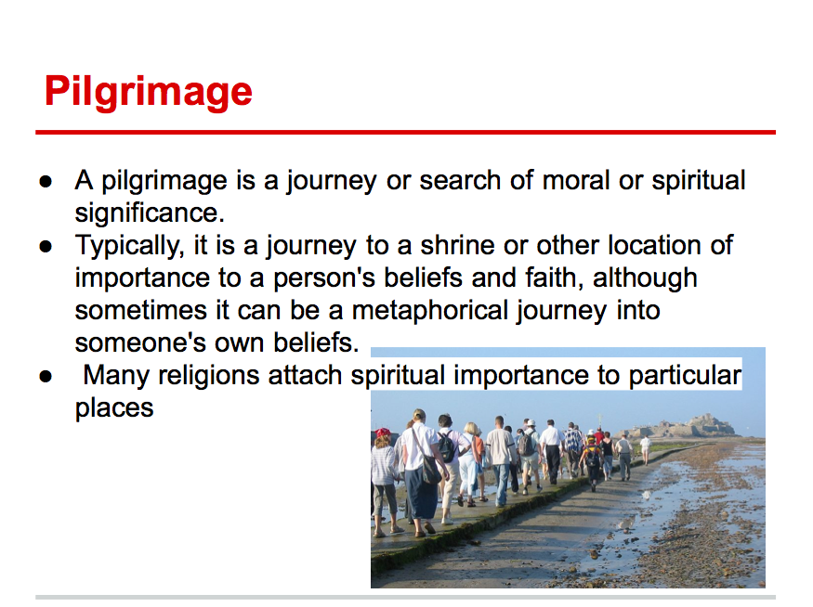
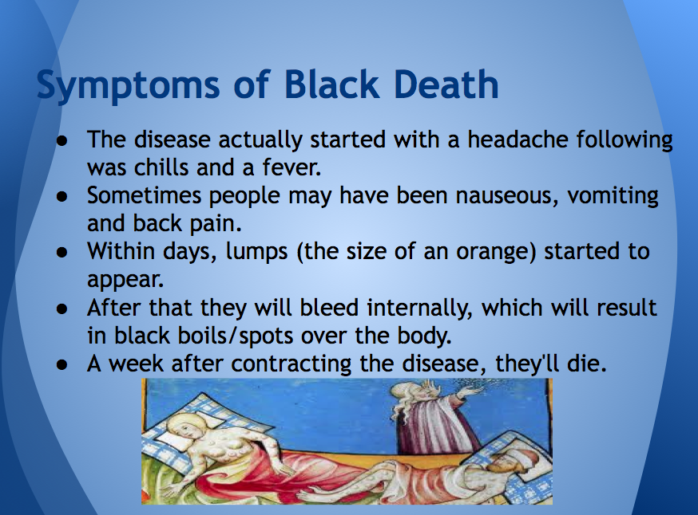
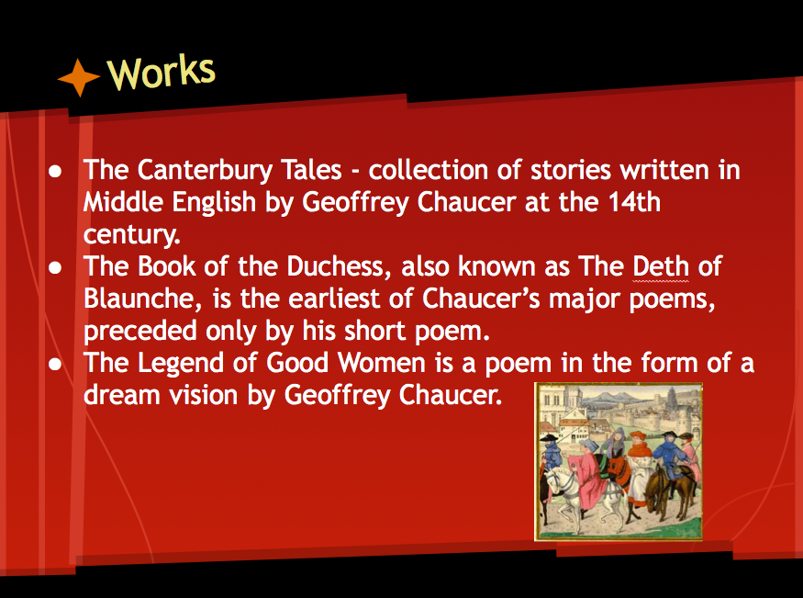
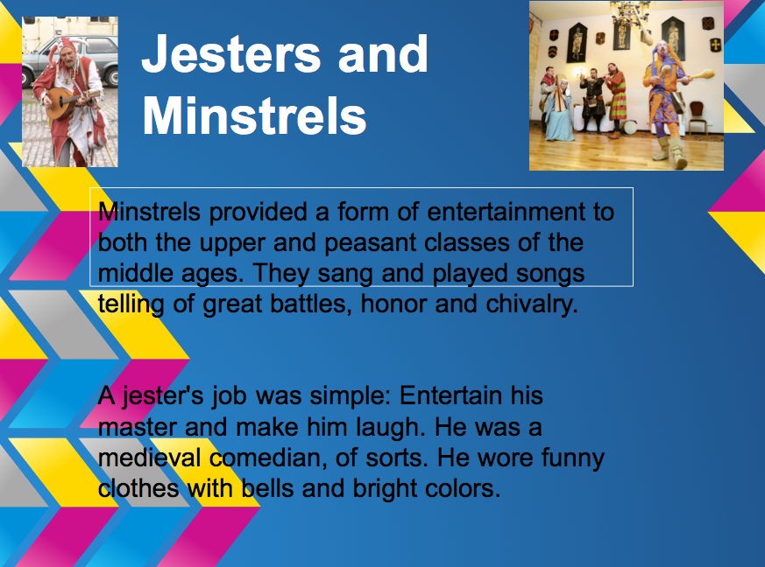
The purpose of this project is to familiarize students with background information on the Middle Ages and Geoffrey Chaucer, before we begin our class study of the Canterbury Tales. In groups that I have assigned, students will research the following topics (also assigned.)

GROUP #1 - The Black Death

GROUP #2 - The Life of Geoffrey Chaucer

GROUP #3 - Thomas a Becket

GROUP #4 - What is a pilgrimage?

GROUP #5 - Events taking place in England during the Late Middle Ages

GROUP #6 - Events taking place throughout the World during the Late Middle Ages

Students are to adhere to all requirements discussed in the Making Power Point Slides presentation discussed in class on Thursday, February 28, 2013. A copy of this presentation was distributed to each student. Each student will complete 4 slides. Each slide will include one image and one to two facts.

Presentations in Google Docs
Google Presentation allows you to create a slideshow in the Cloud. This is an opportunity for you to work on a group project from anywhere there is Internet access. Creating slideshows in Google Presentations is very similar to Microsoft Power Point in the way that you can create slides, move them around, change their background, and more. You can insert images and videos using the insert menu and add speaker notes as well. Files can be uploaded from and downloaded to a computer

Create a Google Docs presentation
1. Sign in to your Google account and to your Google Docs homepage.
2. Click on the Create button and select Presentation
3. Name your presentation by clicking on Untitled Presentation and typing in the new name.
4. Use the presentation tools in the top toolbar or pull-down menus to insert text or images.
5. Right-click on the side thumbnails in the left sidebar to open a slide management menu where you can insert, delete, move, duplicate, copy and paste slides. You can also drag and drop slides in the left sidebar.
6. To begin your presentation click on Start Presentation at the top of the screen.
Sharing Google Docs in the Classroom
When students work on a project, either individually or collaboratively, they should always share their document with their teacher. (You must share with your fellow group members in order to work on the PowerPoint Presentation.)
When students share in Google Docs, they can work together without physically being in the same space. Students working together can make changes directly to the text or comment on each other’s work using the Insert feature.
Evaluation Using the Common Core
Turnitin.com provides many services which include a Common Core Rubric for the teacher to use for evaluation. These lessons will use my website to demonstrate how to use the features of Turnitin. com to help students to evaluate their own work and for teachers to use the features provided by the service.

http://technologycommoncore.weebly.com/index.html
The password is RUFUS

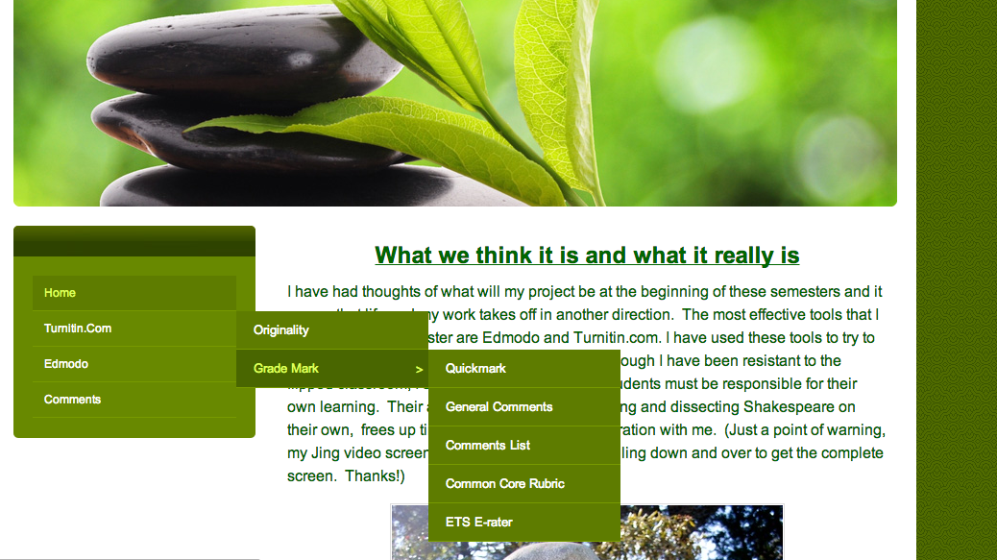

Common Core Standards:
1. Demonstrate command of the conventions of standard English grammar and usage when
writing or speaking.
a. Use parallel structure.*
b. Use various types of phrases (noun, verb, adjectival, adverbial, participial, prepositional, absolute) and clauses (independent, dependent; noun, relative, adverbial) to convey specific meanings and add variety and interest to writing or presentations.

3. Apply knowledge of language to understand how language functions in different contexts, to make effective choices for meaning or style, and to comprehend more fully when reading or
listening.
- Write and edit work so that it conforms to the guidelines in a style manual
(e.g.,MLA Handbook, Turabian’s Manual for Writers) appropriate for the discipline and writing type.

- Common Core Rubrics: These rubrics can be used to show student fulfillment of Common Core standards. Using Grademark, a service provided by Turnitin.com, students can see the Common Core rubric and adhere to said guidelines accordingly.

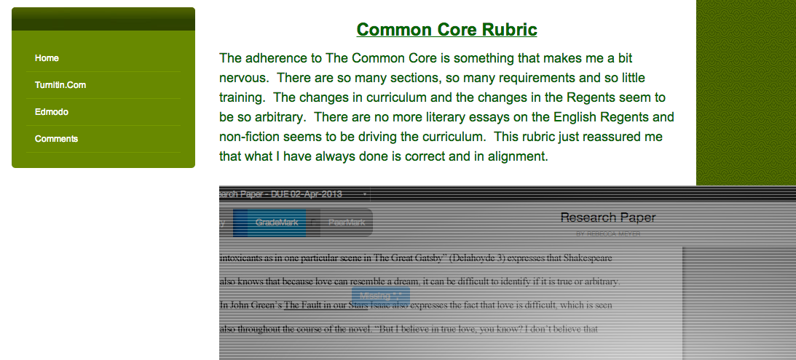

- Voice Comments: Teacher can leave voice comments for students. Students receive visual, auditory and sensory clues about how to improve writing based on the common core.

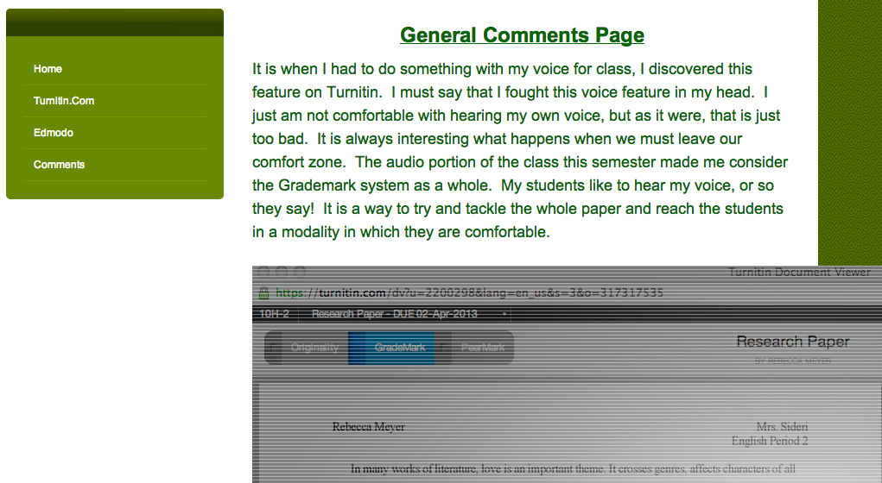

- ETS comments: For basic grammar and usage corrections, the ETS comment system can be used. This particular technology is representative of the standard used by the College Board to grade the Essay Portion of the SAT. Familiarity with these rules and standards supports not only the Common Core, but also aids in strengthening of skills for the SAT.

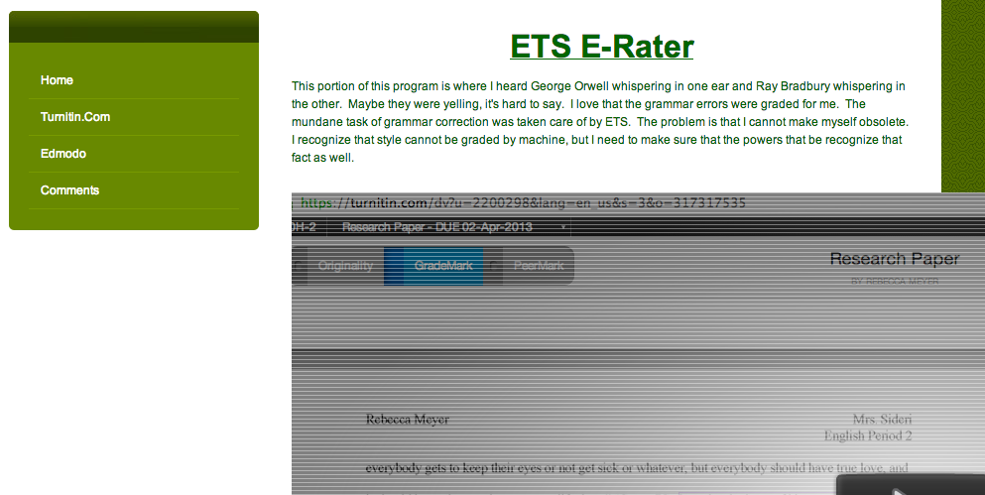

- Grademark: In this particular area, teachers are able to create a list of comments they would like to use but they can also click and write comments candidly.
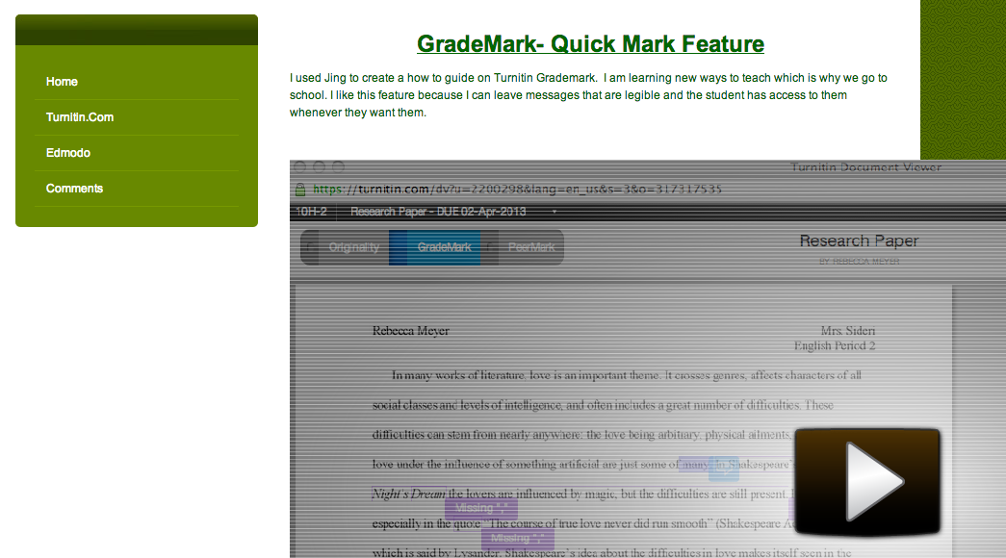

Works Cited

Conclusions. Nesbitt-Johnston Writing Center, Hamilton College. 17 May 2005
<http://www.hamilton.edu/academic/Resource/WC/SampleConclusions.html>.

Hunter, David. "Checking Credibility of Sources." Online video clip.
YouTube. YouTube, Web. 14 March 2012.

Kakutani, Michiko. “Light Out, Huck, They Still Want to Sivilize You”. The New York
Times. 6 January 2011

Kelly, Melissa. Censorship and Book Banning in America. About.com. 25 July 2013.
Books/http://712educators.about.com/cs/bannedbooks/a/bookbanning.htm

Lewis, M. ELA-WRITING Unit 1. Inwood 52. February 2012 <http://inwood52.org/>

Neha, K. Against Banning Books. Teen Ink. 25 July 2013
<http://teenink.com/opinion/social_issues_civics/article/131038/Against-Banning->

Strategies for Writing a Conclusion. Literacy Education Online, St. Cloud State
University. 18 May 2005. <http://leo.stcloudstate.edu/acadwrite/conclude.html>.

