Butterflies
Sagebrush Checkerspot Flowering Plant:
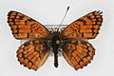 _______________________
Great Basin Fritillary
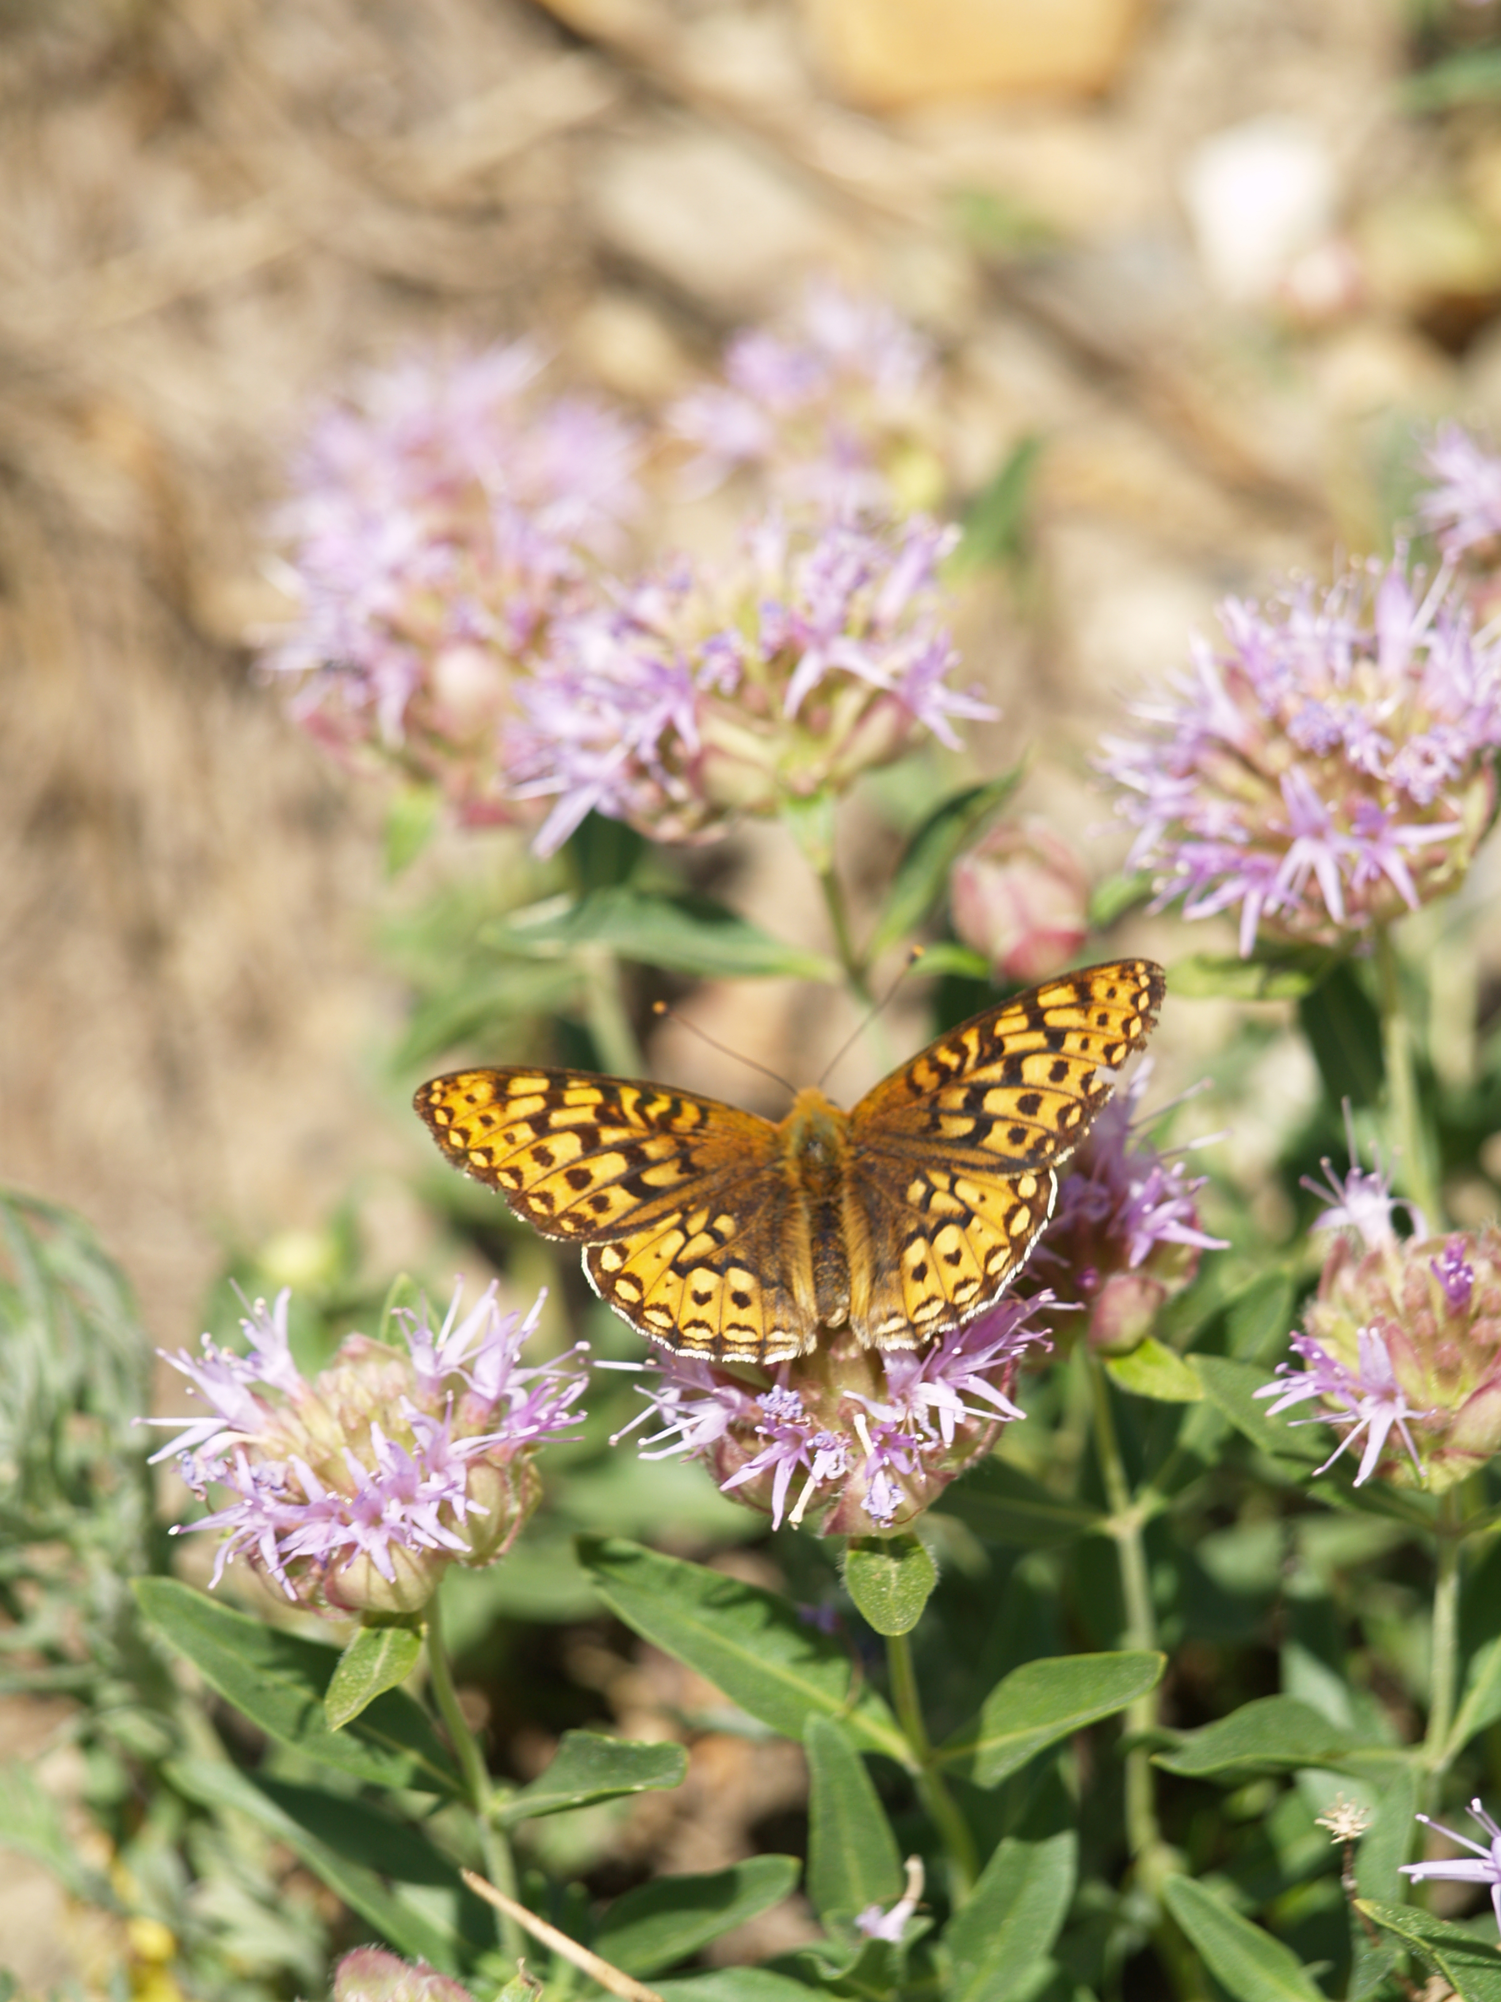 ________________________
Monarch Butterfly
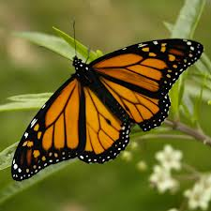 ________________________
Flowering Plants
Rabbit Brush Butterfly:
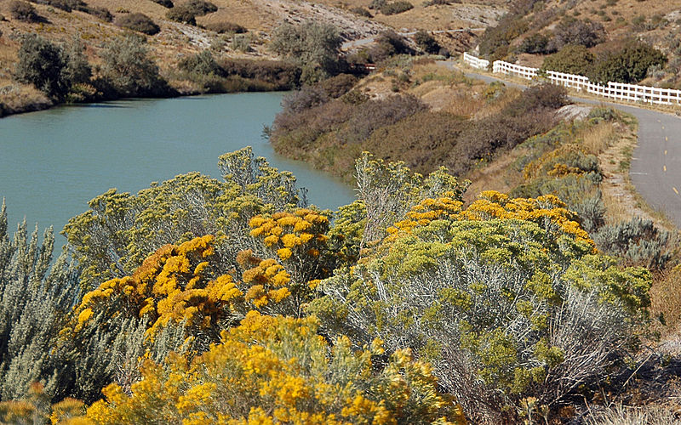
Violets
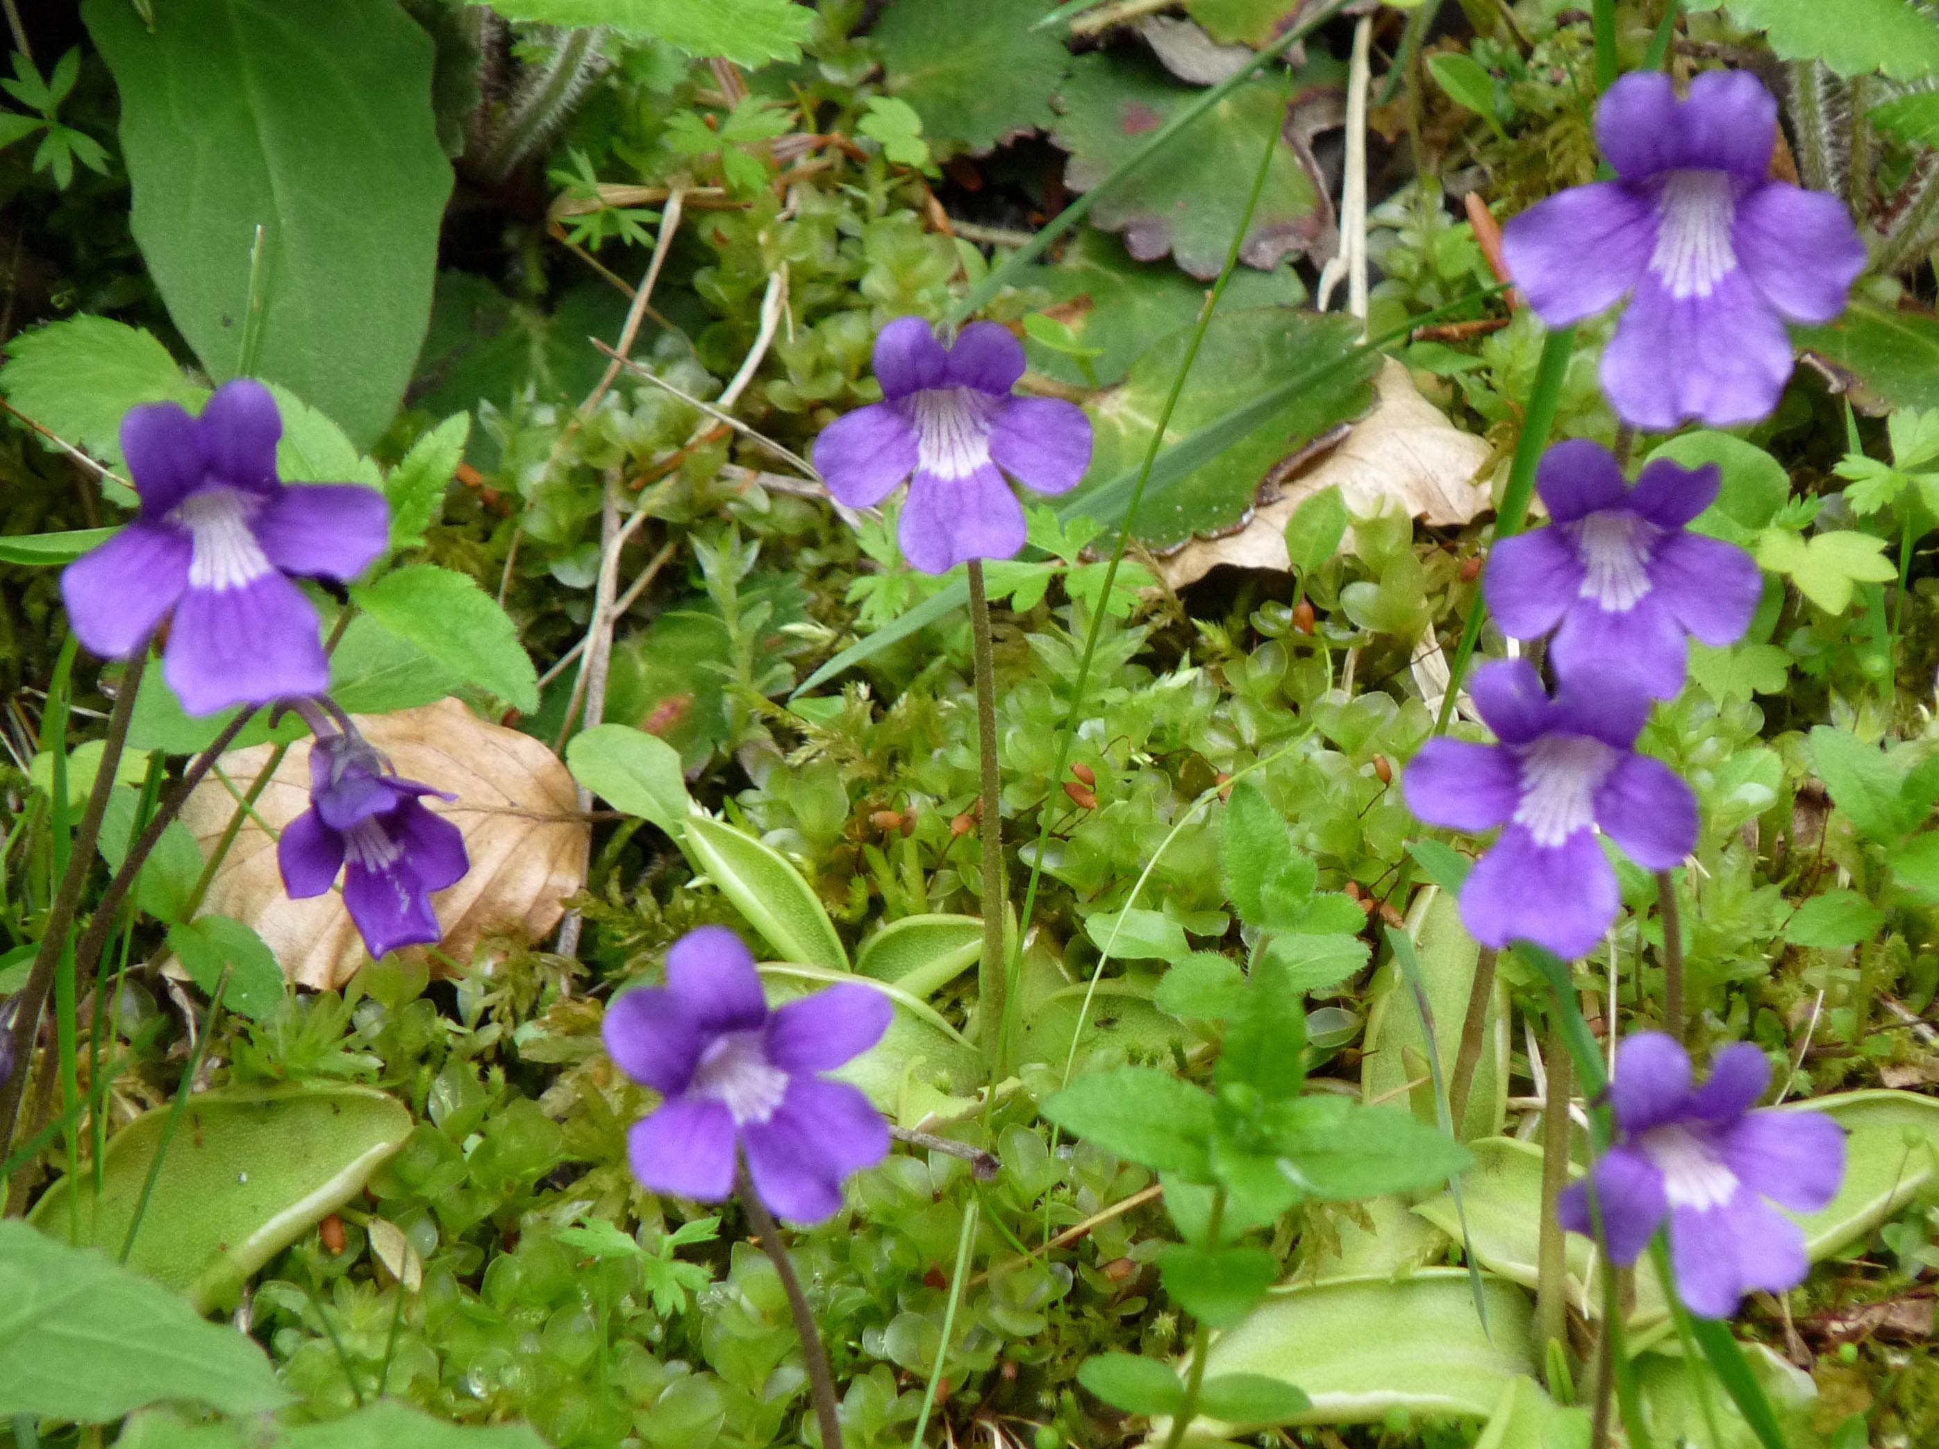
Milkweed
