Name Date
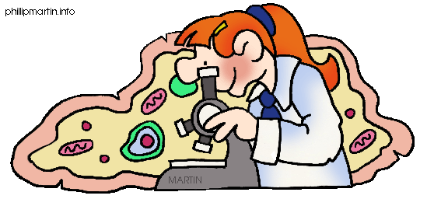Parts of a Cell

Structure | Animal Cell (y/n) | Plant Cell (y/n) | Function | Material Used in Model | Why Material Used?
Cell Wall
Cell Membrane
Cytoplasm
Chloroplast
Golgi Bodies
Endoplasmic Reticulum
Lysosome
Nucleus
Nucleolus
Ribosomes
Vacuole
Mitochondrion

