Lab 2: Stretch it to the Limit
Linear Force Relationship
Adapted from Real-World Math Made Easy, © 2005 Texas Instruments

START THINKING

When a force is applied to a rubber band, it stretches a certain amount. Exactly how much it stretches depends on the applied force and the characteristics of the rubber band. For this lab, you will model this linear relationship by stretching a rubber band and measuring the amount of stretch.

- What kind of force is applied to rubber bands?

- What do you think is the relationship between force and stretch of the rubber band?

- We know the relationship will be linear. What does a linear graph look like?

- So, when you collect your data and see the graph, what should the data points form?

- If they do not form that shape, what should you do?

GET READY FOR THE LAB

You will complete this lab in pairs. Once you are at a work station, make sure you have all the materials you need:

1 Nspire
1 Lab Cradle
1 CBR and connectivity cable
1 Force Sensor and connectivity cable
utility handle (in Force Sensor kit)
4 different rubber bands
stick or pencil
SET UP THE LAB

Place the Nspire into the Lab Cradle and place it on a table.

Set the Force Sensor range switch to 10 N. Stack the CBR on top of the Force Sensor and connect them together using the utility handle. The CBR and hook of the Force Sensor should face the same direction. Plug the CBR and Force Sensor into the calculator using the connectivity cables.

Hook the rubber band onto the force detector. When you pull on the rubber band, use a pencil or stick (not your hands) and stretch it directly over the meter stick so it can take the measurements.

Turn on the calculator. If it doesn’t automatically put you on the Vernier DataQuest screen, choose 7:Add Vernier DataQuest. Your screen should look like this:

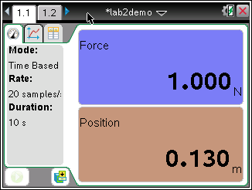

One partner should press the green play start button to begin data collection.

The other partner should gently stretch and relax the rubber band, moving the pencil/stick along the meter stick between the Force Sensor and the CBR. Do not let your hand get any closer than 50 cm from the CBR.

After data collection is complete, a graph will appear. Before continuing with the lab, make sure your graph is in the shape that you expected to get. Every time you move the rubber band closer or farther away there should be a V shape in the upper graph. Here is an example:

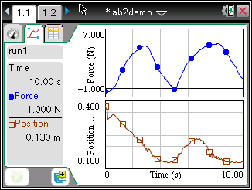

ANALYZE THE RESULTS

Make a scatterplot of your results to confirm that your data is linear. Then run a linear regression on your data to come up with a linear function that describes the relationship between force and distance on the rubber band.

- Press CTRL DOC to open a new page. Choose 2: Add Graphs.
- Press MENU.
- Choose 3: Graph Entry/Edit and then 5: Scatterplot
- For the x variable, press VAR and choose position.
- For the y variable, press VAR and choose force.
- Press ENTER.
- Your scatterplot will appear. If it is linear, keep going with analyzing results. If it is not, go back and get a new data set.
- Now you need to find the linear function to fit your points. Press CTRL DOC to open a new page. Choose 4: Add Lists and Spreadsheets
- Arrow up to the cell called A. Press VAR and choose position. The column will fill with your data.
- Arrow over to the cell called B. Press VAR and choose force. The column will fill with your data.
- Now do the regression. Press MENU.
- Choose 4: Statistics
- Choose 1: Stat Calculations
- Choose 3: Linear (mx+b)
- A list of drop down options will appear. In the x field, push a and choose position.
- In the y field, push a and choose force.
- Tab through the other fields making sure the SaveRegEqn is set to f1 and the Results Column is c[]
- Tab to OK and press ENTER.
- Now you need to see if your regression equation matches your scatterplot. Press CTRL left arrow to go back to your graph.
- Press CTRL G to get your entry line back. It will still be a scatterplot line. To change it back to a function line, press MENU.
- Choose 3:Graph Entry/Edit.
- Choose 1:Function
- Press arrow up once to see your function.
- Press ENTER.
- Your function line should fit nicely over the points in your scatterplot.

QUESTIONS

- Write your linear function here.

- In this lab, x represents force and y represents distance. A constant k shows the proportional relationship between the two. The generic formula is y=Kx. In your function, what is the K value.

- Does the K value depend on the type of rubber band you are using? Why or why not?

TRY IT ON YOUR OWN

Now try this lab on your own. Please repeat the lab with 3 other types of rubber bands and fill in the chart.

Which rubber band did you use?
How does that rubber band compare to the others?
What is your regression equation?
What is your K value?
What might you say about the relationship between the K value and the characteristic of the rubber band?

Which rubber band did you use?
How does that rubber band compare to the others?
What is your regression equation?
What is your K value?
What might you say about the relationship between the K value and the characteristic of the rubber band?

Which rubber band did you use?
How does that rubber band compare to the others?
What is your regression equation?
What is your K value?
What might you say about the relationship between the K value and the characteristic of the rubber band?

