Lab 1: Meet You at the Intersection
Systems of Linear Equations
Adapted from Real-World Math Made Easy, © 2005 Texas Instruments

START THINKING

For this lab, you will model two linear functions by walking at a constant speed toward another person. Each person’s path will be one of the linear functions.

- What do you know about linear functions? What will it look like on the graph?

- If it doesn’t look like that, have you modeled a linear function?

- If it doesn’t look like a linear function, what should you do?

GET READY FOR THE LAB

You will complete this lab as a team of 4 people. Assign a role to each person. You will complete this lab 4 times, so each person will get to do each task once.

- For the first time through the lab who will be…

Walker #1?

Walker #2?

Timer?

Marker?

Make sure you have all the materials you need:

1 Nspire
1 Lab Cradle
1 digsonic connectivity cord
1 USB connectivity cords
2 CBRs
1 stop watch
1 measuring tape on the floor
SET UP THE LAB

Place the Nspire into the Lab Cradle and place it on a table. Use the connectivity cables to plug one CBR into dig/sonic 1 and the other into the mini USB port on the top of your calculator. The CBRs should be placed on the same table(s) about 2 meters apart, facing the same direction, and aimed parallel to one another.

Turn on the calculator. If it doesn’t automatically put you on the Vernier DataQuest screen, choose 7:Add Vernier DataQuest. Your screen should look like this:

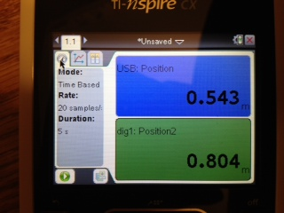

Set up DataQuest for data collection.
- Press b
- Choose 1:Experiment
- Choose 8:Collection Setup
- Using the e and number keys, make sure the top field says Rate(samples/second), Rate (samples/second) is set to 5, and Duration (seconds) is set to 10.
- When your screen matches the screenshot below, press OK.

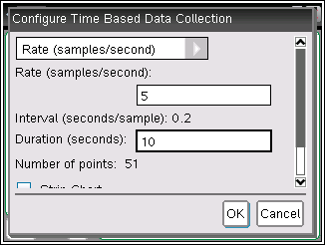

Have Walker #1 stand 2 meters away from the front of the first CBR. Have Walker #2 stand ½ meter away from the second CBR. The two walkers should face each other. The Timer should stand near the calculator and be ready to push the green play triangle button on the calculator AND go and stop on the stop watch. The Marker should be ready to mark where the walkers pass each other on the measuring tape.

When ready, the Timer should say “1, 2, 3, Go.” On GO, the Timer hits start on the calculator and stopwatch at the same time and the two walkers start walking at a SLOW constant rate to the other end of the area.

When the two walkers pass each other the Timer should hit stop on the stopwatch and the Marker should mark the location on the measuring tape.

When the walkers are done walking, press the STOP button.

The screen will show a graph that looks something like this (if it doesn’t look linear or you can’t see the lines crossing, do it again). You are looking at the graph on the top.

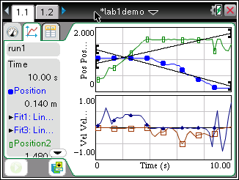

Once you have a good data set, disconnect the CBRs by unplugging them from the calculator and lab cradle.

ANALYZE THE RESULTS

After getting a good data collection (the two graphs should look linear), fill in the chart and answer the questions. Use the directions below the chart for help in filling it out.

 | Direct Measure | Graphical Trace | Solve Equation System
Intersection Time
Intersection Position

For Direct Measure:
- Record what your timer and marker determined.

For Graphical Trace:
- Hover your cursor over the top graph that has Pos Pos… as it’s y-axis. Press ENTER. A dotted line will appear.
- Use the arrow keys to move the dotted line over the point of intersection.
- Look at the data on the right side of the display.
- Record what the “Time” says.
- Look at the two values for Position and choose a value that is very close or in the middle of them.
- In this example, the Time is 2.2 seconds and the Position is approximately 1.0 meters.
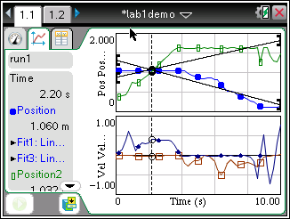

For Solve Equation System:
- Choose MENU
- Choose 4: Analyze
- Choose 6: Curve Fit
- Choose 1:run1.Position
- Choose 1: Linear
- Scroll down to the bottom of the window where it gives the “m” and “b” value. On a separate sheet of paper, write down the linear equation remembering that the form is y=mx+b. You can just write up to 2 numbers past the decimal point. You will need this for the final column.
- Then repeat steps 1-3. On Step 4, choose 2:run1.Position2. Follow steps 5-7 as you did before.
- Press CTRL DOC for a new page.
- Choose 2:Add Graphs
- For f1(x) enter the mx+b portion of the linear equation for the first position (that’s everything after the = sign).
- Press ENTER. Your graph should appear.
- Press CTRL G to get the function line back.
- For f2(x) enter the mx+b portion of the linear equation for the second position.
- Press ENTER. That graph should appear.
- Press MENU
- Choose 7: Points & Lines
- Choose 3: Intersection Point(s)
- Hover the cursor over one of your lines and press ENTER.
- Hover the cursor over the other line and press ENTER.
- You should see a set of coordinates appear.
- The first number in the set of coordinates is the x value, and that is the solution to the equation system. Record it in the chart.
- In this example, it is 2.25.

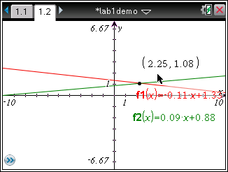

QUESTIONS

- How can you identify which trace is walker one and which is walker two? Identify the trace of each walker for future reference.

- How do the model lines fit the walker data?

- Compare the values you obtained for the intersection time by all three methods: (1) direct measurement by stopwatch and meter stick; (2) graphical intersection by tracing, and (3) by solving the system of equations. Are the values consistent?

- Is it possible for the walkers to move in front of the CBRs so that the resulting plots would not intersect? If so, give an example; if not, explain why.

- Could the walkers move so that their plots intersect more than once? If so, how?

TRY IT ON YOUR OWN

Now try this lab on your own. Each person rotate to the next position. Do the lab again and fill in the chart. Rotate one more time, and fill in the next chart. Then rotate one last time and fill in the final chart.

 | Direct Measure | Graphical Trace | Solve Equation System
Intersection Time
Intersection Position

Walker #1:  Walker #2:  Timer:  Marker: | Are your results consistent?

 | Direct Measure | Graphical Trace | Solve Equation System
Intersection Time
Intersection Position

Walker #1:  Walker #2:  Timer:  Marker: | Are your results consistent?

 | Direct Measure | Graphical Trace | Solve Equation System
Intersection Time
Intersection Position

Walker #1:  Walker #2:  Timer:  Marker: | Are your results consistent?

