Lab 4: Light at a Distance
Distance and Light Intensity
Adapted from Real-World Math Made Easy, © 2005 Texas Instruments

START THINKING

While traveling in a car at night, you may have observed the headlights of an oncoming vehicle. The light starts as a dim glow in the distance, but as the vehicle gets closer, the brightness of the headlights increases rapidly. This is because the light spreads out as it moves away from the source. As a result, light intensity decreases as the distance from a typical light source increases. What is the relationship between distance and intensity for a simple light bulb?

There are two models for light intensity. One is an inverse square in the form of y=C/x². The second model is the general power law of y=ax^{b}. We will look at each model to see which is a better fit. In either case, you should get a rational function.

- What will a rational function look like on the graph?

- If it doesn’t look like that, have you modeled a rational function?

- If it doesn’t look like a rational function, what should you do?

- Our calculators will not do a rational regression. It will only do a power regression. How is a rational function related to a power function? Write an example below.

- What is your prediction for the relationship between intensity and the distance to a light source?

MATERIALS

1 Nspire
1 Lab Cradle
1 Light Sensor and connectivity cord
1 light source
1 meter stick

SET UP THE LAB

Place the Nspire into the Lab Cradle and place it on a table. Use the connectivity cable to plug in the Light Sensor. Set the light sensor to 0-600 lux. Your calculator should automatically put you on the Vernier DataQuest screen, but if it doesn’t, press the c. Then press 1:New Document, NO for saving, and 7:Add Vernier DataQuest.

Now you need to set up the experiment.

- Press MENU
- Choose 1:Experiment
- Choose 7: Collection Mode
- Choose 2:Events with Entry
- A setup window will appear. Type “Distance” for Event and “cm” for units.

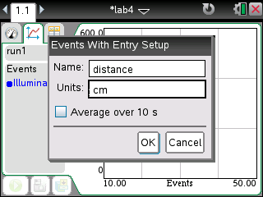

- Tab to OK and press ENTER. Your screen should look like this:

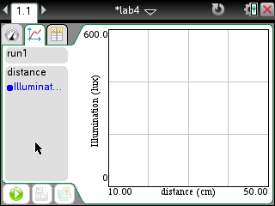
play button
graph button

If you don’t see this screen, click on the graph icon in the upper left hand corner.

Now you are ready to begin collecting data.

Place the Light Sensor at 0 on the meter stick. Place your light source facing the sensor, 10 cm away.

Press the Green Play arrow in the lower left hand corner of your screen.

Watch the blue data dot. When it stabilizes, press the camera icon in the lower left corner of the screen. Enter 10 for the event because you are 10 cm away. A blue data point should appear on your screen.

Move the light source ten centimeters back and repeat the process until your lux value is 10% of your starting value. Press the red stop button in the lower left hand corner of your screen. When you are finished, your screen will look something like this:

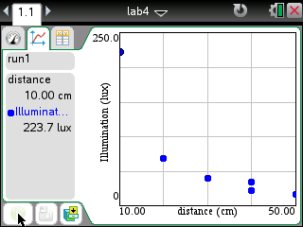

ANALYZE THE RESULTS

After getting a good data collection fill in the chart and answer the questions. Use the directions below the chart for help in filling it out.

Left-most point X value
Left-most point Y value
Initial model parameter C
Optimized inverse-square model y=C/x²
Power law model y=ax^{b}

Left-most point X and Y values
- hover your arrow over the left-most point on your graph
- Press x.
- A vertical dotted line should appear.
- Look at the distance and illumination data on the left side of your screen. Decide which is the x value and which is the y value and fill in the chart above.

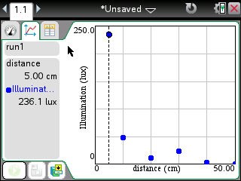
distance and illumination data

Initial parameter C
- Put your data in a scatterplot.
- Click the table icon.

table icon

- It should look something like this:

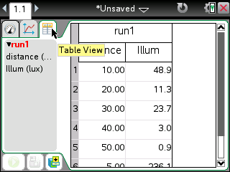

- Press CTRL DOC to get a new page.
- Choose 2: Add Graphs
- Change the graph type to a scatterplot by pressing MENU, 3: Graph Entry/Edit, and 5: Scatterplot
- For x, press the VAR button and choose distance.
- For y, press the VAR button and choose illumination.
- Press ENTER.
- If your data doesn’t appear, you will need to change the window. You can do this by pressing MENU, 4:Window/Zoom, 9:Zoom-Data
- You need to estimate a value for C. To do this, you’ll need to try one out. First, you’ll need to change the entry line back to function. To do this, press MENU, 3:Graph Entry/Edit, 1: Function
- Type 1/x² and ENTER.
- Double click on the function to edit it. Change the numerator until you have a function that overlaps most of your data points. Record that numerator in the chart above.

Optimized Inverse Square
- Use your line of best fit that you just found and write the equation for that curve in the space.

Power Law Model
- You will use your calculator to do a power regression. Hit CTRL DOC to get a new page. Choose 4: Lists and Spreadsheets.
- At the top of the A column, press VAR, 3:Link To and choose distance.
- At the top of the B column, press VAR, 3: Link To and choose illumination.
- Press MENU.
- Choose 4: Statistics
- Choose 1: Stat Calculations
- Choose 9: Power Regression
- You will get a drop down menu.
- For X List, press x and choose distance.
- For Y List, press x and choose illumination.
- Make sure the Save RegEqn is in f2 and the 1st Result Column is c[]
- Tab to OK and press ENTER.
- You should see the regression information appear.
- Press CTRL left arrow to go back to your graphs page.
- Press TAB to get the function line. Hit arrow up to see your regression equation. Press ENTER to see the graph.
- Copy the regression equation into the chart above. Your screen will look something like this with both equations and both graphs, color coded, on it:

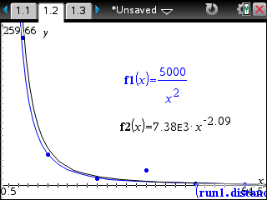

QUESTIONS

- Is the graph of the light intensity versus distance consistent with your earlier prediction?

- How well does the inverse-square model y=C/x² fit the experimental data?

- How well does the power law model fit the data? Could it fit any better than the inverse-square model? Could it fit more poorly?

- How would using a brighter bulb affect the parameters a, b, and C in the two models?

TRY IT ON YOUR OWN

Now try this experiment with two other light sources. Then answer the extension questions.

Light source:

Left-most point X value
Left-most point Y value
Initial model parameter C
Optimized inverse-square model y=C/x²
Power law model y=ax^{b}

Light source:

Left-most point X value
Left-most point Y value
Initial model parameter C
Optimized inverse-square model y=C/x²
Power law model y=ax^{b}
EXTENSION QUESTIONS

- Suppose that your patio is illuminated by an overhead light fixture with two bulbs. You decide to save on electricity by removing one of the bulbs. If the light is currently mounted 5 m off the ground, to what height should the light fixture be moved in order to retain the same amount of light on the patio with one bulb? Does your answer depend on the model you use?

- Two identical light bulbs shine on your favorite reading chair from different locations in the room. The first bulb is 3 m from your chair and provides an intensity of .6 mW/cm². The second is 2 m from your chair. What intensity does this bulb provide? Does your answer depend on the model you use?

