Subject: H.S. Geometry

Lesson Plan
Discovering the Formula for the Sum of the Measures of the Interior Angles of Polygons

Objective: Students will be able to use the sum of the measures of the interior angles of a triangle to discover the formula for calculating the sum of the measures of the interior angles of a polygon when given only the number of sides of the polygon.
Standards: 4.8.6 Form generalizations and validate conclusions about geometric figures and their
properties.

4.12.6 Solve problems using complementary and supplementary angles, congruent angles, vertical angles, angles formed when parallel lines are cut by a transversal and angles in polygons.

I Can: 1. I can determine the sum of the measures of the interior angles of a polygon by using the sum of the measures of the angles in a triangle.
2. I can calculate the sum of the measures of the interior angles of a polygon given only the number of sides.
Materials: Worksheets, pencil, rulers
Procedure: 1. Review the sum of the measures of the interior angles of a triangle is 180º.
2. Using the worksheet, “Sum of the Measures of the Interior Angles of Polygons”, students will begin with the quadrilateral and draw in the diagonals.
3. Have students count the number of triangles formed.
4. Using the number of triangles, have students calculate the sum of the measures of the interior angles of the quadrilateral.
5. Repeat steps 2-4 with a pentagon, hexagon, and decagon.
6. Have students use the data to predict a formula for finding the sum of the measures of the interior angles of a polygon by using only the number of sides of the polygon.
7. Practice using the formula derived in step 6 giving students only the number of sides of a polygon.

NAME________________________________________
Sum of the Measures of the Interior Angles of Polygons
POLYGON |  | NUMBER OF SIDES | NUMBER OF TRIANGLES |  | SUM OF THE TRIANGLE MEASURES
Triangle
Quadrilateral
Pentagon | 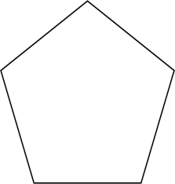
Hexagon
Octagon
Formula for finding the sum of the measures of the interior angles of a polygon
POLYGON |  | NUMBER OF SIDES |  | SUM OF THE INTERIOR ANGLES
Decagon | 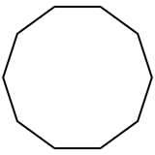
Dodecagon | 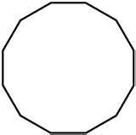
15-gon  (Pentadecagon) | 