

Grades 6-8 Social Studies Research Enrichment
Scope and Sequence CAP

Woodland Middle School
East Meadow Union Free School District

Summer 2012

Facilitator: John Comer
Writers: John Comer, Arzije Dervisi, Staci Kluczka
Superintendent: Mr. Louis R. DeAngelo
Principal: Mr. James Lethbridge

Table of Contents

2

Title Page ..............................................................................1

Table of Contents .................................................................2

Abstract ................................................................................. 3

Rationale ................................................................................4

Enrichment Research ......................................................... 5-51



Abstract
The primary goal of this CAP is to create a quarter long Social Studies Research course for Middle School students that demonstrates the New York State Social Studies Standards, as well as the Common Core Standards. At the end of each marking period, student will generate a research project. On the path to creating a research project students will research a topic of their choice, which promotes the students to have a personal investment in the project. Additionally, they will develop research skills as they act as historians discovering how to uncover primary sources, build historical context and form historical interpretations. In the end, students will become experts on their research topic.

3

In an effort to promote student research, the CAP created a quarter- long Social Studies Research course for Middle School students, which is to take place during the Enrichment period. Through the use of a backwards design approach, the CAP infused the New York State Social Studies Standards with the Common Core Standards to create the optimal learning environment for students. At the end of each marking period, student will generate a research project. On the path to creating a research project, students will research a topic of their choice, which promotes the students to have a personal investment in the project. Secondly, the pupils will develop research skills as they act as historians discovering how to uncover and analyze primary and secondary sources, build historical context and form historical interpretations. Finally, the students will become experts on their research topic
To create a college and career ready environment for the students, this course will help them develop attributes that are critical for future success. For example, with the guidance of the teacher, students will partake in critical thinking and problem-solving. Throughout this course students will develop the skills to conduct research, as well as oral and written communication and presentation skills. Finally, to develop the students’ social and emotional learning this course will foster self-esteem and confidence and a sense of responsibility for and involvement in the democratic process.

Rationale

4
The following Common Core Standards will be addressed during the course of this project:

College and Career Readiness Anchor Standards for Language
Conventions of Standard English
- Demonstrate command of the conventions of standard English grammar and usage when writing or speaking.

2. Demonstrate command of the conventions of standard English capitalization, punctuation, and spelling when writing.

College and Career Readiness Anchor Standards for Reading
Key Ideas and Details

1. Read closely to determine what the text says explicitly and to make logical inferences from it; cite
specific textual evidence when writing or speaking to support conclusions drawn from the text.

2. Determine central ideas or themes of a text and analyze their development; summarize the key
supporting details and ideas.

- Analyze how and why individuals, events, or ideas develop and interact over the course of a text.

Craft and Structure
- Interpret words and phrases as they are used in a text, including determining technical, connotative,
and figurative meanings, and analyze how specific word choices shape meaning or tone.

5. Analyze the structure of texts, including how specific sentences, paragraphs, and larger portions of the
text (e.g., a section, chapter, scene, or stanza) relate to each other and the whole.

- Assess how point of view or purpose shapes the content and style of a text.

Integration of Knowledge and Ideas
7. Integrate and evaluate content presented in diverse formats and media, including visually and
quantitatively, as well as in words.

- Delineate and evaluate the argument and specific claims in a text, including the validity of the reasoning as well as the relevance and sufficiency of the evidence.

9. Analyze how two or more texts address similar themes or topics in order to build knowledge or to
compare the approaches the authors take.

5
Reading Standards for Literacy in History/Social Studies 6–12
Key Ideas
- Cite specific textual evidence to support analysis of primary and secondary sources.
- Determine the central ideas or information of a primary or secondary source; provide an accurate summary of the source distinct from prior knowledge or opinions.
- Identify key steps in a text’s description of a process related to history/social studies. and Structure
- Determine the meaning of words and phrases as they are used in a text, including vocabulary specific to domains related to history/social studies.
- Describe how a text presents information (e.g.,sequentially, comparatively, causally).
- Identify aspects of a text that reveal an author’s point of view or purpose (e.g., loaded language, inclusion or avoidance of particular facts).

Integration of Knowledge and Ideas
- Integrate visual information (e.g., in charts, graphs, photographs, videos, or maps) with other information in print and digital texts.
- Distinguish among fact, opinion, and reasoned judgment in a text.
- Analyze the relationship between a primary and secondary source on the same topic.

College and Career Readiness Anchor Standards for Writing
Text Types and Purposes
- Write arguments to support claims in an analysis of substantive topics or texts using valid reasoning and relevant and sufficient evidence.

2. Write informative/explanatory texts to examine and convey complex ideas and information clearly and
accurately through the effective selection, organization, and analysis of content.

- Write narratives to develop real or imagined experiences or events using effective technique, well-chosen details and well-structured event sequences. Production and Distribution of Writing

- Produce clear and coherent writing in which the development, organization, and style are appropriate to task,purpose, and audience.

- Develop and strengthen writing as needed by planning, revising, editing, rewriting, or trying a new approach.

- Use technology, including the Internet, to produce and publish writing and to interact and collaborate with others.

7. Conduct short as well as more sustained research projects based on focused questions, demonstrating
understanding of the subject under investigation.

- Gather relevant information from multiple print and digital sources, assess the credibility and accuracy of each source, and integrate the information while avoiding plagiarism.

9. Draw evidence from literary or informational texts to support analysis, reflection, and research.

6
The following New York State Standards will be addressed during the course of this project:

Studies Standard 1: History of the United States and New York
Students will use a variety of intellectual skills to demonstrate their understanding of major ideas, eras, themes, developments, and turning points in the history of the United States and New York.

Key Idea 2
Investigate key turning points in New York State and United States history and explain why these events or developments are significant.

Key Idea 3
Interpret and analyze documents and artifacts related to significant developments and events in world history.

Key Idea 4
Consider the sources of historic documents, narratives, or artifacts and evaluate their reliability
Understand how different experiences, beliefs, values, traditions, and motives cause individuals and groups to interpret historic events and issues from different perspectives
Compare and contrast different interpretations of key events and issues in New York State and United States history and explain reasons for these different accounts
Describe historic events through the eyes and experiences of those who were there.

Social Studies Standard 2: World History

Students will use a variety of intellectual skills to demonstrate their understanding of major ideas,
eras, themes, developments, and turning points in world history and examine the broad sweep of
history from a variety of perspectives.

Key Idea 1
Interpret and analyze documents and artifacts related to significant developments and events in world history.

7

Key Idea 2
Develop timelines by placing important events and developments in world history in their correct chronological order.
Study about major turning points in world history by investigating the causes and other factors that brought about change and the results of these changes.

Key Idea 3
Investigate the roles and contributions of individuals and groups in relation to key social, political, cultural, and religious practices throughout history.
Interpret and analyze documents and artifacts related to significant developments and events in world history.

Key Idea 4
Explain the literal meaning of a historical passage or primary source document, identifying who was involved, what happened, where it happened, what events led up to these developments, and what consequences or outcomes followed.
Analyze different interpretations of important events and themes in world history and explain the various frames of reference expressed by different historians.
View history through the eyes of who witnessed key events and developments in world history by analyzing their literature, diary accounts, letters, artifacts, art, music, architectural drawings, and other documents.

Social Studies Standard 3: Geography

Students will use a variety of intellectual skills to demonstrate their understanding of the geography
of the interdependent world in which we live-local, national, and global- including the distribution of people, places, and environments over the Earth’s surface.

Key Idea 1
Understand the characteristics, functions, applications of maps, globes, aerial and other photographs,
Describe the relationships between people and environments and the connections between people and places.

Key Idea 2
Present geographic information in a variety of formats, including maps, tables, graphs, charts and diagrams.

8

Social Studies Standard 4: Economics
Students will use a variety of intellectual skills to demonstrate their understanding of how the United States and other societies develop economic systems and associated institutions to allocate scarce resources, how major decision-making units function in the U.S. and other national economies, and how an economy solves the scarcity problem through market and nonmarket mechanisms.

Key Idea 2
Identify and collect economic information from standard reference works, newspapers, periodicals, computer data bases, textbooks and other primary and secondary sources.

Social Studies Standard 5: Civics, Citizenship, and Government
Students will use a variety of intellectual skills to demonstrate their understanding of the necessity for establishing governments; the governmental system of the U.S. and other nations; the U.S. Constitution; the basic civic values of American constitutional democracy; and roles, rights, and responsibilities of citizenship, including avenues of participation.

Key Idea 1
Analyze the sources of a nation’s value as embodied in it’s constitutions, statues and important court cases.

9



Day 1- What do investigators do and why are they important? What investigative skills do you use in your everyday life?

Aim: Why is research so important?
Do now: Investigator ditto.

Day 2- Introducing the theme. Brief overview of the different types of projects. Examples of sample topics are provided.

Aim: Why are turning points in history so important?
Do now: Discuss what a turning point is.

Day 3- Sourcing- What are primary and secondary sources and examples of each. Scavenger hunt for primary and secondary sources.

Aim: How are sources different?
Do now: Primary and secondary sources ditto.

Day 4- Teaching what an annotated bibliography is and then allowing students to gather information.

Aim: Why are annotated bibliographies important?
Do now: Determine which source is more credible ditto.

Day 5- Commence the research process.

Day 6- Creating a research question. How to develop a question and narrow it down to a more specific one. Teacher will guide students and help to refine their research question.

Aim: How to develop a research question and thesis statement.
Do now: Write three specific questions that you would want to learn about the topic that you are researching.

Day 7-8- Research. Minimum of 20 sources- 10 primary, 10 secondary.

Aim: How are the quality of primary and secondary sources evaluated?
Do now: List the differences between a primary and secondary sources and are all sources created equal?

Research schedule

10


Day 9- Teacher/student Conference and checkpoint One. Students will self-check their progress and complete a checkpoint worksheet. The teacher at this point will review and help the students evaluate their sources.

Day 10- Continue research and refine information.

Aim: Why is it important to revise your work during the research process?
Do now: List any changes that you had to make so far and why did you have to make these changes?

Day 11-13- Select one and begin performance task (Exhibit, Paper, Glogster).

Day 14- Teacher/ student Conference and checkpoint Two.

Day 15-17- Continue to work on performance task.

Day 18- Introduce process paper.

Aim: Why is a process paper important when doing research?
Do now: Discussion on process paper.

Day 19- Teacher/ student Conference and checkpoint Three on process paper.

Day 20-21- Refining and finalizing process paper and project.

Day 22- Present projects to classmates.
Research schedule

11



Investigator: _____________________________
________________________________________________________________________________________________________________________________________________________________________________________________________________________________________________________________________________________________________________________________________________________________________________________________________________________________

What skills does a good investigator need?
________________________________________________________________________________________________________________________________________________________________________________________________________________________________________________________________________________________________________________________________________________________________________________________________________________________________
Name ___________________________________________ Date ______________
Do Now: Explain what an investigator does.

12




Directions:
Analyze the credit card statement.

Make annotations next to the items that give you clues on what type of person this statement belongs to.

Describe in the space provided who you think this person is
and what their life may be like.
________________________________________________________________________________________________________________________________________________________________________________________________________________________________________________________________________________________________________________________________________________________________________________________________________________________________________________________________________
List below, times in your life when you would need to use your investigative skills.

Name ___________________________________________ Date ______________

13
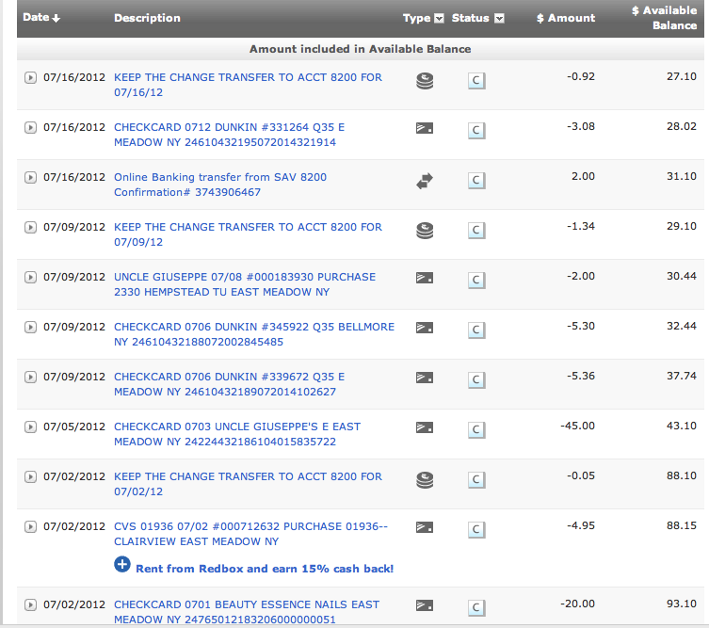

14
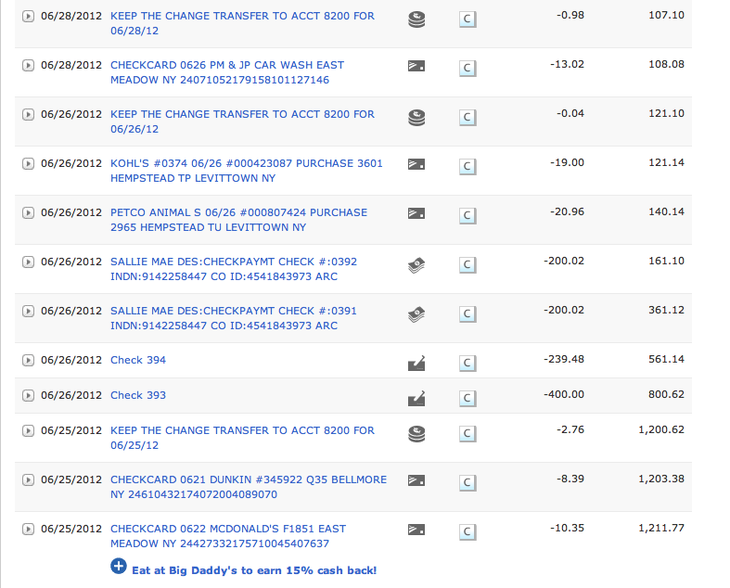

15




The theme for the project is “Turning Points in History: People, Ideas, and Events.” Since you get to choose the topic, you know that you will be interested in learning about it!

Perhaps the first question you are asking yourself is what exactly is a turning point in history? The dictionary defines “turning point” as a point at which a decisive change takes place. So a turning point in history is more than just an important event that happened a long time ago. It is an idea, event or action that directly, and sometimes indirectly, caused change. This change could be social or cultural, affecting a society’s way of thinking or way of acting. It could be political, leading to new legislation or to a new government taking charge. It could be economic, affecting how goods are produced, bought and sold, or how much or how little a society has to spend on such items. A turning point can even cause all of these changes and more. Don’t just think about how you understand the topic but also how people at the time thought about what was happening. It is important to examine the historical context of your topic so that you see your topic more clearly, understanding the “big picture.”

“Turning Points in History: People, Ideas, Events” always have at least two sides, or opposing perspectives. Part of being a thorough researcher is looking at a topic from all angles to see the whole story. Discovering the historical background of your topic will allow you to do this.

After choosing a topic, you will research the topic and keep an annotated bibliography of all the sources you used. The bibliography should be separated into primary and secondary sources.
After conducting research, you will be asked to write a process paper and create either an essay, exhibit or website representing your topic and how it relates to the theme of Turning Points in History: People, Ideas and Events.

Attached are some sample topics you may choose but you are not limited to these topics.
Research Project
TURNING POINTS IN HISTORY: People, Ideas, Events
Name ___________________________________________ Date ______________

16
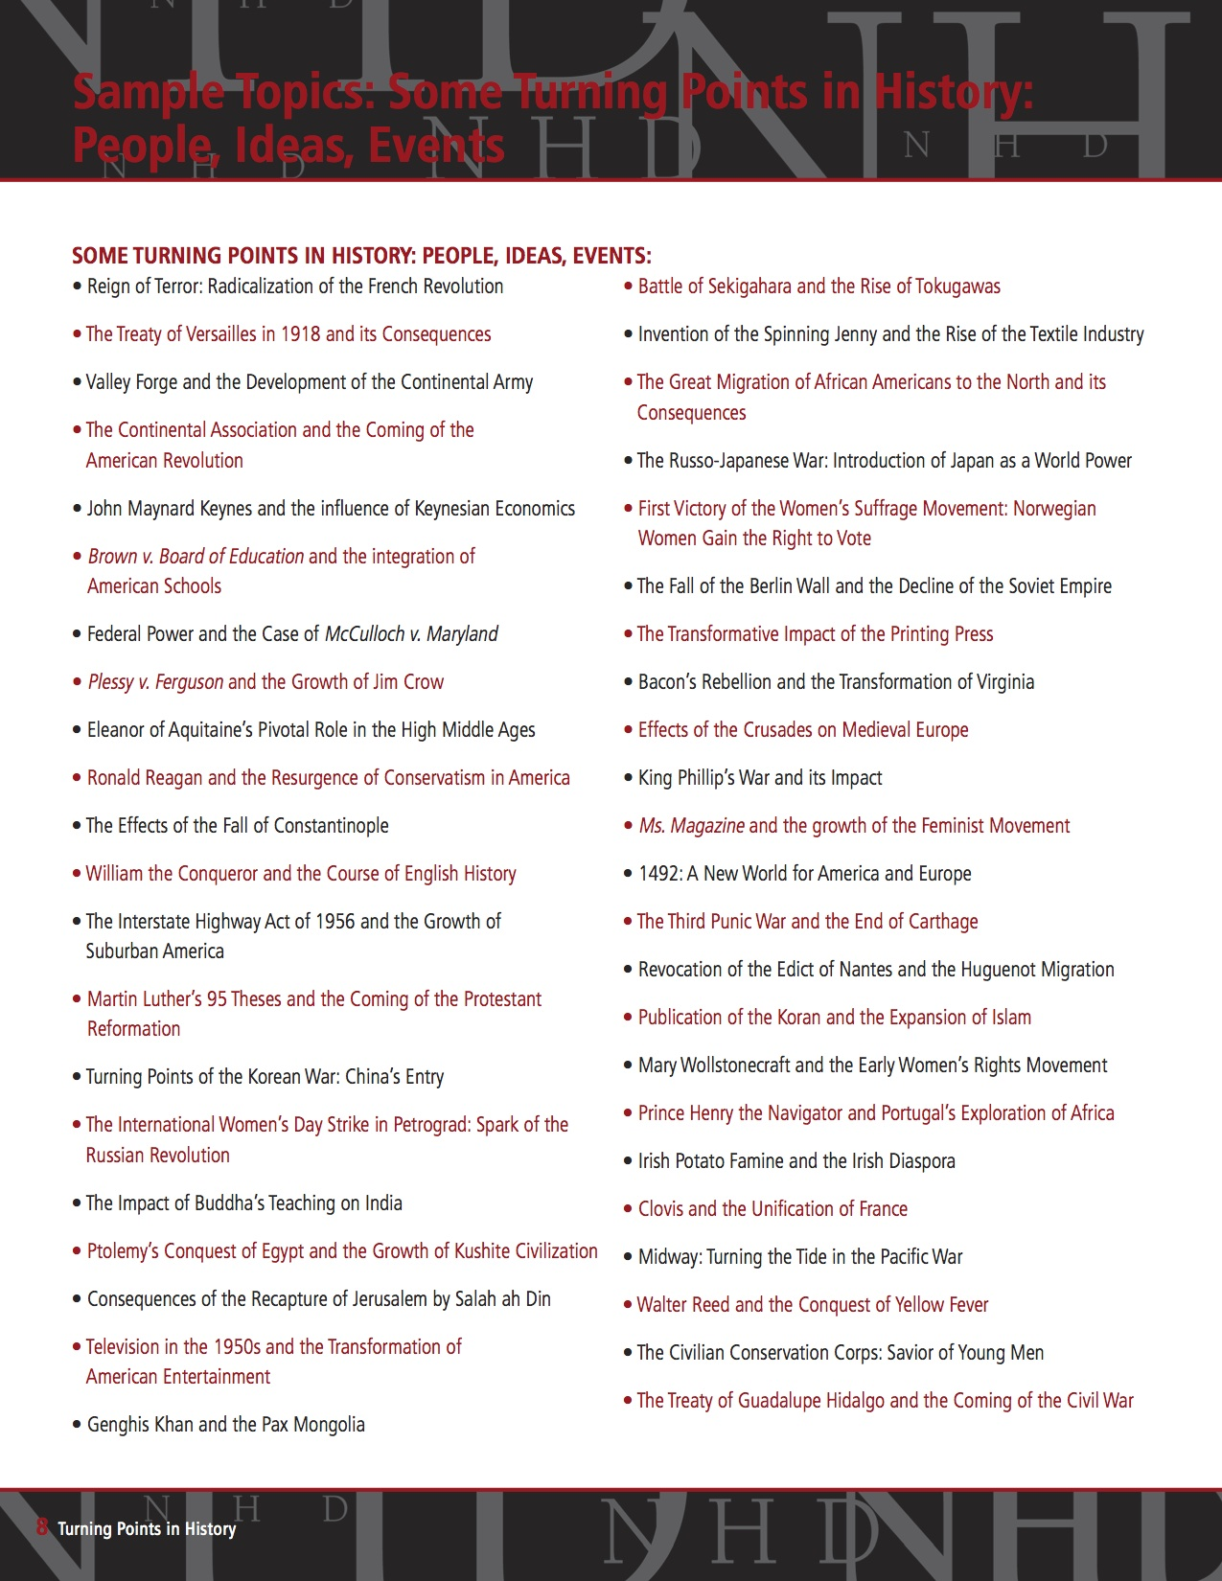

17
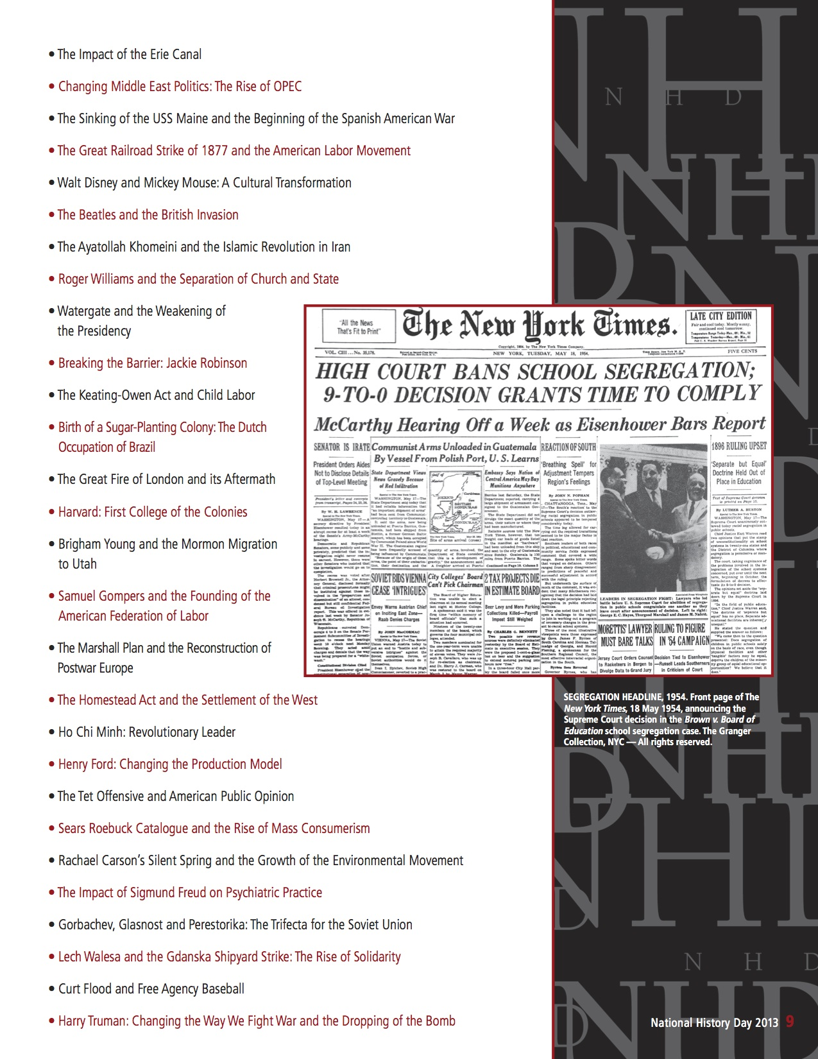

18



Process Paper
A process paper is a description of no more than 500 words explaining how you conducted your research and created and developed your entry. You must conclude your description with an explanation of the relationship of your topic to the contest theme.

A title page is required as the first page of written material in every category. Your title page must include the title of your project and your name.

-The first section should explain how you chose your topic.

-The second section should explain how you conducted your research.

-The third section should explain how you selected your presentation category and created your project.

-The fourth section should explain how your project relates to the theme.

RESEARCH PROJECT REQUIREMENTS:

Your research project must include :

1-Research question and thesis
2- Primary and secondary sources
3- Choose one of the following: creation of an exhibit, paper or glogster.
4- A process paper
5-Annotated bibliography

19
SAMPLE PROCESS PAPER
-------------------------------------
Martin Luther and the Reformation

Why I chose this topic:
Last year, I researched Johann Gutenberg, which led me to learn about the Renaissance and the Reformation. After that assignment, I did additional research on the influence of the printing press in contributing to the Reformation and learned about Martin Luther. Luther and his influence seemed very interesting and I wanted to learn more. Also, since I had a good knowledge of the early history of Europe from my Gutenberg project, I decided to build on that and chose to research Martin Luther and the Reformation.

How I conducted my research:
First, I went on the Internet at school. I then consulted a librarian at my school and got two very useful books. I took notes on those sources. I then outlined my ideas on large flip-chart paper. After doing that I learned that I needed much more information to continue. I went to the electronic encyclopedia on my computer at home and printed out every topic I needed more information on. I went to the public library. I also conducted an interview with our minister to be able to discuss my developing ideas. Next, I interviewed a research librarian at the Illiff School of Theology and acquired primary sources. There were a lot of these. They helped me understand why Luther’s impact on society was so great. I immediately started my annotated bibliography so it would not be left to the last minute. Again, but with much more information now, I laid out key ideas on flip charts and started planning my exhibit.

How I created and developed my exhibit:
I prepared one flip chart that outlined events before Martin Luther, another that outlined events after Luther, and the last one, events that occurred during the lifetime of Luther. I then made a draft of the timeline, text and picture captions that I was going to use on my board. Then I typed up the text and printed it out in the size and font I needed for the exhibit. I experimented with different boards, and found one that would be wonderful. I laid everything out on my board as a “draft.” I condensed the information down so everything would fit, tell the story. Finally, I glued everything down. I then outlined my oral presentation and practiced it in front of my parents.

How my project relates to the theme:
My project relates to the theme in several ways. My project focuses on Martin Luther- a person, yet, when you learn about Luther, it is directly tied in with an event-posting the 95 theses, and the Protestant Reformation- an idea. It is also a turning point in history. If Martin Luther and other reformers had not taken action, there might not be all of the different religions we know today. The primary religion in Europe and in the New World might still be Roman Catholicism.

20

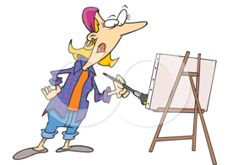
Exhibit
Historical exhibition presents information about an event, person, place, or idea from the past by physically displaying documents, images, or objects. We often see such exhibits at museums, but they are also presented at many other places such as archives, historic sites, park visitor centers, classrooms, and even airports and train stations

An exhibit is a visual representation of your research and interpretation of your topic’s significance in history, much like a small museum exhibit. The analysis and interpretation of your topic must be clear and evident to the viewer. Labels and captions should be used creatively with visual images and objects to enhance the message of your exhibit.

Rule 1: Size Requirements
The exhibit should be displayed on a tri-fold poster board.

Rule 2: Word Limit
There is a 500-word limit that applies to all text created by the student that appears on or as part of an exhibit. This includes the text you write for titles, subtitles, captions, graphs, timelines, media devices (e.g., video, slides, computer files) or supplemental materials (e.g., photo albums, scrapbooks, etc.)

21
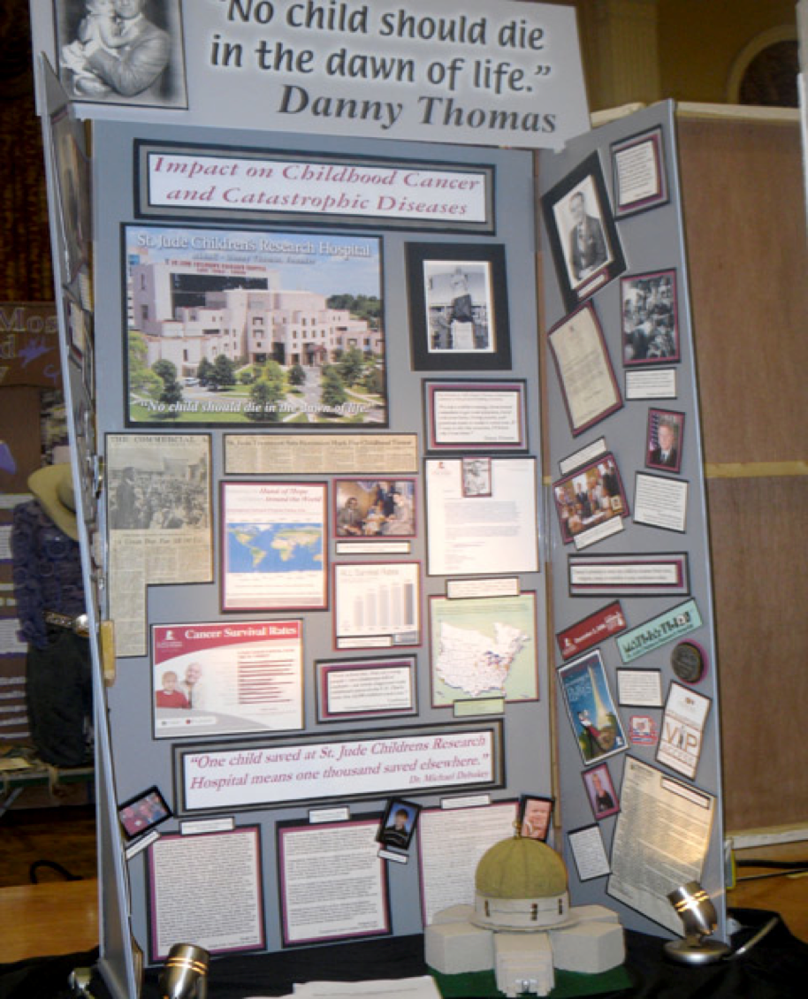

Sample Exhibit

22
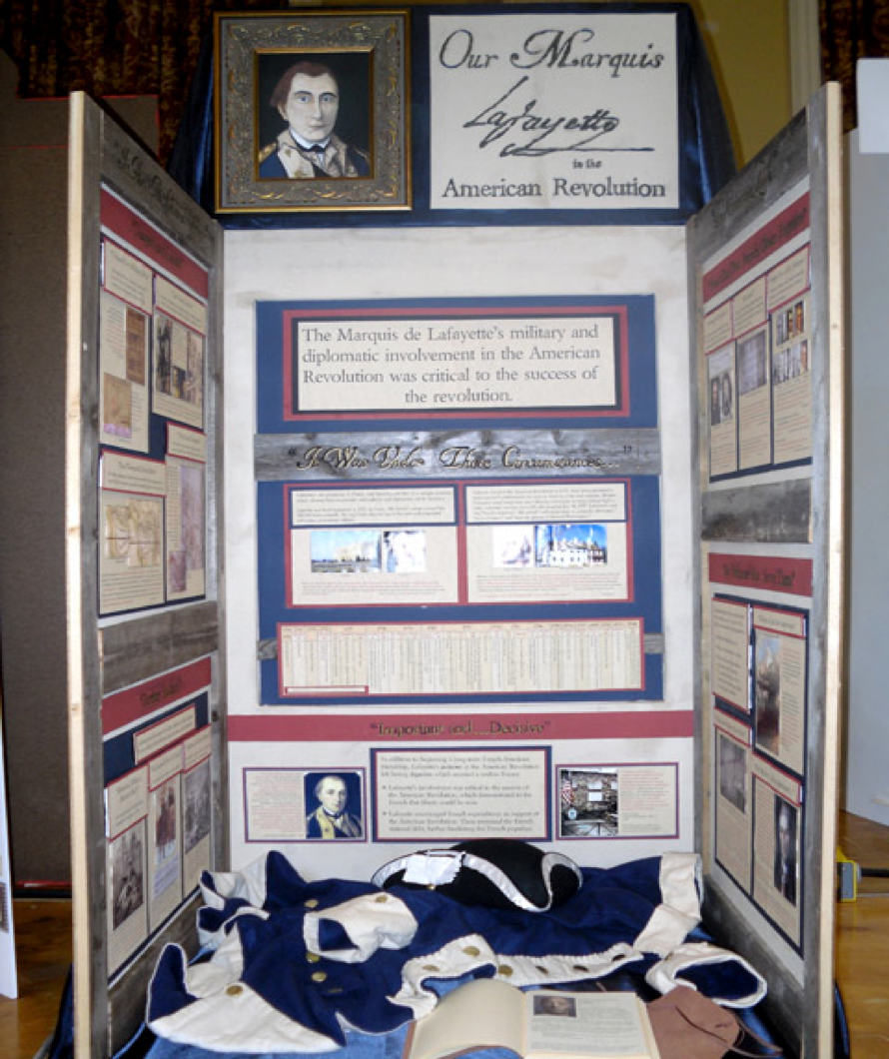
Sample Exhibit

23
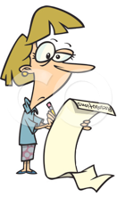
Paper
A paper is the traditional form of presenting historical research. Various types of creative writing (for example, fictional diaries, poems, etc.) are permitted. Your paper should be grammatically correct and well written.

Rule 1: Length Requirements
The text of historical papers must be no less than 1,500 and no more than 2,500 words in length.

Rule 2: Citations
Citations—citing the sources that you use are required.

Rule 3: Preparation Requirements
Papers must be typed, computer printed, or legibly handwritten in ink on plain, white paper. Pages must be numbered and double-space.

24





Make an outline. Using your notes, you can create a list of the main information you want to include in your paper, where each piece of information will go, and in what order. This will help when you sit down to write your paper.

Start writing. You might begin by writing your introduction in which you state your thesis.

-Introduction: your introduction should tell the reader where you intend to go with the rest of your paper. Your introduction should include a topic sentence (take the question you are answering and put it into sentence form, background information and a thesis (list what you are going to discuss in your body paragraphs.

-Body: the main body of your paper is where you make your case. Present your evidence, the primary sources, and your analysis of how they support your thesis.

-Conclusion: your conclusion is like the summary of your paper. It should summarize your main points that prove your thesis.

Read and Revise. A polished product takes time, so it is important to re-read and revise your paper. Check for clarity, unity, and coherence. Is it full of evidence and does it include a well-written introduction and body paragraphs? Does your conclusion flow logically from your thesis?
Conduct your research. Examine secondary and primary sources, taking careful notes and keeping track of which source each piece of information came from. From your research, you should come up with your thesis – the argument you want to make in your paper.
Steps to writing a research paper:

2

3

4

1

25


BODY Paragraph 1:

1st part of the topic (idea) to be explained:

(a) ________________________________________________________

What source will I use as evidence?

_________________________________________________________

What outside information will I mention to support this?

__________________________________________________________

Topic Sentence:

Background Info:

Thesis Statement:

Research paper - Organizer

26



BODY Paragraph 2:

2nd part of the topic (idea) to be explained:

(a) ________________________________________________________

What source will I use as evidence?

_________________________________________________________

What outside information will I mention to support this?

__________________________________________________________

information I should use in my conclusion:

27

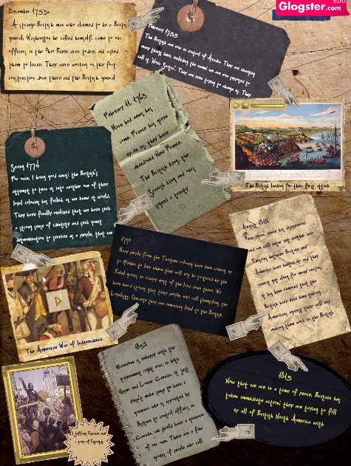
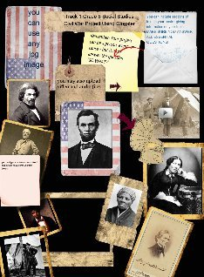

Glogster

Create an online web poster that combines, music, photos, documents and information about your topic.

Rule 1: Your glogster must include primary and secondary sources.

Rule 2: It should be an accumulation of research and argument that incorporates textual and non-textual (photographs, maps, music, etc.) description, interpretation, and multimedia sources to engage and inform viewers about your chosen topic.

Create a three dimensional, physical display. exhibits use color, images, documents, objects, graphics, and design as well as words, to explain a topic. Exhibits can be interactive by asking viewers to play music, look at a video, open a door or window to see more documents or photos.

28
Name_____________________ Grading RUBRIC
Criteria | Excellent | Very Good | Satisfactory | Needs Improvement | Teacher Comments
Historical Quality
60%

-Project is historically accurate

-Shows analysis & interpretation
-Contains a clear thesis

-Places topics in historical context

-Uses a variety of sources

-Primary Sources & secondary sources are relevant to topic

Relation To Theme
20%

-Clearly relates topic to theme

-Demonstrates significance of topic in history & draws a conclusion

Clarity of Presentation
20%

-Project is original, clear, appropriate , well organized, & articulate

Requirements Fulfilled

-Appropriate number of sources used

- Process Paper is included

-Annotated Bibliography completed

-Performance Project relates to thesis

Total Grade

__________

29

Do Now: Primary & Secondary Sources
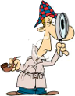
Directions: In your own words, explain what primary & secondary sources are.

TYPE OF SOURCE | YOUR DEFINITION | DEFINITION
Primary Source
Secondary Source

Name ___________________________________________ Date ______________

30


Scavenger Hunt
Directions: Using the internet, find primary and secondary sources for the topic that you have selected.
TOPIC | PRIMARY SOURCE | SECONDARY SOURCE
 | Source:  Why? | Source:  Why?
 | Source:  Why? | Source:  Why?
 | Source:  Why? | Source:  Why?
 | Source:  Why? | Source:  Why?
DISNEYWORLD | Source:  Why? | Source:  Why?

Name ___________________________________________ Date ______________

31


A
Forensic Expert Says Bigfoot Is Real
Stefan Lovgren
for National Geographic News
October 23, 2003

It's been the subject of campfire stories for decades. A camera-elusive, grooming-challenged, bipedal ape-man that roams the mountain regions of North America. Some call it Sasquatch. Others know it as Bigfoot.
Thousands of people claim to have seen the hairy hominoid, but the evidence of its existence is fuzzy. There are few clear photographs of the oversized beast. No bones have ever been found. Countless pranksters have admitted to faking footprints.
scientists remain undeterred. Risking ridicule from other academics, they propose that there's enough forensic evidence to warrant something that has never been done: a comprehensive, scientific study to determine if the legendary primate actually exists.

B

I was driving home with my baby late after visiting her grandma one July night. The lights of my car started hitting something that I thought was a telephone pole or a guardrail at first but I knew that it was something crouched down on the last cement guardrail post as I got closer. When I got closer the thing stood up from almost sitting on it’s heels and jumped into the middle of my lane and threw it’s hands up in the air. It was all black and definitely not a bear. It’s arms stretched high like a man’s not like a bear and I didn’t see a longer nose like a black bear has, it was like a man not a dog’s face. My drivers side tires went over its head and it was a very loud boom boom as I rode over it with all four tires. I immediately started thinking about stopping and seeing if it was still alive but all I could think is that if I got out it might come after me. I cried the whole way home thinking I had just killed the only Bigfoot there was.
Name ___________________________________________ Date ______________
- What is the difference between the two sources?

2. Which one of these sources is more accurate and credible? Why?

3. What must every source have? Why?

Do Now:

Do Now:

32


Citations/Bibliographies

A bibliography is the list of works cited. There is a specific format to be used when creating a bibliography.

Annotated Bibliography

An annotated bibliography is required for all categories. The annotations for each source must explain how the source was used and how it helped you understand your topic. You should also use the annotation to explain why you categorized a particular source as primary or secondary. Sources of visual materials and oral interviews, if used, must also be included.
List only those sources that you used to develop your entry. An annotation normally should be only 1-3 sentences long.

Source (example):
Bates, Daisy. The Long Shadow of Little Rock. 1st ed. New York: David McKay Co. Inc., 1962.

Annotation (example):
Daisy Bates was the president of the Arkansas NAACP and the one who met and listened to the students each day. This first-hand account was very important to my paper because it made me more aware of the feelings of the people involved.

Name ___________________________________________ Date ______________

33
Bibliography Format
Book
Basic Format
The author’s name or a book with a single author's name appears in last name, first name format. The basic form for a book citation is:
Lastname, Firstname. Title of Book. City of Publication: Publisher, Year of Publication. Medium of Publication.
Book with One Author
Gleick, James. Chaos: Making a New Science. New York: Penguin, 1987. Print.
Henley, Patricia. The Hummingbird House. Denver: MacMurray, 1999. Print.
Book with More Than One Author
Gillespie, Paula, and Neal Lerner. The Allyn and Bacon Guide to Peer Tutoring. Boston: Allyn, 2000. Print.
Wysocki, Anne Frances, Johndan Johnson-Eilola, Cynthia L. Selfe, and Geoffrey Sirc. Writing New Media: Theory and Applications for Expanding the Teaching of Composition. Logan: Utah State UP, 2004. Print.
Two or More Books by the Same Author
List works alphabetically by title. (Remember to ignore articles like A, An, and The.) Provide the author’s name in last name, first name format for the first entry only. For each subsequent entry by the same author, use three hyphens and a period.
Palmer, William J. Dickens and New Historicism. New York: St. Martin's, 1997. Print.
---. The Films of the Eighties: A Social History. Carbondale: Southern Illinois UP, 1993. Print.
Article in a Magazine
Author(s). "Title of Article." Title of Periodical Day Month Year: pages. Medium of publication.
Poniewozik, James. "TV Makes a Too-Close Call." Time 20 Nov. 2000: 70-71. Print.
Buchman, Dana. "A Special Education." Good Housekeeping Mar. 2006: 143-48. Print.

34
Article in a Newspaper
Brubaker, Bill. "New Health Center Targets County's Uninsured Patients." Washington Post 24 May 2007: LZ01. Print.
Krugman, Andrew. "Fear of Eating." New York Times 21 May 2007 late ed.: A1. Print.
If the newspaper is a less well-known or local publication, include the city name and state in brackets after the title of the newspaper.
Behre, Robert. "Presidential Hopefuls Get Final Crack at Core of S.C. Democrats." Post and Courier [Charleston, SC] 29 Apr. 2007: A11. Print.
Trembacki, Paul. "Brees Hopes to Win Heisman for Team." Purdue Exponent [West Lafayette, IN] 5 Dec. 2000: 20. Print.
A Review
Review Author. "Title of Review (if there is one)." Rev. of Performance Title, by Author/Director/Artist. Title of Periodical day month year: page. Medium of publication.
Seitz, Matt Zoller. "Life in the Sprawling Suburbs, If You Can Really Call It Living." Rev. of Radiant City, dir. Gary Burns and Jim Brown. New York Times 30 May 2007 late ed.: E1. Print.
Weiller, K. H. Rev. of Sport, Rhetoric, and Gender: Historical Perspectives and Media Representations, ed. Linda K. Fuller. Choice Apr. 2007: 1377. Print.
An Editorial & Letter to the Editor
Cite as you would any article in a periodical, but include the designators "Editorial" or "Letter" to identify the type of work it is.
"Of Mines and Men." Editorial. Wall Street Journal east. ed. 24 Oct. 2003: A14. Print.
Hamer, John. Letter. American Journalism Review Dec. 2006/Jan. 2007: 7. Print.

35
An Article in a Scholarly Journal
Author(s). "Title of Article." Title of Journal Volume.Issue (Year): pages. Medium of publication.
Bagchi, Alaknanda. "Conflicting Nationalisms: The Voice of the Subaltern in Mahasweta Devi's Bashai Tudu." Tulsa Studies in Women's Literature 15.1 (1996): 41-50. Print.
A Page on a Web Site
"How to Make Vegetarian Chili." eHow. Demand Media, Inc., Web. 24 Feb. 2009.
An Image (Including a Painting, Sculpture, or Photograph)
Goya, Francisco. The Family of Charles IV. 1800. Museo Nacional del Prado, Madrid. Museo National del Prado. Web. 22 May 2006.
Klee, Paul. Twittering Machine. 1922. Museum of Modern Art, New York. The Artchive. Web. 22 May 2006.
An Article in an Online Scholarly Journal
Dolby, Nadine. “Research in Youth Culture and Policy: Current Conditions and Future Directions.” Social Work and Society: The International Online-Only Journal 6.2 (2008): n. pag. Web. 20 May 2009

Speeches, Lectures, or Other Oral Presentations

Stein, Bob. "Computers and Writing Conference Presentation." Purdue University. Union Club Hotel, West Lafayette, IN. 23 May 2003. Keynote Address.

A Painting or Photograph

Goya, Francisco. The Family of Charles IV. 1800. Museo del Prado, Madrid.

36

Directions: Using the internet, search for sources on the topic you are researching. After you find a source, using your bibliography guide sheet, create a citation for each below.
Source | Citation
Book
Website
Newspaper

Magazine Article

Name ___________________________________________ Date ______________

37

Source name and type :

Where did you find it:

Circle one Primary source or Secondary source

Why it is useful:
Source name and type :

Where did you find it:

Circle one Primary source or Secondary source

Why it is useful:

Annotation Sheet

38
Source name and type :

Where did you find it:

Circle one Primary source or Secondary source

Why it is useful:
Source name and type :

Where did you find it:

Circle one Primary source or Secondary source

Why it is useful:

Annotation Sheet

39






Topic: ______________________
Every document that is used must have annotations in order to help you investigate your sources.

Source Sheet
How it relates to the topic:
Primary source:

1.

2.

How it relates to the topic:
Secondary source:

1.

2.

40

Topic: ______________________
Every document that is used must have annotations in order to help you investigate your sources.

Source Sheet
How it relates to the topic:
Primary source:

1.

2.

How it relates to the topic:
Secondary source:

1.

2.

41

Topic: ______________________
Every document that is used must have annotations in order to help you investigate your sources.

Source Sheet
How it relates to the topic:
Primary source:

1.

2.

How it relates to the topic:
Secondary source:

1.

2.

42

Topic: ______________________
Every document that is used must have annotations in order to help you investigate your sources.

Source Sheet
How it relates to the topic:
Primary source:

1.

2.

How it relates to the topic:
Secondary source:

1.

2.

43



Investigators are those who devote themselves to doing research about a particular topic. You are going to become an investigator and learn how to successfully research a particular topic.

Topic:
Research Question:
Name ___________________________________________ Date ______________
Research

Topic:
Effective projects not only describe an event or a development, but they also analyze
and place it in its historical context. To help you draw conclusions about your topic’s significance in history, ask yourself the following questions:

• How is my topic important?
• How was my topic significant in history in relation to the theme?
Theme- Turning points in History: People, Ideas, Events.
• How did my topic develop over time?
• How did my topic influence history?

Example:

Topic: Title IX

Research Question: Did title IX have a positive impact on female participation in athletics?

44

Thesis:
Thesis:
Your projects should do more than just tell a story. Every exhibit, website and paper should make a point about its topic. To do this, you must develop your own argument of the historical impact of the person, event, pattern or idea you are studying. The point you make is called a thesis statement. A thesis statement is not the same as a topic. Your thesis statement explains what you believe to be the impact and significance of your topic in history.

THESIS Statement is what you are trying to prove. It is a statement that you will explore in your project. It is the answer to your research question.
Now that you have began gathering your sources, write a thesis statement that will answer the research question.

Example:

Topic: Title IX

Research Question: Did title IX have a positive impact on female participation in athletics?

Thesis: Title IX had a positive impact on female athletics.

45




List what you have done so far for your research:

1- Topic:

2- Research question:

3- Thesis:
List what you still need to do and what your next steps will be to complete your research:

Teacher Student Conference and Checkpoint One

46




Sources that you have found:
Primary Sources:
Teacher comments or suggestions:
Secondary Sources:

Teacher Student Conference and Checkpoint One

47
List what you have done so far for your research:
List what you still need to do and what your next steps will be to complete your research:

Teacher Student Conference and Checkpoint Two

48

Teacher comments or suggestions:
How are you representing your theme?

How are you representing your topic?

How are you representing your thesis?

How are you representing the opposing side?

Teacher Student Conference and Checkpoint Two

49
List what you have done so far for your research:
List what you still need to do and what your next steps will be to complete your research:

Teacher Student Conference and Checkpoint Three

50

Teacher comments or suggestions:
Process Paper

How did you choose your topic?

How did you conduct your research?

How did you create your project?

How does your project relate to the theme?

Teacher Student Conference and Checkpoint Three

51

Wineburg, S. (2011). Beyond The Bubble. Retrieved August 2012, from http://beyondthebubble.stanford.edu/about-us

Biblography

Wineburg, S. (2011). Reading like a historian: Teaching literacy in middle and high school classrooms. New York: Teachers College Press.

