1 | Which of the following does not represent a way to find slope?
 | A | $$m=\frac{Rise}{Run}$$
 | B | $$m=\frac{x_{2}-x_{1}}{y_{2}-y_{1}}$$
 | C | $$m=\frac{y_{2}-y_{1}}{x_{2}-x_{1}}$$
 | D | $$m=\frac{∆y}{∆x}$$
2 | What is 0.00502 in scientific notation?
 | A | $$5.02×{10}^{3}$$
 | B | $$50.2×{10}^{4}$$
 | C | $$5.02×{10}^{-3}$$
 | D | $$50.2×{10}^{-4}$$
3 | Which equation has the greatest rate of change?
 | A | y= 2x-9
 | B | y= 2x+100
 | C | y= -3x+1000
 | D | y= 9x+ 1
4 | What is the slope of a line passing through the points (-2,-6) and (3,5)?
 | A | $$-\frac{1}{5}$$
 | B | $$-1$$
 | C | $$-5$$
 | D | $$\frac{11}{5}$$
5 | What is half of $2^{8}?$
 | A | 1⁴
 | B | 2⁴
 | C | 1⁷
 | D | 2⁷
6 | 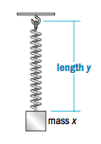  The table below gives the length of a spring when different masses are suspended from it.  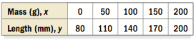  Write an equation for the function.
 | A | $$y=\frac{3}{5}x+80$$
 | B | $$y= x+60$$
 | C | $$y=30x+50$$
 | D | $$y=\frac{5}{35}x+80$$
7 | Two numbers have a sum of 72. One number is twice the other. Find the smaller number.
 | A | 24
 | B | 48
 | C | 72
 | D | 36
8 | Which of the following is equivalent to 9⁻⁴$×$9³?
 | A | $$\frac{1}{9^{12}}$$
 | B | $$9$$
 | C | $$\frac{1}{9}$$
 | D | 9⁷
9 | Which one of the graphs represents a function?
 | A |  | C
 | B |  | D
10 | Which set of ordered pairs represents a linear function?
 | A | {(-6,-2), (-3,-1),(-6,1),(1,3)}
 | B | {(-8,0),(-8,-3),(-8,-6),(-8,-9)}
 | C | {(-1,1),(0,2),(-1,4),(2,-7)}
 | D | {(-4,1),(-1,1),(2,3),(8,7)}
11 | What is the slope of the lines passing through points A and B?
 | A | $$-\frac{1}{3}$$
 | B | $$-3$$
 | C | $$3$$
 | D | $$\frac{1}{3}$$
12 | Select a graph for the situation. You wait for the express bus for 30 minutes, get on and ride the bus non-stop for 3 miles, and then walk another mile to your home.
 | A | 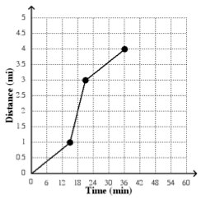 |  | C | 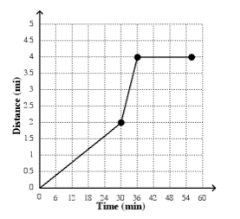
 | B | 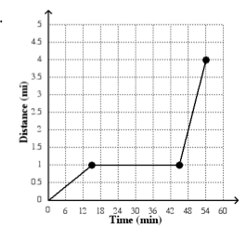 |  | D | 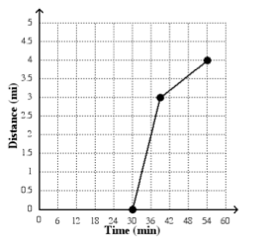
13 | The equation y=5 is
 | A | A vertical line.
 | B | Parallel to the y-axis.
 | C | Has zero slope.
 | D | Has no slope.
14 | What are the coordinates$(x,y)$ at which the graphs $2x+3y=12$ and $2x-y=4$ intersect?
 | A | $$(3,2)$$
 | B | $$(2,3)$$
 | C | $$(1,-2)$$
 | D | $$(-3,6)$$
15 | What is the slope of the line 3x+2y=12?
 | A | 2
 | B | $$\frac{3}{2}$$
 | C | $$-\frac{3}{2}$$
 | D | 3
16 | Solve for x: $0.7x + 2(x-3)=0.2x + 3$
 | A | 2.5
 | B | 3.5
 | C | 3.6
 | D | 4.5
17 | If a system of equations has no solution, what does it look like?
 | A | Perpendicular lines
 | B | Parallel lines
 | C | Same Line
 | D | Skew Lines
18 | What is the range of the following set of ordered pairs:  {(2,9), (3,8), (4,8), (4, 9), (-3, 9)}
 | A | {-3, 2, 3, 4}
 | B | {8, 9}
 | C | {-3, 2, 3, 4, 4}
 | D | {8, 8, 9, 9, 9}
19 | 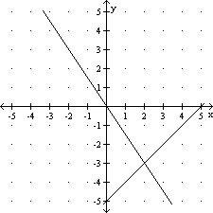  A system of two linear equations has been solved graphically. Use the graph to find any solutions.
 | A | infinite solutions
 | B | no solutions
 | C | (2, -3)
 | D | (-3,2)
20 | Which of the following statements is true about the relation shown on the graph below?
 | A | It is not a function because there are multiple y-values for a given x-value.
 | B | It is a function because there exists one x-coordinate for each y-coordinate.
 | C | It is a function because there exists one y-coordinate for each x-coordinate.
 | D | It is not a function because there are multiple x-values for a given y-value.

21 | Solve the system of equations graphically and check the solution. Show all work. Do not forget to label.  y + 3 = $\frac{1}{2}$ x y – x = 0  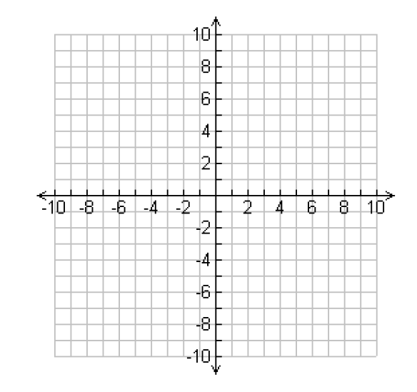  Solution: ___________  Check: Check:
22 | Solve for x.  $\frac{2}{3}$ (6x – 12) = 2x – 3  x=____________________________
23 | Using the table below, write an equation of the line in slope-intercept form.  x 2 4 6 8 10 12  y 15 29 43 57 71 85  _______________________________________________________________________

