Unit Title | Investigating Circumference and Pi |  | Unit Number | 2.2
Learning Objectives | To be able to define Pi  To use Pi to calculate circumference
Learning Outcome | To be able to apply understanding to practical problems
Find the circumference of the following circles. Remember to use the formula
Circumference = Dπ
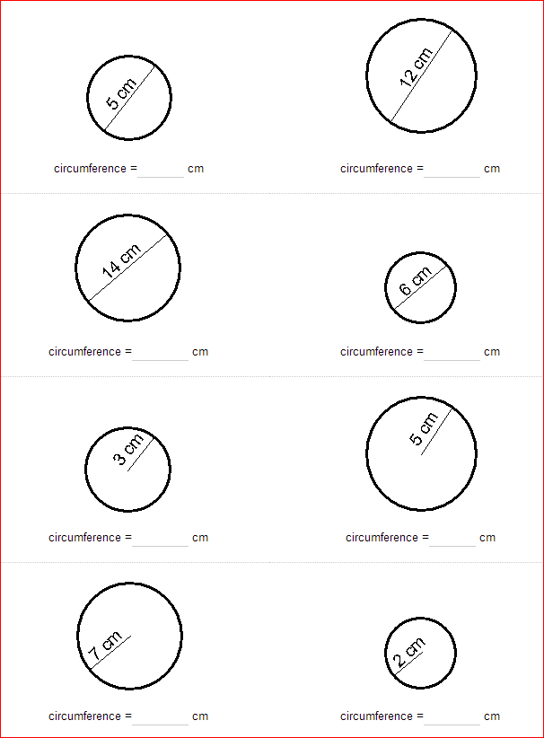
Circumference= D x π where π= 3.14
Look carefully at these before you do them!

Guided Learning Assignment: Title
Feedback
Please complete as it’s important to know how you are doing?
 | Student’s Comments | Teacher’s Feedback to Comments
How long did it take you to complete this task?
Look at the Learning objectives set at the start of this unit. Do you feel that you have achieved these objectives?
Look at the Learning outcome and the work you have produced. Do you feel that you have achieved the Learning Outcome set for you?
Is the anything you would have changed or done differently if you were to repeat the Learning Outcome?
List 3 things you learnt from doing this piece of work

If you wish to make any other comments about the work you have just carried out in this assignment please feel free to do so below:

