Author: Emily Troilo
Lesson Title: Digital Poetry
Suggested Grade Level: 11-12
Estimated Lesson Time: 60 minutes
Abstract:
Students will read/view and discuss digital poetry. They will notice the use of normal literary and poetic techniques and analyze how and to what effect they are used in digital poetry. They will then begin to create a digital poem of their own by choosing words and phrases from a passage from Running in the Family by Michael Ondaatje (a book read in a previous novel) using prezi.
Student Prior Knowledge:
Students have completed the unit on poetry and have a clear idea of poetic and literary techniques and how they are generally used in poetry (alliteration, metaphor, etc). Students have previously written their own poems.
Standards:
LA.1112.1.6.2: The student will listen to, read, and discuss familiar and conceptually challenging texts.
Learning Goals:
Students will read and discuss challenging digital poetry and evaluate its use of normal literary and poetic techniques. They will be able to analyze how and why they are used in the texts.
Students will create their own digital poem using the techniques they have learned and discussed.

Learning Objectives:
- Students should be able to discuss in class the literary and poetic techniques used in the selected digital poetry.
- Students should be able to create one digital poem of their own using a passage from a previously read work as an out-of-class project.

Resources:
A computer for you and each student
Projector
Selected digital poems
http://tinyurl.com/digitalpoem
http://tinyurl.com/digitalpoem2
http://tinyurl.com/digitalpoem3
http://tinyurl.com/digitalpoem4
Attached handout for students to use in creating their poem
Procedures:
- 3 minutes: Review of poetry – review the concepts you’ve gone over about poetry (definition of poetry, literary and poetic techniques, etc)
- 5 minutes: Introduction to digital poetry – Explain how digital poetry is a combination of technology and poetry where writers are able to use any multi-media elements (sounds, images, movement, video, interactivity and words) and how it creates new poetic forms and experiences for both the writer and reader and uses all of the literary devices and techniques that you’ve been discussing relating to poetry.
- Benefits to writers: some poets aren’t satisfied with the limitations of print, some poets believe that digital poetry does things rather than says things
- Benefits to readers: readers can play within the possibilities of the electronic poem more than they can in a print poem and each reading of a digital poem is intensely personal so every reader can have a different experience.
- 5 minutes: Play with digital poetry – have your students play on their own with the provided digital poems.
- 5 minutes: Discuss digital poetry – go over student impressions of digital poetry; what the students liked and didn’t like, what they think the advantages and disadvantages of digital poetry are, etc.
- 3 minutes: Introduction to project – explain to students that they will be creating their own digital poem. Pass out the attached handout that contains a passage from Running in the Family by Michael Ondaatje and tell them to choose words and phrases that they like from it or that speak to them and to re-arrange them and add words to create their own poem. Tell them to use the provided images or to look for images of their own online to help portray the ideas in their poem. From this hey will create a digital poem using prezi.
- 20 minutes: Explanation of prezi – give your students an overview of how to use prezi. By showing a tutorial of the prezi website, you can show students specific features they can use to best digitize their poetry (spiral effects, etc). Find an example of a student digital poem created on prezi to show your students.
- 20 minutes: Start on prezi poem – give your students time in class to start making a mock-up of their poem. They can physically cut out words and pictures from the handout or highlight or use a word document to type out words and phrases and images they like and move them around and play with them. Then make them start their prezi poem and answer any questions or difficulties they might be having with the project. Assign the project and give them maybe a week o complete it.

Video explaining procedures:
http://youtu.be/4gUKMGwMy4Q

Assessment:
A participation grade will be used for the class discussion and a rubric will be used to assess student performance on their digital poem project.

Running in the Family by Michael Ondaatje pg. 17

Drought since December.
All across the city men roll carts with ice clothed in sawdust. Later on, during a fever, the drought still continuing, his nightmare is that thorn threes in the garden send their hard roots underground towards the house climbing through windows so they can drink sweat off his body, steal the last of the saliva off his tongue.
He snaps on the electricity just before daybreak. For twenty five years he has not lived in this country, though up to the age of eleven he slept in rooms like this—with no curtains, just delicate bars across the windows so no one could break in. And the floors of red cement polished smooth, cool against bare feet.
Dawn through a garden. Clarity to leaves, fruit, the dark yellow of the King Coconut. This delicate light is allowed only a brief moment of the day. In ten minutes the garden will lie in a blaze of heat, frantic with noise and butterflies.
Half a page—and the morning is already ancient.

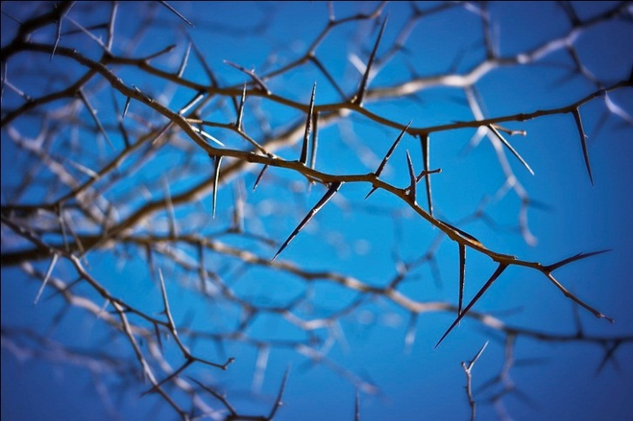

http://jasonsstory.files.wordpress.com/2010/07/thorn-tree.jpg

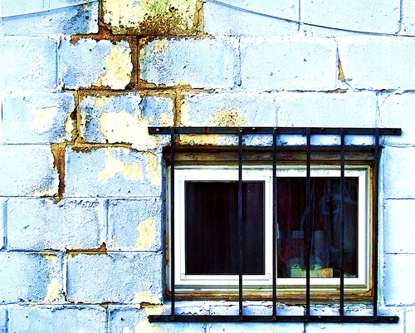

http://www.wiretotheear.com/wp-content/uploads/2007/11/window_bars.jpg

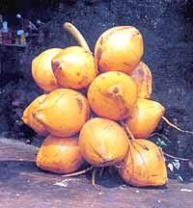

http://infolanka.com/org/srilanka/food/7.jpg

