Unit Title | Bikes: Investigating Materials |  | Unit Number | 1.1
Learning Objectives | To identify the materials used in the construction of a typical bike
 | To record the use of these materials using appropriate technology
 | To research and then compare and contrast these materials with bike construction of the past and high performance bikes of the present.
Learning Outcome | To Produce a presentation showing the materials used in the construction of a typical bike and those used in the past and in high performance bikes
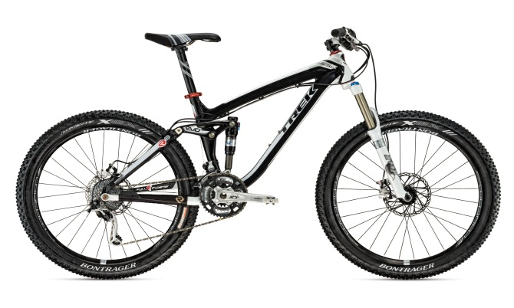
What do you need to do/consider/achieve?
Starting point: Read through the section on bike design on this website: Squidoo: Bike Science
Consider the information given, how useful is it? Does it give you some guidance as to the materials used in bikes?

Plan how you will investigate and record the materials used in your bike. Record your ideas below.

Consider how you will present your findings. What do you need to do to find information and how will you present your work.

Guided Learning Assignment: Feedback
Bikes: Investigating Materials
Please complete as it’s important to know how you are doing?
 | Student’s Comments | Teacher’s Feedback to Comments
How long did it take you to complete this task?
Look at the Learning objectives set at the start of this unit. Do you feel that you have achieved these objectives?
Look at the Learning outcome and the work you have produced. Do you feel that you have achieved the Learning Outcome set for you?
Is the anything you would have changed or done differently if you were to repeat the Learning Outcome?
List 3 things you learnt from doing this piece of work

If you wish to make any other comments about the work you have just carried out in this assignment please feel free to do so below:

