NAME: Louis Toedt
SUBJECT/GRADE LEVEL: 7th Grade Civics
TITLE/TOPIC OF LESSON: America’s First Political Cartoons: Reflections of America’s Founding Principles in Mass Media
ESSENTIAL “GUIDING” QUESTION FOR THIS LESSON How did media reflect, shape and comment on the principles that gave shape to the early forms of American constitutional government through the visual medium of political artwork?
SUNSHINE STATE STANDARDS ADDRESSED BY THIS LESSON:
    - SS.912.C.1.1- Evaluate the ideals and principles of the founding documents (Declaration of Independence, Articles of Confederation, Federalist Papers) that shaped American Democracy.
    - SS.912.C.2.13- Analyze various forms of political communication and evaluate for bias, factual accuracy, omission, and emotional appeal.
    - SS.912.C.2.15- Evaluate the origins and roles of political parties, interest groups, media, and individuals in determining and shaping public policy.
LESSON OBJECTIVES:
-Students will construct meaning from political cartoons in response to specific prompts, first individually and then in pairs. Students will then compare the meaning that they’ve constructed with explanations of the artwork in question offered by prominent historians.
-Students will identify symbolic meaning, intended message and personal bias on the part of the author/ illustrator in wide range of political cartoons with origins across the historical spectrum.
-Using a brief excerpt from a scholarly article entitled “Early Political Caricature in America” as a guide, students will compare and contrast the political cartoons from 1754-1790 that they’ve just analyzed to a slightly more sophisticated political cartoon from the 1830’s that actually makes use of the political caricature that so dominates the modern school of political cartooning.
LESSON CONTENT:
The type of language used in written media from the time when the U.S. was founded tends to be exceedingly difficult for many middle school students to comprehend without significant scaffolding, so instead we will focus on the visual media emerging from that era. This lesson will require students to react to some of the earliest examples of American political artwork, beginning with Benjamin Franklins “Join or Die”, widely recognized as America’s first political cartoon. Students will first react to each stimulus individually, and then develop their ideas in pairs as they attempt to construct meaning from an increasingly difficult series of images. Since this lesson comes towards the end of an overarching civics unit entitled "Foundations of American Democracy", students will have recently covered the process of the Constitutional Convention and the document’s ratification by the 11 states (excluding North Carolina and Rhode Island) necessary for the new government to be put into operation. Prior to this lesson, students will also have covered the move of the U.S. capital from New York to Philadelphia and eventually to Washington, D.C.
STUDENT GROUPING:
-Students will be grouped in pairs so that they can assist one another in constructing meaning from the antiquated political artwork without wasting much class time getting into groups. Students will simply turn to their immediate neighbor and discuss when prompted.
METHODS:
-Visual Discovery: Students will construct meaning from political cartoons in response to specific prompts individually at first.
-Think-Pair-Share: Students will develop their own interpretations of the cartoons with the help of a partner, and then be asked to share the meaning that they’ve constructed with the class.
-Short-Answer Compare/Contrast Essay: Using a brief excerpt from a scholarly article as a guide, students will compare and contrast the early American political cartoons that they’ve just analyzed to a slightly more sophisticated political cartoon from the 1830’s.
ACTIVITIES:
Opening/Bellringer:
-Display the first slide of the PP presentation and briefly field responses from a few students as to what they think the message of the cartoon (“Oprah for President”) might be. This should serve as a relatively non-intimidating way for students to ease into the lesson.
Main Activity: Think-Pair-Share:
  - THINK
    - Pass out copies of “America’s Earliest Political Cartoons: Activity Sheet.” (see below)
    - Display Ben Franklin’s “Join or Die” cartoon on projector screen and instruct students to silently fill in responses to questions #1-2.
  - PAIR
    - Instruct students to pair up and discuss their ideas, adding to what they’ve already written down if they think their partner noticed something that they haven’t.
  - SHARE/CLASS DISCUSSION
    - Field responses from a few of the student pairs pertaining to the answers to questions #1-2 on the activity sheet.
    - Move the PP along to the next slide, which offers explanation and background information from earlyamerica.com.
-Repeat this process for all remaining artwork, all of which are followed in the PP by a historian’s perspective from the Library of Congress or from the George Washington University website. Silde #5 is merely a close-up of a portion of slide 4, and slides 9-11 are all variations of each other and therefore share a single explanation.
Closing:
-See Assignment #2 below. Students will write a brief essay explaining the differences they’ve noticed between a more recent (1830’s) political cartoon and the older cartoons they’ve analyzed in class.
Important Questions to Ask:
- See Assignment #1 below. Students will share their cooperative responses with the class.

MATERIALS:
-PP Presentation entitled “America’s Earliest Political Cartoons”
-Projector
-Printouts (front and back) of assignments #1 and #2 (below)
The first two allow all students to see the cartoons very clearly in the classroom (as opposed to printing them on the activity sheets). The printouts are simply to give students concrete tasks to complete.
EVALUATION
Students will be evaluated by the extent to which they have completed assignment #1 in class (I won’t be grading for interpretive accuracy, although I may not tell them this ahead of time), they extent to which they have willingly participated in the class discussion, and the extent to which they have attempted to answer the questions and follow the prompts set forth in assignment #2. I realize that a lot of these question prompts may prove very challenging to a lot of 7th graders; therefore, their grades will be determined almost solely by the amount of effort they appear to have put forth and the extent to which they tried to follow the instructions given.

Name____________________ Assignment # 1
Date______ Civics
Period_____ Mr. Toedt
America’s Earliest Political Cartoons: Activity Sheet
“Join Or Die”:
1.) What do you think the snake represents in this cartoon? What do you think the individual pieces of the snake represent? ___________________
_________________________________________________________
__________________________________________________________________________________________________________________
2.) This cartoon was published by one of the more famous founding fathers; what message do you think he was trying to convey to the American people by doing so? _______________________________________________
_________________________________________________________
_________________________________________________________Bonus Question: Which founding father do you think it was? ____________
“‘The Bloody Massacre Perpetrated in King Street”
3.) What do you see taking place in this image? What time of day / year do you think it is? Is there anything else of significance that you notice?_____
_________________________________________________________
_________________________________________________________
_________________________________________________________
4.) From what you’ve noticed about this image, what can you tell me about the author and message behind it? _______________________________
_________________________________________________________
_________________________________________________________
“The Looking Glass for 1787”
5.) What do you notice going on this illustration? ____________________
_________________________________________________________
_________________________________________________________
6.) What do you think was going on America in 1787, and how does the action of this early political cartoon reflect that? ________________________
_________________________________________________________
_________________________________________________________
“Federal Superstructure”
7.) In the first of these images (they were printed in a series), whose hand do you think is raising the pillars into place? What does this suggest about how Americans saw themselves? _________________________________
_________________________________________________________
_________________________________________________________
8.) Consider what was happening in 1788; what do you think it means when a new column is added to the overall structure? _______________________
_________________________________________________________
_________________________________________________________
“A New Song”
9.) What major characters do you notice in the foreground? What event appears to be taking place in this 1790 cartoon? ____________________
_________________________________________________________
_________________________________________________________
10.) What do think the bystanders in the background might be saying about the events taking place in the foreground? _________________________
_________________________________________________________
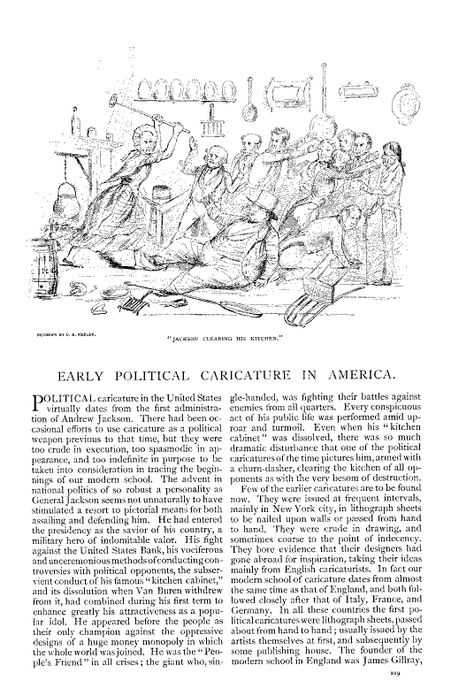
Name____________________ Assignment # 2
Date______ Civics
Period_____ Mr. Toedt
America’s Earliest Political Cartoons: Homework
The author of Early Political Caricature in America asserts that the art of political cartooning did not begin to resemble “our modern school” of political caricature until the Presidency of Andrew Jackson in the 1830’s. In a brief paragraph of 3-6 sentences, explain some of the differences in tone, clarity of message and overall impact on you as a viewer that you’ve noticed between the cartoon above the article (“Jackson Clearing His Kitchen”) and some of the older political cartoons that you saw in the PowerPoint presentation. Is the 1830’s cartoon harder or easier to understand than the older cartoons? What about it makes it so, in your opinion, and why do you think that might be the case? Do you think political cartoons became more or less “cartoonish” over time? Based on the article, how might Jackson’s persona as President have contributed to these changes?_______________________
_________________________________________________________
_________________________________________________________
_________________________________________________________
_________________________________________________________
_________________________________________________________
_________________________________________________________
_________________________________________________________
_________________________________________________________
_________________________________________________________
_________________________________________________________

