Middle School STEM Science Lab/Activity Planner
Name of Lab/Activity: Where does the energy come from when matter changes? |  |  | Grade: 8
California Science Standard(s): (please copy and paste standards taught during this lesson)

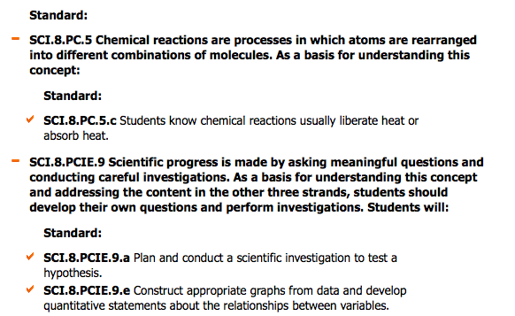

Review Standards from Prior Grade 6

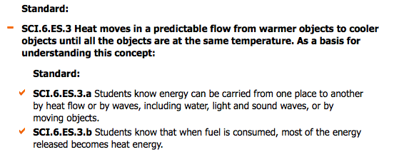

Learning Objective/Goal: Students will explore changes in matter from various chemical reactions to measure changes in temperature of the system. Students will make predictions about where the energy comes from to change the temperature and will test their idea by changing the parameters in a basic chemical reaction. Students will better understand the ideas of exothermic or endothermic reactions as a result of the investigation and will demonstrate their ability to use experimental evidence to support their scientific claim about this concept.

Language Objective/Goal: (based on California Common Core Standards)
Literacy in Science and Technical Subjects
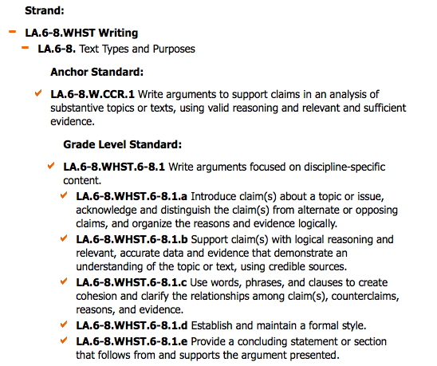

8th Grade English/Language Arts Standards
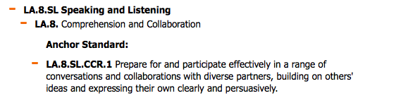

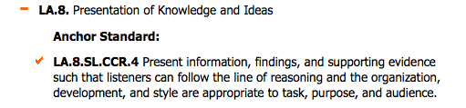

Materials & Resources:
Safety Equipment should include:
Safety googles, tray to contain any spills

Chemicals:
1. Baking Soda (5 grams per reaction) – modified amounts of 10 and 15 grams (premeasured) for inquiry investigation
2. Calcium Chloride (10 grams per reaction) modified amounts of 10 and 30 grams (premeasured) for inquiry investigation
3. Epsom Salts (5 grams per reaction) – modified amounts of 10 and 15 grams (premeasured) for inquiry investigation
4. Ammonia Solution (10 mL – premeasured)

Equipment
5. Thermometer or Temperature Probe
6. Two Beakers for each station for the reactions
7. Graduated cylinder for water
8. Another container (possibly a larger beaker) to use as a water bath
9. Stop watch or other timer if using a thermometer

All data should be recorded in each student’s lab notebook.

Procedure:  Overview of Inquiry Process:  Detailed student procedures will be attached separately for the first part of the session. These will provide a basic structure for variables and measurements that can be investigated, and also provide some reflection questions to start the more student directed inquiry process.  The final student products for evaluation will include the initial experimental data, analysis and answers to the reflection questions and more importantly the full inquiry lab that is documented either in the lab notebook or typed separately.  High-Level Description of Lab Activities  1. Students are directed to follow the attached procedure (Insert file name here) whereby they record the temperature of one reactant prior to the experiment (reactant in solution), then after adding the second reactant record the temperature every 30 seconds. Students will have an exothermic reaction (Baking soda solution and calcium chloride) and an endothermic reaction (ammonia solution with Epsom salts.)  2. Students will then analyze the data by graphing the results of the two changes to matter.  4. The groups will stop and discuss the results as a group and share whole class the answers to the reflection questions and make some predictions about why some reactions produce heat and others absorb heat. This discussion produces the claim for investigation in the second experiment.  Probing Discussion Questions might be:  Why do we have to put the baking soda in water before we add the calcium chloride?  Do students understand that the water provides a way for the molecules to collide and interact? If so how would the temperature of the water affect the results?  In what ways can we add energy to our chemical reaction system?  Do students understand that stirring or shaking as well as heating up the solution provides energy (kinetic energy to the system?)  Do they understand that adding more reactant to an exothermic reaction will create more energy? (More wood on a fire makes it burn longer. Once the wood is consumed the fire goes out.) More reactant on endothermic requires more energy to be absorbed.  Do you think you could stop any of these chemical reactions, and how might you do it? Could you restart them? Can you think of any way we stop chemical reactions in our everyday lives?  Can they connect the idea of refrigerating our food to keep it from decomposing or stopping the growth of bacteria etc is an example of limiting energy to an endothermic reaction? Do they have other ideas or examples.  5. Students will then be asked to develop an experiment that would provide more evidence to support their claim. They will be given access to a freezer or ice; moderate increased or decreased amounts of reactants; bath of water to try and moderate the heat available to the reaction. (Students can use the original experimental procedure as a guide and just identify new independent variable for analysis – e.g. amount of reactant, starting temperature of the solution, ice bath, room temperature bath or hot bath for the reaction) Ideas can be scaffolded through questioning of individual groups by the teacher.  6. Students will write their final lab report with a full materials, procedure, data tables, graphs for analysis, discussion of results, and final conclusion, and students will provide a quick summary of their results to the whole class (Our claim was___________, and we thought that if we ______________ then ____________ would happen. We found that ________________. This makes sense because ________________ (Or we found ________ and we would like to try ___________________ if we could do this experiment again.) |  | Teaching Notes: (include timing)  Two sessions are recommended:  1. Conduct the basic experiments to understand that changes to matter can produce or absorb energy. Use those findings to develop another experiment to provide evidence about the source of the energy.  2. Conduct the new investigation and document the evidence and reasoning that may support the claim.  Grouping:  Students are in lab groups to conduct the experiments. Every student makes observations, records and analyzes the data. Groups of four are recommended and students can alternate roles of  - time keeper  - Thermometer reader  - Data recorder  - Equipment/Safety manager  Heterogeneous grouping would be recommended.  Students by this time should be familiar with developing a procedure for an experiment, and should have adequate direct instruction on the claims, evidence and reasoning. A standard class rubric for evaluating explanations will have already been introduced.  This activity should develop and demonstrate the students ability to articulate their claim and proper use of evidence and reasoning to support or refute their claim. Getting positive results are not required, but rather evaluating proper use of the evidence
Math Connection:  Students will measure the temperature of the reaction at various times; record the data in a table and graph the data. They will interpret the trend to understand basic energy producing changes (exothermic) or energy absorbing changes (endothermic). |  | Teaching Notes:
Technology Extension of Learning:  1. Students will preview videos to explain the how the concepts of heat (flow of energy), temperature, and total energy of a system are all different but related quantities.  YouTube Eureka Episodes 20 and 21:  2. Some students may use a temperature probe to acquire and graph the data and may use the tool to observe more refined temperature changes as a result of change to the experimental system.  3. More advanced students can review the interactive lesson on energy and temperature from |  | Teaching Notes:
Formative Assessment: (please attach a copy)  Sort changes to matter into exothermic or endothermic or can’t tell and explain the rule you used. (Provide verbal examples as well as chemical equations, and graphs of energy of reactants transition to energy of products) to see if students can properly identify the idea from simple empirical data, |  | Teaching Notes:  Prior to the lesson, use a probe to determine and reinforce prior knowledge of energy, energy transfer, heat and temperature.  The exothermic/endothermic probe can be used at the end of the first lab activity and then again at the end to show development of understanding.  A formative assessment of the language arts objective will be a peer review worksheet on the claim, evidence and reasoning (see attached.)
Strategies for EL and Special Needs Students:  After viewing the video (at home or in prior class periods) students will provide examples that describe and differentiate the concepts of heat, temperature and energy. This will be shared as a lab group and also as a whole class. A lab group will be asked to develop a quick model (pantomime) to describe the movement of energy from one system to the other and the resulting changes. (Heat moves from hot to cold – colder system goes up in temperature as energy is transferred and the hotter system becomes cooler. When they reach the same temperature the changes stop. A basic heat transfer probe from Keeley would be nice to insert at this point to see how clear all students are with this concept. (Will need to locate)  Sentence frames/graphic organizer will be provided to scaffold the writing of a claim-evidence and reasoning of the final lab report. (See attached from PS-Cubed Claim Evidence Reasoning Graphic Organizer)  Special need students may need support with the mathematical skills of properly reading the thermometer, carefully recording the data and finally graphing the results. If necessary, provide printed data tables for them.  At the end of the lesson the explicit definition of exothermic and endothermic reactions will be provided for note taking/note making. Students should be able to provide additional examples and evidence from everyday life of other exothermic or endothermic reactions (heat packs (exothermic), activated cold packs (endothermic), composting (exothermic), burning wood (exothermic), acne treatments activated with water (exothermic), digesting food (exothermic). (Exit card – I can think of four can you come up with at least two?) – Share with group first then turn in (practice scientific conversation and explain with written explanation) |  | Vocabulary:  Heat  Temperature  Energy  Absorb / Produce  Exothermic  Endothermic  Reactant  Product
Alignment in science unit: (Brief description of lessons taught prior to & after this lab/activity)
Science Conceptual Knowledge
Prior to this activity students will have developed:
a moderate understanding of the transfer of energy from one system to another (6th grade with basic review);
a good understanding that energy moves from a hot to cold (6th grade with review);
a good understand that during a chemical reaction matter is changed from one substance to another substance (evidence of chemical reaction);
a good understanding that compounds and molecules are formed by atoms that are chemically bonded together (most substances are combinations of atoms).

Language Arts Skills and Knowledge
Prior to this activity they will have developed a good understanding of what a scientific claim is as compared to scientific evidence. They will also understand what constitutes good evidence (observable not inferences), and finally can utilize their understanding of chemical bonding to develop reasoning to connect the evidence to the claim.

Brief description of lessons taught after this lab/activity:
After this activity we will have an directed teaching session to define and describe the ideas of activation energy and how one can describe the energy of the reactant and products using bonds formed and broken. Students will need to understand that all reactions (endothermic and exothermic require some energy be added to the system to either provide additional collisions of reactants and some energy to break the initial reactants into their constituents so that they can form the new products. The direct instruction will also summarize the concept that the chemical bonds provide “pockets” of potential energy. It takes energy to break them and some energy to reform them. If the energy released by breaking them is greater than the energy needed to make the new bonds then the energy is released (exothermic) and visa versa for enothermic.

Fully understanding the molecular mechanisms for chemical reactions can support the understand that mass in conserved in a chemical reaction, and energy can be transferred from the chemical system to its environment.

Lab/Activity adapted from: (website, textbook, etc.)  1. Investigations: CPO Focus on Physical Science, 10A Chemical Reactions.  2. University of Florida Chemistry Outreach Program - Temperature of Reactions – tempprobe.pdf from curriki.org. | Formative Assessment adapted from:  PS-Cubed – Peer Evaluation of Claim-Evidence and Reasoning.
This lesson was developed by:
Teacher’s Name | Currently Teaching at: (School & District)
Mary Enright | Cupertino Middle School, in the Cupertino Union School District

