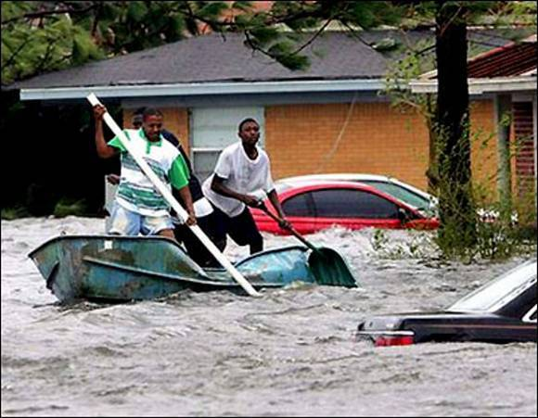

Title
Hurricane Katrina Image

Description
As a society we are exposed to images of the apocalypse from different types of media. The end of the world is a popular issue in pop culture and in science. Movies depicting the end of the world often use natural disasters to bring about Armageddon. This image shows residents of New Orleans performing a search and rescue effort. Using this image to facilitate a discussion would be beneficial in discussing, not necessarily the apocalypse, but natural disasters and their affects on members of the community and how their personal world may end in many ways. In a social studies class images of Hurricane Katrina can be used to talk about the government relief effort and what could have been done better and how the government can help victims of natural disasters in the future.

Subject
Natural Disasters, history in the 21st century, controversial issues, government aide

Keywords
Relief, Disaster, Hurricane Katrina

