Learning Object: Chart describing the many facets of the financial/economic crisis from 2007-2009
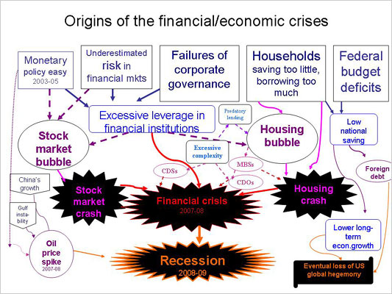

http://topics.blogs.nytimes.com/2008/12/26/origins-of-the-economic-crisis-in-one-chart/

