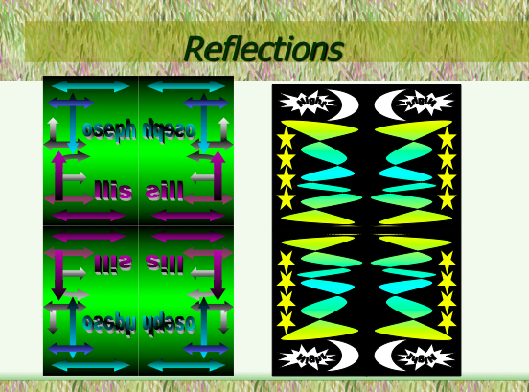
Here are some samples in color of rotations and reflections that can be made with Microsoft Word by Leonard Herman Middle School Students in San Jose, CA.

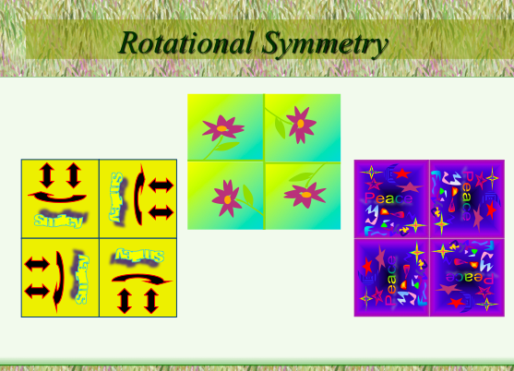

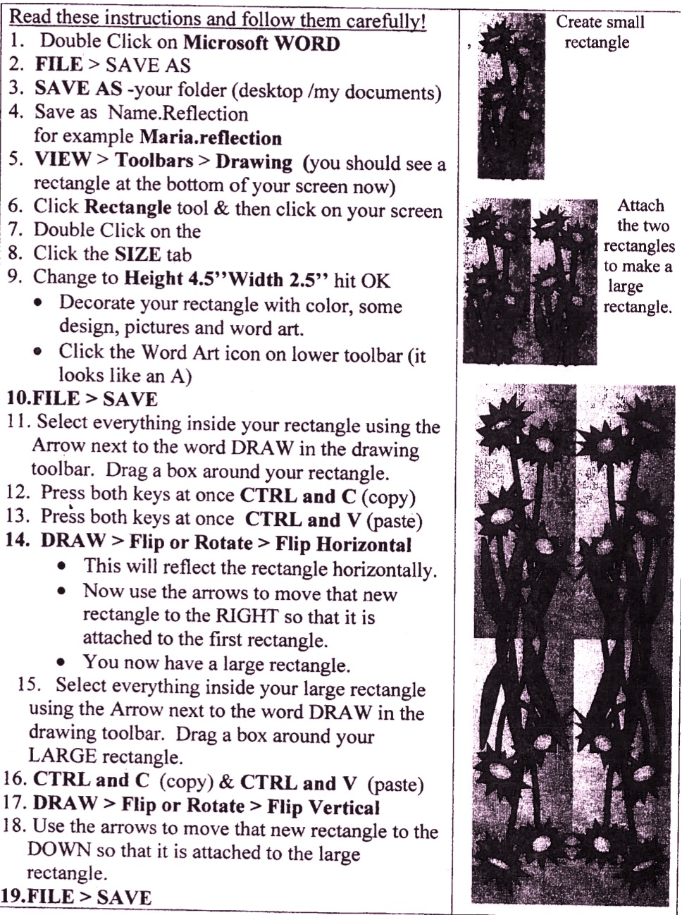
Instructions for Reflections

Instructions for Rotations
